|  |  |
| --- | --- |
|  | E |
| International Union for the Protection of New Varieties of Plants |  |

|  |  |
| --- | --- |
| Working Group on Biochemical and Molecular Techniques  and DNA-Profiling in Particular  Twentieth Session Alexandria, United States of America, September 22 to 24, 2021 | BMT/20/6  Original: English  Date: September 16, 2021 |

Session to facilitate cooperation

Document prepared by the Office of the Union

Disclaimer: this document does not represent UPOV policies or guidance

The purpose of this document is to report on the outcome of discussion groups on cooperation at the Technical Working Parties and to invite participants at the BMT to form discussion groups to allow participants to exchange information on their work on biochemical and molecular techniques and explore areas for cooperation.

The BMT is invited to:

(a) recall the information provided by participants at the nineteenth session of the BMT on their work on biochemical and molecular techniques and areas for cooperation, as reproduced in Annex to this document;

(b) note the information on discussion groups to allow participants to exchange information on their work on biochemical and molecular techniques and explore areas for cooperation and

(c) form discussion groups to allow participants to exchange information on their work on biochemical and molecular techniques and explore areas for cooperation.

# Background

The background to this matter is provided in document TWP/4/7 “Molecular Techniques”.

The TC, at its fifty-fourth session[1], noted that discussion groups had been formed at the sixteenth session of the BMT for: agricultural crops; fruit crops; ornamental plants and forest trees; and vegetables, for BMT participants to exchange information on their work and explore areas for cooperation (see document TC/54/31 “Report”, paragraphs 278 and 281).

The TC, at its fifty-fourth session, agreed that the results of the coordination session in the BMT be reported to the TWPs. The TC agreed to invite the TWPs to undertake a similar session to build on the BMT outcomes and feed into the future work of the BMT. The TC agreed that discussion groups should be formed for the main crops at each TWP to allow participants to exchange information on their work and explore areas for cooperation.

# Developments at the Technical Committee

The TC, at its fifty-sixth session, noted the information provided by participants at the nineteenth session of the BMT on their work on biochemical and molecular techniques and areas for cooperation, as reproduced in Annex to this document (see document TC/56/27 “Report”, paragraphs 52 to 54).

The TC agreed to invite the TWPs and BMT to form discussion groups to allow participants to exchange information on their work on biochemical and molecular techniques and explore areas for cooperation.

The TC noted that the BMT had discussed “confidentiality, ownership and access to molecular data” at its nineteenth session.

# Developments at the TWPs at their sessions in 2021

The development at the TWPs at their sessions in 2021 were as follows:

Technical Working Party for Vegetables (TWV)

The TWV, at its fifty-fifth session, held on May 3 to May 7, 2021, noted the information provided by participants at the nineteenth session of the BMT on their work on biochemical and molecular techniques and areas for cooperation, as reproduced in Annex I to document TWP/5/7.

The TWV formed a discussion group to allow participants to exchange information on their work on biochemical and molecular techniques and explore areas for cooperation. Tomato, lettuce and pepper were discussed during the discussion group.

Technical Working Party for Ornamental Plants and Forest Trees (TWO)

The TWO, at its fifty-third session, held on June 7 to June 11, 2021, noted the information provided by participants at the nineteenth session of the BMT on their work on biochemical and molecular techniques and areas for cooperation, as reproduced in document TWP/5/7, Annex I.

Technical Working Party for Agricultural Crops (TWA)

The TWA, at its fiftieth session, held on June 21 to June 25, 2021, noted the information provided by participants at the nineteenth session of the BMT on their work on biochemical and molecular techniques and areas for cooperation, as reproduced in document TWP/5/7, Annex I.

The TWA held a discussion session to allow participants to exchange information on their work on biochemical and molecular techniques and explore possible areas for cooperation for Soybeans, Potato, Oilseed Rape, Hemp, Faba Bean and Wheat. The TWA agreed to invite presentations to be made at its fifty-first session, to be held in 2022, on biochemical and molecular techniques in the different crops discussed.

Technical Working Party for Fruit Crops (TWF)

The TWF, at its fifty-second session, held on July 12 to July 16, 2021, noted the information provided by participants at the nineteenth session of the BMT on their work on biochemical and molecular techniques and areas for cooperation, as reproduced in document TWP/5/7, Annex I.

The TWF held a discussion session to allow participants to exchange information on their work on biochemical and molecular techniques and explore areas for cooperation for Apple, Strawberry and Peach. The TWF agreed to invite the experts from the European Union and France to make presentations on the use of molecular techniques in DUS examination of apple varieties, at its fifty‑third session.

*The BMT is invited to:*

*(a) recall the information provided by participants at the nineteenth session of the BMT on their work on biochemical and molecular techniques and areas for cooperation, as reproduced in Annex to this document;*

*(b) note the information on discussion groups to allow participants to exchange information on their work on biochemical and molecular techniques and explore areas for cooperation as presented in this document and*

*(c) form discussion groups to allow participants to exchange information on their work on biochemical and molecular techniques and explore areas for cooperation.*

[Annex follows]

INFORMATION PROVIDED BY PARTICIPANTS AT THE BMT/19 SESSION (ENGLISH ONLY)

1. Where do you work?

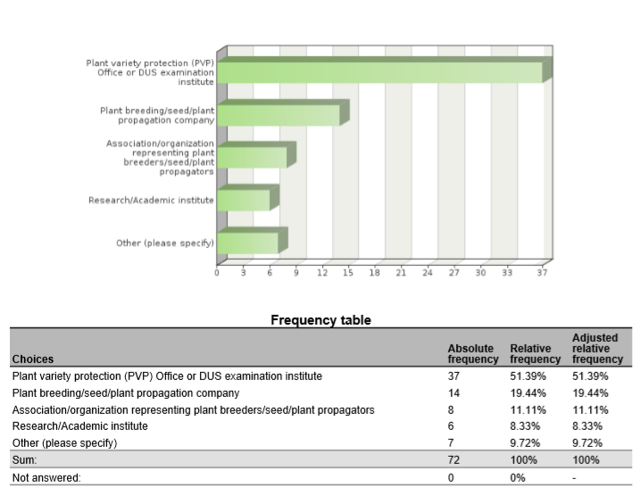

1. Are you cooperating with (other) UPOV members in the use of biochemical and molecular techniques?



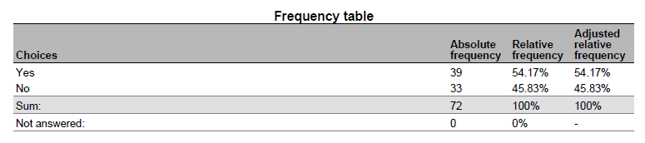

1. Please indicate with which UPOV members you are cooperating on biochemical and molecular techniques

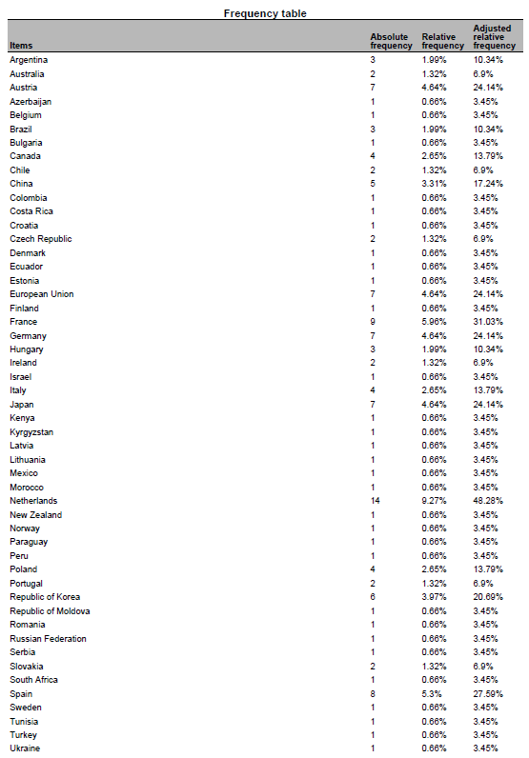

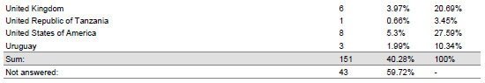

1. What are the objectives of the cooperation with the indicated UPOV members?

* validation and harmonization of crop-specific SNP sets My colleagues are also involved in projects to help with setting up a DUS examination procedures and facilities
* data base of tomato and wheat to improve the choose of comparators for DUS test
* Partner in Tomato project.
* tomato SNP project
* Associated partner in the OSR SNP research project.
* Use of SNP to varietal description
* Development of molecular tools for management of reference collection and assessment of specific traits
* gain knowledge
* Tomato SNP project
* Management of Reference collection; Quality management
* International harmonization and validation of a SNP set for the management of tomato reference collection
* molecular markers panel and method validation, molecular marker selection to describe varieties collection
* IMODDUS project of Tomato
* selection and validation of a molecular markers panel for genotyping core collection and varieties
* We are a member of the group involved in the use of SSR markers for potato DUS in Europe
* CPVO project
* Some research project are crop specific and are looking at identifying markers, some are more horizontal such as exchange on possible ideas for the use of molecular markers in DUS (within the IMODDUS group).
* expand use of SNP markers in DUS for soybeans
* developing SNP panels for soybean and barley
* Harmonization of marker sets
* identification of BMTs which can be applied in varietal identity and purity certification
* Build capacity for establishing distinction among varieties, based on genotype parameters.
* DUS, Infringements

5. Have you presented a paper on your cooperation with UPOV members at this BMT?

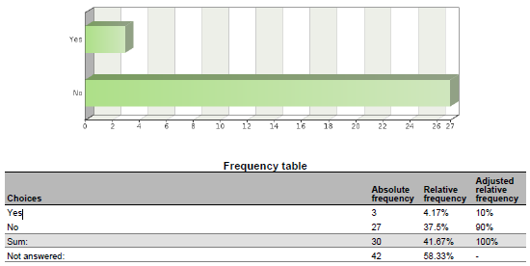

6. If you have not presented the paper, why not?

* I did in previous BMT sessions to introduce these cooperations. The projects we are working on are not yet in the phase to report on the results. Hopefully next year.
* The work is in progress and we are no acting as coordinators
* United Kingdom have not presented because France presented earlier in today.
* Because the work is in progress
* This project just starts from this year.
* This project just starts from this year.
* Because the project is not progressing.
* work is in progress
* There have been no significant changes in the work since the last BMT.
* involved with INVITE project
* I'm DUS expert
* Because the CPVO made a presentation, not necessary for breeders to do. ISF will present the outcome of a survey to which we (Euroseeds) also contributed.
* I have presented many in the past, but did contribute to a presentation this year.
* Cooperation with OECD was included into the Secretariat’s document on cooperation with IOs

7. In what areas would cooperation with UPOV members be valuable to you?

* harmonization of MM sets and also harmonized use of these MM sets in DUS examination. Common databases with variety descriptions and genotyping data to be used by all Examination offices world wide.
* fruit varieties
* Share markers used and platforms, and experience on the species.
* Interested in the development of a DNA reference database for potato.
* The use of DNA markers in DUS testing
* The use of biochemical and molecular techniques for management of reference collections
* Molecular techniques in variety identification, Variety description databases including databases containing molecular data
* Development of molecular tools to support DUS testing. Exploration of new markers (e.g. NGS) and new models (e.g. vmDUS)
* Obtaining information details on some specific procedures, if needed; Exchange of data; etc
* MODEL 1
* methods for analysis of molecular data and data management in database , molecular technique for varieties identification
* Share experience, platforms used and marker's set.
* Language barriers and general contact introductions.
* Developing new markers, sharing research cost, ring test to harmonize protocol between offices
* not main part of my work so wouldn't lead in this area
* Use of markers in creating efficiencies in DUS testing, organization of reference collection.
* standardized method, agreed marker sets agreement on molecular data access rules
* Standardization of methods and markers
* We perform variety identification by using SSR markers for grapevine, wheat and maize. 1) In future we would like to perform variety identification for rye, triticale and soybean - if someone has experience with applicable method. 2) DUS examination office is interested in molecular technique in relation to DUS for more effective management of ref. coll. for barley and wheat.
* Expand use of markers in DUS
* exchange of DUS examination reports, PVP statistics
* Exchange information on techniques/methods, molecular data of specific varieties.
* ISO seeks UPOV input for their use of ISO standards in Agriculture
* cannabis and hemp SNP panel development. Soybean and Barley.
* Give input from industry point of view
* Harmonization of MM techniques, including marker sets and distinctness thresholds.
* varietal identity
* Molecular techniques for identifying plant varieties
* Build capacity
* Representing ISTA
* DUS, Infringements

8. Please indicate which UPOV members you would wish to cooperate on biochemical and molecular techniques

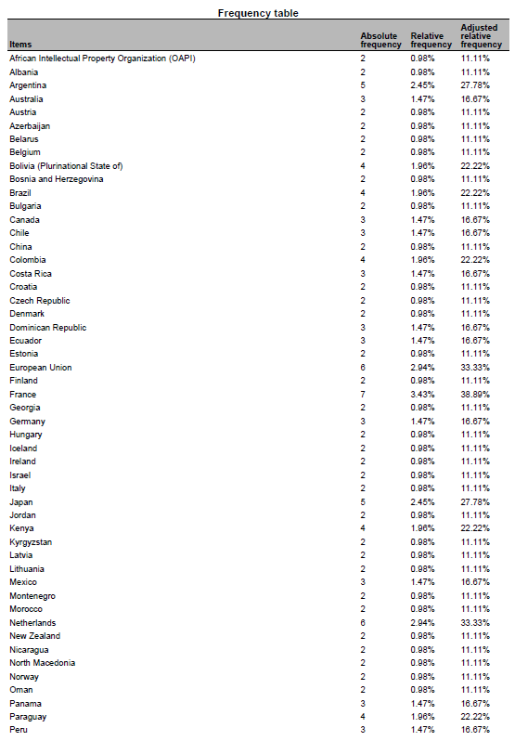

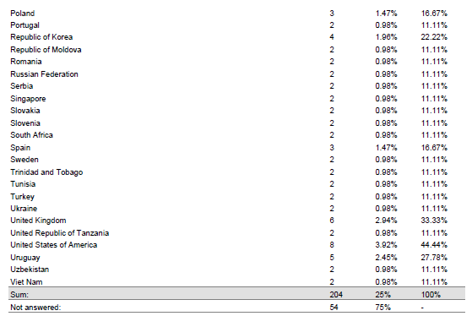

9. Please indicate the crops for which you would like to develop cooperation with UPOV members

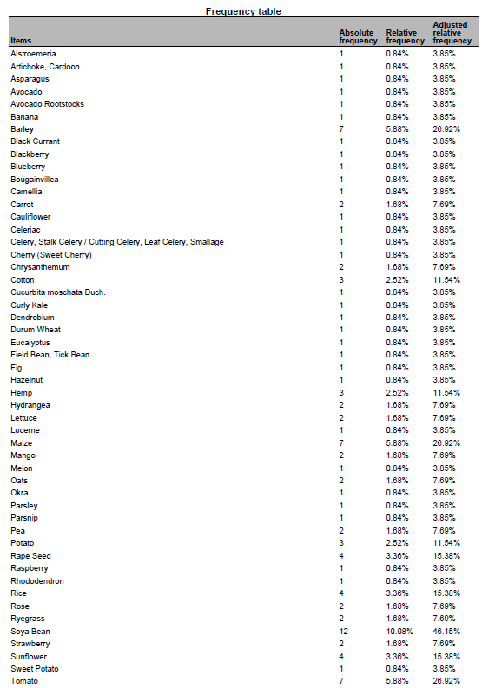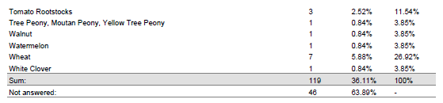

10. Please indicate the techniques for which you would like to develop cooperation with UPOV members

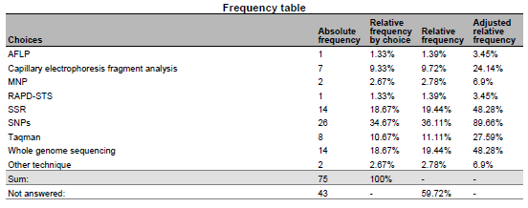

11. Please indicate the objectives of the cooperation:

* harmonization of SNP sets; common DNA databases
* To develop a potato reference collection including morphological and molecular info
* The use DNA markers in DUS testing
* A possibility to buy testing/pre-screening services from a testing authority
* Varietal description, Validation of protocols for the use of molecular markers in varietal description, collaboration to facilitate the exchange of knowledge in the use of new methodologies, Facilitate the acquisition of innovative processes
* Explore new approaches to solve Distinctness issues or test the potentialities of new markers
* To obtain a common database of MM for interested species in order to have better quality in the analysis of DUS (specially model 1)
* gathering information
* Varieties description, exchange of data and material, molecular technique in DUS examination, methods for integrating molecular and DUS and VCU data
* For DUS testing
* We have a lot of experience in potato but wish to broaden our work into other avenues particularly sweet potato, raspberry, strawberry, blackberry, pea
* sharing research cost, harmonization of methods
* harmonization of methods
* Standardisation of methods and open source markers
* to have an overview of available methods, ring trials participation if it's within the capabilities of our lab
* Expand use of markers in DUS
* Speed up DUS examination
* ISO provides methods across business and government. The methods provide a clear platform for their use.
* developing services useful for commercial protection
* Harmonization of MM techniques, including marker sets and distinctness thresholds.
* To train molecular techniques
* Build capacity
* Representing ISTA

12. What are the main obstacles to cooperation with UPOV members?

* Money; the agreement of the breeders to use their varieties for these purposes
* financing
* Development of internal and external MoU for accessing or generating DNA profiles
* The main obstacles are lack of experiences in introducing promised technologies to plant examination and some disadvantages in national legislation
* Lack of resources available for this kind of work
* Funding of non-EU members
* harmonization of methods and selected markers
* we do not have the clear vision
* Different level of expertise and available resources (technical and financial)
* lack of mechanisms and procedures to do so.
* UPOV acceptance of expanded marker use
* Not accepting to take over an existing DUS examination report
* UPOV is legislative, ISO is voluntary
* lack of contact information
* Time. Mutual interest. Organization/facilitation of interaction.
* Shared platform

13. What could UPOV do to help you to cooperate with UPOV members?

* research funds (similar to the IMODDUS by CPVO) agreement of the breeding industry
* For Canada to participate in any exercise for the development of an Agreement template
* We would like to participate in international projects and methodology testing
* Provide opportunities to exchange and establish concrete contacts.
* These forums at the BMT are a great way of putting researchers form different countries in contact. Maybe some kind of database with common interest could be created to facilitate new co-operation.
* Funding research project. Give information on the uses of Upov models by other members
* Provide agreed standards and protocols, alignment among PVP offices on the used methods, capacity building.
* establish liaison with ISO/TC34/SC16
* Make sure that a DUS examination report is accepted by another country. This would save both the applicant and the DUS offices time & money
* Save time in screening primers and share data on varieties
* Continue to observe ISO proceedings
* Cooperation between PVPOs and Breeders allows for expedited validation of MM use for PVP/PBR
* introducing upov members interested in the crops pointed above
* Organization/facilitation of interaction.
* Facilitate sharing methodology

[End of Annex and of document]

1. at its fifty-fourth session, held in Geneva on October 29 and 30, 2018