E
International Union for the Protection of New Varieties of Plants

Working Group on Biochemical and Molecular Techniques  and DNA-Profiling in Particular  Seventeenth Session  Montevideo, Uruguay, September 10 to 13, 2018 | BMT/17/25  Original: English  Date: September 13, 2018
report
adopted by the Working Group on Biochemical and Molecular Techniques and DNA-Profiling in Particular
Disclaimer: this document does not represent UPOV policies or guidance

Opening of the session
The Working Group on Biochemical and Molecular Techniques and DNA-Profiling in Particular (BMT) held its seventeenth session in Montevideo, Uruguay, from September 10 to 13, 2018. The list of participants is reproduced in Annex I to this report.

The BMT was opened by Mr. Nik Hulse (Australia), Chairperson of the BMT, who welcomed the participants. The BMT was welcomed by Mr. Enzo Benech, Minister of Agriculture, Livestock and Fisheries and Mr. Pedro Queheille, President of Instituto Nacional de Semillas (INASE). A copy of the presentation made by Mr. Pedro Queheille is reproduced in Annex II to this document.

Adoption of the agenda
The BMT adopted the agenda as reproduced in document BMT/17/1 Rev.2.

Preparatory information
The BMT received a presentation from the Office of the Union on preparatory information, a copy of which is provided in document BMT/17/4.

Reports on developments in UPOV concerning biochemical and molecular techniques
The BMT received a presentation from the Office of the Union on developments in UPOV concerning biochemical and molecular techniques, a copy of which is provided in document BMT/17/2.

Report of work on molecular techniques in relation to DUS examination

The United States Molecular Marker Working Group: Background for the use of DNA markers in DUS
The BMT considered document BMT/17/17 and received a presentation by Mr. Paul T. Nelson (SAA), a copy of which would be provided as document BMT/17/7 Add.

Use of DNA-Based Markers in Testing for Distinctness, Uniformity and Stability (DUS) and Enforcement of Plant Breeders Rights (PBR)
The BMT considered document BMT/17/20, which was presented by Ms. Marymar Butruille (SAA).

Test of the potential use of SNPs markers on oilseed rape varieties
The BMT considered document BMT/17/8 and received a presentation by Mr. Arnaud Remay (France), a copy of which would be provided as document BMT/17/8 Add.

Use of Molecular Marker Techniques in DUS Testing and Enforcement of Breeder’s Right in the Republic of Korea
The BMT considered document BMT/17/14 Rev., which was presented by Mr. Jinkee Jung (Republic of Korea).

Do resistance markers for tomato fulfil the requirements of TGP/15?
The BMT considered document BMT/17/21 and received a presentation by Ms. Amanda van Dijk-Veldhuizen (Netherlands), a copy of which would be provided as document BMT/17/21 Add.

The BMT agreed that the method presented in document BMT/17/21 was consistent with the model “Characteristic-Specific Molecular Markers” in document TGP/15. The BMT agreed to propose that a new example be added to document TGP/15, on the basis of the example provided by the Netherlands, to illustrate a situation where the characteristic-specific marker did not provide complete information on the state of expression of a characteristic.

The BMT agreed to propose that paragraph 3.1.4 (reproduced below) from document UPOV/INF/18/1 be introduced in document TGP/15 to clarify that it was the responsibility of the authority to decide on the reliability of the link between the gene and the expression of the characteristic. When considering whether to include the method in the Test Guidelines, the BMT further proposed that TGP/15 include an explanation that it would be the responsibility of the respective TWP and the TC to assess whether the reliability of the link between the gene and the expression of the characteristic was satisfied.

“3.1.4 In considering the model and example, as presented in Annex 1 of this document, the TC emphasized the importance of meeting the assumptions. In that regard, it clarified that it is a matter for the relevant authority to consider if the assumptions are met (see document TC/45/16 “Report”, paragraph 152).”

Use of SNP markers for soybean variety protection purposes in Argentina
The BMT considered document BMT/17/22, which was presented by Ms. Ana Laura Vicario (Argentina).

Short presentations on new developments in biochemical and molecular techniques by DUS experts, biochemical and molecular specialists, plant breeders and relevant international organizations
The BMT received presentations by Ms. Cécile Collonnier (European Union), copies of which are provided in documents BMT/17/23 and BMT/17/24.

Review of document UPOV/INF/17 “Guidelines for DNA-Profiling: Molecular Marker Selection and Database Construction (‘BMT Guidelines’)”
The BMT considered documents BMT/17/10, BMT/17/10 Add. and UPOV/INF/17/2 Draft 1.

Section A. Introduction
The BMT agreed to amend the first sentence of the text of the Introduction to read as follows:

“The purpose of this document (BMT Guidelines) is to provide guidance on harmonized for developing harmonized methodologies principles for the use of DNA based markers with the aim of generating high quality molecular data for a range of applications.”

Section B. General Principles
The BMT agreed to revise document UPOV/INF/17 on the basis of the joint comments from the European Union, France and the Netherlands.

Section 1. Selection of a Molecular Marker Methodology
The BMT agreed to delete Section 1.

Section 2. Selection of Molecular Markers
The BMT agreed to amend the title of Section 2 to read “1. Phase 1: Selection of Molecular Markers” and renumber the section accordingly.

Section 2.1 (a)
The BMT agreed that the text proposed by the European Union, France and the Netherlands should be abbreviated to refer only to the need to achieve a balance between the number of markers and the resolution or discriminative power according to the objective and taking into account the error-rate. It was agreed that the figure should be omitted.

Section 2.1 (c)
The BMT agreed to amend Section 2.1 (c) to read as follows:

“Coverage of the genome and the linkage should reflect the objectives. Knowing the position of the selected markers on the genome (i.e. map position) is not essential but enables the selection of markers that may be linked together to be avoided.”

New Section 1.1 (d)
The BMT agreed to add new Section 1.1 (d). The BMT also agreed that the European Union, France and the Netherlands should revise their proposal to list the possible sources without assessment of their suitability, because this would be influenced by the circumstances.

New Sections 1.1 (f) to (k)
The BMT agreed to add new Sections 1.1 (f) to (k) and to move new Section 1.1 (h) “Avoidance of linkage disequilibrium” next to new Section 1.1 (c).

Section 2.2 Criteria for specific types of molecular markers
The BMT agreed to delete the Section 2.2.

New Sections 1.2 and 1.3
The BMT agreed not to include new Sections 1.2 and 1.3 proposed by the European Union, France and the Netherlands.

New Section 2
The BMT agreed to add a new Section 2 “Phase 2: Selection of the Detection Method” without the following text “As a prerequisite, whatever the source of material, the method for sampling and DNA extraction should be standardized and documented”.

New Section 2.1
The BMT agreed to add a new Section 2.1 “Genotyping methods - general criteria” with the following subsection 2.1.1. With regards to the subsection 2.1.1, the BMT agreed to avoid classifying the criteria as “Mandatory criteria” or “Optional criteria” and to delete “(e) Applicable for both diploid species and polyploidy species”. The BMT also agreed to include a new item “sustainability of databases” to subsection 2.1.1. The BMT agreed not to include a new subsection 2.1.2, concerning improvements in technology.

New Section 2.2
The BMT agreed that the European Union, France and the Netherlands should combine the proposed elements in new Section 2.1.

Section 3. Access to the Technology
The BMT agreed to renumber Section 3 to Section 2.3.

New Section 2.4
The BMT agreed that the European Union, France and the Netherlands should shorten the proposed text and present it in a preamble at the beginning of the document.

Section 4. Material to be Analyzed
The BMT agreed to move current texts and subsections in Section 4 to a new Section 5.2 “Requirements of the plant material”.

Section 4.4
The BMT agreed with the text proposed by the European Union, France and the Netherlands in Section 4.4, except that the third sentence should be replaced by a reference to document TGP/5: Section 1 concerning transfer of material.

Section 5. Standardization of Analytical Protocols
The BMT agreed to delete current Section 5 and replace with a new Section 4 “Phase 4: Harmonization and Validation of the Marker Set and Method”.

Section 5.1
The BMT agreed to delete current Section 5.1 and replace with a new Section 4.1 “Harmonisation and validation – general criteria”. The BMT also agreed that the European Union, France and the Netherlands should revise proposed texts under the new Section 4.1 to clarify that usage of validated methods will lead to harmonized results.

Section 5.2
The BMT agreed to delete current Section 5.2 and replace with a new Section 4.2 “Performance criteria”. With regards to the proposed texts under the new Section 4.1, the BMT agreed to list the criteria without the additional explanatory information.

Section 5.3
The BMT agreed to delete current Section 5.3 and replace with a new Section 3 “Phase 3: Evaluation of the Selected Marker Set and Detection Method (fit for purpose validation of the marker set and technological validation of the method)”. With regards to the proposed subsection 3.1.1 under the new Section 3, the BMT agreed that the European Union, France and the Netherlands should revise the texts in order to explain the need to use a suitable set of varieties to develop marker sets and a further set of varieties to evaluate the marker set. With regards to the proposed subsection 3.1.2, the BMT agreed that the European Union, France and the Netherlands should review the text.

New Section 4.3
The BMT agreed to add a new section 4.3 “Consistence criteria - harmonization of markers and methods in different laboratories Performance criteria”. The BMT also agreed that the European Union, France and the Netherlands should review this new section in order to avoid duplication with previous sections.

Section 6. Databases
The BMT agreed to introduce a new Section 6. “Data exchange” after Section 5 “Databases”. With regards to the texts proposed by the European Union, France and the Netherlands, the BMT agreed that the European Union, France and the Netherlands should remove the wording “shared databases” from their revised proposal on databases and should provide the full names for “VCF” and “BCF” in the list of acronyms.

New Section 5.3
The BMT agreed that the European Union, France and the Netherlands should avoid a recommendation for “open-source tools” in Section 5.3 (d), replace the word “cultivar” with “variety” and provide the meaning of “bam” and “CRAM” in the list of acronyms.

Section 6.1
The BMT agreed to renumber Section 6.1. as new Section 5.4. With the proposed text, the BMT agreed that the European Union, France and the Netherlands should delete the link to the standard and review whether it should be indicated as a preferred method.

Section 6.2
The BMT agreed to renumber Section 6.2. as Section 5.5 and to add the following sentences to the end of the current texts “For variants obtained from sequencing data, storing VCF files in a relational or no SQL database is recommended. In this case, each database record for a variant has a defined genome version, chromosome, position, reference allele”.

Section 6.3
The BMT agreed to renumber Section 6.3. as Section 5.6.

Section 6.3.1 (b)
The BMT agreed to amend the title of Section 6.3.1 (b) to read “Reference genome position / Locus code:” with the following texts “Preferably, a genome assembly version, chromosome and position should be provided if a reference genome is available for the species concerned, e.g. SL2.50ch05:63309763 for tomato Solanum lycopersicum assembly version 2.50 on chromosome 5 position 63309763. If no reference genome is available or the location is unknown, a name or code of the locus for the species concerned can be used, e.g. gwm 149, A2, etc.”

Section 6.3.1 (c)

The BMT agreed to amend the title of Section 6.3.1 (c) to read “Genotype” with the following texts “For SNP genotypes, the allele composition of the SNP or MNP should be given, e.g. A/T or A/A. For other techniques, genotype indicates the name or code of the allele of a given locus for the species concerned, e.g. 1, 123, etc.” The BMT agreed that the European Union, France and the Netherlands should provide the meaning of “MNP” in the list of acronyms.

Section 6.3.1 (d)

The BMT agreed to amend the title of Section (d) to read “Allele depths / Data value:” with the following texts “For SNPs obtained from next generation sequencing data this should indicate the depth of coverage for alleles e.g. 10/20 for an A/T allele in which the A is covered by 10 reads and the T by 20. Otherwise, indicates a data value for a given sample on a given locus-allele, e.g. 0 (absence), 1 (presence), 0.25 (frequency) etc.”.

New section 6. “Phase 4: Database Management”
The BMT agreed not to include the proposal to add the new Section 6.

Section 7. Summary
The BMT agreed that the summary would need to be revised in accordance with the changes to the structure and content of the document.

New section C “DEFINITIONS”
The BMT agreed not to add a new section C “DEFINITIONS”.

GLOSSARY
The BMT agreed that the glossary should become a list of acronyms providing the meanings of abbreviations but should not provide explanations of any terms.

The BMT agreed to propose to the TC that the EU, France, Netherlands to prepare a new draft of INF/17 for consideration of the eighteenth session of the BMT.

Variety description databases including databases containing molecular data

Construction of a European Potato database with varieties of common knowledge and its implementation in the potato DUS testing system

Part I: Construction, maintenance and use of the common database

The BMT considered document BMT/17/11 and received a presentation by Ms. Beate Rücker (Germany), a copy of which would be provided as document BMT/17/11 Add.

Part II: Generation of molecular data

The BMT considered document BMT/17/12 and received a presentation by Mr. Alex Reid (United Kingdom), a copy of which would be provided as document BMT/17/12 Add.

A DNA database for Rose – Development and validation of a SNP marker set
The BMT considered document BMT/17/15 and received a presentation by Ms. Hedwich Teunissen (Netherlands), a copy of which would be provided as document BMT/17/15 Add.

Cooperation between international organizations
The BMT considered document BMT/17/3. The BMT noted that ISTA was not in a position to agree to the proposed joint activities with UPOV and OECD at that time and agreed to propose to the TC that UPOV and OECD should make progress on the matters previously agreed by the TC, namely:

(a) to develop a joint document explaining the principal features of the systems of the OECD, UPOV and ISTA;

(b) to develop an inventory on the use of molecular marker techniques, by crop, with a view to developing a joint OECD/UPOV/ISTA document containing that information, in a similar format to UPOV document UPOV/INF/16 “Exchangeable Software”, subject to the approval of the Council and in coordination with OECD and ISTA; and

(c) the proposal for the BMT, at its fifteenth session, to develop lists of possible joint initiatives with OECD and ISTA in relation to molecular techniques for consideration by the TC to be presented at the TC, at its fifty-third session.

The BMT agreed that ISTA should be welcomed to join the above initiatives as and when it was in a position to do so.

DNA-based methods for variety testing: ISTA approach
The BMT considered document BMT/17/6 and received a presentation by Ms. Ana Laura Vicario (ISTA).

Revision of document TGP/15 “Guidance on the Use of Biochemical and Molecular Markers in the Examination of Distinctness, Uniformity and Stability (DUS)”
The BMT considered documents BMT/17/7 and TGP/15/2 Draft 1.

The BMT considered the revision of the example of parent lines in maize prepared by the experts from France. The BMT noted that the establishment of an additional threshold for genetic distance below GAIA distance 2 had not been implemented in France at that time. The BMT noted that the nature of document TGP/15 was to present examples of the use of molecular markers in DUS examination among UPOV members. The BMT agreed to recommend that the example in document TGP/15 be revised at a later stage once the additional threshold level had been implemented in France.

The BMT considered the new application model “Genetic Selection of Similar Varieties for the First Growing Cycle” and agreed that it should be proposed for inclusion in document TGP/15 on the basis of a simplified version of draft text presented in document TGP/15/2 draft 1. The BMT agreed that the proposal to be put forward for approval by the TC should contain the description of the method without comparison to other approaches. The BMT also agreed to invite the Netherlands to review whether the schematic explaining the process was necessary and/or might be simplified.

The use of molecular techniques in examining essential derivation
The BMT received a presentation from the Office of the Union on the concept of essentially derived varieties, a copy of which is provided in document BMT/17/4.

Do new breeding techniques lead to Essentially Derived Varieties?
The BMT considered document BMT/17/9 and received a presentation by Mr. Jan de Riek (CIOPORA), a copy of which would be provided as document BMT/17/9 Add.

The use of molecular techniques in variety identification
The BMT received a presentation from the Office of the Union on the role of UPOV in variety identification, a copy of which is provided in document BMT/17/4.

Implementation of SNP markers to identify soybean varieties commercialized in Uruguay
The BMT considered document BMT/17/13 and received a presentation by Ms. Mariana Menoni (Uruguay), a copy of which would be provided as document BMT/17/13 Add.

Corn Hybrid parental identification: The Use of Hybrid Monomorphic Profile compared to Pericarp Genotyping
The BMT considered document BMT/17/16 and received a presentation by Ms. Marymar Butruille (SAA), a copy of which would be provided as document BMT/17/16 Add.

Variety identification in soybeans using SNPs
The BMT considered document BMT/17/18 and received a presentation by Mr. Barry K. Nelson (SAA), a copy of which would be provided as document BMT/17/18 Add.

The BMT welcomed the offer from Mr. Nelson to explore the possibility to make a software tool for marker selection using the traveling salesman algorithm available to others for further development. It was agreed that any experts wishing to explore that with Mr. Nelson would contact him directly and that he would be invited to report on developments to the BMT at its eighteenth session.

Presentation of a set of 11 SNPs capable of discriminating 80 soybean varieties from a reference collection
The BMT considered document BMT/17/19 and received a presentation by Mr. Carlos Azambuja (SAA) a copy of which would be provided as document BMT/17/19 Add.

Session to facilitate cooperation
The BMT considered document BMT/17/5.

Discussion groups were formed for: maize and soybeans; other agricultural crops; fruit crops and forest trees; ornamental plants; and vegetables, for BMT participants to exchange information on their work and explore areas for cooperation.

The BMT was informed of the following outcomes of the discussions:

Maize and Soybean

Summary of crop interest

Maize | United States of America
Soybean | Argentina, Brazil, Canada, United States of America, CropLife

Plans for cooperation

- Argentina to consult whether the selected subset of markers from the 6K Illumina chip could be shared with Brazil and United States of America. In case possible, United States of America would test the discriminating power of the subset on a different variety collection. Argentina and United States of America would also consider establishing a common subset of markers suitable for different technologies (e.g. Genotyping by Sequencing).
- United States of America breeders to coordinate with Brazilian breeders to formulate a proposal to be presented to the Brazilian Plant Variety Protection Office (SNPC) for a study on the use of molecular markers in DUS examination for soybeans (e.g. similar to the study conducted in Argentina).
- CropLife to collaborate with the initiative from the United States of America for the establishment of marker sets and methods to support DUS examination.

Proposals for UPOV initiatives

The coordination group on maize and soybeans agreed that the UPOV Office should follow up with participants on the possible test of discriminating power of the subset of molecular markers selected by Argentina and the possible establishment of a common subset of markers suitable for different technologies.

Other agricultural crops

Summary of crop interest

Barley | Canada, Czech Republic, France, Germany, United Kingdom
Cotton | Brazil
Durum wheat | Italy, European Union
Hemp | Netherlands
Lucerne | France
Oats | Canada
Oilseed Rape | Canada, France, Germany, United Kingdom, Corteva
Potato | Canada, European Union, Germany, Finland, Netherlands, United Kingdom
Rice | Japan, Republic of Korea
Ryegrass | Belgium, Netherlands, United Kingdom
Sorghum | France
Sunflower | France
Wheat | Canada, Czech Republic, Estonia, France, Italy, United Kingdom, Corteva

Plans for cooperation

- Potato: Canada and the Republic of Korea to approach the partners in the European Potato Database to discuss their possible involvement in the database.
- Rice: Japan and the Republic of Korea to discuss cooperation between China, Japan and the Republic of Korea in the East Asia Plant Variety Protection Forum.
- Ryegrass: Belgium, Czech Republic and the Netherlands to share information on their work and plans.

Proposals for UPOV initiatives

The coordination group on other agricultural crops agreed that it would be useful to introduce an item at the eighteenth session of the BMT for participants to provide information on how they managed cooperation between partners and service providers, including confidentiality, access to data and material, authorization for work to be performed and availability of results and information to partners.

Vegetables

Summary of crop interest

Cabbage | Republic of Korea
Chinese cabbage | China, Republic of Korea
Cucumber | Netherlands, Republic of Korea, BASF
Eggplant | Italy
French bean | Netherlands
Lettuce | Australia, Canada, Netherlands, Republic of Korea, BASF, Croplife International, Sakata Seed Sudamerica
Melon | China, Netherlands, Republic of Korea, BASF, Sakata Seed Sudamerica
Onion | Italy, Netherlands, BASF
Oriental melon | Republic of Korea
Pea | Netherlands, United Kingdom
Pepper | Italy, China, Netherlands, Republic of Korea, BASF, Croplife International, Sakata Seed Sudamerica
Pumpkin | Republic of Korea, Sakata Seed Sudamerica
Radish | Republic of Korea, BASF
Shallot | Netherlands
Squash | Italy, Sakata Seed Sudamerica
Tomato | Italy, China, Netherlands, Republic of Korea, BASF, Croplife International, Sakata Seed Sudamerica
Water melon | China, Italy, Republic of Korea, BASF, Croplife International

Proposals for UPOV initiatives

The coordination group on vegetable crops agreed that it would be useful to introduce an item at the BMT, inviting breeders, lawyers and policy makers to discuss ownership matters, and establish criteria to make possible for exchanging materials and DNA information among UPOV members.

Fruit crops and forest trees

Summary of crop interest

Apple | Canada, European Union, France, Netherlands, Republic of Korea, CIOPORA
Apricot | France
Blueberry | Netherlands, Republic of Korea, United Kingdom
Cherry | France
Citrus | CIOPORA
Elm (Ulmus) | Netherlands
Fraxinus | Netherlands
Japanese Plum | France
Peach | France, Republic of Korea
Pear | France
Raspberry | Netherlands, United Kingdom
Strawberry | China, France, Netherlands

Proposals for UPOV initiatives

The coordination group on fruit crops and forest trees agreed the importance of ownership matters in order to facilitate international cooperation in relation to the use of molecular techniques.

Ornamental plants

Summary of crop interest

Chrysanthemum | Netherlands
Gypsophila | Netherlands
Helleborus | Netherlands
Hydrangea | France
Lilium | Netherlands
Phalaenopsis | Netherlands
Rose | China, Netherlands, CIOPORA
Tree Peony | China

Plans for cooperation

- Rose: After finalizing cooperation between the Netherlands and CIOPORA, China could explore the possibility to cooperate on validating between labs.

Proposals for UPOV initiatives

The coordination group on ornamental plants, at its second round, agreed that it would be useful to organize sessions to share experiences on how to overcome the ownership matters in order to facilitate international cooperation in relation to the use of molecular techniques.

The coordination group on ornamental plants agreed that it would be useful to establish common databases to facilitate international cooperation in relation to the use of molecular techniques.

Taking into account the reports of the cooperation sessions, the BMT noted the common interest to address issues concerning cooperation between partners and service providers, including confidentiality, access to data and material, authorization for work to be performed and availability of results and information to partners and agreed to add this as an agenda item for it eighteenth session in order for experts, including breeders, to present information on their experiences (see proposed agenda item 8 “Management of databases and exchange of data and material” for the eighteenth session of the BMT).

The BMT agreed to propose to the TC that the results of the coordination session in the BMT be reported to the other Technical Working Parties (TWPs) and that the TWPs be invited to undertake a similar session to build on the BMT outcomes and feed into the future work of the BMT. The BMT agreed that the information on crop interest by participants at the sixteenth session of the BMT should be added to the above in the document to be prepared for the TWPs and the eighteenth session of the BMT.

Date and place of next session
The BMT welcomed the invitation of China to hold its eighteenth session in Hangzhou, China, from October 16 to 18, 2019, back-to-back with the TWC session in order to facilitate the discussions on areas of mutual interests, with the elements of the preparatory workshop included in the session.

Future program
During its eighteenth session, the BMT planned to discuss the following items:

1. Opening of the session
2. Adoption of the agenda
3. Reports on developments in UPOV concerning biochemical and molecular techniques (document to be prepared by the Office of the Union)
4. Short presentations on new developments in biochemical and molecular techniques by DUS experts, biochemical and molecular specialists, plant breeders and relevant international organizations (oral reports by participants)
5. Report of work on molecular techniques in relation to DUS examination (papers invited)
6. Cooperation between international organizations (document to be prepared by the Office of the Union)
7. Variety description databases including databases containing molecular data (papers invited)
8. Management of databases and exchange of data and material¹ (papers invited)
9. Methods for analysis of molecular data (papers invited)
10. Report on developments of a software tool for marker selection using the traveling salesman algorithm
11. The use of molecular techniques in examining essential derivation (papers invited)
12. The use of molecular techniques in variety identification¹ (papers invited)
13. Review of document UPOV/INF/17 “Guidelines for DNA-Profiling: Molecular Marker Selection and Database Construction
14. Revision of document TGP/15 “Guidance on the Use of Biochemical and Molecular Markers in the Examination of Distinctness, Uniformity and Stability (DUS)”
15. Session to facilitate cooperation
16. Date and place of next session
17. Future program
18. Report of the session (if time permits)
19. Closing of the session

The BMT adopted this report at the close of its session, on September 13, 2018.

[Annexes follow]

BMT/17/25

ANNEX I

LIST OF PARTICIPANTS

I. MEMBERS OF THE UNION
argentina
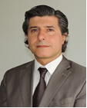 | Raimundo LAVIGNOLLE (Mr.), Presidente del Directorio, Instituto Nacional de Semillas (INASE), Secretaría deAgroindustria, Azopardo 1.205 - Piso 17º - Unidad Presidencia, C1107ADQ Buenos Aires  (tel.: +54 11 4363 6893/92/91 e-mail: rlavignolle@inase.gov.ar)
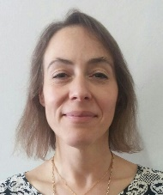 | Ana Laura VICARIO (Ms.), Head of Phytopathology and Molecular Markers Lab., Quality Department, Instituto Nacional de Semillas (INASE), Secretaría de Agroindustria, C1107ADQ Buenos Aires  (tel.: +54 11 4349 2037 e-mail: alvicario@inase.gov.ar)
australia
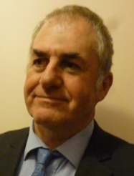 | Nik HULSE (Mr.), Chief of Plant Breeders’ Rights, Plant Breeder's Rights Office, IP Australia, 47 Bowes Street, Phillip ACT 2606  (tel.: +61 2 6283 7982 e-mail: nik.hulse@ipaustralia.gov.au)
brazil
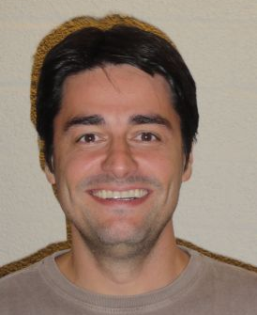 | Ricardo ZANATTA MACHADO (Mr.), Fiscal Federal Agropecuário, Coordinador do SNPC, Serviço Nacional de Proteção de Cultivares (SNPC), Ministério da Agricultura, Pecuária e Abastecimento, Esplanada dos Ministerios, Bloco 'D', Anexo A, Sala 254, 70043-900 Brasilia, D.F.  (tel.: +55 61 3218 2549 fax: +55 61 3224 2842  e-mail: ricardo.machado@agricultura.gov.br)
Virginia ARANTES FERREIRA CARPI (Ms.), Coordinator, Ministério da Agricultura, Pecuária e Abastecimento (MAPA), Bloco D, Anexo - Ala A, 3º andar, Sala 338, Brasília/DF, Brazil
(tel.: +55 61 3218 2828 e-mail: virginia.carpi@agricultura.gov.br)
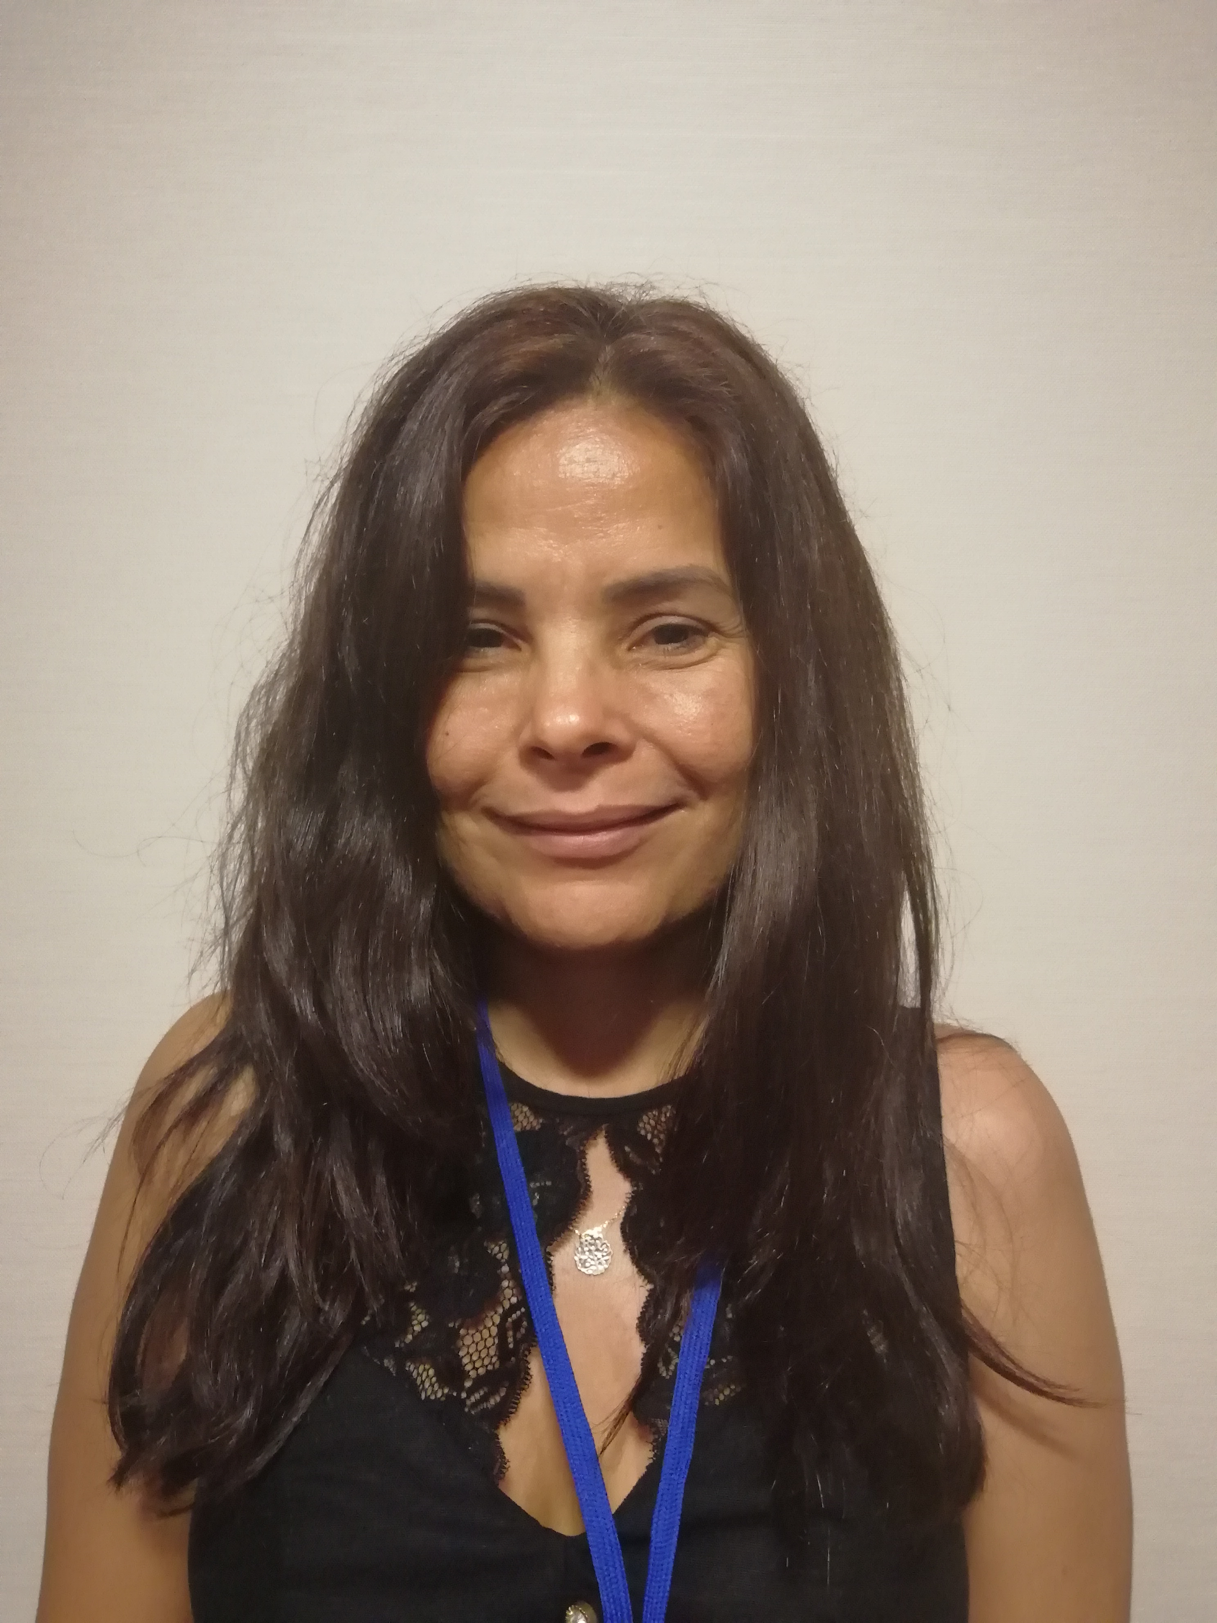 | Maria DA GLÓRIA TRINDADE (Ms.), Federal Inspector, Ministry of Agriculture, Livestock and Food Supply, R. da Divisa, St- Jao, Goiânia 74674-025  (tel.: +55 62 32327203 fax: ++55 62 3232 7205  e-mail: maria.trindade@agricultura.gov.br
canada
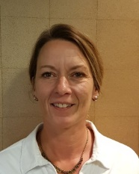 | Lisa LEDUC (Ms.), Examiner, Plant Breeders' Rights Office, 59 Camelot Drive, Room 59-2E-124, Ottawa Ontario ON  (tel.: +1 613 773 7139 fax: +1 613 773 7115 e-mail: lisa.leduc@canada.ca)
china
Ping HUANG (Mr.), Assistant Researcher, Research Institute of Forestry Chinese Academy of Forestry, Dongxiaofu 1, Xiangshan Road, Haidian District, Beijing 100091
(tel.: +86 10 62889592 fax: +86 10 62872015 e-mail: huangping_caf@126.com)
Xuedan YU (Ms.), Assistant Researcher, Research Institute of Forestry, Chinese Academy of Forestry Sciences, Dongxiaofu 1, Xinagshan Road, Haidian District, Beijing 100091
(tel.: 86 10 6288 9645 fax: 86 10 628 720 15 e-mail: Yuxd@caf.ac.cn)
czech republic
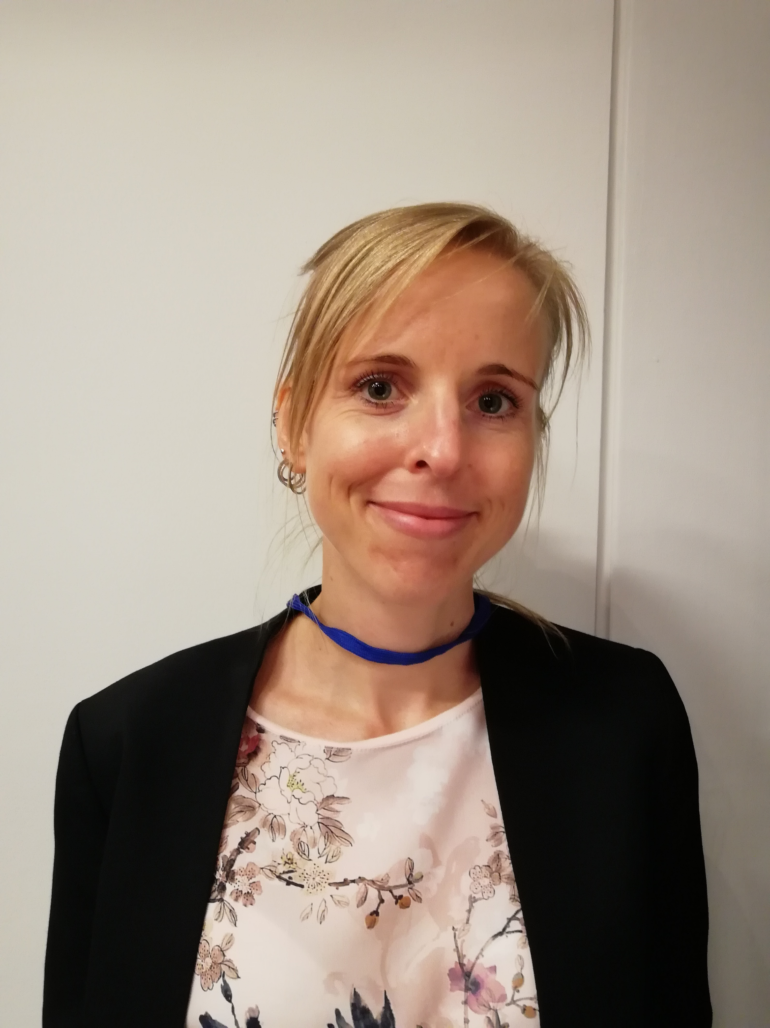 | Jitka KLEMPOVA (Ms.), Molecular Diagnostics Analyst, Central Institute for supervising and testing in agriculture (ÚKZÚZ), 63/2 Hroznova, 656 06 Brno  (tel.: +420 543 548 378 e-mail: jitka.klempova@ukzuz.cz)
european union
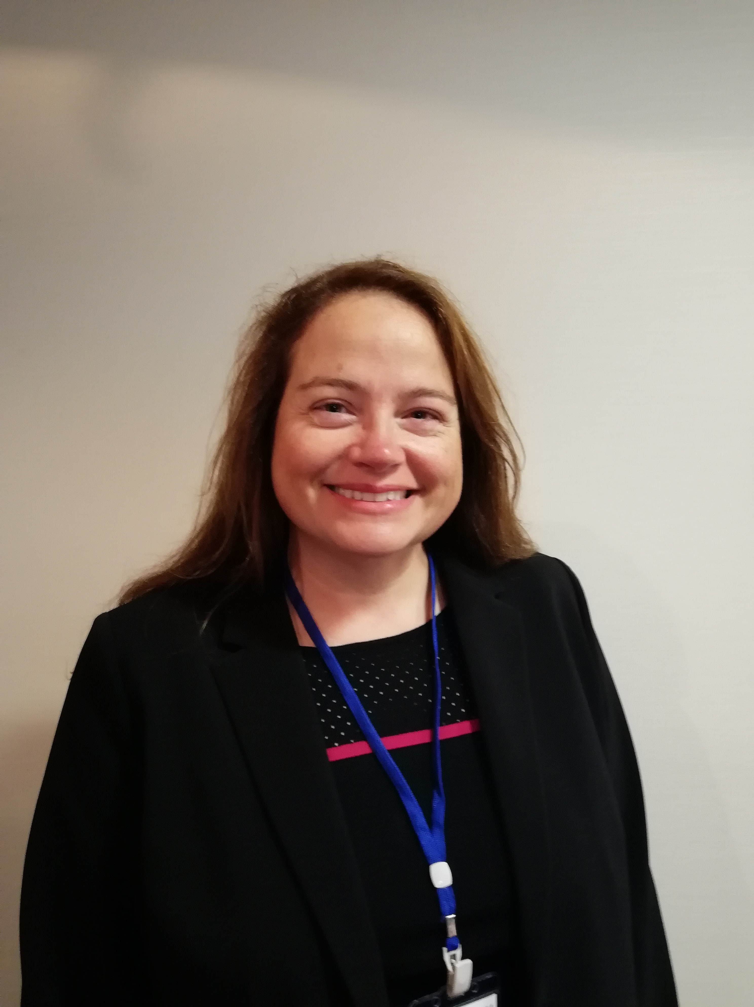 | Cécile COLLONNIER (Ms.), Expert biomolecular techniques, CPVO, 3 Boulevard Foch, CS10121, 49101 Angers Cedex 2  (tel.: +33 241 256 400 fax: +33 241 256 410 e-mail: collonnier@cpvo.europa.eu)
finland
Kaarina PAAVILAINEN (Ms.), Senior Officer, Seed Certification, Finnish Food Safety Authority Evira, Tampereentie 51, P.O. Box 111, 32201 Loimaa
(tel.: +358 40 833 2480 fax: +358 29 530 5317 e-mail: kaarina.paavilainen@evira.fi)
france
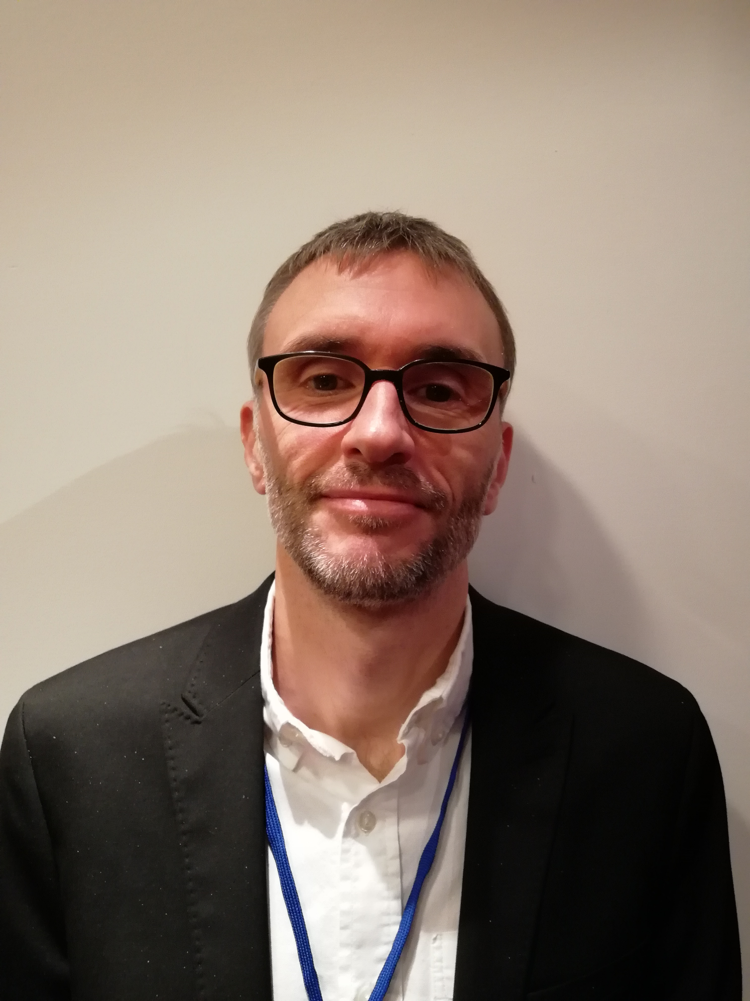 | René MATHIS (Mr.), BioGEVES Director, Groupe d'étude et de contrôle des variétés et des semences (GEVES), rue Georges Morel, BP 90024, 49071 Beaucouzé Cedex  (tel.: + 33 2 41225834 fax: +33 2 41 228602 e-mail: rene.mathis@geves.fr)
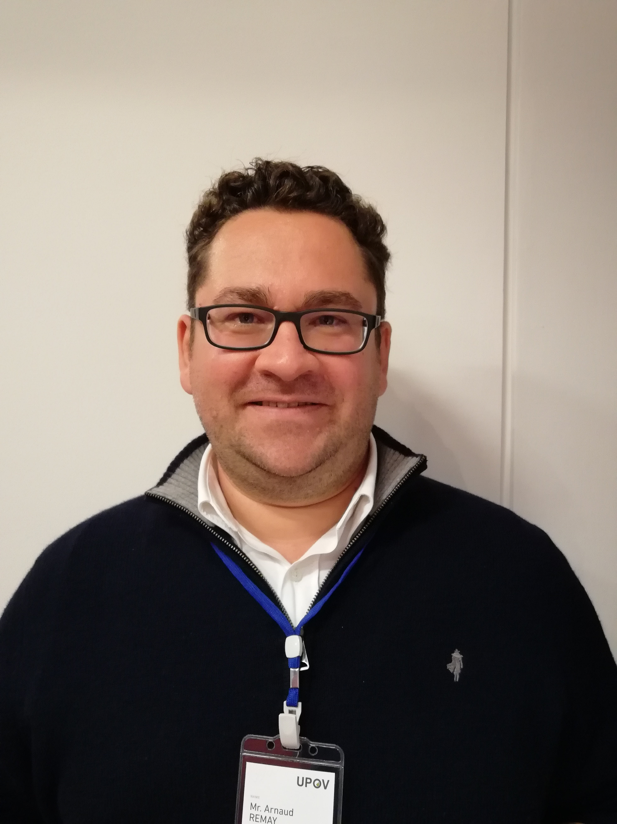 | Arnaud REMAY (Mr.), Head of the genotyping unit – BioGEVES, Groupe d’étude et de contrôle des variétés et des semences (GEVES), Domaine du Magneraud, CS40052, 17700 Surgères (tel.: +33 546 683 038 fax: +33 546 683 100 e-mail: arnaud.remay@geves.fr)
germany
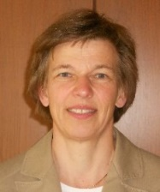 | Beate RÜCKER (Ms.), Head of Departement, Bundessortenamt, Osterfelddamm 80, Postfach 61 04 40, 30627 Hanover  (tel.: +49 511 9566 5639 fax: +49 511 956 69600  e-mail: beate.ruecker@bundessortenamt.de)
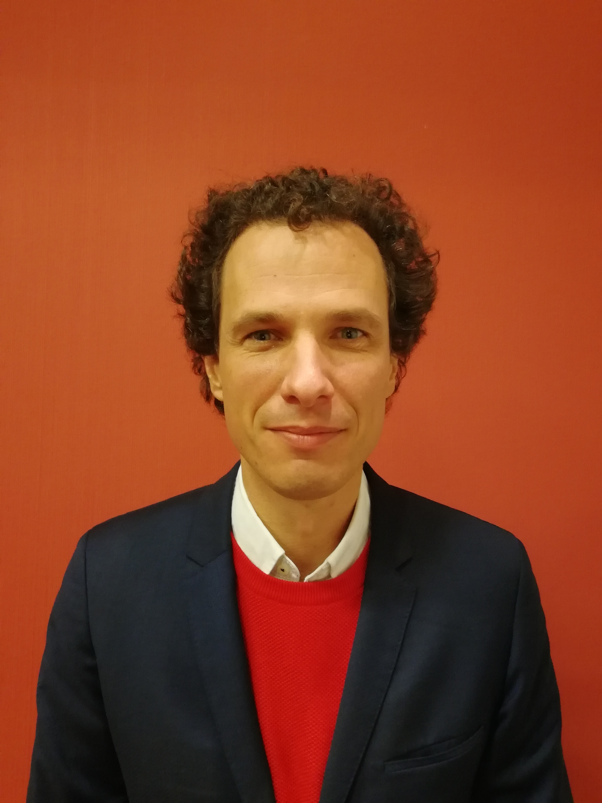 | Stefan HAFFKE (Mr.), Bundessortenamt, Osterfelddamm 80, 30627 Hanover  (tel.: +49 511 9566 5649 fax: +49 511 956 69600  e-mail: stefan.haffke@bundessortenamt.de)
italy
Chiara DELOGU (Ms.), Senior Researcher, CREA-DC Seed testing Station, Via Emilia 19 KM 307, Lodi, 26838 Tavazzano
(tel.: +39 371 76 19 19 fax: +39 371 76 08 12 e-mail: chiara.delogu@crea.gov.it)
japan
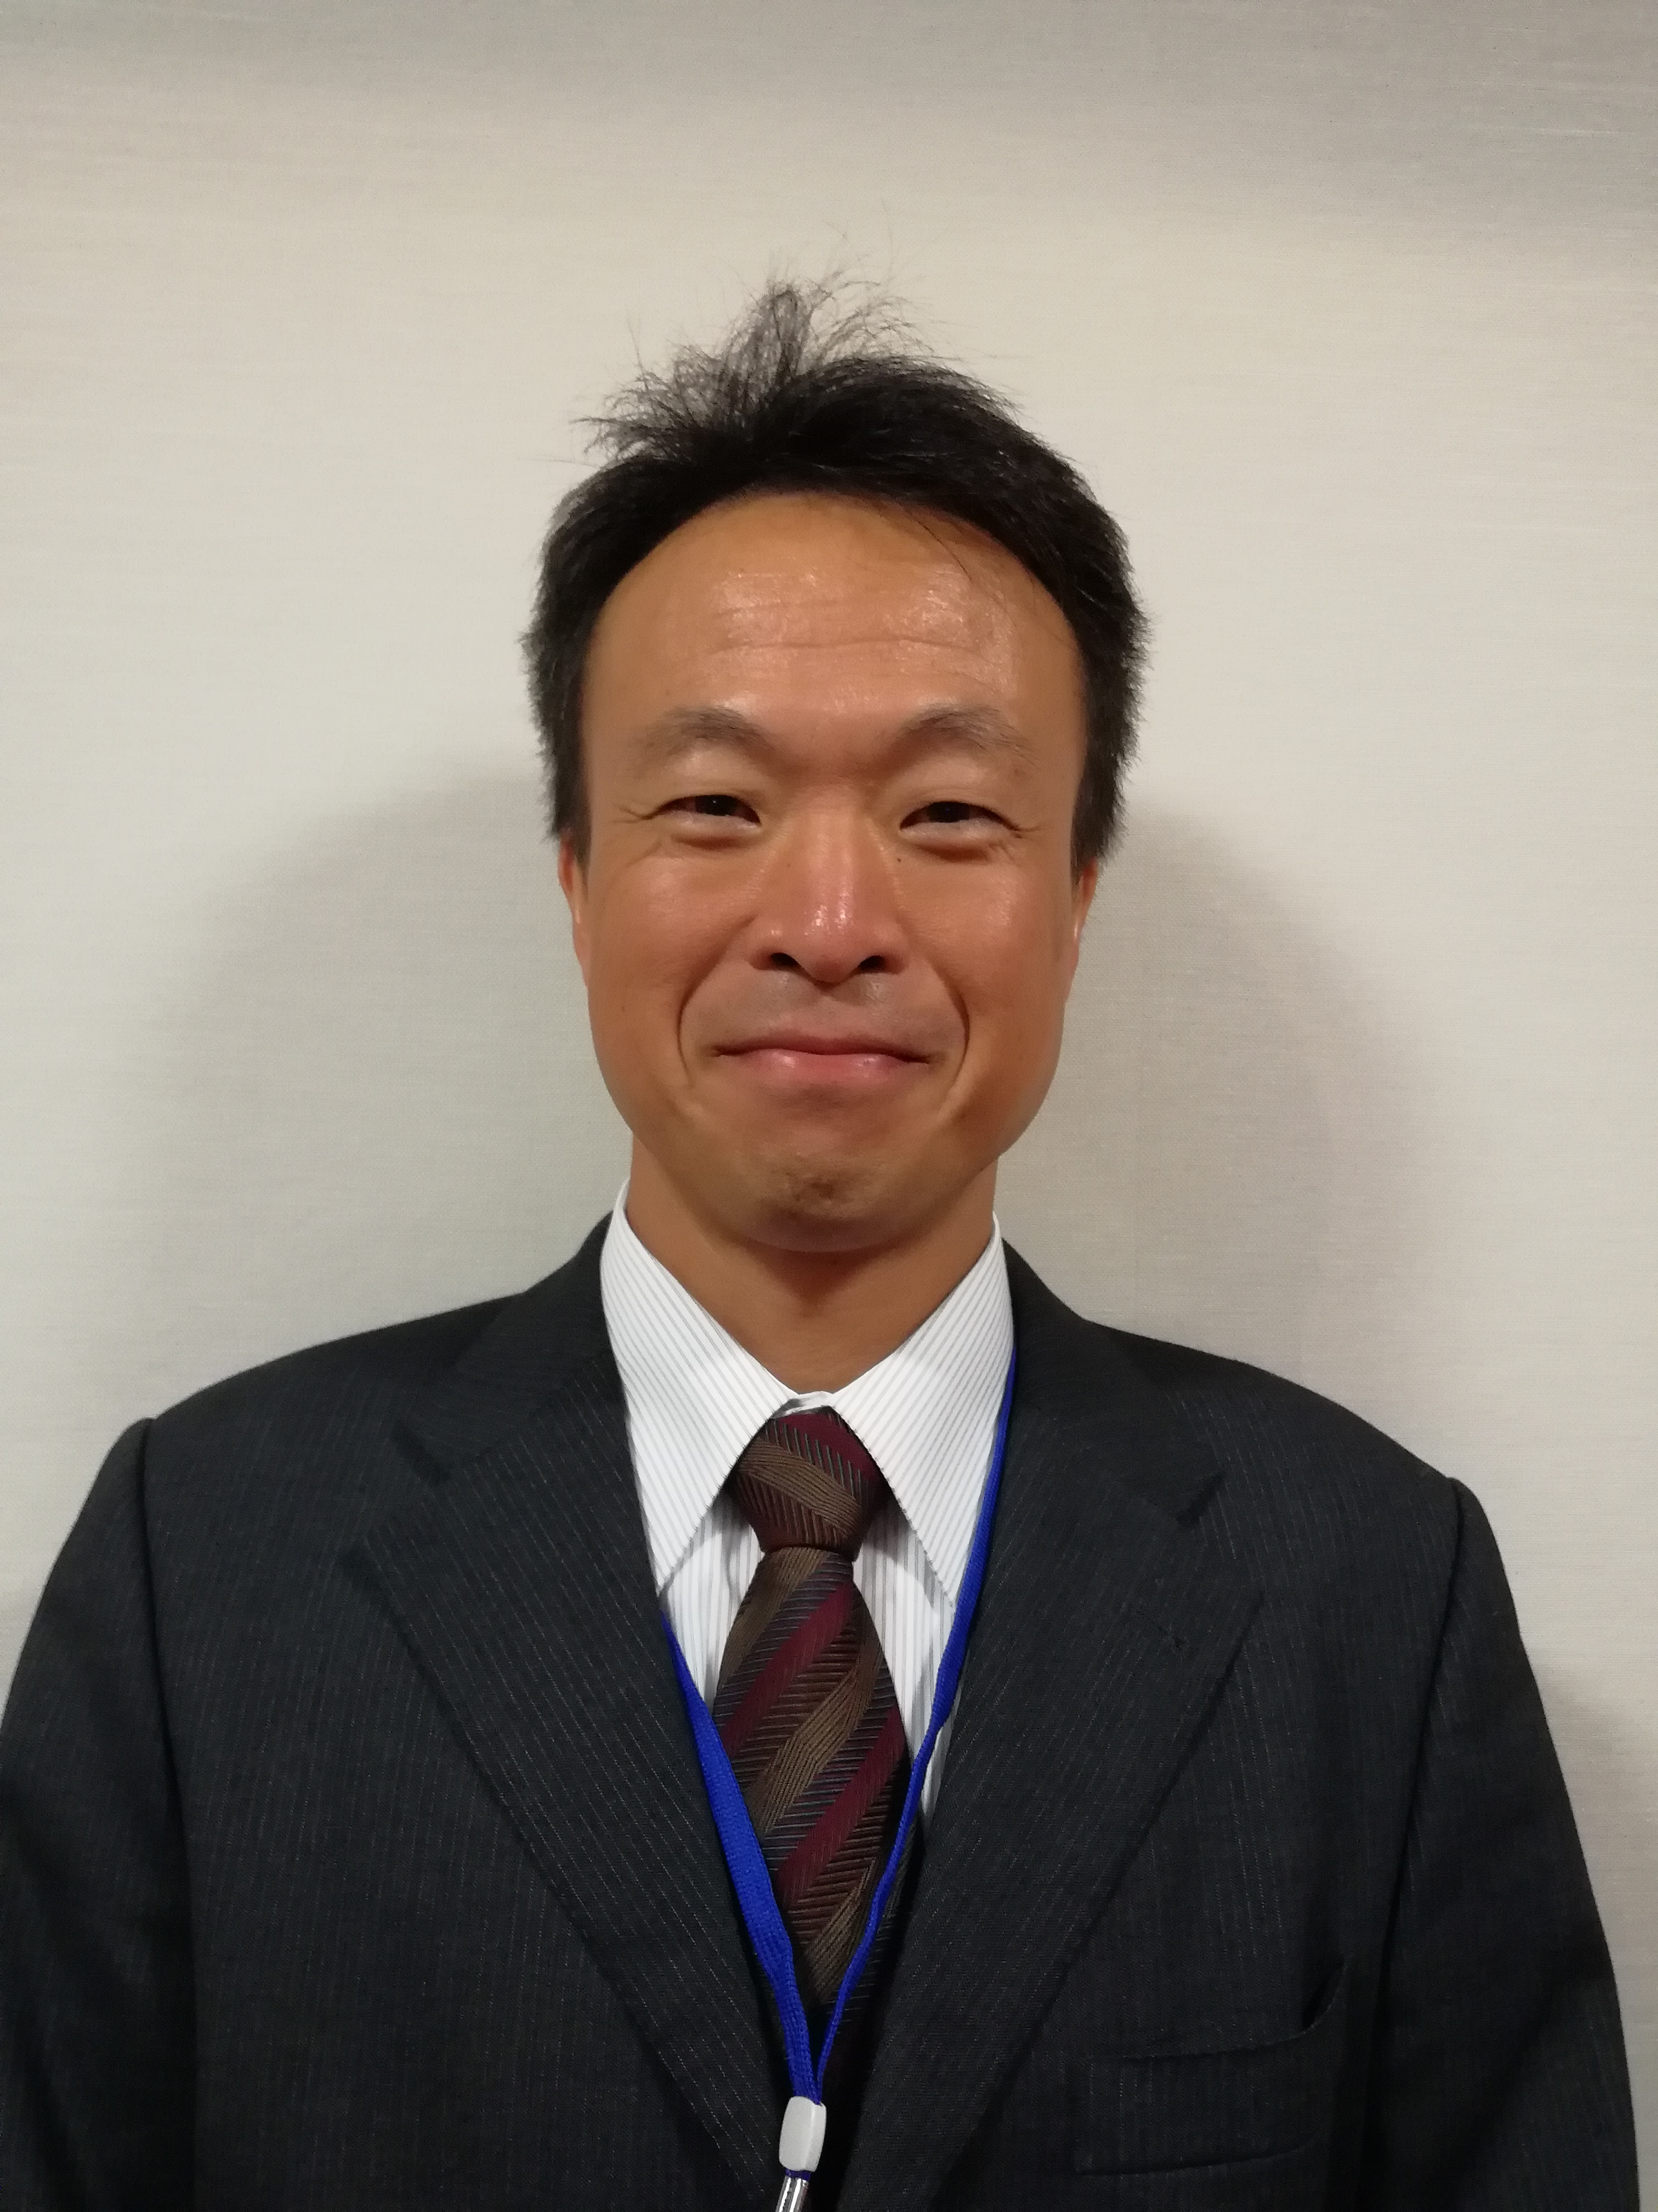 | Takeshi SUGISAWA (Mr.), Examiner, Plant Variety Protection Office, Intellectual Property Division, Food Industry Affairs Bureau, Ministry of Agriculture, Forestry and Fisheries (MAFF), 1-2-1, Kasumigaseki, Chiyoda-ku, Tokyo  (e-mail: takeshi_sugisawa820@maff.go.jp)
netherlands
Kees VAN ETTEKOVEN (Mr.), Senior PVP Policy Advisor, Naktuinbouw NL, Sotaweg 22, 2371 GD Roelofarendsveen
(tel.: +31 71 332 6128 e-mail: c.v.ettekoven@naktuinbouw.nl)
Hedwich TEUNISSEN (Ms.), Molecular Biologist, Naktuinbouw, Sotaweg 22, 2371 GD Roelofarendsveen
(tel.: 31 71 3326251 fax: 31 71 3326366 e-mail: h.teunissen@naktuinbouw.nl)
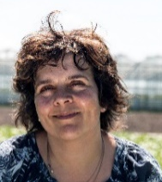 | Amanda VAN DIJK-VELDHUIZEN (Ms.), Manager team DUS, Naktuinbouw, Sotaweg 22, P.O. Box 40, 2370 AA Roelofarendsveen  (fax: +31 646841019 e-mail: a.v.dijk@naktuinbouw.nl)
PARAGUAY
Dólia GARCETE GONZÁLEZ (Ms.), General Manager, APROSEMP, Tajy e/ Los Naranjos y Vicente Machuca – Barrio Laguna Grande – Fracción Lomas, Verdes II – San Lorenzo
(tel.: +595985520141 e-mail: gerencia@aprosemp.org.py)

Olinda OCAMPOS (Ms.), General Manager, PARPOV, Olga Blinder. Edificio Brisas del Este, Bloque “D” – oficina 13, Paraná Country Club Hernandarias
(tel.: 061 578 701 e-mail: gerencia@parpov.com.py)
republic of korea
Seung-In YI (Mr.), Head of Seed Testing and Research Center, Korea Seed and Variety Service (KSVS), 119 Hyeoksin 8-ro, Gimcheon-si, Gyeongsangbuk-do 39660
(tel.: +82 54 912 0220 fax: +82 54 912 0277 e-mail: seedin@korea.kr)
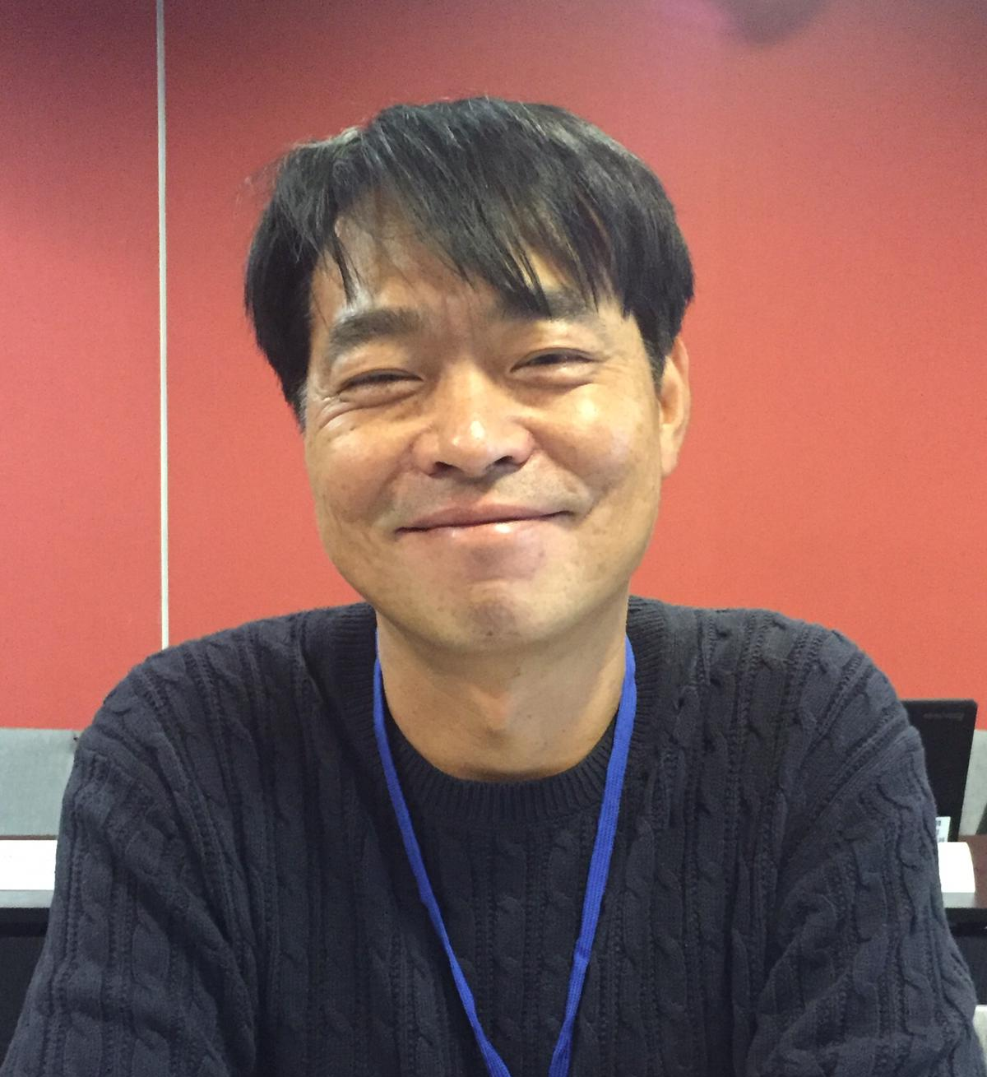 | Jinkee JUNG (Mr.), Gene analysis team, Seed Testing and Research Center, Korea Seed & Variety Service (KSVS), 119, Hyeoksin 8-ro, Gimcheon-si, Gyeongsangbuk-do 39660  (tel.: +82 54 912 0231 fax: +82 54 912 0277 e-mail: jinkeejung@korea.kr)
united kingdom
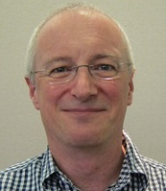 | Alex REID (Mr.), Senior Molecular Biologist, SASA, Roddinglaw Road, Edinburgh EH12 9FJ  (tel.: +44 131 244 8910 fax: +44 131 244 8926 e-mail: alex.reid@sasa.gsi.gov.uk)
Margaret WALLACE (Ms.), Technical Manager, (Cereals, Field Beans And Kale) Agricultural Crops Characterisation, National Institute of Agricultural Botany (NIAB), Huntingdon Road, Cambridge CB3 0LE
(tel.: +44 1223 342288 e-mail: margaret.wallace@niab.com)
united states of america
Ruihong GUO (Ms.), Deputy Administrator, AMS, Science & Technology Program, United States Department of Agriculture (USDA), 1400 Independence Avenue, SW, Room 3543 - South Building, Mail Stop 0270, 20250 Washington D.C.
(tel.: +1 202 720 8556 fax: +1 202 720 8477 e-mail: ruihong.guo@ams.usda.gov)
uruguay
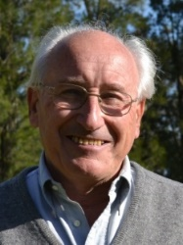 | Pedro QUEHEILLE (Mr.), President, Instituto Nacional de Semillas (INASE), Cno. Bertolotti s/n R-8 Km 29, Barros Blancos, Canelones  (e-mail: pqueheille@inase.uy)
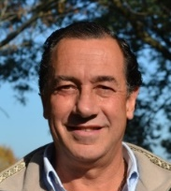 | Daniel BAYCE MUÑOZ (Mr.), Director Ejecutivo, Instituto Nacional de Semillas (INASE), Camino Suárez s/n, Ruta 8 y Ruta 101, Barros Blancos, Canelones  (e-mail: dbayce@inase.uy)
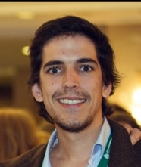 | Andrés AROTXARENA (Mr.), Manager / Director, Uruguayan Chamber of Seeds (CUS)  (e-mail: aarotxarena@cus.org.uy)
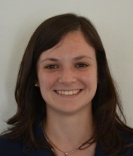 | Mariana MENONI (Ms.), Head of Molecualar and Plant Health Sector, Instituto Nacional de Semillas (INASE), Camino Bertolotti s/n, Ruta 8, Km. 29, Barros Blancos, Canelones  (e-mail: mmenoni@inase.uy)
Marco DALLA RIZZA (Mr.), Biotechnology Unit Coordinator, National Agricultural Research Institute (INIA)
(e-mail: mdallarizza@inia.org.uy)
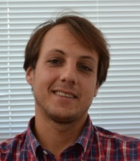 | Carlos DA ROSA (Mr.), Seed and Plant Certification Manager, National Seed Institute (INASE)  (e-mail: cdarosa@inase.uy)
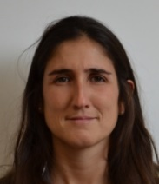 | Melisa CUADRO (Ms.), Communication Coordinator, National Seed Institute (INASE)  (e-mail: mcuadro@inase.uy)
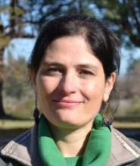 | Vanessa SOSA (Ms.), Seed Quality Laboratory Manager, National Seed Institute (INASE)  (e-mail: vsosa@inase.uy)
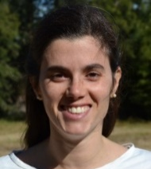 | Inés FORNOS (Ms.), Communication Manager, National Seed Institute (INASE)  (e-mail: ifornos@inase.uy)
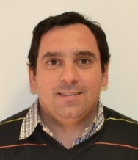 | Federico BOSCHI (Mr.), Técnico, Evaluación y Registro de Cultivares, Instituto Nacional de Semillas (INASE)  (e-mail: fboschi@inase.uy)
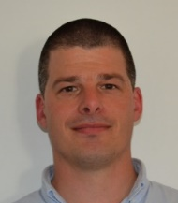 | Sebastián Luis MOURE CHRISTOPHERSEN (Mr.), Técnico, Evaluación y Registro de Cultivares, Instituto Nacional de Semillas (INASE)  (e-mail: smoure@inase.uy)
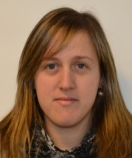 | Jessica MATEAUDA (Ms.), Quality Assistant / Seed Quality Laboratory, Instituto Nacional de Semillas (INASE)  (e-mail: jmateauda@inase.uy)
iI. organizations
mercosur
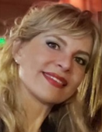 | Irene KUTSCHER (Ms.), MERCOSUR Secretariat, Luis Piera 1992, Montevideo, Uruguay  (tel.: + 598 2412 90 24 e-mail: irenekutscher@mercosur.int)
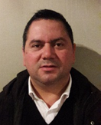 | Mario MELGAREJO (Mr.), MERCOSUR Secretariat, Luis Piera 1992, Montevideo, Uruguay  (tel.: + 598 2412 90 24 e-mail: melgarejo@mercosur.int)
ORGANISATION FOR ECONOMIC CO-OPERATION AND DEVELOPMENT (OECD)
Kristiina DIGRYTE (Ms.), Adviser, Plant Health Department, Lai Street 39/41, 15056 Tallinn, Estonia
(tel.: +372 6256 275 e-mail: kristiina.digryte@agri.ee)
CROPLIFE INTERNATIONAL
Marcel BRUINS (Mr.), Consultant, CropLife International, 326, Avenue Louise, Box 35, 1050 Bruxelles , Belgium
(tel.: +32 2 542 0410 fax: +32 2 542 0419 e-mail: mbruins1964@gmail.com)
INTERNATIONAL COMMUNITY OF BREEDERS OF ASEXUALLY REPRODUCED ORNAMENTAL AND FRUIT PLANTS (CIOPORA)
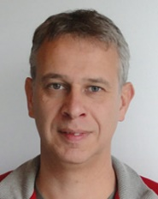 | Jan DE RIEK (Mr.), Molecular Genetics & Breeding - Group Leader, ILVO-Plant, Applied Genetics and Breeding Institute for Agricultural and Fisheries Research, Caritasstraat 39, 9090 Melle, Belgium  (tel.: +32 9 272 2881 fax: +32 9 272 2901 e-mail: jan.deriek@ilvo.vlaanderen.be)
SEED ASSOCIATION OF THE AMERICAS (SAA)
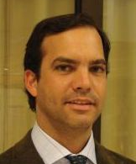 | Diego A. RISSO (Mr.), Director Ejecutivo, Seed Association of the Americas (SAA), Av. Gral. Rondeau 1908 - Esc. A, CP:11800, Montevideo, Uruguay  (tel.: +598 2 9291565 fax: +598 2 9291565 e-mail: drisso@saaseed.org)
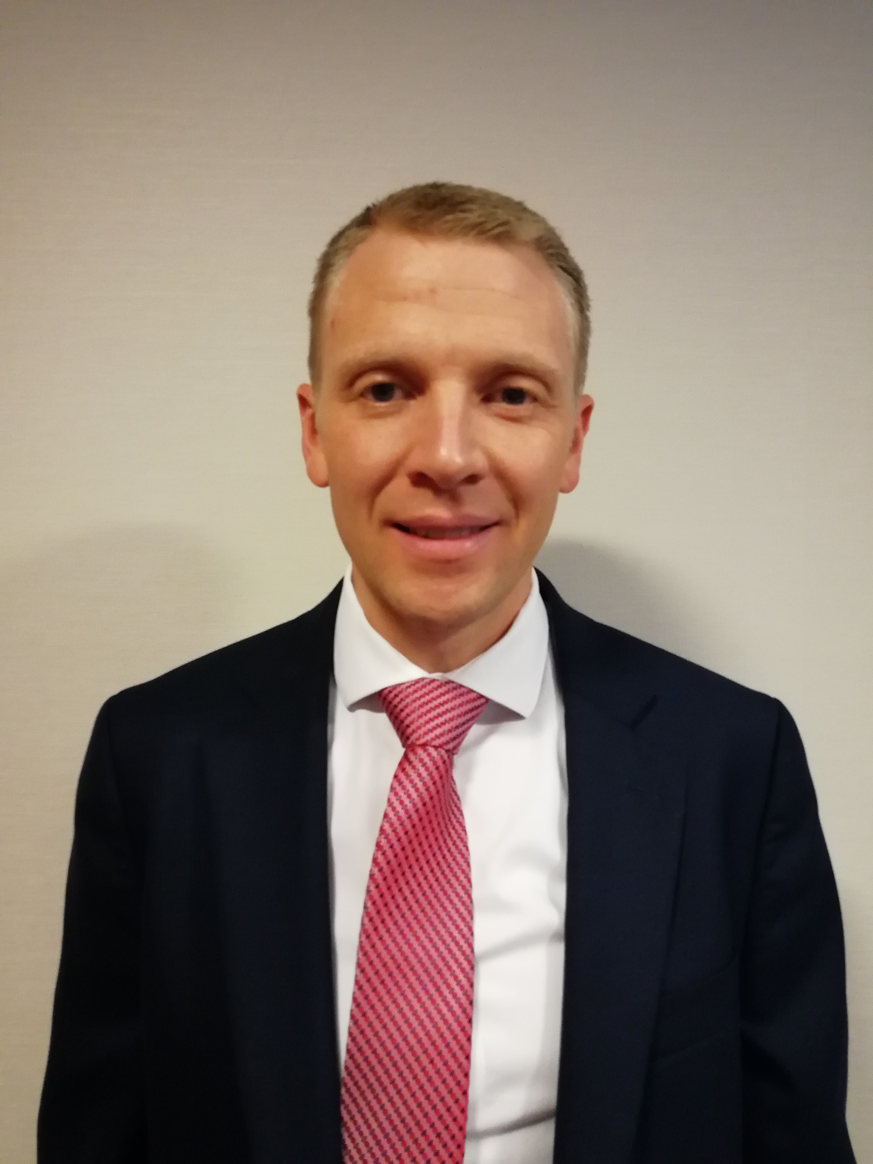 | Paul T. NELSON (Mr.), Chair, US Molecular Marker Working Group, 700 Chesterfield Pkwy W, Chesterfield, Missouri, MO 63017, United States of America  (tel.: +1 636 737 2609 e-mail: paul.nelson@bayer.com)
Barry K. NELSON (Mr.), Research Scientist, Corteua AgrisucienceTM, Adivision of DowDupont, 7300 N.W. 62nd avenue, Johnston IA 50131, United States of America
(tel.: 1 515 535 202 fax: 1 515 535 3934 e-mail: barry.nelson@pioneer.com)
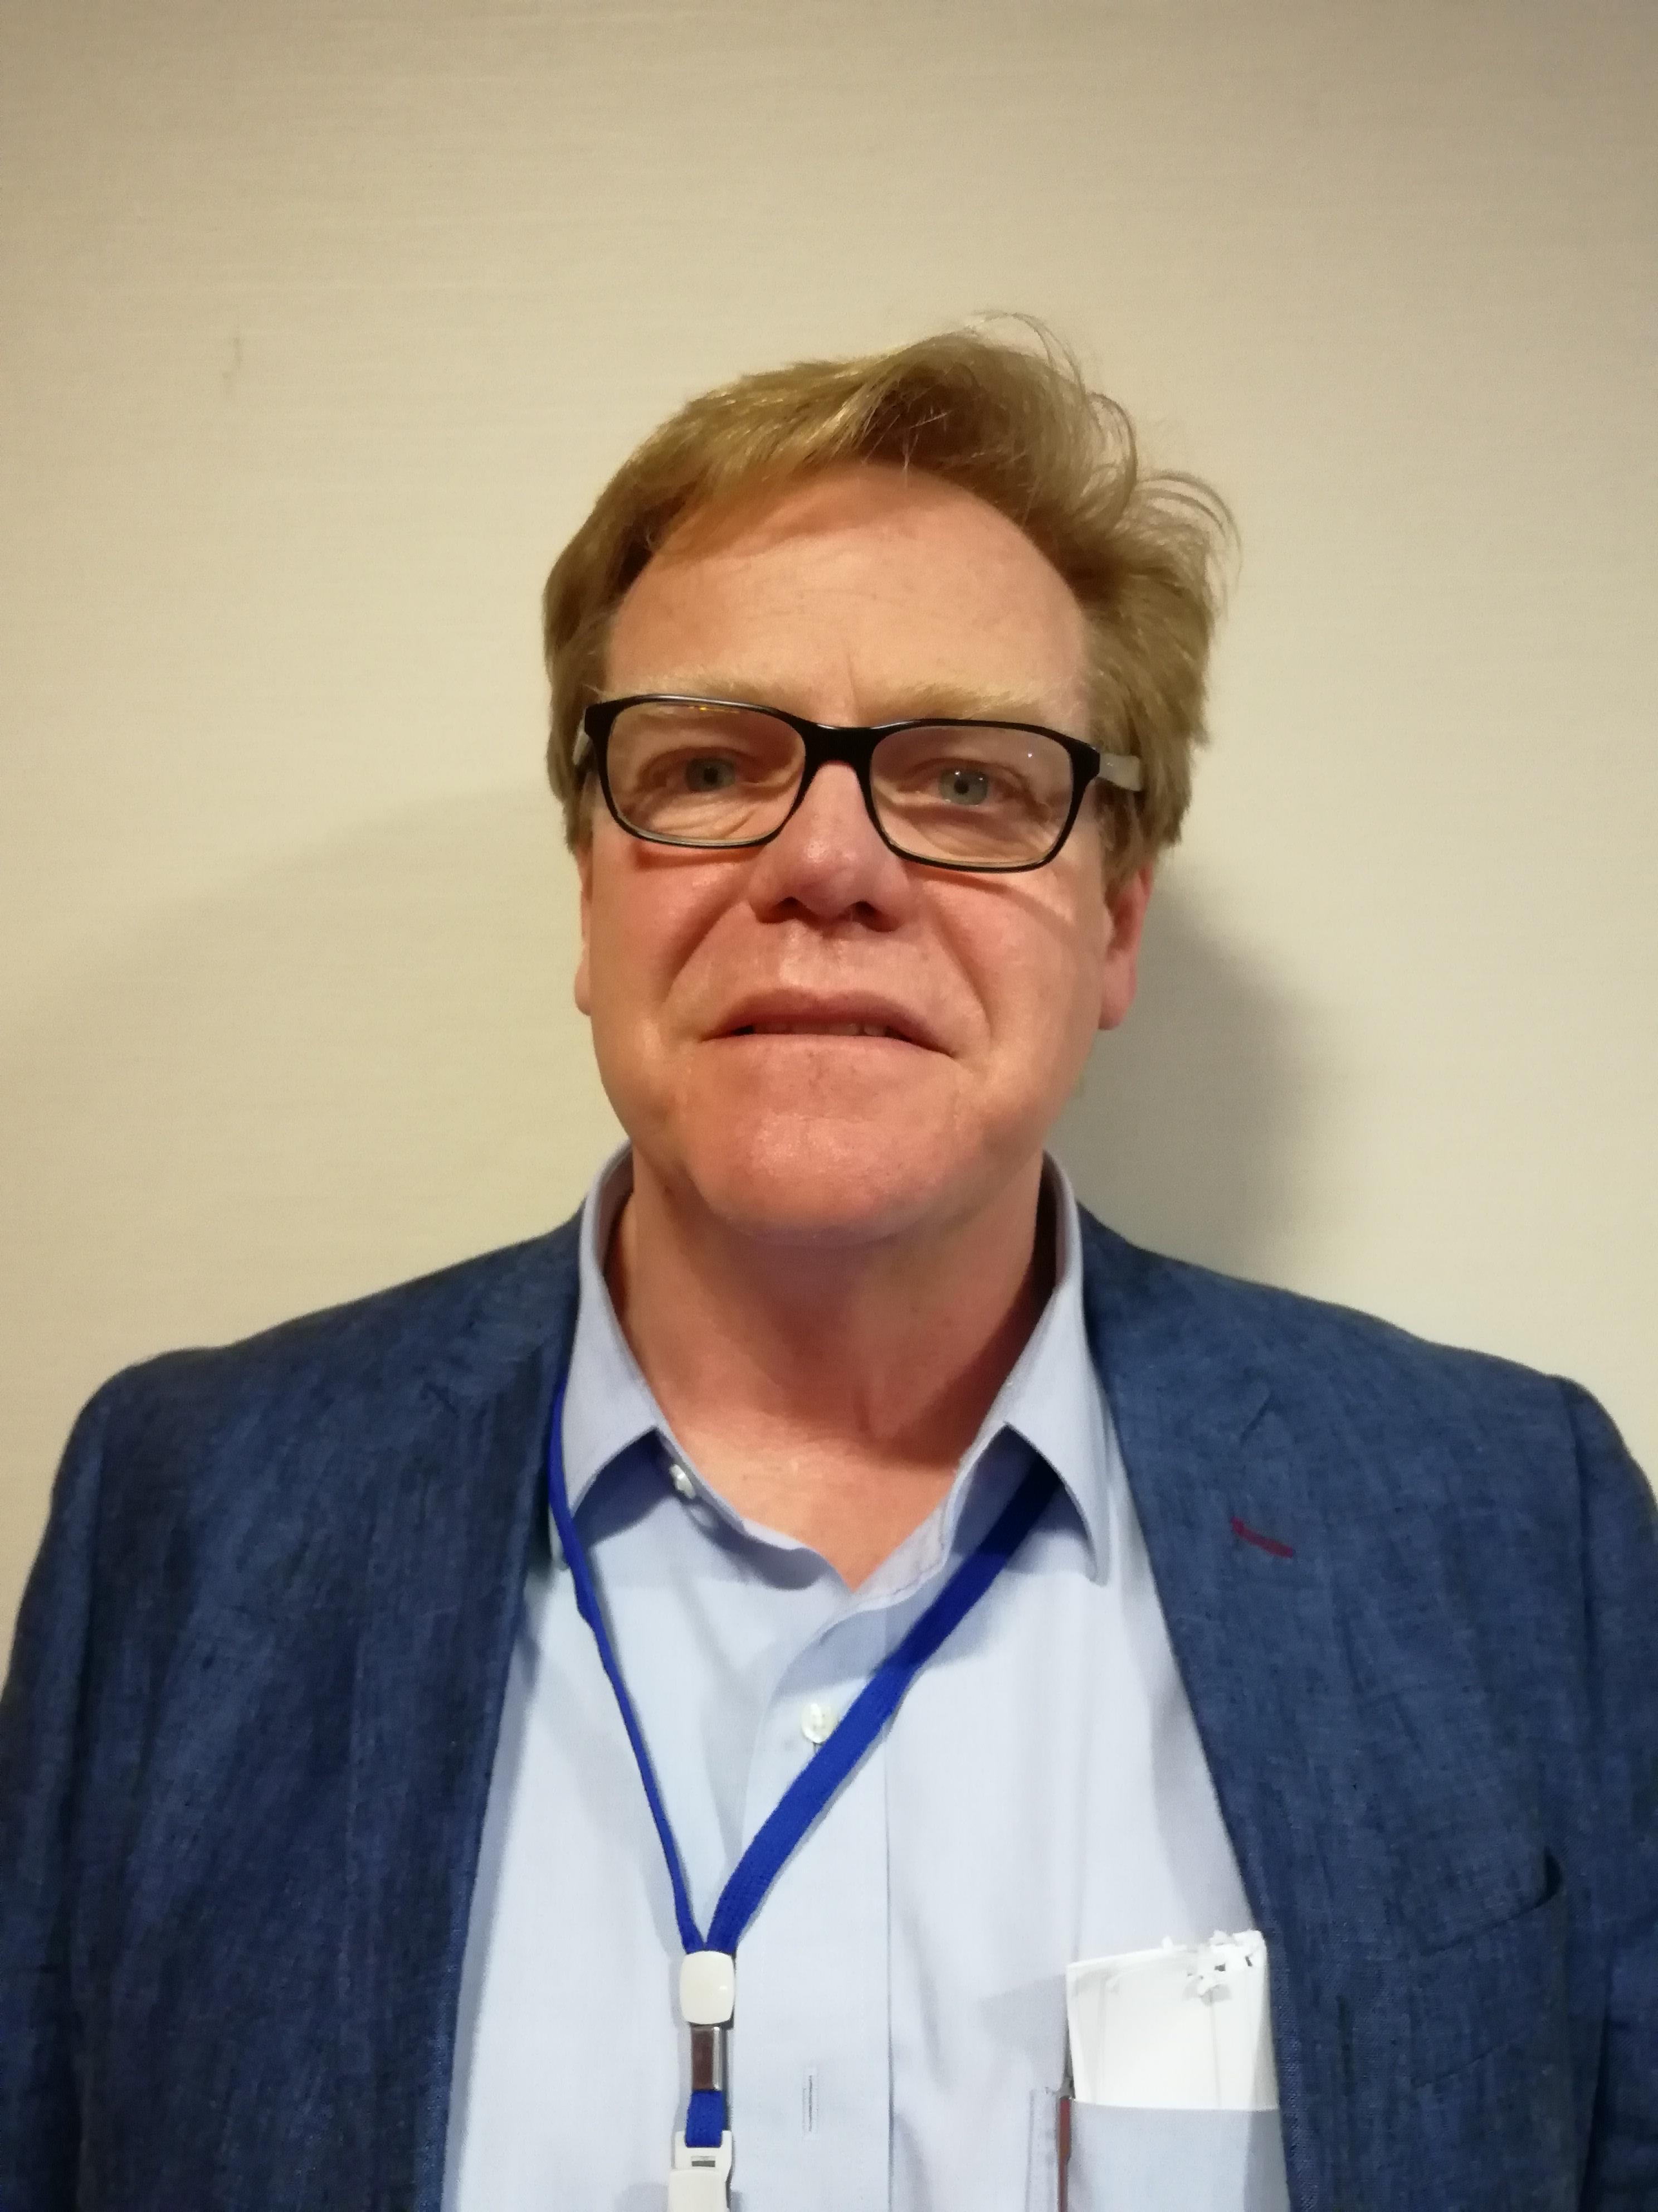 | Carlos AZAMBUJA (Mr.), Director, GENIA - Laboratory of molecular biology, Zonamerica, Ruta 8, km 17,500, Biotec local 012, MONTEVIDEO, Uruguay  (tel.: +598 25182044 fax: +598 25182044 e-mail: azambuja@geniageo.com)
Mirta ANTONGIOVANNI (Ms.), Manager Global of Regulatory Affair and Register of Varieties, Ruta 7. km 208, Chacabuco, Buenos Aires, Argentina
(tel.: +54 2364646124 e-mail: mantongiovanni@gmseeds.com)
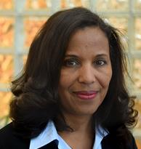 | Marymar BUTRUILLE (Ms.), Germplasm IP Stewardship Coordinator, Monsanto Company, 3302 SE Convenience Boulevard, Ankeny, Iowa 50021, United States of America  (tel.: +1 515 965 3077 e-mail: marymar.butruille@monsanto.com)
Natalia Fernandez (Ms.), Monsanto, Argentina
(tel.: + 5411 4316 2400 e-mail: natalia.fernandez.eraso@monsanto.com)
Victoria Stewart (Ms.), Gerente Operativo, Asociación Civil Uruguaya para la Protección de los Obtentores Vegetales (URUPOV), Uruguay
(tel.: +598 2 6000805 e-mail: victoria@urupov.org.uy)
III. OTHER PARTICIPANTS
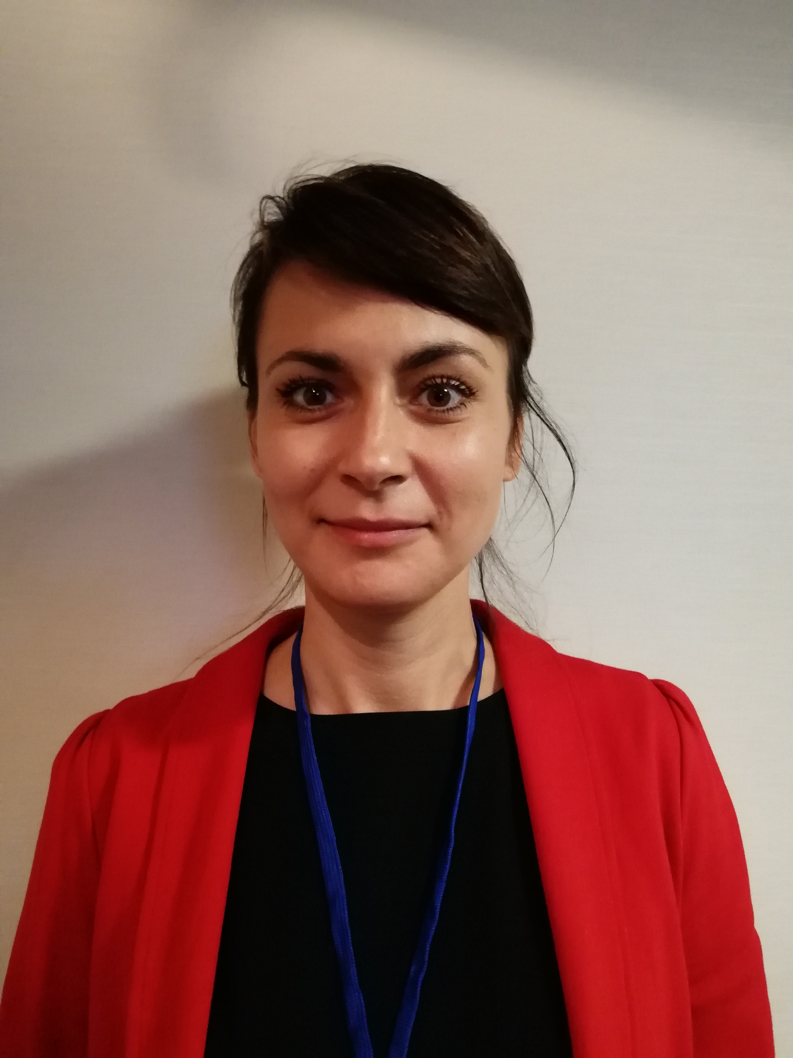 | Monika SLAWIAK (Ms.), Molecular Quality Assurance Senior Scientist, Napoleonsweg 152, 6083 AB Nunhem, Netherlands  (tel.: +31 (0) 475 599 374 e-mail: monika.slawiak@vegetableseeds.basf.com)
Fabio YAMASHITA BARLETTA (Mr.), Biotechnology Assistant, Sakata Seed Sudamerica Ltda, Avenida Plinio Salgado, 4320, Uberaba, Bragança Paulista SP 12906-840, Brazil
(tel.: +55 11 4034 8838 e-mail: fabio.barletta@sakata.com.br)

IV. OFFICER
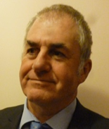 | Nik HULSE (Mr.), Chair
V. OFFICE OF UPOV
Mr. Peter BUTTON (Mr.), Vice Secretary-General, International Union for the Protection of New Varieties of Plants (UPOV) Chemin des Colombettes 34, 1211 Geneva 20, Switzerland
(e-mail: peter.button@upov.int)
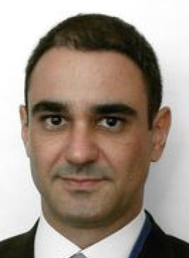 | Leontino TAVEIRA (Mr.), Technical/Regional Officer (Latin America/Carribean), International Union for the Protection of New Varieties of Plants (UPOV), Chemin des Colombettes 34, 1211 Geneva 20, Switzerland  (tel.: +41 22 338 8426 fax: +41 22 733 0336 e-mail: leontino.taveira@upov.int)
Tomochika MOTOMURA (Mr.), Technical/Regional Officer (Asia), International Union for the Protection of New Varieties of Plants (UPOV), Chemin des Colombettes 34,
1211 Geneva 20, Switzerland
(tel.: +41 22 338 7442 fax: +41 22 733 0336 e-mail: tomochika.motomura@upov.int)
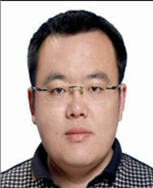 | Ruixi HAN (Mr.), Fellow, International Union for the Protection of New Varieties of Plants (UPOV), Chemin des Colombettes 34, 1211 Geneva 20, Switzerland  (tel.: +41 22 338 7079 fax: +41 22 733 0336 e-mail: ruixi.han@upov.int)

[Annex II follows]

OPENING REMARK BY MR. PEDRO QUEHEILLE,
PRESIDENT OF INSTITUTO NACIONAL DE SEMILLAS (INASE), URUGUAY

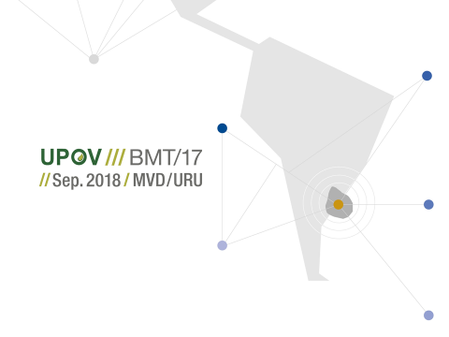

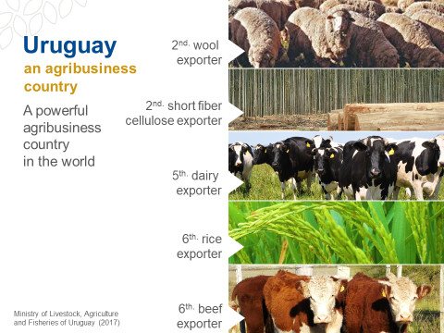

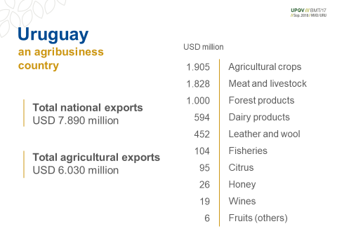

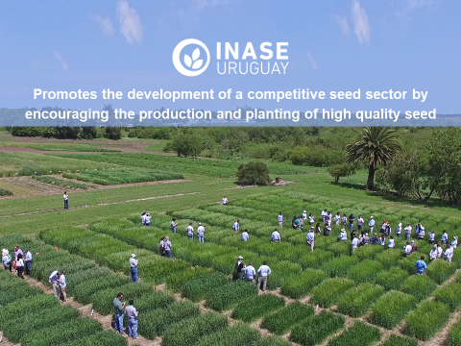

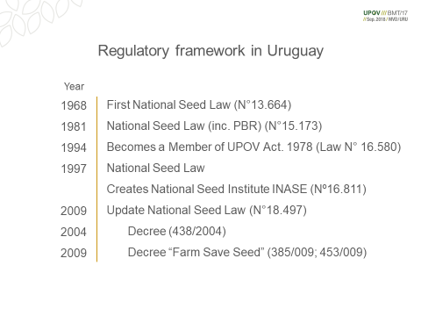

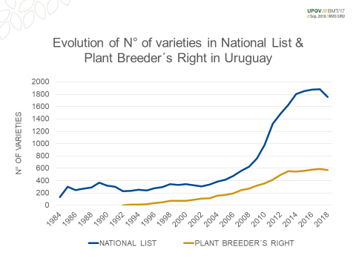

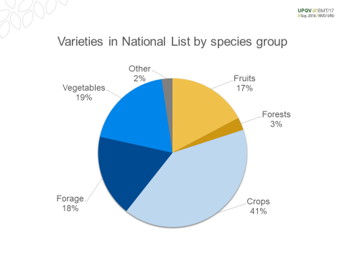

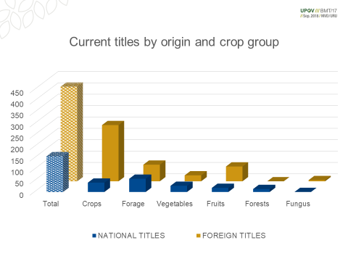

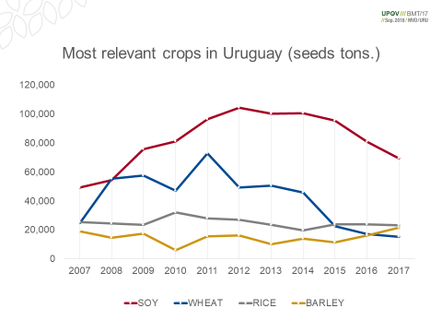

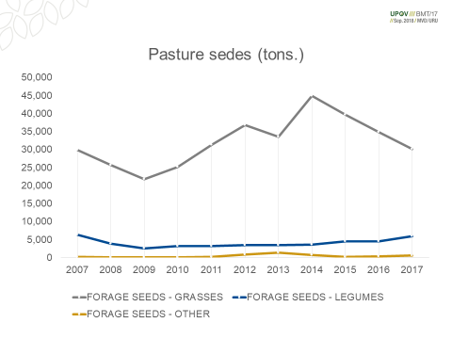

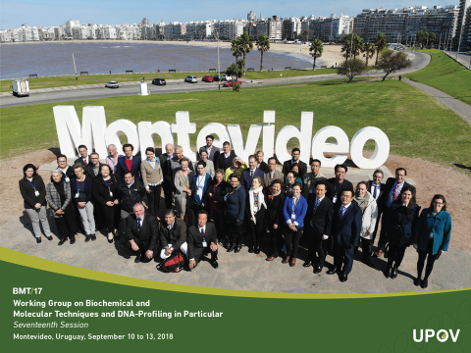

[End of Annex II and of document]

Breeders’ Day

