E
International Union for the Protection of New Varieties of Plants

Working Group on Biochemical and Molecular Techniques  and DNA-Profiling in Particular  Seventeenth Session  Montevideo, Uruguay, September 10 to 13, 2018 | BMT/17/22  Original: English  Date: September 7, 2018
Use of SNP markers for soybean variety protection purposes in Argentina
Document prepared by an expert from Argentina
Disclaimer: this document does| not represent UPOV policies or guidance
The presentation prepared by an expert from Argentina on the “Use of SNP markers for soybean variety protection purposes in Argentina” is reproduced in the Annex to this document.

[Annex follows]

USE OF SNP MARKERS FOR SOYBEAN VARIETY PROTECTION PURPOSES IN ARGENTINA

Presentation prepared by an expert from Argentina

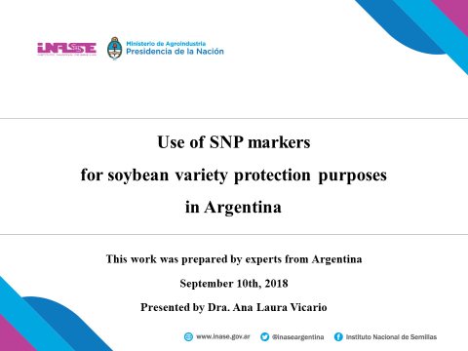
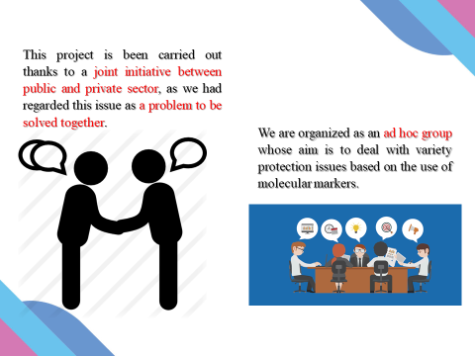
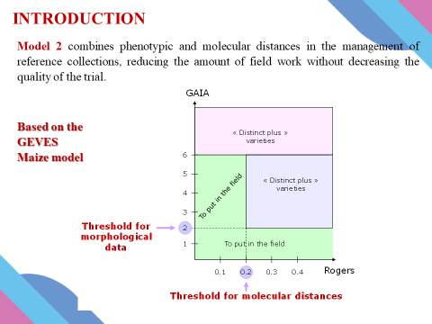
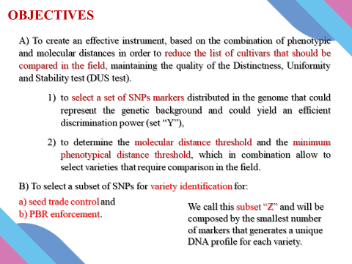
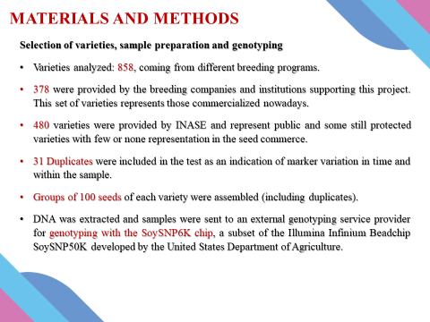
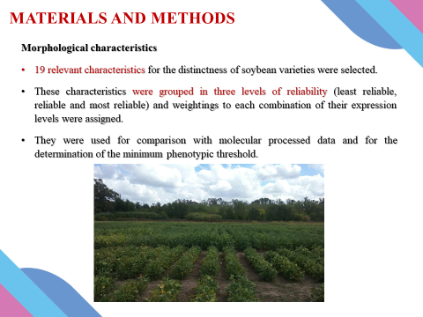
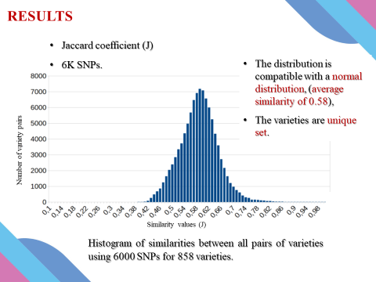
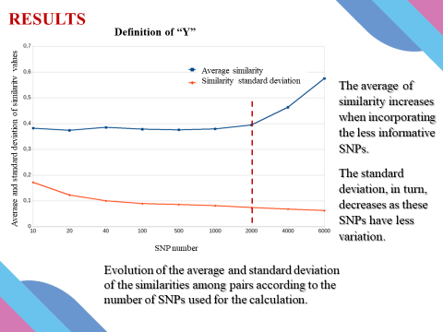
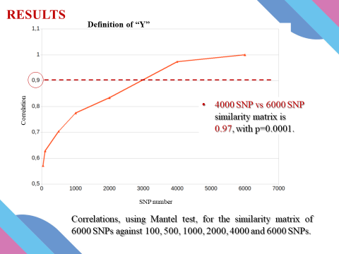
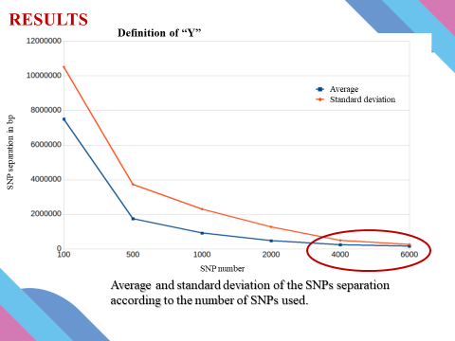
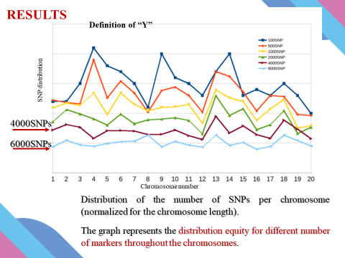
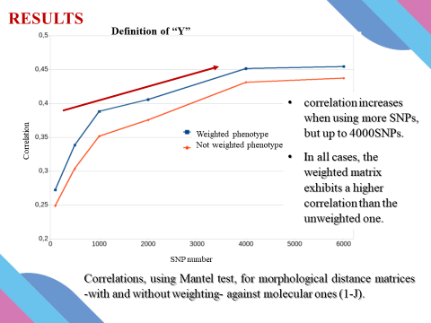
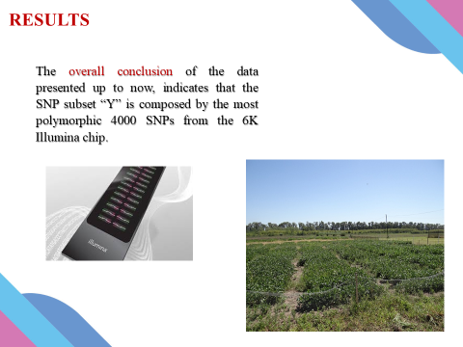
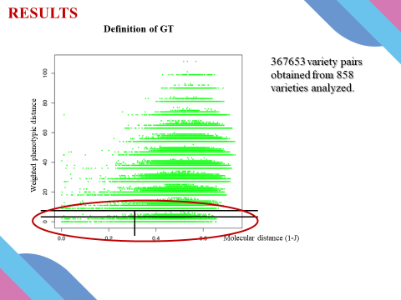
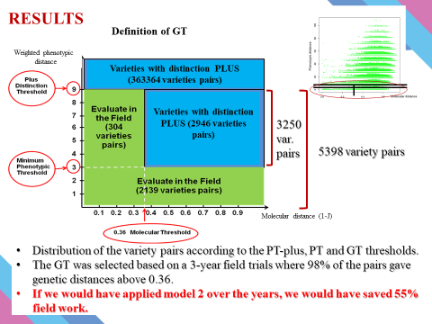
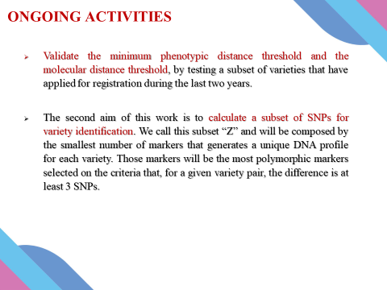
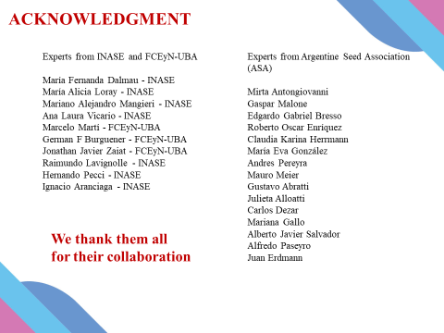
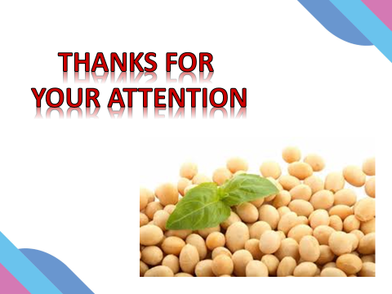

[End of Annex and of document]

