E
International Union for the Protection of New Varieties of Plants

Working Group on Biochemical and Molecular Techniques  and DNA-Profiling in Particular  Sixteenth Session  La Rochelle, France, November 7 to 10, 2017 | BMT/16/9  Original: English  Date: October 18, 2017
THE USE OF MOLECULAR DISTANCE AS A CHARACTERISTIC? ASSESSMENT OF THe REFERENCE VARIETY MODEL BASED ON GEVES SNP MAIZE DATA
Document prepared by an expert from France
Disclaimer: this document does not represent UPOV policies or guidance
As a follow up to the previous presentations by the American Seed Trade Association (ASTA) (document BMT/14/5 “The Use of Reference Varieties in Varietal Distinction: an Approach under Investigation in the US for Potential Application in Plant Variety Protection”), and the Netherlands (document BMT/15/22 Rev “Can Molecular Distance be used as Characteristic?”), we are testing this new concept based on genetic distances to so called “reference” varieties. Our study explores different calculations to transform genetic distances into characteristics and highlights some consequences of the potential use of this approach in DUS examination.

[Annex follows]

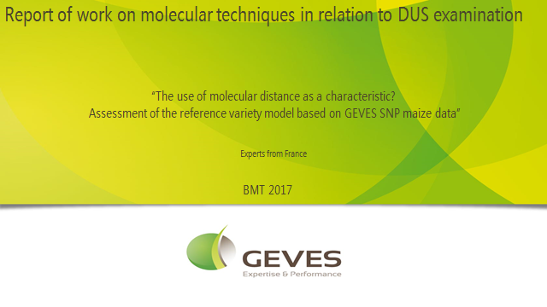

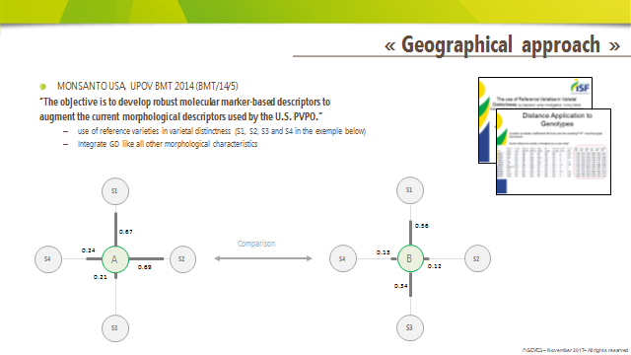

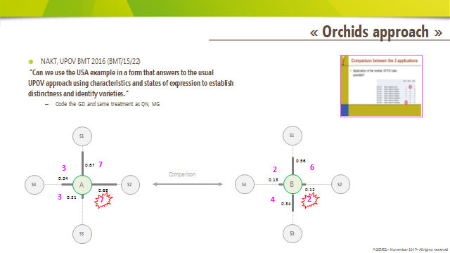

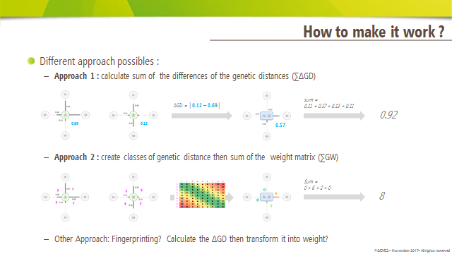

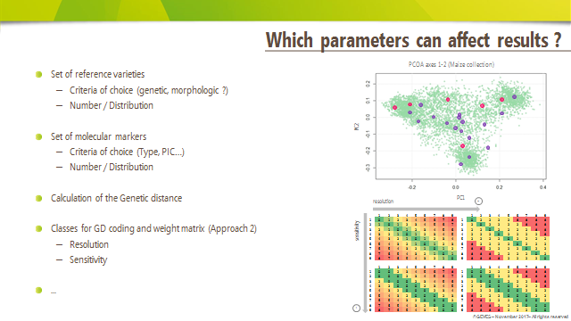

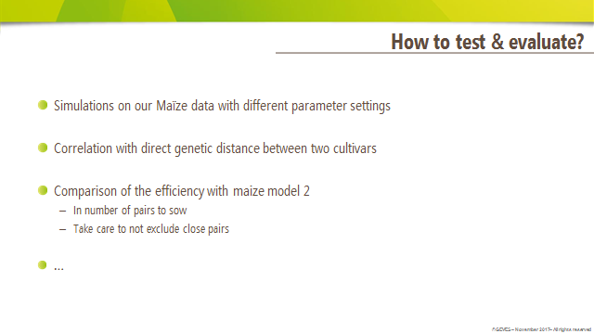

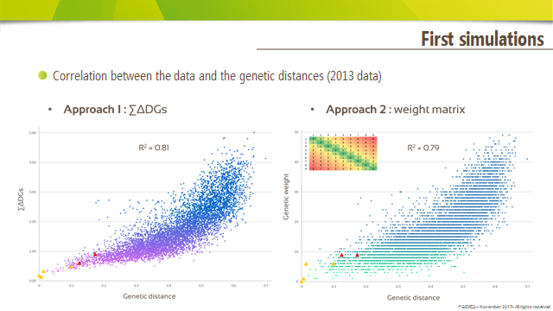

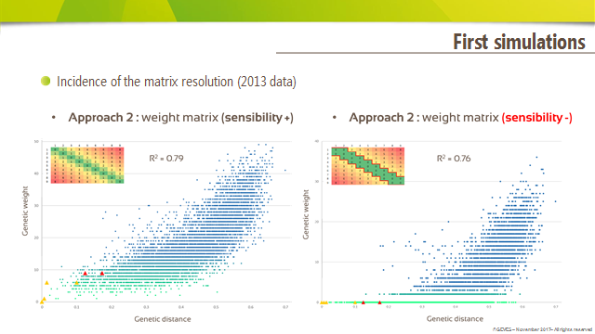

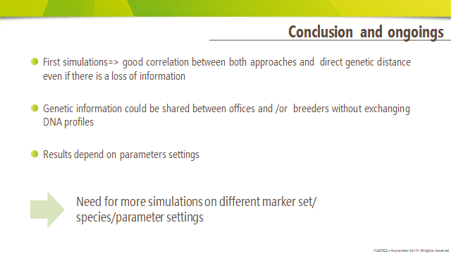

[End of Annex and of document]

