E
International Union for the Protection of New Varieties of Plants

Working Group on Biochemical and Molecular Techniques  and DNA-Profiling in Particular  Sixteenth Session  La Rochelle, France, November 7 to 10, 2017 | BMT/16/29  Original: English  Date: November 10, 2017
REPORT
adopted by the Working Group on Biochemical and Molecular Techniques and DNA-Profiling in Particular
Disclaimer: this document does not represent UPOV policies or guidance

Opening of the session
The Working Group on Biochemical and Molecular Techniques and DNA-Profiling in Particular (BMT) held its sixteenth session in La Rochelle, France, from November 7 to 10, 2017. The list of participants is reproduced in Annex I to this report.

The BMT was opened by Mr. Kees van Ettekoven (Netherlands), Chairperson of the BMT, who welcomed the participants. The BMT was welcomed by Mr. Fréderic Malterre, Direction générale de l'alimentation, Ministère de l’agriculture et de l’alimentation, Mr. Christian Huyghe, Directeur Scientifique Agriculture, Institut national de recherche agronomique (INRA), Mr. Arnaud Deltour, Directeur général, Groupe d’étude et de contrôle des variétés et des semences (GEVES), and Ms. Anne-Lise Corbel, Responsible for DUS, GEVES - Variety sector. Copies of the opening remarks are reproduced in Annexes II to V to this document, respectively.

Adoption of the agenda
The BMT adopted the agenda as reproduced in document BMT/16/1 Rev.

Reports on developments in UPOV concerning biochemical and molecular techniques
The BMT received a presentation from the Office of the Union on developments in UPOV concerning biochemical and molecular techniques, a copy of which is provided in document BMT/16/2.

Short presentations on new developments in biochemical and molecular techniques by DUS experts, biochemical and molecular specialists, plant breeders and relevant international organizations (oral reports by participants)
No presentations were made under this item. However, the participants agreed to share experiences and explore opportunities for future cooperation during an interactive session, which is reported under “Cooperation session”

Report of work on molecular techniques in relation to DUS examination

Genetic Distance-based selection of similar varieties for wheat distinctness test
The BMT considered document BMT/16/6 and received a presentation by Mr. Ruyu Li (China).

Test of the potential use of SNPs markers on oilseed rape varieties
The BMT considered document BMT/16/7 and received a presentation by Mr. Arnaud Remay (France).

The use of molecular markers (SNP) for maize DUS testing in France (2013 to 2016)
The BMT considered documents BMT/16/8 and BMT/16/8 Add. and received a presentation by Mr. Jehan-Baptiste Mauroux (France).

The BMT agreed that France should propose a revision to document TGP/15 “Guidance on the Use of Biochemical and Molecular Markers in the Examination of Distinctness, Uniformity and Stability (DUS)”, Annex II, “Example: Parent Lines in Maize”, to reflect the refinements that had been made in France on the basis of its experience in the application of the Model “Combining Phenotypic and Molecular Distances in the Management of Variety Collections”, for consideration by the Technical Committee at its fifty-fourth session.

The BMT agreed that it would be advantageous if the draft revision of document TGP/15, to be considered by the TC at its fifty-fourth session, could be published sufficiently before the forty-seventh session of the Technical Working Party for Agricultural Crops (TWA), to be held in Naivasha, Kenya, from May 21 to 25, 2018, and before the seventeenth session of the BMT, in order that any comments of the TWA and BMT on the draft revision could be reported to the TC at its fifty-fourth session.

The use of genetic distances as characteristics? Assessment of this approach based on GEVES SNP maize data
The BMT considered document BMT/16/9 Rev. and received a presentation by Mr. René Mathis (France).

The use of molecular markers (SNP) for maize DUS testing: Development and official applications to assess distinctness of hybrids varieties (France)
The BMT considered document BMT/16/10 and received a presentation by Ms. Valérie Uyttewaal (France).

An attempt to use molecular markers for winter wheat reference collection management
The BMT considered document BMT/16/11 and received a presentation by Ms. Anne-Lise Corbel (France).

Update on the American Seed Trade Association and United States PVP Office Molecular Marker Working Group
The BMT considered documents BMT/16/12 and BMT/16/12 Add. and received a presentation by Mr. Paul T. Nelson (Seed Association of the Americas (SAA))

The use of Reference Variety Similarities in Varietal Distinctness II: Reference Variety Selection
The BMT considered documents BMT/16/14 and BMT/16/14 Add. and received a presentation by Mr. Paul T. Nelson (SAA).

Imoddus proposal: Developing a toolbox to distinguish apple mutants for DUS testing
The BMT considered document BMT/16/15 Rev. and received a presentation by Mr. Jean Maison (European Union).

Use of GBS for Lucerne Variety Distinction
The BMT considered document BMT/16/17 and received a presentation by Ms. Bernadette Julier (France).

Genetic selection of similar varieties for the first growing cycle: example French bean
The BMT considered documents BMT/16/19 and BMT/16/19 Add., and received a presentation by Ms. Amanda van Dijk-Veldhuizen (Netherlands).

The BMT agreed that the approach presented in document BMT/16/19 and BMT/16/19 Add. was a suitable use of molecular techniques in the examination of DUS and should be proposed for inclusion in document TGP/15. Therefore, it was agreed that the Netherlands should prepare an explanation of the method as a basis for a revision of document TGP/15 to be considered by the Technical Committee at its fifty-fourth session.

The BMT agreed that it would be advantageous if the draft revision of document TGP/15, to be considered by the TC at its fifty-fourth session, could be published sufficiently before the fifty-second session of the Technical Working Party for Vegetables (TWV), to be held in Beijing, China, from September 17 to 21,2018, and before the seventeenth session of the BMT, in order that any comments of the TWV and BMT on the draft revision could be reported to the TC at its fifty-fourth session.

SDN-assisted plant breeding and potential impact on DUS testing
The BMT considered document BMT/16/20 and received a presentation by Ms. Cécile Collonnier (European Union).

Report on IMODDUS activities in 2017
The BMT considered document BMT/16/22 and received a presentation by Mr. Martin Ekvad (European Union).

The Tomato project proposal in CPVO IMODDUS program
The BMT considered document BMT/16/27 and received a presentation by Ms. Hedwich Teunissen (Netherlands).

International guidelines on molecular methodologies including cooperation between the OECD, UPOV, ISTA and ISO
The BMT considered document BMT/16/3.

The BMT noted that a Joint OECD/UPOV/ISTA/AOSA Workshop on Biochemical and Molecular Methods had been held in Paris on June 8, 2016, and that the recommendations of the Joint OECD/UPOV/ISTA/AOSA Workshop as reproduced in document BMT/16/3, paragraph 9, were approved by the Annual Meeting of the OECD Seed Schemes, held in Paris on June 9 and 10, 2016; BMT/16/3 page 4.

The BMT noted that the TC, at its fifty-third session, had agreed that possible future collaboration between UPOV, the Organization for Economic Co-operation and Development (OECD) and the International Seed Testing Association (ISTA) might include the harmonization of terms and methodologies used for different crops and the possible development of standards, after agreement by those organizations.

The BMT noted that practical workshops on “DNA Techniques and Variety Identification” had been held in Roelofarendsveen, Netherlands, from May 8 to 10, 2017 and from September 20 to 22, 2017.

The BMT noted that the TC had agreed that UPOV and OECD should consider making progress in the matters reported in this document if ISTA was unable to participate in the near future.

The BMT recalled that the TC, at its fifty-first session, had agreed (see document TC/52/29 Rev. “Revised Report”, paragraph 129):

(a) to develop a joint document explaining the principal features of the systems of the OECD, UPOV and ISTA; and
(b) to develop an inventory on the use of molecular marker techniques, by crop, with a view to developing a joint OECD/UPOV/ISTA document containing that information, in a similar format to UPOV document UPOV/INF/16 “Exchangeable Software”, subject to the approval of the Council and in coordination with OECD and ISTA; and
The BMT agreed that the initiatives above, and consideration of possible harmonization of terms and methodologies used for different crops and the possible development of standards, might be advanced through a further international practical workshop, to be jointly coordinated by OECD, UPOV and ISTA and supported by Naktuinbouw and/or another partner with the relevant facilities.

Practical workshops on DNA techniques and variety identification
The BMT considered document BMT/16/13 and received a presentation by Mr. Bert Scholte and Ms. Hedwich Teunissen (Netherlands).

The BMT considered document BMT/16/3 Add. and received a presentation by Ms. Chiara Delogu (Italy).

OECD Seed Certification Schemes
The BMT considered document BMT/16/23 and received a presentation by Mr. Gerald Hall (OECD).

Variety description databases including databases containing molecular data

Integration of molecular data into DUS testing in Durum Wheat: Use of a standardized method for the efficient management of reference collections
The BMT considered document BMT/16/21 and received a presentation by Ms. Alexandra Ribarits (Austria).

Methods for analysis of molecular data
No information was presented under this item.

The use of molecular techniques in examining essential derivation
The BMT considered document BMT/16/2 and received a presentation from the Office of the Union.

The use of molecular techniques in variety identification

Assessment of reproducibility of 6K SNP genotyping in soybean across laboratories
The BMT considered document BMT/16/16 and received a presentation by Mr. Frédéric Achard (SAA) and Ms. Jin Xiong (SAA).

Assignment Tests for Genotype Classification
The BMT considered document BMT/16/18 Rev. and received a presentation by Mr. Jan De Riek (Flanders Research Institute for Agriculture, Fisheries and Food (ILVO)).

Development on Use of Molecular Technique for PVP in Republic of Korea
The BMT considered documents BMT/16/24 and BMT/16/24 Add. and received a presentation by Mr. Seung-in Yi (Republic of Korea).

The BMT noted the proposal made in the presentation to organize an international consortium to work on molecular techniques and agreed to discuss that matter during the cooperation session.

Determination of purity and quantification of varietal components through NGS (Next Generation Sequencing)
The BMT considered document BMT/16/25 and received a presentation by Mr. Carlos Azambuja (SAA).

Determining the parameters to characterize Soybean varieties using single nucleotide polymorphisms
The BMT considered document BMT/16/26 and received a presentation by Mr. Barry K. Nelson (SAA).

Confirmation of validation for DNA variety identification technique
The BMT considered document BMT/16/28 and received a presentation by Mr. Hiroshi Goto (Japan).

Review of document UPOV/INF/17 “Guidelines for DNA-Profiling: Molecular Marker Selection and Database Construction (‘BMT Guidelines’)”
The BMT considered documents BTM/16/4 and BMT/16/5 and received a presentation by the Office of the Union, on “Standards for databases containing molecular information”, a copy of which is reproduced BMT/16/5 Add.

The BMT agreed to invite members and observers to provide comments on document UPOV/INF/17 “Guidelines for DNA-profiling: Molecular Marker Selection and Database Construction (‘BMT Guidelines’)”. The comments would be compiled by the Office of the Union in a document that would form the basis of a review of document UPOV/INF/17 by the BMT at its seventeenth session. The BMT further agreed to propose to introduce a new chapter concerning cooperation in the exchange of data and construction of databases in document UPOV/INF/17 on the basis of document BMT/16/5.

Date and place of next session
The BMT welcomed the invitation of Uruguay to hold its seventeenth session in Montevideo, Uruguay, from September 10 to 13, 2018, with the elements of the preparatory workshop included in the session.

Chairperson
The BMT thanked Mr. Kees van Ettekoven for his chairmanship and noted that he was awarded a UPOV bronze medal in recognition of his chairmanship of the BMT from 2015 to 2017.

Future program
Coordination session

Discussion groups were formed for: agricultural crops; fruit crops; ornamental plants and forest trees; and vegetables, for BMT participants to exchange information on their work and explore areas for cooperation.

The BMT was informed of the following outcomes of the discussions:

Agricultural Crops

The United Kingdom will compile a list of crops of interest to members of the Union.

Fruit Crops

The following interest in cooperation were identified:

- Apple: Australia, Canada, France, Republic of Korea, United Kingdom, CIOPORA
- Stone fruit: France, Republic of Korea, Spain, United Kingdom
- Berries: Austria, Germany, Netherlands, United Kingdom, CIOPORA
- Nuts: China, Spain

Ornamental Plants and Forest Trees

Opportunities for cooperation on Rose will be explored by Netherlands (coordinator), China, United Kingdom and CIOPORA.

Vegetables

The following UPOV members will share their criteria for selecting crops for work in relation to the use of molecular techniques: Canada; China; France; Germany; Netherlands (coordinator); Republic of Korea; United Kingdom.

Program for the seventeenth session
During its seventeenth session, the BMT planned to discuss the following items:

1. Opening of the session
2. Adoption of the agenda
3. Reports on developments in UPOV concerning biochemical and molecular techniques (document to be prepared by the Office of the Union)
4. Short presentations on new developments in biochemical and molecular techniques by DUS experts, biochemical and molecular specialists, plant breeders and relevant international organizations (oral reports by participants)
5. Report of work on molecular techniques in relation to DUS examination (papers invited)
6. Cooperation between international organizations (document to be prepared by the Office of the Union)
7. Variety description databases including databases containing molecular data (papers invited)
8. Methods for analysis of molecular data (papers invited)
9. The use of molecular techniques in examining essential derivation (papers invited)
10. The use of molecular techniques in variety identification* (papers invited)
11. Review of document UPOV/INF/17 “Guidelines for DNA-Profiling: Molecular Marker Selection and Database Construction
12. Revision of document TGP/15 “Guidance on the Use of Biochemical and Molecular Markers in the Examination of Distinctness, Uniformity and Stability (DUS)”
13. Session to facilitate cooperation
14. Date and place of next session
15. Future program
16. Report of the session (if time permits)
17. Closing of the session

Visit

On the afternoon of November 9, 2017, the BMT participants visited the facilities of BIOGEVES at Le Magneraud, France, where they were welcomed by Mr. René Mathis, Director, BIOGEVES, and Mr. Bruno Richard, Responsible du service Experimentation, GEVES, Le Magneraud, The BMT visited the variety collection of GEVES at Le Magneraud with capacity for up to 32,000 samples in cold storage. The BMT visited the laboratory of molecular biology and biochemistry, where an overview was provided by Ms. Anne Bernole, Technical Manager Molecular Biology, BIOGEVES, Mr. Arnaud Remay, Head, Genotyping unit, GEVES, and Ms. Muriel Thomasset, Genotyping Bioanalysis, BIOGEVES. The BMT also received presentations on current studies on entomology at GEVES by Mr. Pierrick Aupinel, Directeur d’Unite Entomomogie, and Mr. Jean-François Odoux, Ingenieur chercheur, one of which is reproduced in Annex VI to this report.

The BMT adopted this report at the close of its session, on November 10, 2017.

[Annexes follow]

BMT/16/29

ANNEX I

LIST OF PARTICIPANTS
I. MEMBERS
australia
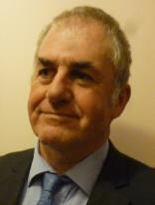 | Nik HULSE (Mr.), Chief of Plant Breeders’ Rights, Plant Breeder's Rights Office, IP Australia, 47 Bowes Street, Phillip ACT 2606  (tel.: +61 2 6283 7982 e-mail: nik.hulse@ipaustralia.gov.au)
austria
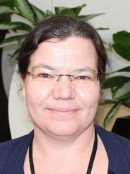 | Alexandra RIBARITS (Ms.), Expert, Institute for Seed and Propagating Material, Phytosanitary Service and Apiculture, Division for Food Security, Spargelfeldstrasse 191, 1220 Wien  (tel.: +43 50 555 34914 e-mail: alexandra.ribarits@ages.at)
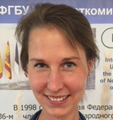 | Verena PETERSEIL (Ms.), Molecular Biologist, Austrian Agency for Health and Food safety (AGES), Institut Biochemie, Spargelfeldstrasse 191, 1220 Wien  (tel.: +43 50 555 32203 fax: +43/50555/32219 e-mail: verena.peterseil@ages.at)
belarus
Svetlana VAKULA (Ms.), Research Scientist, Institute of Genetics and Cytology of NAS, Akademicheskaya street, 27, 220072 Minsk
(tel.: +375 17 284 1912 fax: +375 17 284 1917 e-mail: s.vacula@igc.by)

canada
Renée CLOUTIER (Ms.), Examiner, Plant Breeders' Rights Office, Canadian Food Inspection Agency (CFIA), 59 Camelot Drive, Ottawa Ontario, Canada K1A 0Y9
(tel.: +1 613 773 7191 fax: +1 613 773 7115 e-mail: Renee.Cloutier@inspection.gc.ca)
china
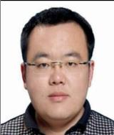 | Ruixi HAN (Mr.), Senior Examiner, Division of DUS Tests, Development Center of Science and Technology, Ministry of Agriculture, Keji Building, No.A18, Ronghua Nanlu, Etown Daxing District, 100176 Beijing  (tel.: +86 10 59198194 fax: +86 10 59199393 e-mail: wudifeixue007@163.com)
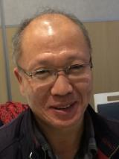 | Ruyu LI (Mr.), Researcher, Crop Research Institute, Shandong Academy of Agricultural Sciences, Gongye Beilu 202, Jinan, 250100 Shandong  (tel.: +86 0531 83178713 fax: +86 0531 83179088 e-mail: li_ruyu@sina.com)
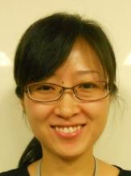 | Xuedan YU (Ms.), Assistant Researcher, Research Institute of Forestry, Chinese Academy of Forestry, Dongxiaofu 1, Xiangshan Road, Haidian District, Beijing 100091  (tel.: 86 10 6288 9645 fax: 86 10 628 720 15 e-mail: Yuxd@caf.ac.cn)
czech republic
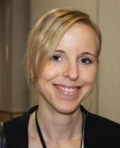 | Jitka KLEMPOVA (Ms.), Molecular Diagnostics Analyst, Central Institute for supervising and testing in agriculture (ÚKZÚZ), 63/2 Hroznova, 656 06 Brno  (tel.: +420 543 548 378 e-mail: jitka.klempova@ukzuz.cz)
estonia
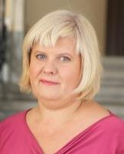 | Kristiina DIGRYTE (Ms.), Adviser, Plant Health Department, Lai Street 39/41, 15056 Tallinn  (tel.: +372 6256 275 e-mail: kristiina.digryte@agri.ee)
european union
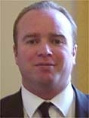 | Martin EKVAD (Mr.), President, Community Plant Variety Office (CPVO), 3, boulevard Maréchal Foch CS 10121, 49101 Angers Cedex 02  (tel.: +33 2 4125 6415 e-mail: ekvad@cpvo.europa.eu)
Diana CHARELS (Ms.), Policy Officer, Plant Health Unit, Directorate General for Health and Food Safety (DG SANTE), European Commission, rue Froissart 101, 06/80, 1049 Bruxelles
(tel.: +32 2 295 4452 fax: +32 2 295 8542 e-mail: diana.charels@ec.europa.eu)

Jean MAISON (Mr.), Deputy Head, Technical Unit, Community Plant Variety Office (CPVO), CS 10121, 49101 Angers Cedex 02
(tel.: +33 2 4125 6435 e-mail: maison@cpvo.europa.eu)
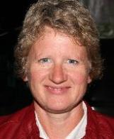 | Anne WEITZ (Ms.), Technical Expert Agricultural Crops, Community Plant Variety Office (CPVO), 3, boulevard Maréchal Foch, CS 10121, 49101 Angers Cedex 02  (tel.: +33 2 41 25 64 37 e-mail: weitz@cpvo.europa.eu)
Cécile COLLONNIER (Ms.), Expert biomolecular techniques, CPVO, 3 Boulevard Foch, CS10121, 49101 Angers Cedex 2
(tel.: +33 241 256 400 fax: +33 241 256 410 e-mail: collonnier@cpvo.europa.eu)
finland
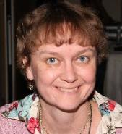 | Kaarina PAAVILAINEN (Ms.), Senior Officer, Seed Unit, Finnish Food Safety Authority Evira, Tampereentie 51, P.O. Box 111, 32201 Loimaa  (tel.: +358 40 833 2480 fax: +358 29 530 5317 e-mail: kaarina.paavilainen@evira.fi)
france
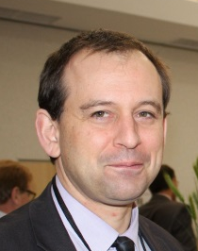 | Fréderic MALTERRE (Mr.), Direction générale de l'alimentation, Ministère de l’agriculture et de l’alimentation
Arnaud REMAY (Mr.), Head, Genotyping unit, Groupe d'étude et de contrôle des variétés et des semences (GEVES), La Minière, 78285 Guyancourt
(tel.: +33 546 683 038 fax: +33 546 683 100 e-mail: arnaud.remay@geves.fr)
 | Arnaud DELTOUR (Mr.), Directeur général, Groupe d’étude et de contrôle des variétés et des semences (GEVES)
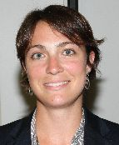 | Virginie BERTOUX (Ms.), Vice-Secretary General, National Committee for Registration of Plant Varieties, INOV-GEVES, 25 Rue Georges Morel, CS 90024, 49071 Beaucouzé Cedex  (tel.: +33 2 41 22 86 49 fax: +33 2 41 22 86 01 e-mail: virginie.bertoux@geves.fr)
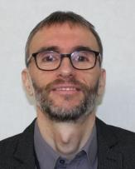 | René MATHIS (Mr.), BioGEVES Director, GEVES, rue Georges Morel, BP 90024, 49071 Beaucouzé Cedex  (tel.: + 33 2 41225834 fax: +33 2 41 228602 e-mail: rene.mathis@geves.fr)
Bernadette JULIER (Ms.), Research director, Institut National de Recherche Agronomique (INRA), URP3F, CS80006, 86600 Lusignan
(tel.: +33 549 556 038 fax: +33 549 556 044 e-mail: bernadette.julier@inra.fr)

Patrick BAGOT (Mr.), Head of DUS Testing on Potato, Unité expérimentale de l'Anjouère, La Pouëze, 49370 Erdre-en-Anjou
(tel.: +33 241 228 686 e-mail: patrick.bagot@geves.fr)

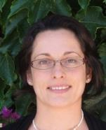 | Stéphanie CHRISTIEN (Ms.), Manager of DUS Vegetable Studies, Groupe d'Étude et de contrôle des Variétés Et des Semences (GEVES), GEVES Brion, Domaine de la Boisselière, 49250, Brion  (tel.: +33 2 41 57 03 70 fax: +33 2 41 57 46 19 e-mail: stephanie.christien@geves.fr)
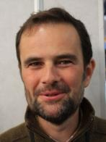 | Pascal COQUIN (Mr.), Director of Field Testing Station, Groupe d'étude et de contrôle des variétés et des semences (GEVES), Brion  (tel.: +33 2 41 57 23 22 fax: 33 2 41 57 46 19 e-mail: pascal.coquin@geves.fr)
Anne-Lise CORBEL (Ms.), Technical Manager of DUS Testing on rapeseed, cruciferae, flax and hemp,GEVES, Domaine de l'Anjouère, 49370 La Poueze
(tel.: +33 24 122 8705 fax: +33 24 122 8660 e-mail: anne-lise.corbel@geves.fr)
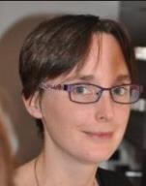 | Carole DIRWIMMER (Ms.), Manager of Fruit DUS team, Groupe d'étude et de contrôle des variétés et des semences (GEVES), 4790 route des Vignères, 84250 Le Thor  (tel.: +33 490 78 66 63 e-mail: carole.dirwimmer@geves.fr)
Frédéric LAFAILLETTE (Mr.), Head manager of DUS Fodder plant and Turf grasses, Domaine de l'Anjouère, La Pouëze, 49370 Erdre-en-Anjou
(tel.: +33 241 228 700 e-mail: frederic.lafaillette@geves.fr)

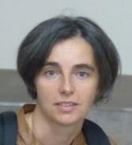 | Christelle GODIN (Ms.) Head manager of DUS testing on cereals, Domaine de l'Anjouère, La Pouëze, 49370 Erdre-en-Anjou  (tel.: +33 241 228 693 e-mail: christelle.godin@geves.fr)
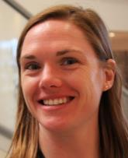 | Valérie UYTTEWAAL (Ms.), Head manager of DUS Testing on Maize and Sorghum and Secretary of the CTPS section "Maize and Sorghum", Unité expériementale du Magneraud, 17700 Surgères  (tel.: +33 546 683 019 e-mail: valerie.uyttewaal@geves.fr)
Anne BERNOLE (Ms.), Technical Manager Molecular Biology, BioGEVES, CS40052, 17700 Surgères
(tel.: +33 5 46 68 30 38 fax: +33 5 46 68 31 00 e-mail: anne.bernole@geves.fr)

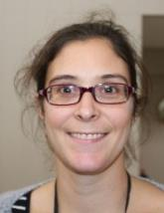 | Aurélia GOULEAU (Ms.), Scientific Coordinator, 25, rue Georges Morel, CS90024, 49071 Beaucouzé  (tel.: +33 241 228 646 e-mail: aurelia.gouleau@geves.fr)
Jehan-Baptiste MAUROUX (Mr.), Geneticist, BioGEVES, Domaine du Magneraud, CS40052, 17700 Surgères
(tel.: +33 546 683 033 fax: +33 546 683 100 e-mail: jehan-baptiste.mauroux@geves.fr)

Muriel THOMASSET (Ms.), Genotyping Bioanalysis, BioGEVES, Domaine Magenraud, CS40052, 17700 Surgères
(tel.: +33 546 683 038 fax: +33 546 683 100 e-mail: muriel.thomasset@geves.fr)

germany
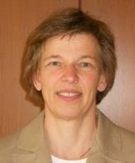 | Beate RÜCKER (Ms.), Head of Departement, Bundessortenamt, Osterfelddamm 80, Postfach 61 04 40, 30627 Hanover  (tel.: +49 511 9566 5639 fax: +49 511 956 69600  e-mail: beate.ruecker@bundessortenamt.de)
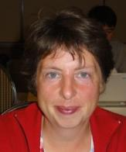 | Swenja TAMS (Mrs), Head of Section General affairs of DUS testing, Bundessortenamt, Osterfelddamm 80, 30627 Hanover  (tel.: +49 511 9566 5607 fax: +49 511 9566 9600  e-mail: Swenja.Tams@bundessortenamt.de)
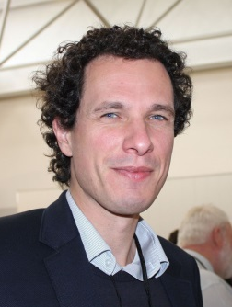 | Stefan HAFFKE (Mr.), Consultant, Bundessortenamt, Osterfelddamm 80, 30627 Hanover  (tel.: +49 511 9566 5649 fax: +49 511 956 69600  e-mail: stefan.haffke@bundessortenamt.de)
italy
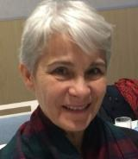 | Chiara DELOGU (Ms.), Researcher, CREA-DC Seed testing Station, Via Emilia 19 KM 307, Lodi, 26838 Tavazzano  (tel.: +39 371 76 19 19 fax: +39 371 76 08 12 e-mail: chiara.delogu@crea.gov.it)
japan
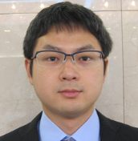 | Hiroshi GOTO (Mr.), Deputy Plant Variety Protection Adviser, Plant Variety Protection Division, Center for Seeds and Seedlings, NARO, 2-2, Fujimoto, Ibaraki, 305-0852 Tsukuba  (tel.: +81 29 838 6589 fax: +81 29 838 6595 e-mail: gotohiro@affrc.go.jp)
netherlands
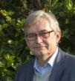 | Bert SCHOLTE (Mr.), Head Department Variety Testing, Naktuinbouw NL, Sotaweg 22, 2371 GD Roelofarendsveen  (tel.: +31 71 332 6167 fax: +31 71 332 6363 e-mail: b.scholte@naktuinbouw.nl)
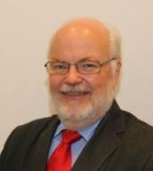 | Kees VAN ETTEKOVEN (Mr.), Senior PVP Policy Advisor, Naktuinbouw NL, Sotaweg 22, 2371 GD Roelofarendsveen  (tel.: +31 61 136 0675 fax: +31 71 332 6363 e-mail: c.v.ettekoven@naktuinbouw.nl)
Hedwich TEUNISSEN (Ms.), Molecular Biologist, Naktuinbouw, Sotaweg 22, 2371 GD Roelofarendsveen
(tel.: 31 71 3326251 fax: 31 71 3326366 e-mail: h.teunissen@naktuinbouw.nl)
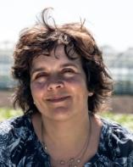 | Amanda VAN DIJK-VELDHUIZEN (Ms.), Specialist Variety testing, Naktuinbouw, Sotaweg 22, P.O. Box 40, 2370 AA Roelofarendsveen  (fax: +31 71 3326366 e-mail: a.v.dijk@naktuinbouw.nl)
poland
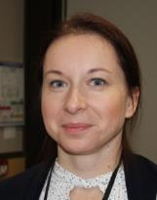 | Beata SZAL (Ms.), Head of Laboratory, Slupia Wielka Experimental Station for Cultivar Testing, COBORU SDOO, 63-022 Slupia Wielka  (tel.: +48 504 219 444 e-mail: beataszal@sdoo.net.pl)
republic of korea
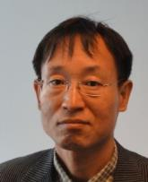 | Seung-In YI (Mr.), Head of Seed Testing and Research Center, Korea Seed and Variety Service (KSVS), 119 Hyeoksin 8-ro, Gimcheon-si, Gyeongsangbuk-do 39660 Republic of Korea  (tel.: +82 54 912 0220 fax: +82 54 912 0277 e-mail: seedin@korea.kr)
spain
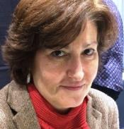 | Nuria URQUÍA (Ms.), Service Chief, Spanish Plant Varieties Office, Calle Almagro 33, 28071 Madrid  (tel.: +34 91 347 4508 e-mail: nurquia@mapama.es)
united kingdom
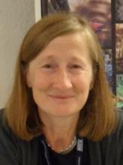 | Elizabeth M.R. SCOTT (Miss), Head of Crop Characterisation, Varieties and Seeds, National Institute of Agricultural Botany (NIAB), Huntingdon Road, Cambridge CB3 0LE  (tel.: +44 1223 342399 e-mail: elizabeth.scott@niab.com)
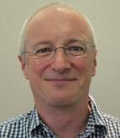 | Alex REID (Mr.), Senior Molecular Biologist, SASA, Roddinglaw Road, Edinburgh EH12 9FJ  (tel.: +44 131 244 8910 fax: +44 131 244 8926 e-mail: alex.reid@sasa.gsi.gov.uk)
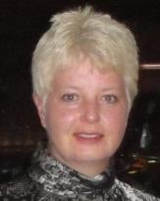 | Cheryl TURNBULL (Ms.), Technical Manager (DUS), Centre for Plant Varieties and Seeds, National Institute of Agricultural Botany (NIAB), Huntingdon Road, Cambridge  (tel.: +44 1223 342291 e-mail: cheryl.turnbull@niab.com)
Margaret WALLACE (Ms.), Technical Manager, (Cereals, Field Beans And Kale) Agricultural Crops Characterisation, National Institute of Agricultural Botany (NIAB), Huntingdon Road, Cambridge CB3 0LE
(tel.: +44 1223 342288 e-mail: margaret.wallace@niab.com)
united states of america
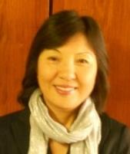 | Ruihong GUO (Ms.), Deputy Administrator, AMS, Science & Technology Program, United States Department of Agriculture (USDA), 1400 Independence Avenue, SW, Room 3542 - South Building, Mail Stop 0270, 20250 Washington D.C.  (tel.: +1 202 720 8556 fax: +1 202 720 8477 e-mail: ruihong.guo@ams.usda.gov)
iI. observers
saudi arabia
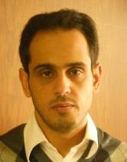 | Marzouq AL AFTAN (Mr.), Patent Examiner, General Directorate of Patents, King Abdulaziz City for Science and Technology (KACST), P.O. Box 6086, Riyadh 11442  (tel.: +966114814654 fax: +966114884351 e-mail: maftan@kacst.edu.sa)
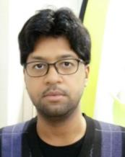 | Fahad AL SWAILIM (Mr.), Patent Examiner, General Directorate of Patents, King Abdulaziz City for Science and Technology (KACST), An Nakhil, Riyadh 11442  (tel.: +966114814161 fax: +966114884351 e-mail: fswailem@kacst.edu.sa)
iiI. organizations
ORGANISATION FOR ECONOMIC CO-OPERATION AND DEVELOPMENT (OECD)
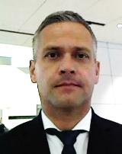 | Csaba GASPAR (Mr.), Programme Manager, OECD Seed Schemes & OECD Forest Seed and Plant Scheme, Organisation for Economic Co-operation and Development (OECD), 2, rue André-Pascal, 75775 Paris Cedex 16, France  (tel.: +33 1 45 24 95 53 fax: +33 1 44 30 61 17 e-mail: csaba.gaspar@oecd.org)
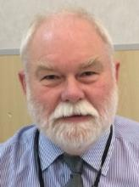 | Gerald HALL (Mr.), Seeds Policy Advisor, Science and Advice for Scottish Agriculture (SASA), Roddinglaw Road, EH12 9FJ Edinburgh , United Kingdom  (tel.: +44 131 244 8856 fax: +44 131 244 8940 e-mail: gerry.hall@sasa.gsi.gov.uk)
CROPLIFE INTERNATIONAL
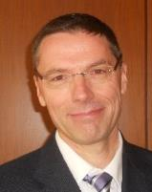 | Marcel BRUINS (Mr.), Consultant, CropLife International, 326, Avenue Louise, Box 35, 1050 Bruxelles , Belgium  (tel.: +32 2 542 0410 fax: +32 2 542 0419 e-mail: mbruins1964@gmail.com)
EUROPEAN SEED ASSOCIATION (ESA)
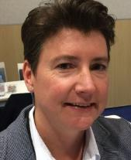 | Petra JORASCH (Ms.), Manager Plant Breeding and Innovation Advocacy, European Seed Association (ESA), Avenue des Arts 52, 1000 Bruxelles , Belgium  (tel.: +32 2 743 2860 e-mail: petrajorasch@euroseeds.eu)
INTERNATIONAL COMMUNITY OF BREEDERS OF ASEXUALLY REPRODUCED ORNAMENTAL AND FRUIT PLANTS (CIOPORA)
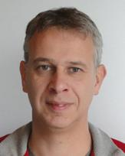 | Jan DE RIEK (Mr.), Molecular Genetics & Breeding - Group Leader, ILVO-Plant, Applied Genetics and Breeding Institute for Agricultural and Fisheries Research, Caritasstraat 21, 9090 Melle , Belgium  (tel.: +32 9 272 2881 fax: +32 9 272 2901 e-mail: jan.deriek@ilvo.vlaanderen.be)
INTERNATIONAL SEED FEDERATION (ISF)
Dennis JOHNSON (Mr.), Seed Health Manager, International Seed Federation (ISF), chemin du Reposoir 7, 1260 Nyon, Switzerland
(e-mail: d.johnson@worldseed.org)
SEED ASSOCIATION OF THE AMERICAS (SAA)
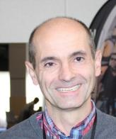 | Frédéric ACHARD (Mr.), Germplasm scientist, 700 Chesterfield PKWY, Chesterfield, MO 63017United States of America  (tel.: 1-314-403-0222 e-mail: fred@achard.us)
Barry K. NELSON (Mr.), Research Scientist, Pioneer Hi-Bred International Inc., 7300 N.W. 62nd avenue, Johnston IA 50131, United States of America
(tel.: 1 515 535 2202 fax: 1 515 535 3934 e-mail: barry.nelson@pioneer.com)
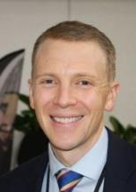 | Paul T. NELSON (Mr.), Corn Breeder, Monsanto, 700 Chesterfield PKWY, Chesterfield, MO 63017, United States of America  (tel.: +1 712 262 1804 fax: +1 712 262 1806 e-mail: paul.t.nelson@monsanto.com)
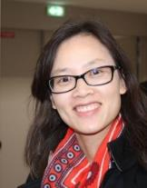 | Jin XIONG (Ms.), Quantitative Geneticist, Dow AgroSciences, 9330 Zionsville Road, Indianapolis, Indiana46268, United States of America  (tel.: +1 317 337 7120 fax: +1 317 337 5989 e-mail: jinxiong@gmail.com)
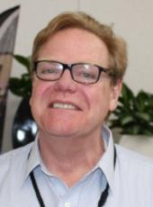 | Carlos AZAMBUJA (Mr.), Director, GENIA - Laboratory of molecular biology, Zonamerica, Ruta 8, km 17,500, Biotec local 012, MONTEVIDEO, Uruguay  (tel.: +598 25182044 fax: +598 25182044 e-mail: azambuja@geniageo.com)
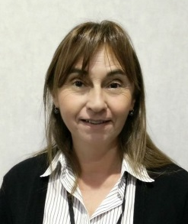 | Mirta ANTONGIOVANNI (Ms.), Manager Global of Regulatory Affair and Register of Varieties, Ruta 7. km 208, Chacabuco, Buenos Aires, Argentina  (tel.: +54 2364646124 e-mail: mantongiovanni@gmseeds.com)
IV. OTHER PARTICIPANTS
bayer
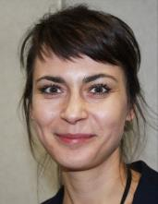 | Monika SLAWIAK (Ms.), Molecular Quality Assurance Senior Scientist, Bayer Vegetable Seeds, Napoleonsweg 152, 6083 AB Nunhem, Netherlands  (tel.: +31 (0) 475 599 374 e-mail: monika.slawiak@bayer.com)
euralis
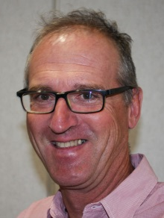 | Philippe (Mr.), Head Breeding support, EURALIS, Chemin de Panedautes, Mondonville, 31700 Blagnac, France  (tel.: +33 5 62 13 64 30 e-mail: philippe.moreau@euralis.com)
V. OFFICER
 |  | Kees van Ettekoven (Mr.), Chair
VI. OFFICE OF UPOV
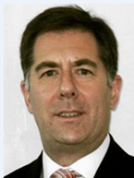 |  | Mr. Peter BUTTON (Mr.), Vice Secretary-General, International Union for the Protection of New Varieties of Plants (UPOV) Chemin des Colombettes 34, 1211 Geneva 20, Switzerland  (e-mail: peter.button@upov.int)
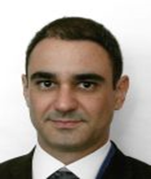 |  | Leontino TAVEIRA (Mr.), Technical/Regional Officer (Latin America/Carribean), International Union for the Protection of New Varieties of Plants (UPOV), Chemin des Colombettes 34, 1211 Geneva 20, Switzerland  (tel.: +41 22 338 8426 fax: +41 22 733 0336 e-mail: leontino.taveira@upov.int)
Tomochika MOTOMURA (Mr.), Technical/Regional Officer (Asia), International Union for the Protection of New Varieties of Plants (UPOV), Chemin des Colombettes 34,
1211 Geneva 20, Switzerland
(tel.: +41 22 338 7442 fax: +41 22 733 0336 e-mail: tomochika.motomura@upov.int)
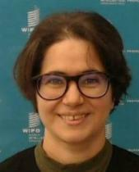 |  | Hend MADHOUR (Ms.), Data Modeler, International Union for the Protection of New Varieties of Plants (UPOV), Chemin des Colombettes 34,  1211 Geneva 20, Switzerland  tel.: +41 22 338 8352 fax: +41 22 733 0336 e-mail: hend.madhour@upov.int)
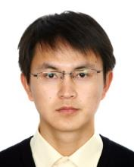 |  | Chao DENG (Mr.), Intern, International Union for the Protection of New Varieties of Plants (UPOV), Chemin des Colombettes 34, 1211 Geneva 20, Switzerland  (tel.: +41 22 338 9980 fax: +41 22 733 0336 e-mail: chao.deng@upov.int)

[Annex II follows]

BMT/16/29

ANNEX II

opening remark by Mr. Fréderic Malterre, Direction générale de l'alimentation, Ministère de l’agriculture et de l’alimentation, France

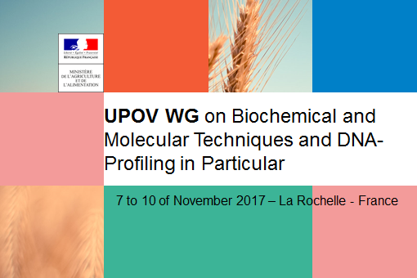

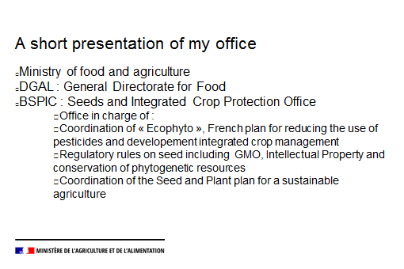

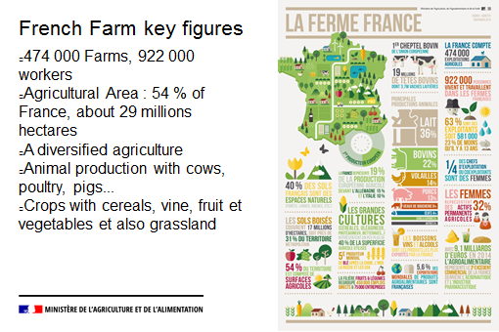

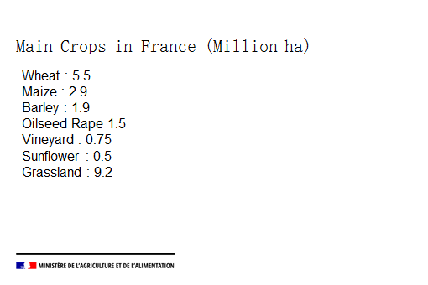
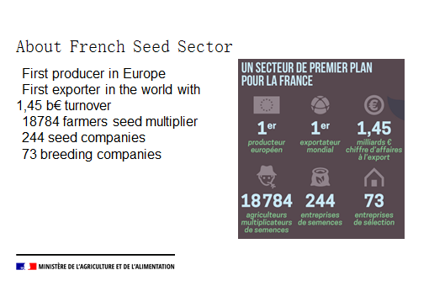

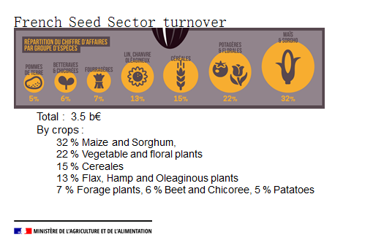
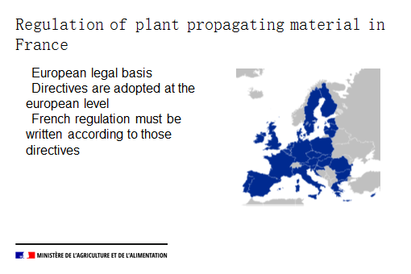

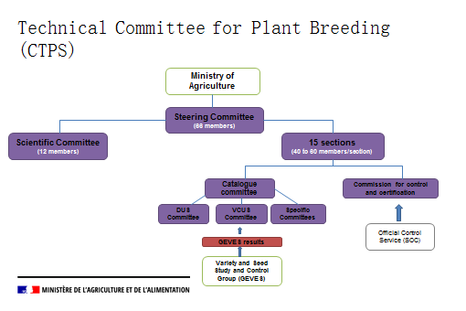

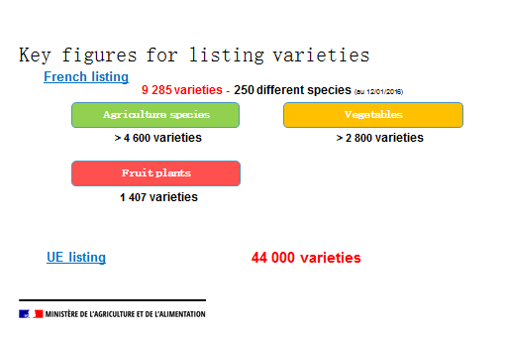

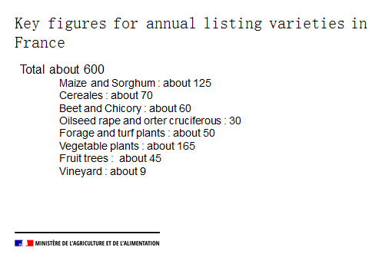

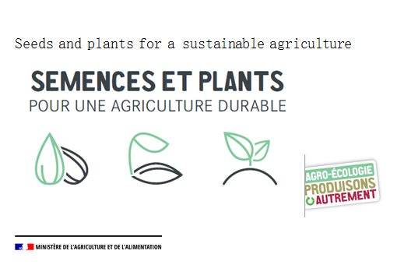

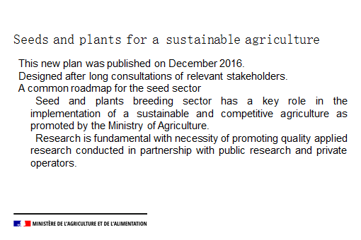

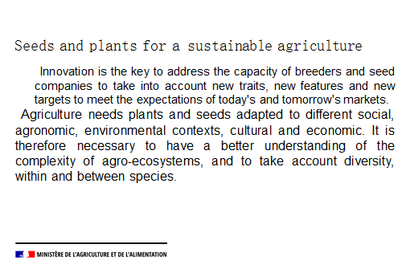

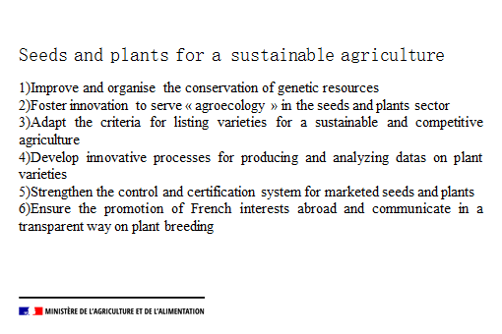

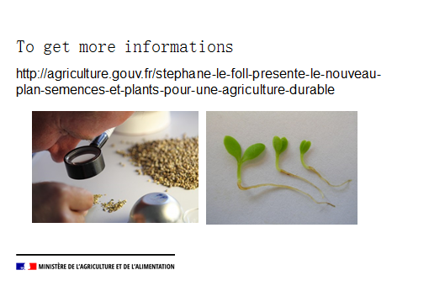

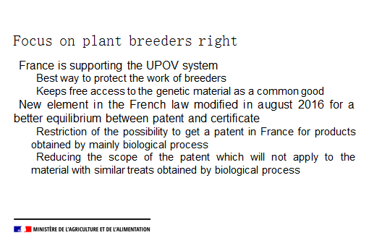
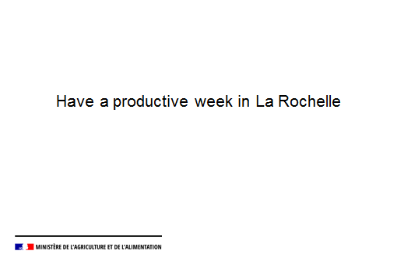

[Annex III follows]

BMT/16/29

ANNEX Iii

opening remark by Mr. Christian Huyghe, Directeur Scientifique Agriculture,
Institut national de recherche agronomique (INRA), France

UPOV BMT16

Christian Huyghe welcom address
Opening session of UPOV BMT 16; 7th of November 2017, La Rochelle, France

Welcome:

Thank you to René Mathis and his team for organizing this meeting and for inviting me to give you this welcome address
My responsibilities are:
-Scientific Director for Agriculture at INRA
-President of the Administrative Board of GEVES
-Chairman of the Scientific Committee of the CTPS

About INRA:

-Founding member of GEVES
-First european research organization in Agriculture
-2nd research organization in Agriculture in the world
-3 pillars: Agriculture (>50%), Food and Environment
-Staff : 8000 permanent members of staff
13000 staff when including PhD, post-doc and associated researchers in UMR
Organisation:
13 scientific divisions
One dedicated to genetics and plant breeding with 1000 staff and many joint research with agronomy and crop protection divisions.
12 experimental units for running trials and short- or long-term experiments
One research unit, in economics department with a special focus on strategy of plan breeding companies and role of intellectual property regime.
Scientific production:
1,4 papers per scientist in BAP (Plant Biology and Breeding), 54% international co-authorship
1,7 papers per scientist in EA (Agronomy and Environment) and SPE (Plant health and environment)
5000 scientific papers per year (5123 in 2016),
50% in international co-authorship

Plant Breeders right is a key issue for plant breeding

Regulations are a main component of any innovation ecosystem
Stability of regulations proved to be a determining factor for investment!
Combined with the national catalogue and the registration procedures, it ensures the genetic gains to better meet the expectations of farmers/consumers/supply chain.
Getting back to the founding concept of plant breeders rights:
-It considers the genetic background as a common good
Nagoya treaty is not fully on line with this view
This should be better underlined
Open science!
-It creates the conditions to maximize the genetic gain rate
-It gives the same opportunities to all countries all around the world
Accessible technologies
What are going to be the accessible

And now?

New technologies for describing/ characterizing varieties
-When PBR concept was established in 1961, DNA had just been discovered and phenotyping was the only technology accessible to all.
-Molecular markers
-Sequencing and GBS
New methodologies for creation
-Genomic selection
-NBT
-Tracing the creation methods?
-VCUS: Describing the phenotype and the ecosystemic services
-PBR: what are the patents on the obtention methods?

I wish you

Fruitful discussions
Sharing the most recent progresses in relevant technologies
Having in mind the possible uses for plant protection with the maximization of the services to all:
-Acknowledging genetic gains while ensuring free access to genetic diversity
-Common views and common possibilities to all countries all around the world
-Long term vision !

[Annex IV follows]

BMT/16/29

ANNEX Iv

opening remark by Mr. Arnaud Deltour, Directeur général, Groupe d’étude et de contrôle des variétés et des semences (GEVES), France

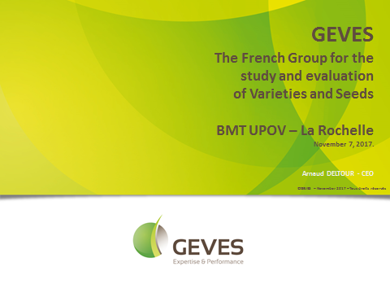

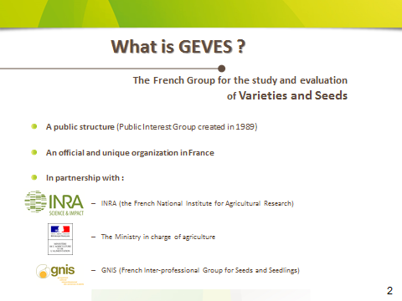

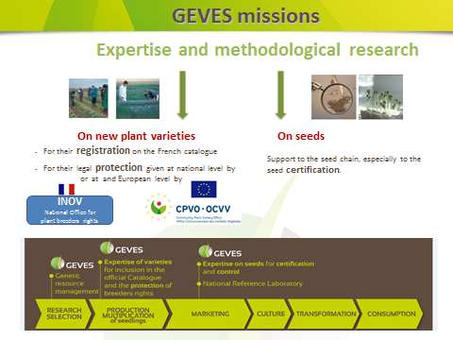

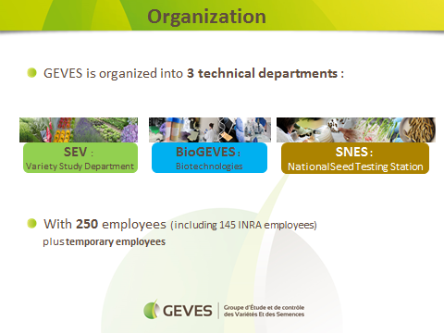
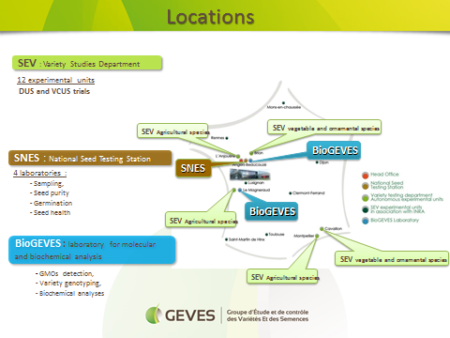

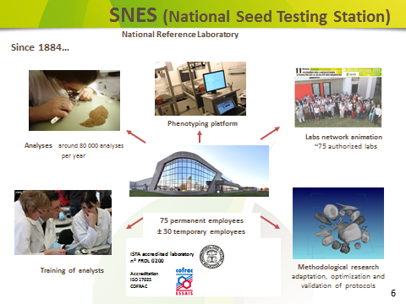
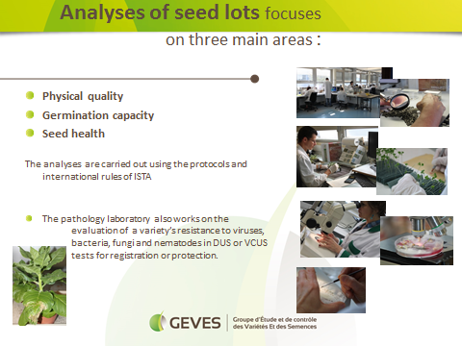

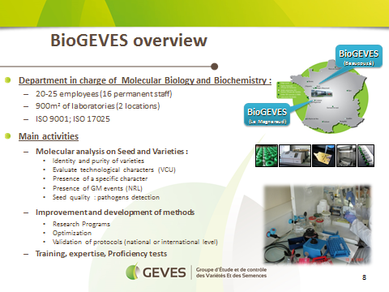
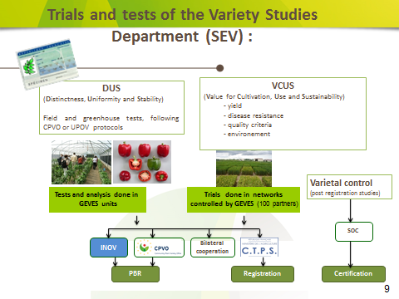

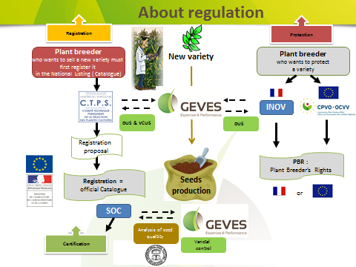
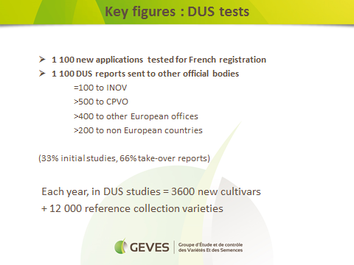

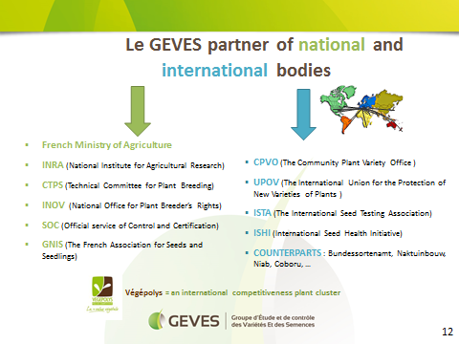
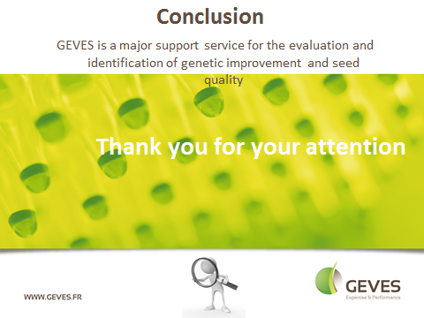

[Annex V follows]

BMT/16/29

ANNEX v

opening remark by Ms. Anne Lise Corbel, Responsible for DUS,
GEVES - Variety sector, France

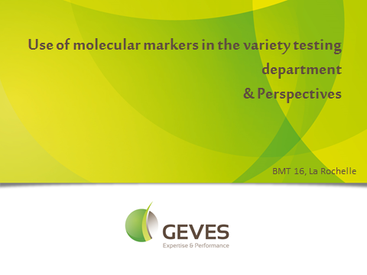

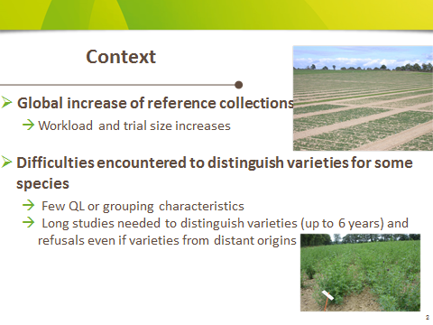

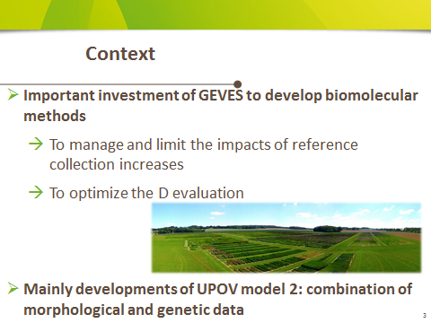

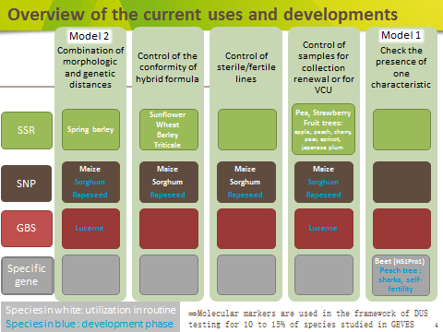

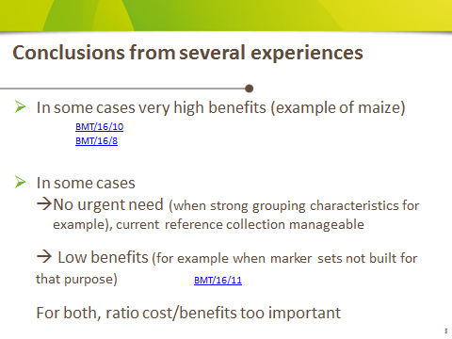

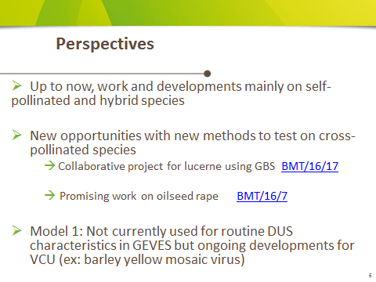

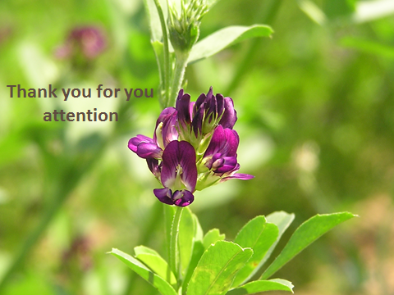

[Annex VI follows]

BMT/16/29

ANNEX VI

PRESENTATION BY MR. JEAN-FRANÇOIS ODOUX AND MR. PIERRICK AUPINEL,
INSTITUT NATIONAL DE RECHERCHE AGRONOMIQUE (INRA), FRANCE

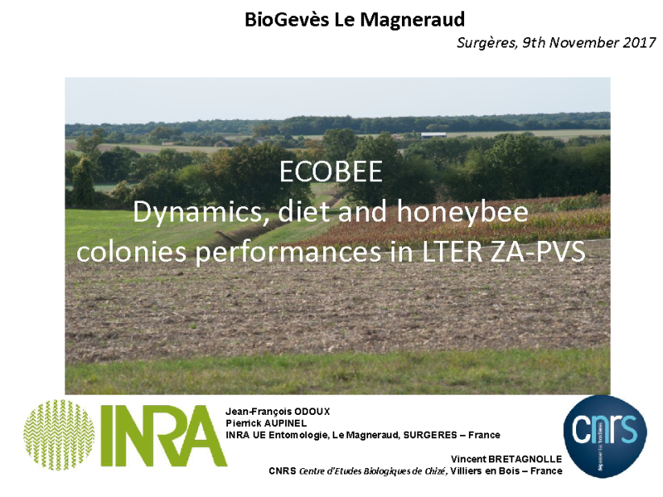

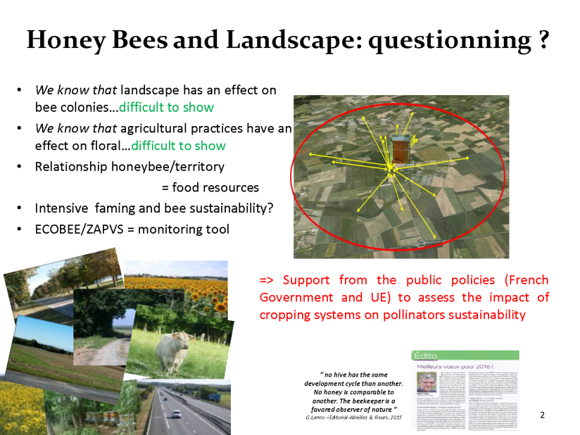
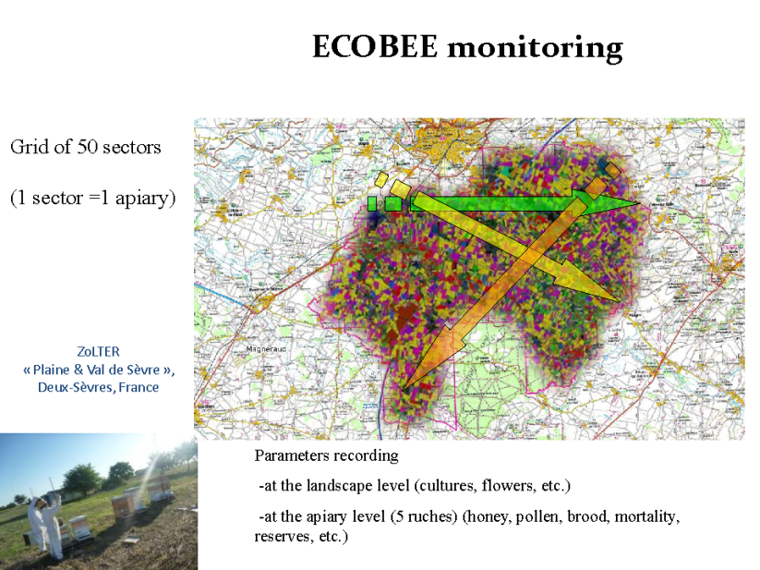

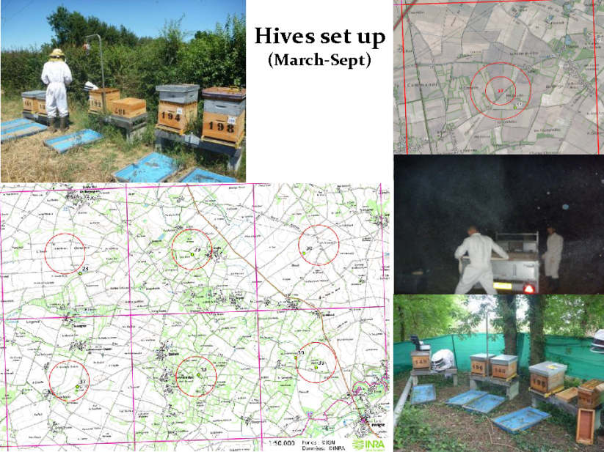

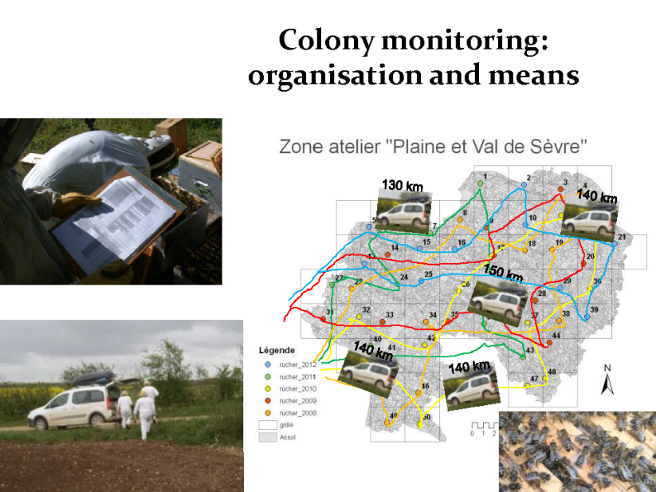

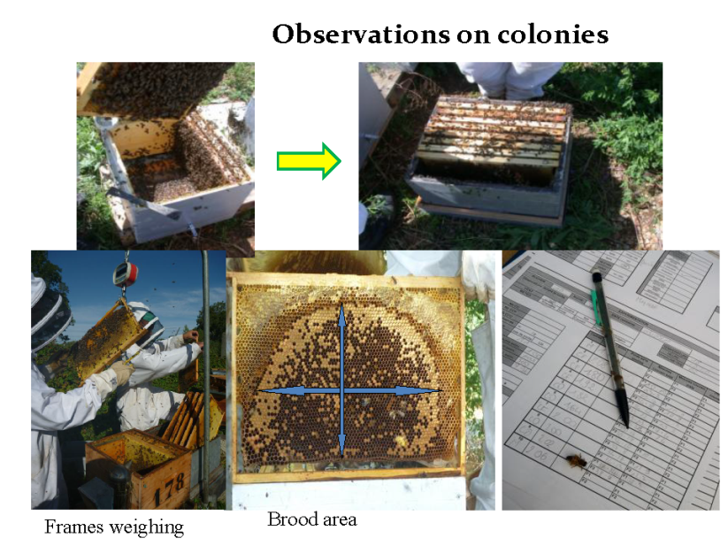

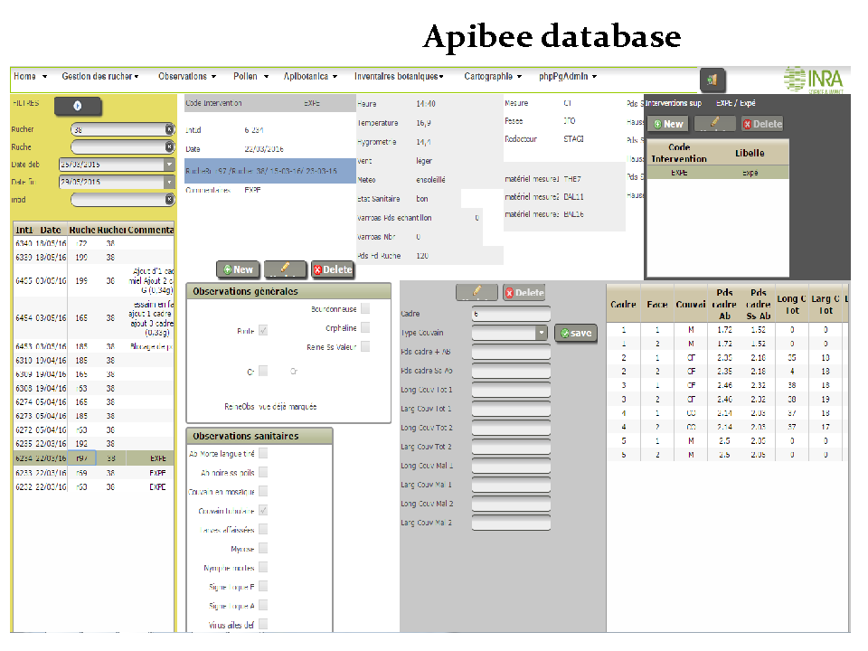

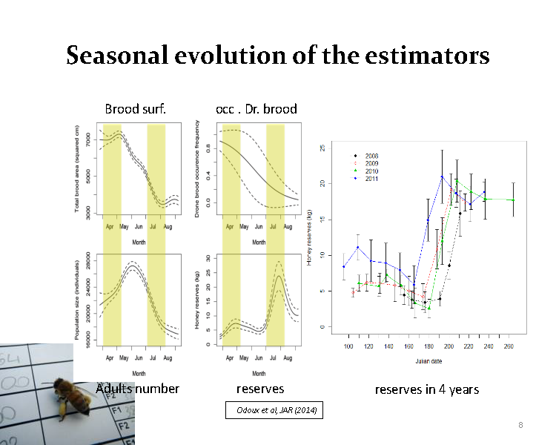

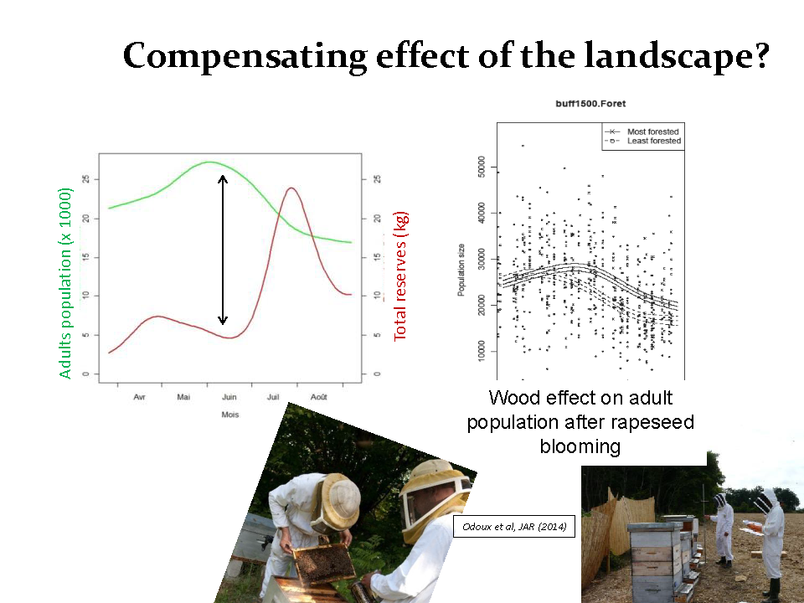

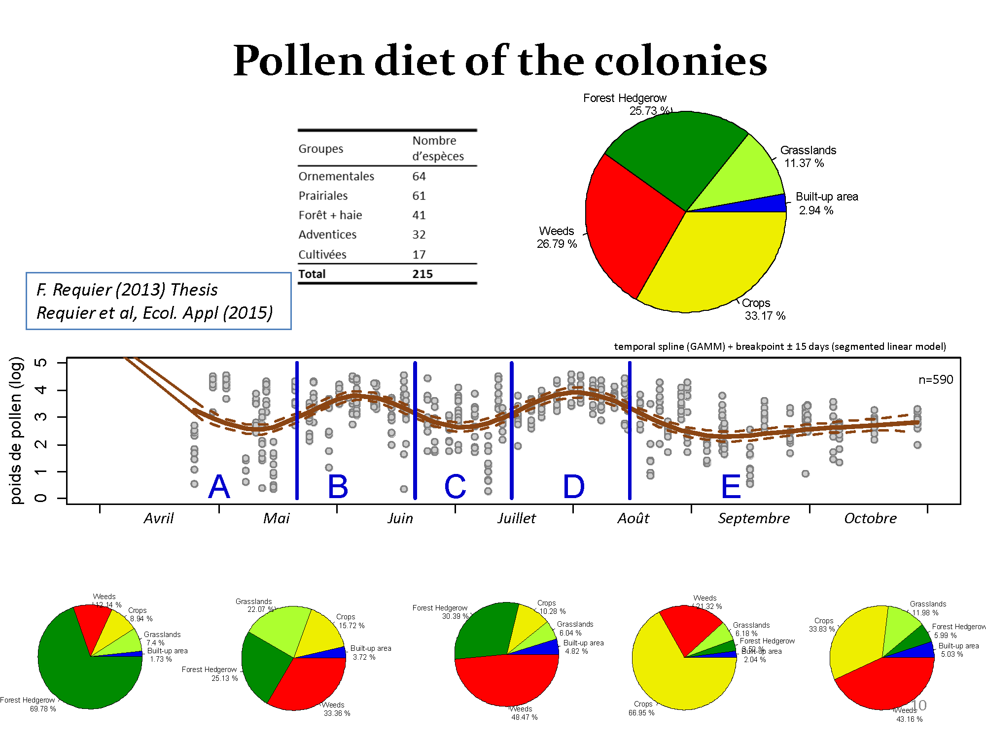

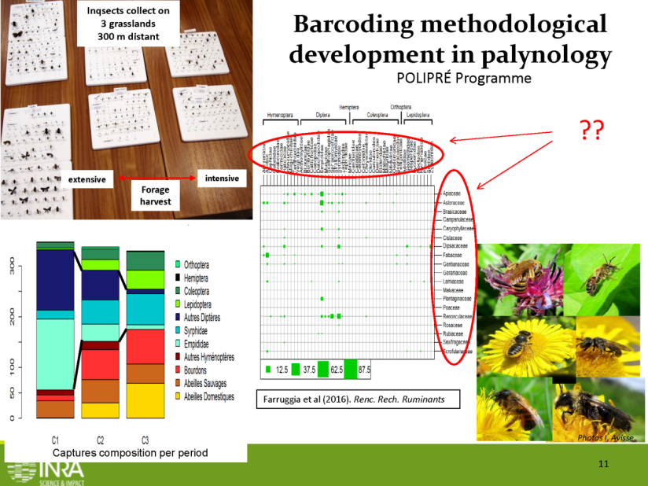

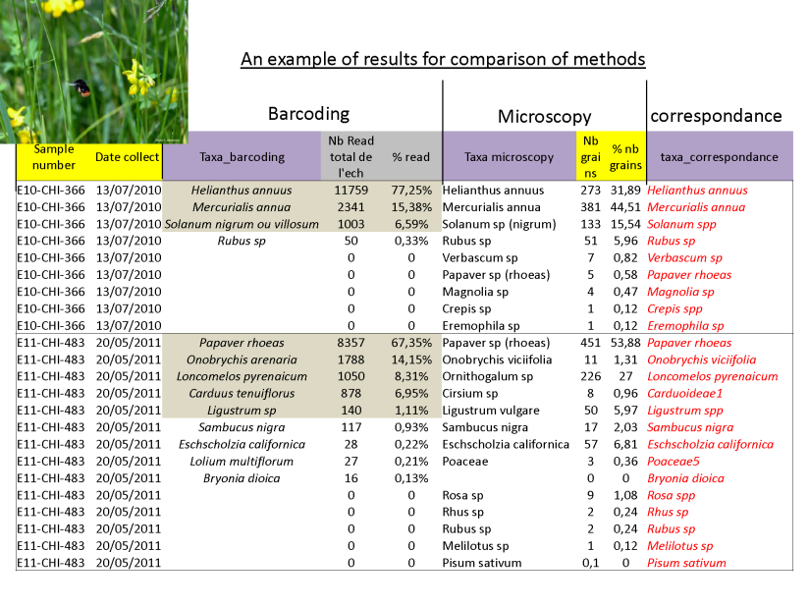

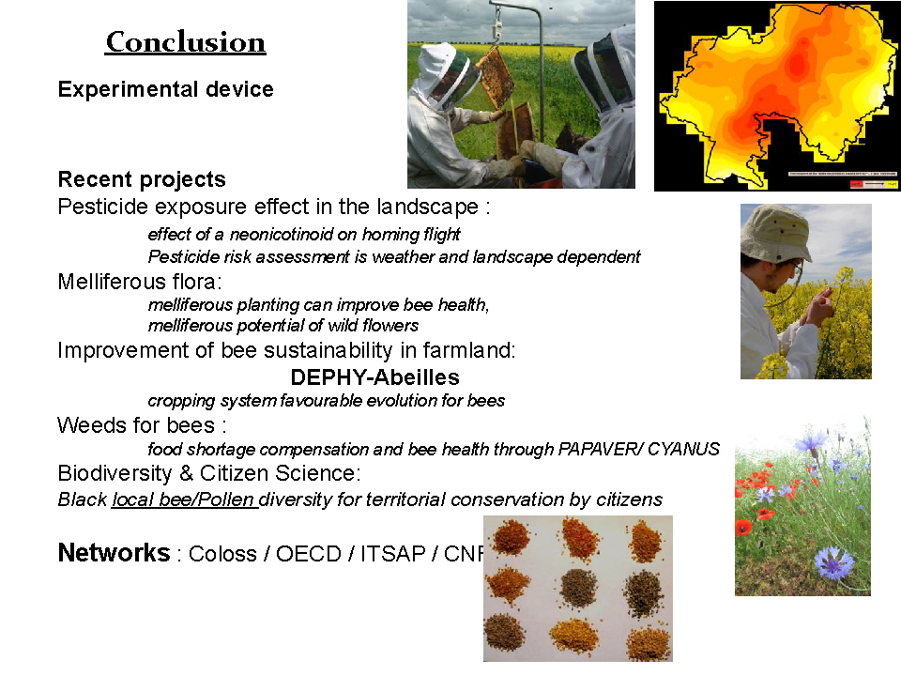

[End of Annex VI and of document]

Breeders’ Day

