E
International Union for the Protection of New Varieties of Plants

Working Group on Biochemical and Molecular Techniques  and DNA-Profiling in Particular  Sixteenth Session  La Rochelle, France, November 7 to 10, 2017 | BMT/16/28  Original: English  Date: November 6, 2017
confirmation of validation for dna variety identification technique
Document prepared by an expert from Japan
Disclaimer: this document does not represent UPOV policies or guidance
The Annex to this document contains a copy of a presentation on “Confirmation of validation for DNA variety identification technique”, prepared by an expert from Japan, to be made at the sixteenth session of the Working Group on Biochemical and Molecular Techniques and DNA Profiling in Particular (BMT).

[Annex follows]

Confirmation of validation for DNA variety identification technique

Presentation prepared by an expert from Japan

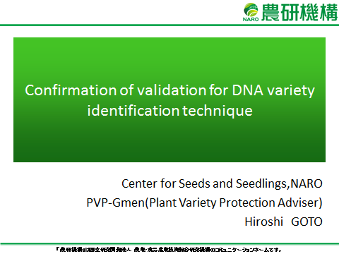

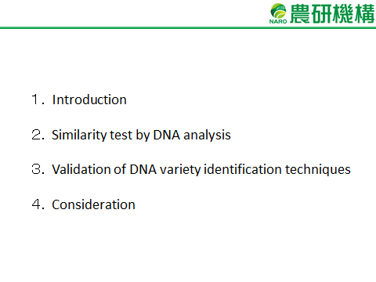

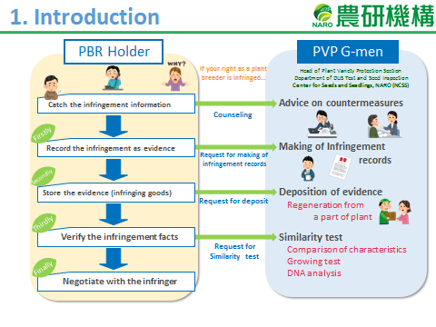

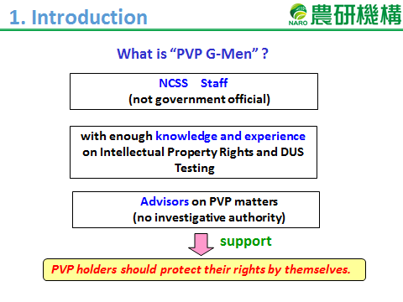

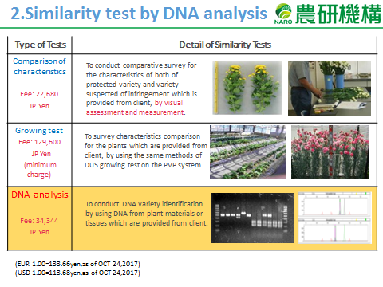

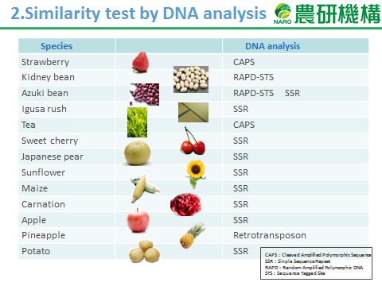

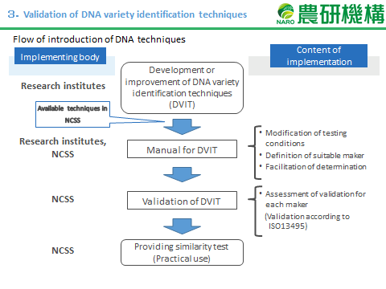

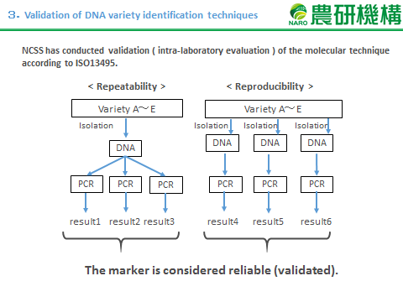

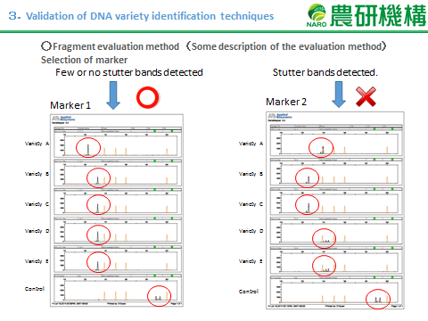

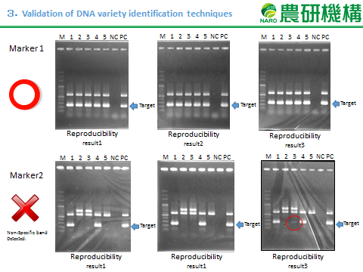

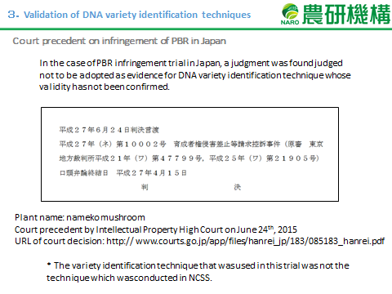

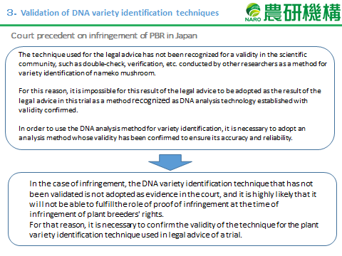

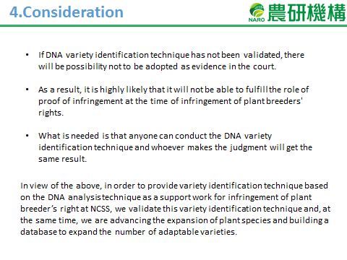

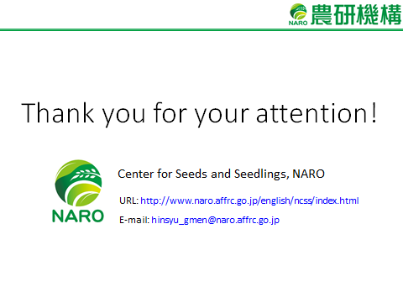

[End of Annex and of document]

