E
International Union for the Protection of New Varieties of Plants

Working Group on Biochemical and Molecular Techniques  and DNA-Profiling in Particular  Sixteenth Session  La Rochelle, France, November 7 to 10, 2017 | BMT/16/21  Original: English  Date: November 6, 2017
Integration of molecular data into DUS testing in Durum Wheat: Use of a standardized method for the efficient management of reference collections
Document prepared by experts from Austria
Disclaimer: this document does not represent UPOV policies or guidance
The Annex to this document contains a copy of a presentation on “Integration of molecular data into DUS testing in Durum Wheat: Use of a standardized method for the efficient management of reference collections”, prepared by experts from Austria, to be made at the sixteenth session of the Working Group on Biochemical and Molecular Techniques and DNA-Profiling in Particular (BMT).

[Annex follows]

Integration of molecular data into DUS testing in Durum Wheat: Use of a standardized method for the efficient management of reference collections

Presentation prepared by experts from Austria

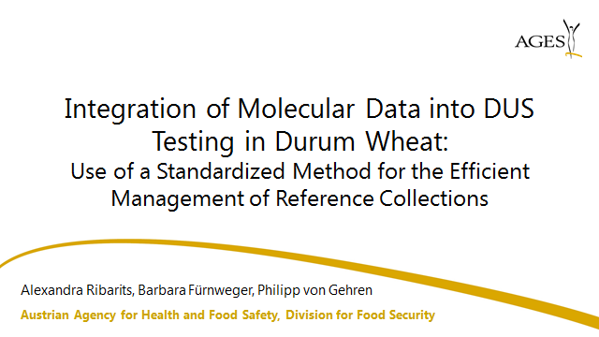

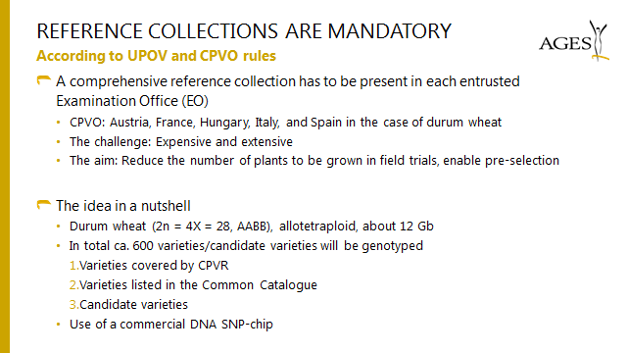

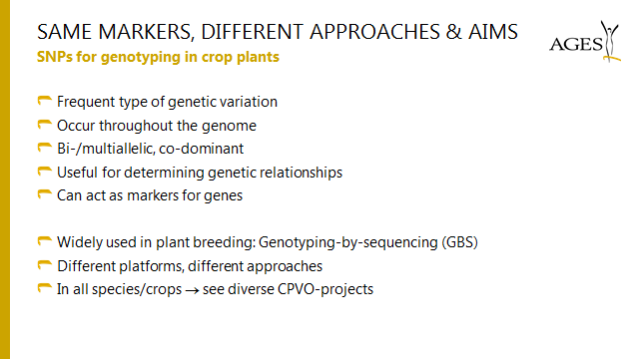

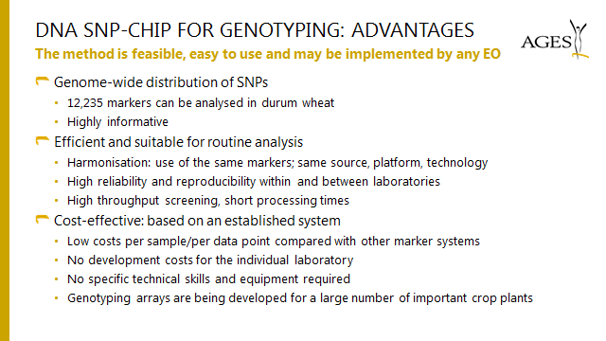

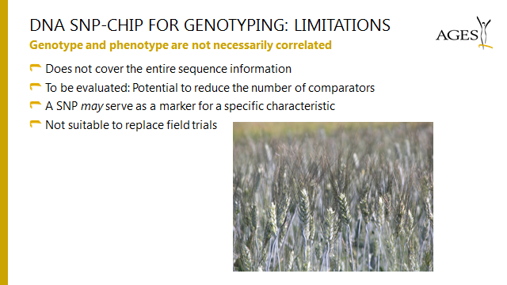

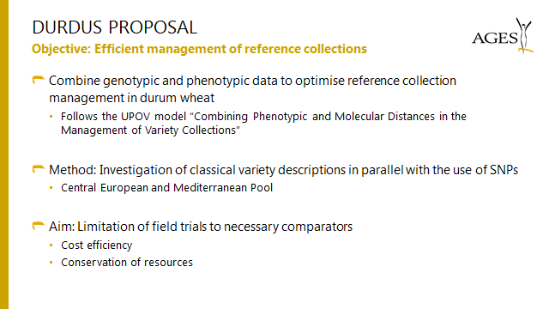

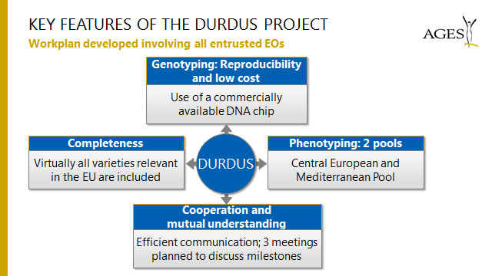

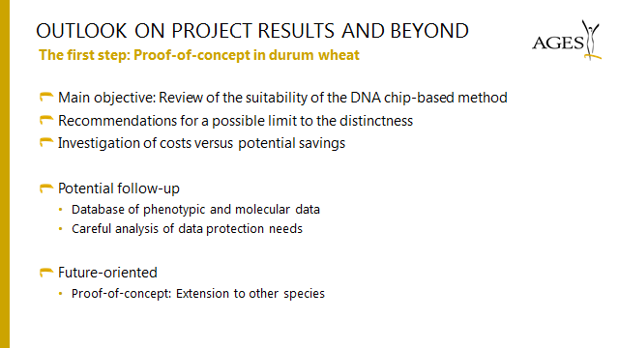

[End of Annex and of document]

