E
International Union for the Protection of New Varieties of Plants

Working Group on Biochemical and Molecular Techniques  and DNA-Profiling in Particular  Sixteenth Session  La Rochelle, France, November 7 to 10, 2017 | BMT/16/19  Original: English  Date: October 30, 2017
Genetic selection of similar varieties for the first growing cycle: example French bean
Document prepared by an expert from the Netherlands
Disclaimer: this document does not represent UPOV policies or guidance
Normally, a DUS test in French bean (Phaseolus vulgaris L.) takes 2 growing cycles. This is described in TG/12/9 Rev. 2. These Test Guidelines consist of 49 characteristics for dwarf bean and 49 characteristics for climbing bean, of which 5 characteristics are resistances.

Nine characteristics are considered to be useful grouping characteristics. 350 to 400 varieties are known to be in one of the groups: dwarf plant, white flower, round, green pod without string, white seed, resistant to BCMNV. Physically it is not practically feasible to put all these varieties in the field trial, and to make side by side comparisons is impossible.

Based on the information of the breeder in the TQ of a new candidate the examination office selects from the large group of possible similar varieties a smaller set. At a national level extra characteristics may be added to the TQ to gain more information. However, the information of the breeder is not always complete and not always reflecting the morphology of the variety in the environment of the examination office, especially in case of quantitative characteristics. Therefore, all information in the TQ must be treated carefully. A DUS expert in French bean needs 2 to 3 hours to select from the database with morphological descriptions a smaller set of similar varieties from the 350+.

The second growing cycle is used to confirm the differences between the closest similar variety and the candidate. Quite often it happens that in the first growing cycle the right similar varieties had not been selected, due to misinformation in the TQ. This may lead to 3 years of testing, instead of 2.

The first selection of similar varieties can be performed more efficiently by using genotypic information of the candidate. Only genetically close varieties will be put in the field trial. After the first growing cycle a second selection takes place by comparing the complete description made by the examination office in year 1 with all descriptions of known varieties. This second selection takes much less time than the traditional first selection, as one can discard influences caused by deviations from the TQ. In the second growing cycle the candidate is put in the field with the closest similar variety from the first year and with all similar varieties from the second selection ‘on paper’. It is known that the candidate is genetically clearly distinct from all these similar varieties and this supports a positive decision on distinctness after the second growing cycle.

Naktuinbouw has a large DNA database of French bean varieties. It consists of AFLP profiles, by 4 primers giving 78 polymorphic bands. Genetic similarities between all varieties are calculated (Jaccard). In the near future a shift will be made to a SNP database. Any validated DNA technique could be used.

Application of the ‘genetic selection’ in 2015 and 2016 resulted in a reduction of 60% of the varieties to be put in the field. One of 14 candidates was declared distinct after 1 year of trials. For none of the 14 candidates a 3rd growing cycle was needed. The process of selection of similar varieties from the morphological database takes less time (about 2 hours less per candidate) and the quality of the side-by-side comparison in the field is better when a lower number of varieties have to be compared.

The proposal is to use this method of genetic first selection for any crop with normally two years of testing when a DNA database and a morphological database are available.

The Annex to this document contains a copy of a schematice overview of this proposal.

Amanda van Dijk-Veldhuizen, Specialist Variety testing, Naktuinbouw

[Annex follows]

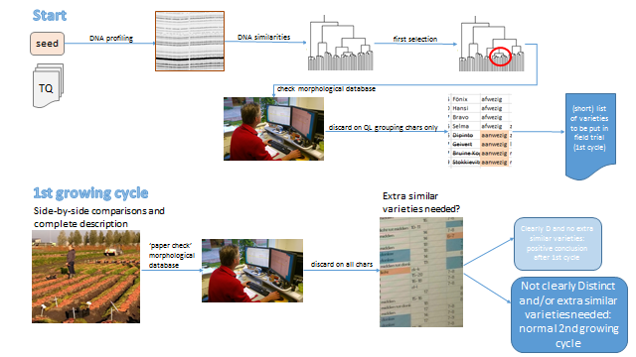

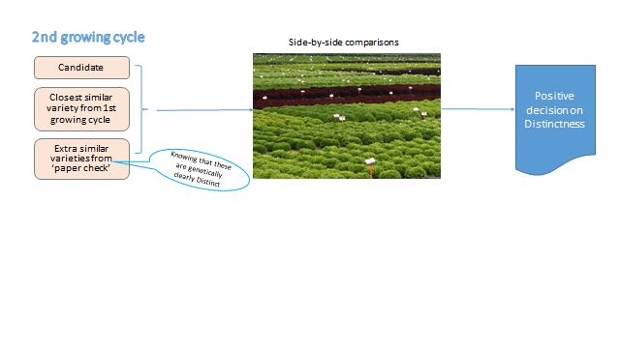

[End of Annex and of document]

