E
International Union for the Protection of New Varieties of Plants

Working Group on Biochemical and Molecular Techniques  and DNA-Profiling in Particular  Sixteenth Session  La Rochelle, France, November 7 to 10, 2017 | BMT/16/18  Original: English  Date: October 17, 2017
assignment tests for genotype classification
Document prepared by experts from the Flanders Research Institute for Agriculture, Fisheries and Food (ILVO)
Disclaimer: this document does not represent UPOV policies or guidance
The Annex to this document contains a copy of a presentation “Assignment Tests for Genotype Classification” to be made at its sixteenth session of the Working Group on Biochemical and Molecular Techniques and DNA-Profiling in particular (BMT).

[Annex follows]

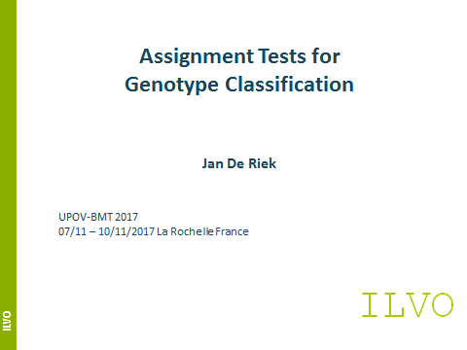

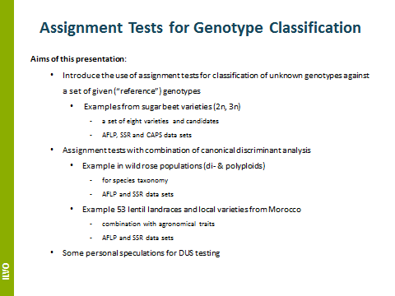

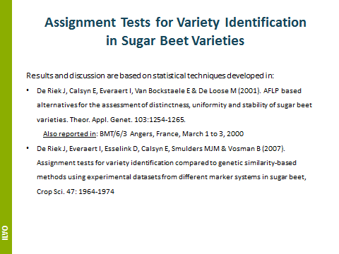

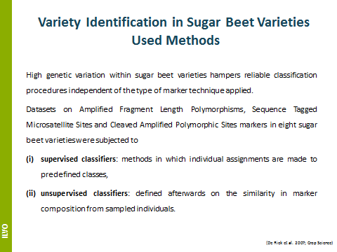

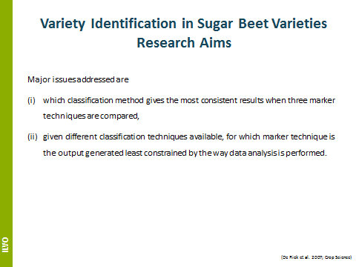

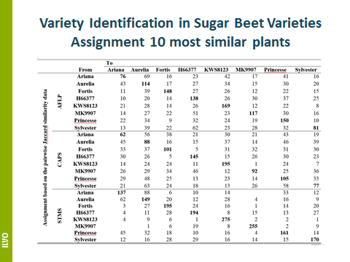

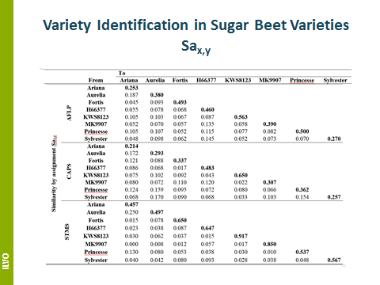

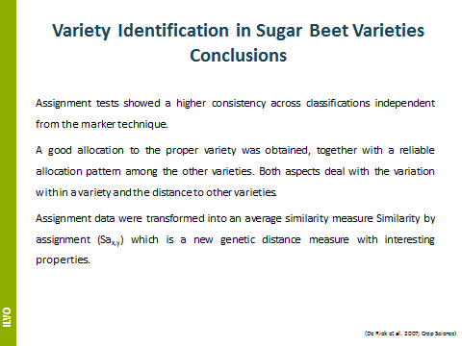

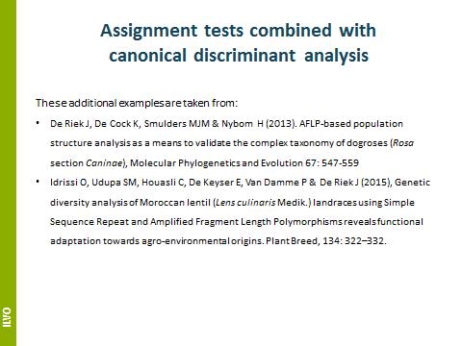

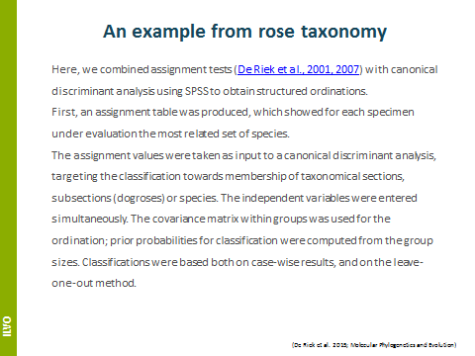

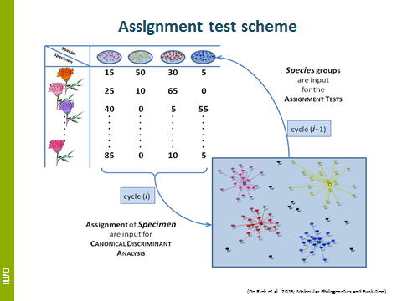

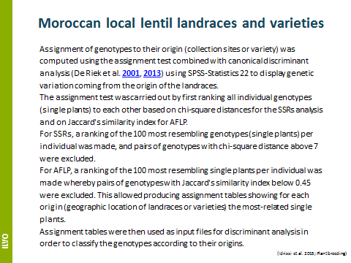

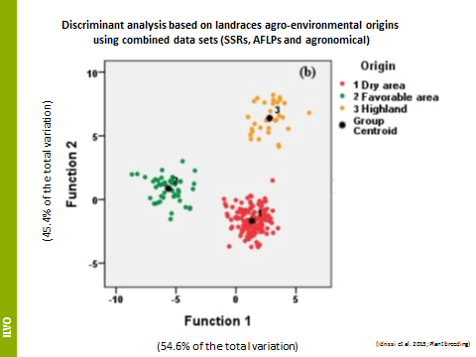

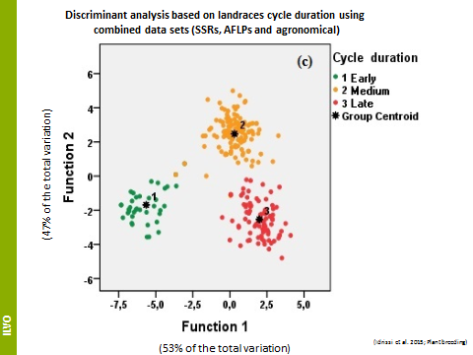

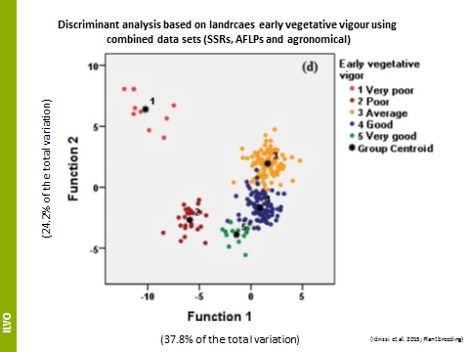

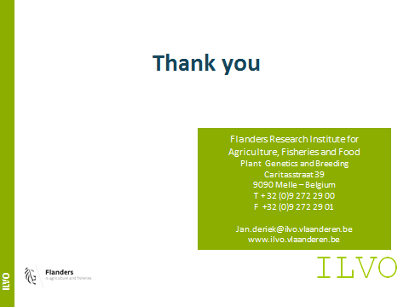

[End of Annex and of document]

