E
International Union for the Protection of New Varieties of Plants

Working Group on Biochemical and Molecular Techniques  and DNA-Profiling in Particular  Sixteenth Session  La Rochelle, France, November 7 to 10, 2017 | BMT/16/13  Original: English  Date: November 2, 2017
dna techniques and variety identification – 2017 evaluation
Document prepared by experts from the Netherlands
Disclaimer: this document does not represent UPOV policies or guidance
The Annex to this document contains a copy of a presentation on “DNA techniques and Variety Identification – 2017 evaluation”, prepared by experts from the Netherlands, to be made at the sixteenth session of the Working Group on Biochemical and Molecular Techniques and DNA-Profiling in Particular.

[Annex follows]

DNA TECHNIQUES AND VARIETY IDENTIFICATION – 2017 EVALUATION

Presentation prepared by experts from the Netherlands

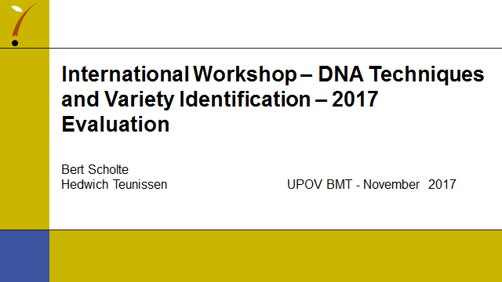

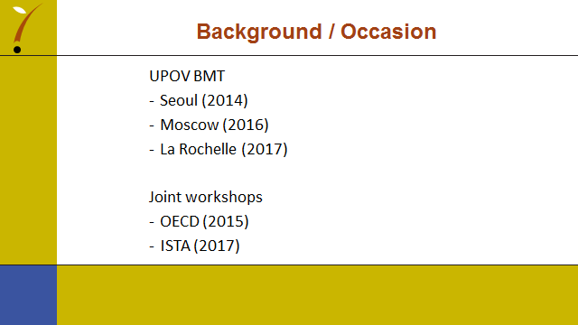

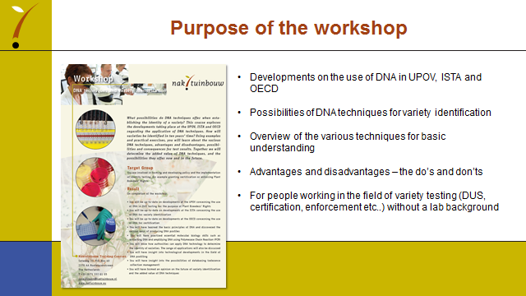

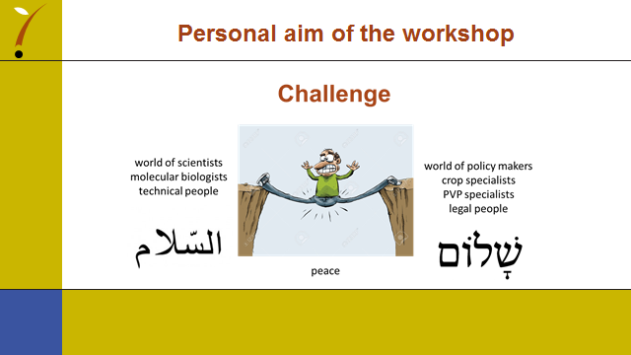

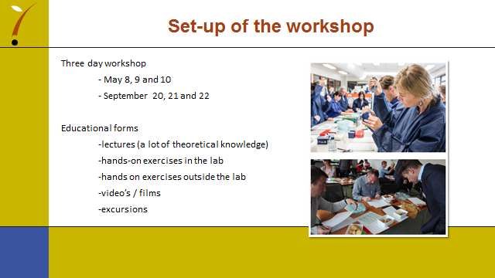

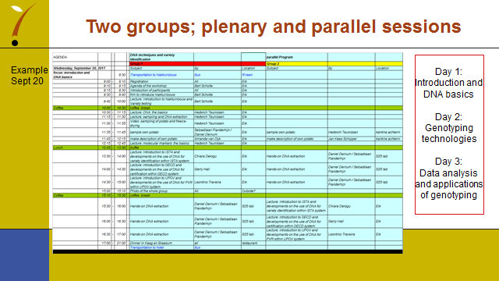

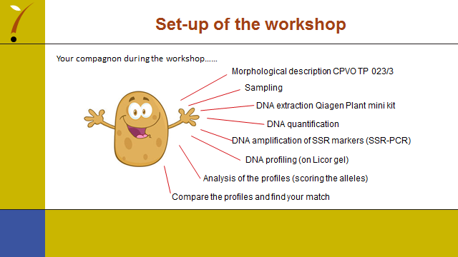

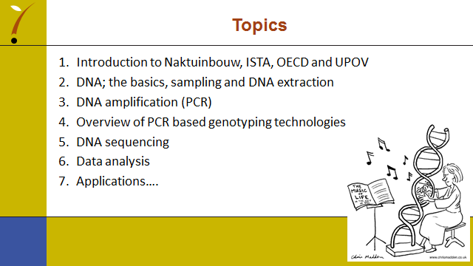

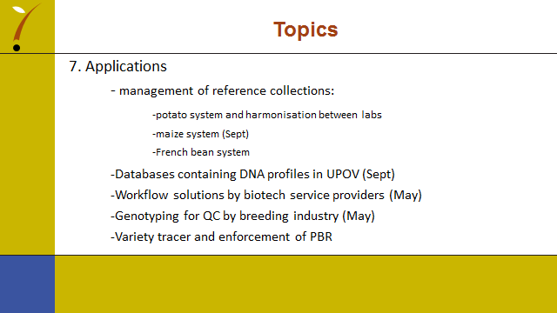

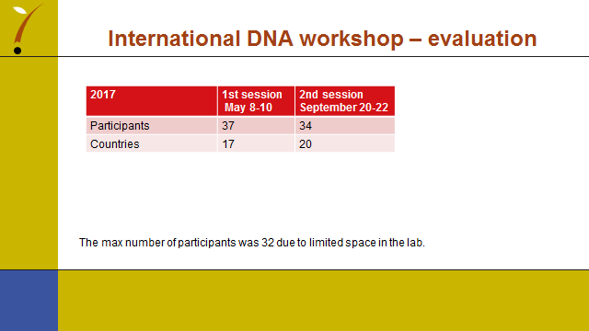

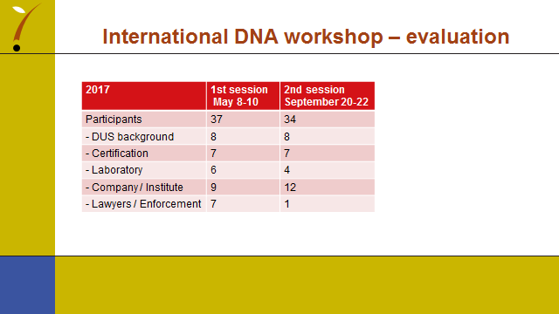

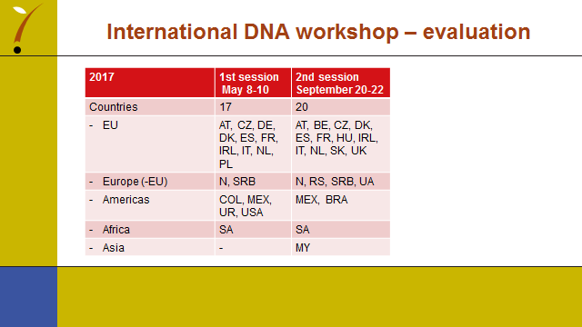

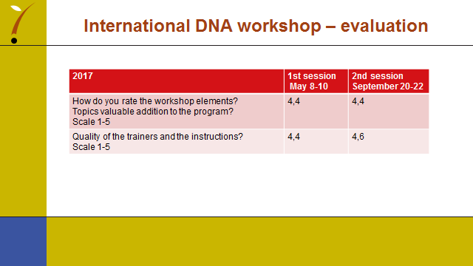

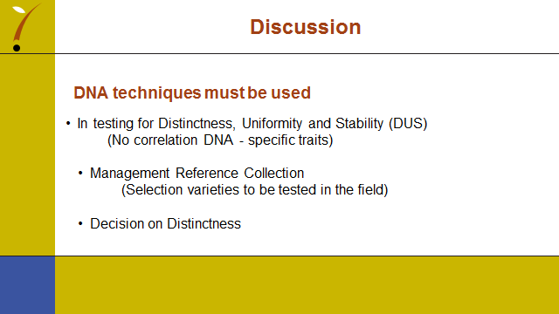

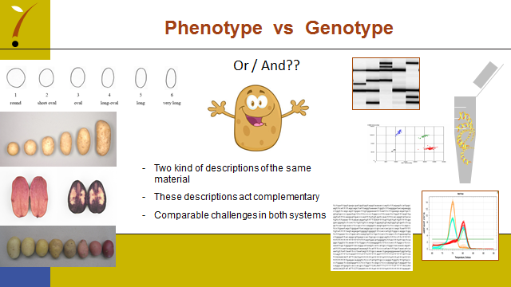

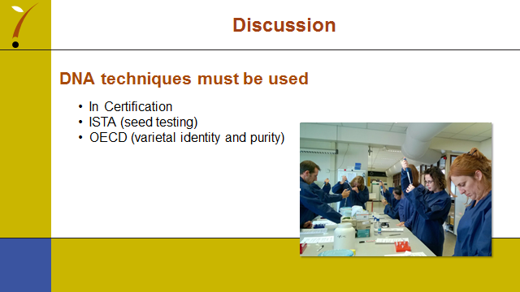

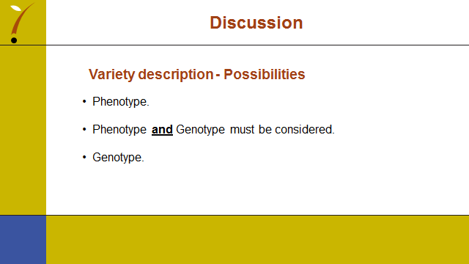

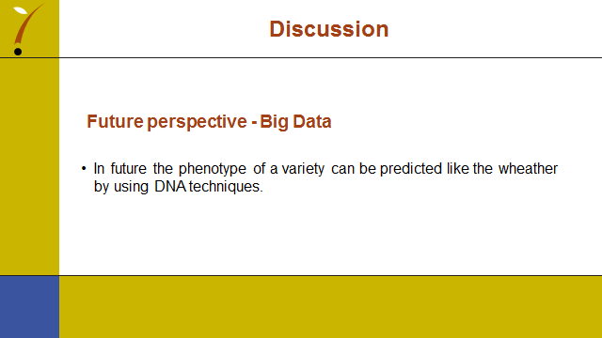

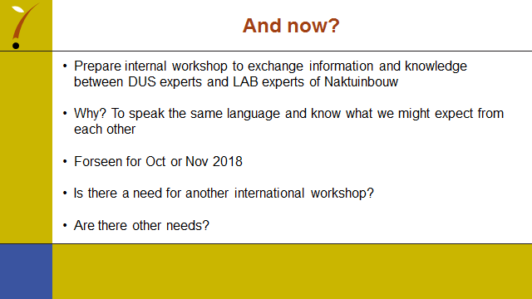

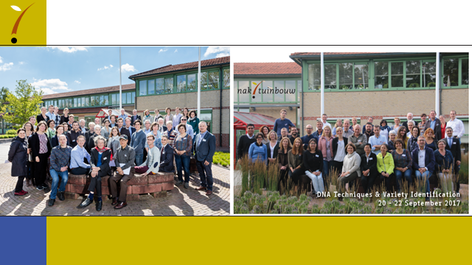

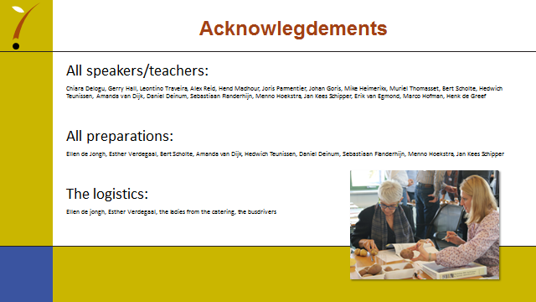

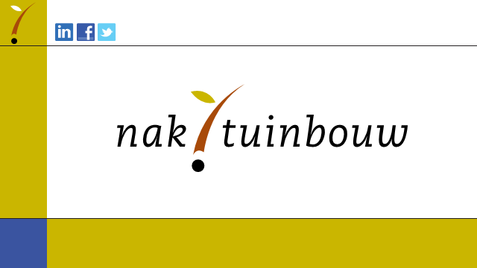

[End of Annex and of document]

