E
International Union for the Protection of New Varieties of Plants

Working Group on Biochemical and Molecular Techniques  and DNA-Profiling in Particular  Sixteenth Session  La Rochelle, France, November 7 to 10, 2017 | BMT/16/11  Original: English  Date: October 17, 2017
AN ATTEMPT TO USE MOLECULAR MARKERS FOR WINTER WHEAT REFERENCE COLLECTION MANAGEMENT
Document prepared by an expert from France
Disclaimer: this document does not represent UPOV policies or guidance
Some years ago, a set of SSR markers was selected by GEVES in the framework of varietal control. Considering the availability of this set and the large size of the reference collection of winter wheat to manage, GEVES decided to look at the possibility to combine phenotypic and genetic distances for the management of its reference collection. This method had already been developed in France for Spring barley.

The results of this study show that, with the current set of markers, the use of genetic distance does not enable the size of field trials to be significantly reduced.

[Annex follows]

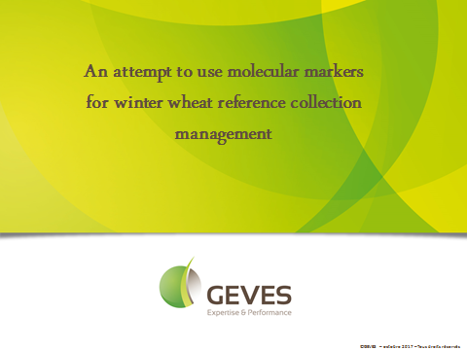

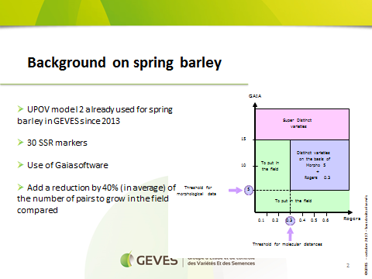

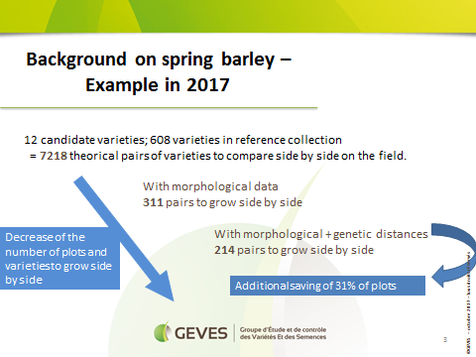

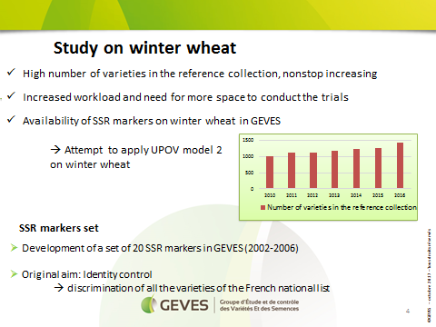

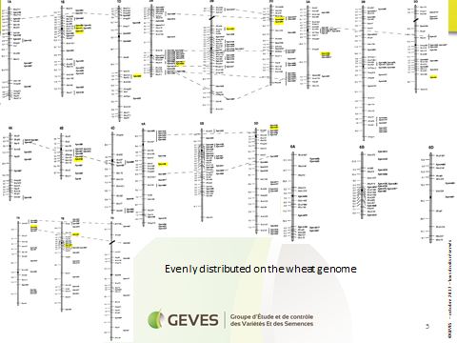

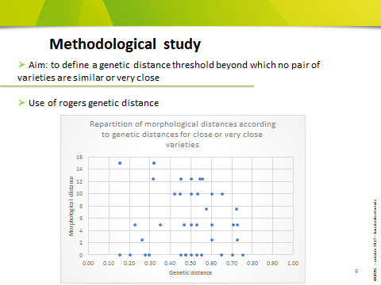

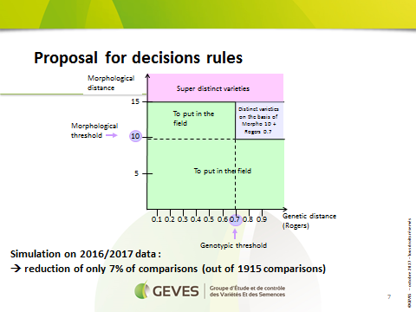

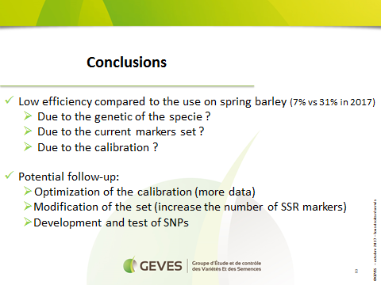

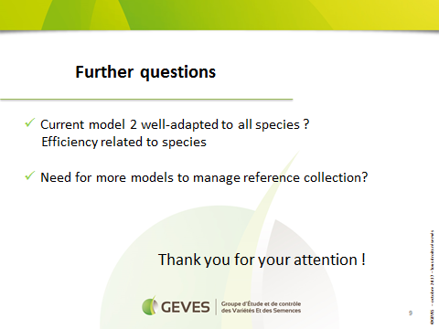

[End of Annex and of document]

