E
International Union for the Protection of New Varieties of Plants

Working Group on Biochemical and Molecular Techniques  and DNA-Profiling in Particular  Sixteenth Session  La Rochelle, France, November 7 to 10, 2017 | BMT/16/10  Original: English  Date: October 17, 2017
THE USE OF MOLECULAR MARKERS (SNP) FOR MAIZE DUS TESTING: DEVELOPMENT AND OFFICIAL APPLICATIONS TO ASSESS DISTINCTNESS OF HYBRIDS VARIETIES (FRANCE)
Document prepared by an expert from France
Disclaimer: this document does not represent UPOV policies or guidance
According to the recommendations in the Test Guidelines for Maize, document TG/2/7, we follow the required steps to assess the distinctness of hybrid varieties. First, we describe their parental lines and check their distinctness in comparison with our reference collection (5000 lines). At the same time, we check the originality of the hybrid formula in comparison with those of the hybrids of our reference collection (4500 hybrids). Finally, we assess distinctness at the hybrid level for varieties with a similar formula.

For the assessment of distinctness of the hybrid lines, we divide our process into different steps in order to identify the similar hybrids (with a similar formula). We have started a study to include molecular data (SNP) in addition to the hybrid formula data and morphological description. After a methodological study, we have been successful in developing a rule taking into account the hybrid formula, morphological data and molecular data.

[Annex follows]

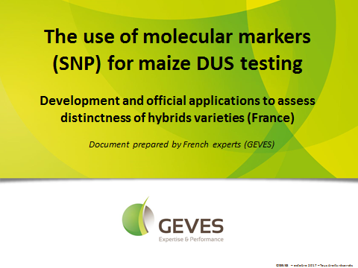

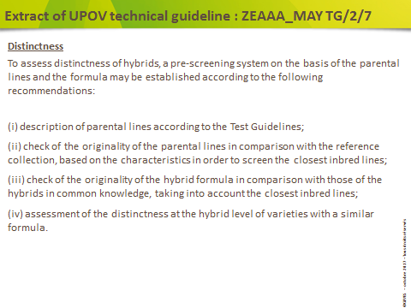

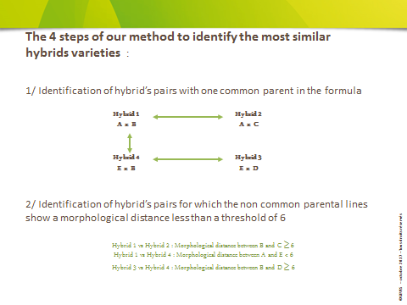

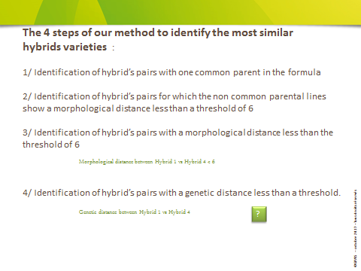

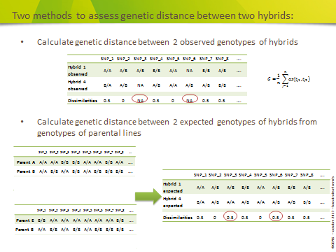

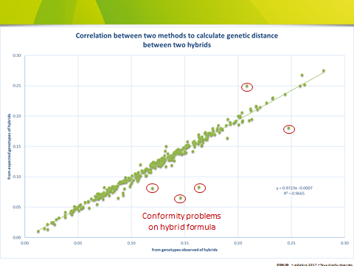

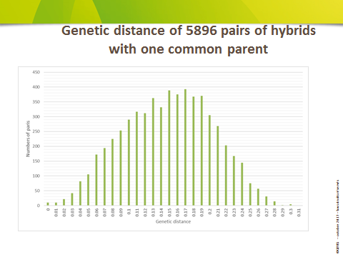

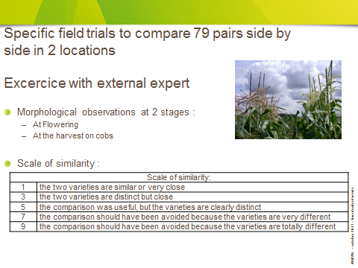

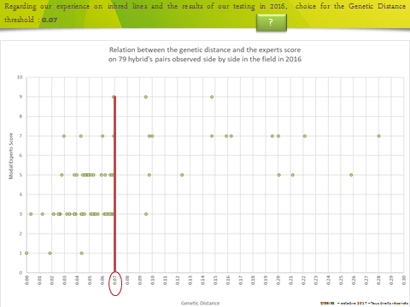

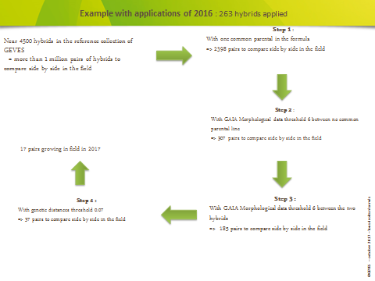

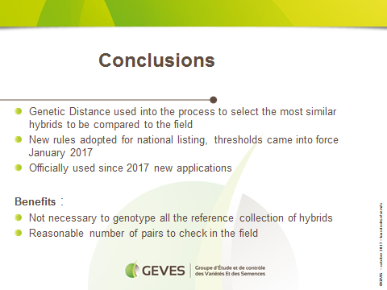

[End of Annex and of document]

