E
BMT/15/6
ORIGINAL: English
DATE: May 18, 2016
INTERNATIONAL UNION FOR THE PROTECTION OF NEW VARIETIES OF PLANTS
Geneva
WORKING GROUP ON BIOCHEMICAL AND MOLECULAR
TECHNIQUES AND DNA PROFILING IN PARTICULAR
Fifteenth Session
Moscow, Russian Federation, May 24 to 27, 2016
Variety identification of barley using KASP genotyping
Document prepared by an expert from the United Kingdom
Disclaimer: this document does not represent UPOV policies or guidance
The Annex to this document contains a copy of a presentation “Variety identification of barley using KASP genotyping” to be made at its fifteenth session of the Working Group on Biochemical and Molecular Techniques and DNA-Profiling in particular (BMT).

Alex Reid, Molecular Biologist, Science and Advice for Scottish Agriculture (SASA), the United Kingdom

[Annex follows]

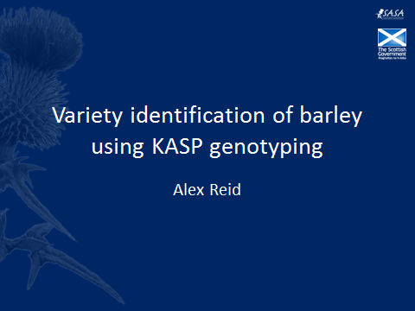

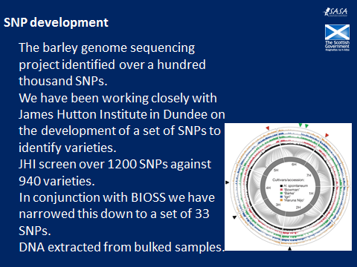

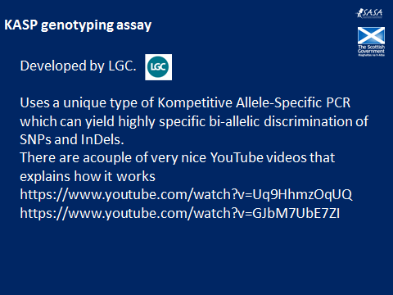

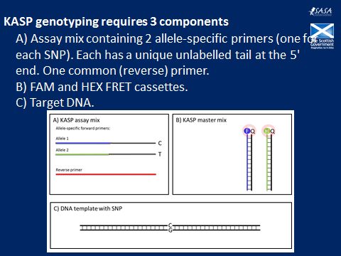

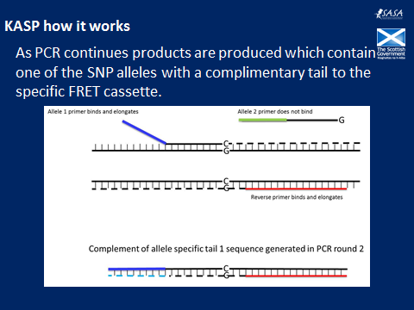

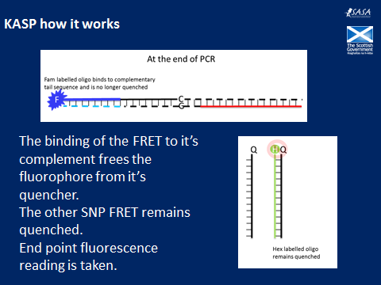

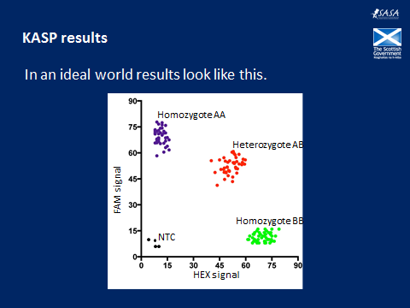

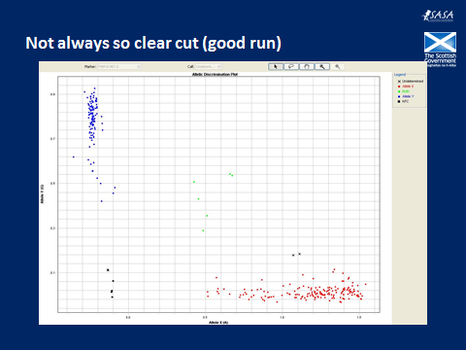

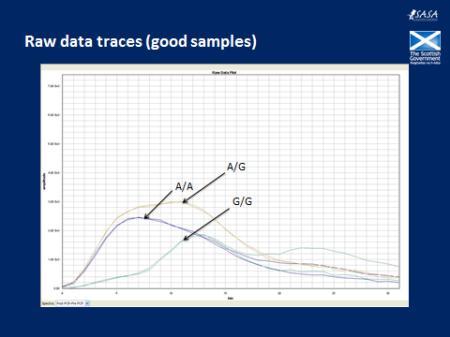

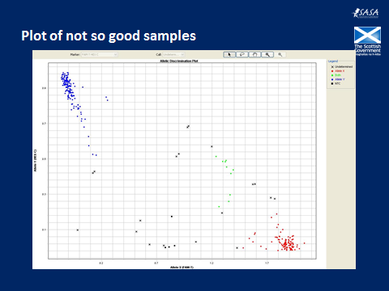

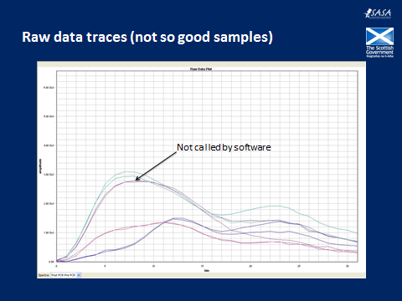

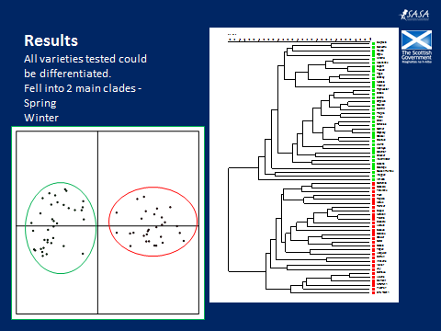

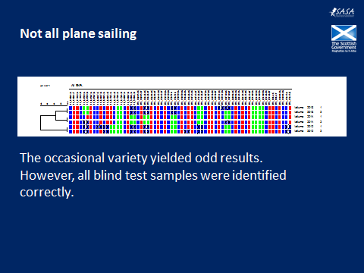

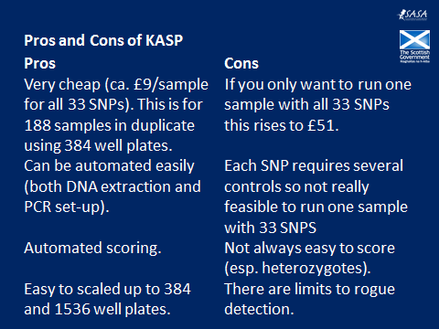

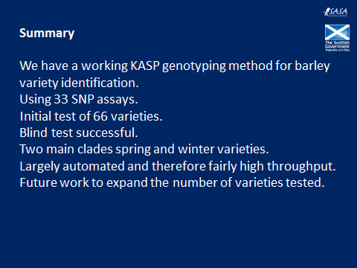

[End of Annex and of document]

