E
BMT/15/28 Rev.
ORIGINAL: English
DATE: November 14, 2016
INTERNATIONAL UNION FOR THE PROTECTION OF NEW VARIETIES OF PLANTS
Geneva
WORKING GROUP ON BIOCHEMICAL AND MOLECULAR TECHNIQUES
AND DNA-PROFILING IN PARTICULAR
Fifteenth Session
Moscow, Russian Federation, May 24 to 27, 2016
REVISED Report
adopted by the Working Group on Biochemical and Molecular Techniques,
and DNA-Profiling in Particular

Disclaimer: this document does not represent UPOV policies or guidance
The Working Group on Biochemical and Molecular Techniques and DNA-Profiling in Particular (BMT) held its fifteenth session in Moscow, Russian Federation, from May 24 to 27, 2016. The list of participants is reproduced in Annex I to this report.

The BMT was opened by Mr. Kees van Ettekoven (the Netherlands), Chairperson of the BMT, who welcomed the participants. The BMT was welcomed by Mr. Evgeny V. Gromyko, First Deputy Minister of Agriculture of the Russian Federation, Mr. Vitaly, S. Voloshchenko, Chairman of State Commission of the Russian Federation for Selection Achievements Test and Protection, Mr. Vladimir M. Kosolapov, Head of Department, Plant Production, Protection and Biotechnology, Russian Science Academy, Mr. Igor A. Lobach, President, National Association of Manufacturers of Seeds of Corn and Sunflower, Ms. Ekaterina V. Zhuravleva, Deputy Chief, Department of Cooperation and Support of Organizations in the Field of Agricultural Sciences, Federal Agency of Scientific Organizations, and Mr. Sergey Lupekhin, President, Russian Potato Union. Mr. Peter Button, Vice Secretary-General, UPOV, also made an opening remark. Copies of the opening speeches are reproduced in Annexes II to VIII to this document.

The BMT received presentations by Mr. Viktor I. Startcev on “Plant Variety Test and Protection System in the Russian Federation”, a copy of which is reproduced as Annex IX to this report.

Adoption of the Agenda

The BMT adopted the Agenda as reproduced in document BMT/15/1 Rev.

Reports on developments in UPOV concerning biochemical and molecular techniques

The Office of the Union provided a report on developments in UPOV concerning Biochemical and Molecular Techniques, on the basis of document BMT/15/2.

Short presentations on new developments in biochemical and molecular techniques by DUS experts, biochemical and molecular specialists, plant breeders and relevant international organizations (oral reports by participants)

The BMT received a presentation by Mr. Martin Ekvad on developments in the CPVO, a copy of which is reproduced in document BMT/15/27 “Reports on Development of Plant Variety Protection System from Members and Observers”. The BMT noted the meeting of the new group on molecular techniques in the CPVO named “IMODDUS”.

Report of work on molecular techniques in relation to DUS examination

Molecular Marker Use in the PVP Application Process; a Joint Project between the US PVP Office and the American Seed Trade Association (document BMT/15/12 and BMT/15/12 Add.)

The BMT received a presentation by Mr. Barry Nelson (Seed Association of the Americas), based on document BMT/15/12 and BMT/15/12 add..

Evaluation of Soybean Molecular Marker Public Resources for Potential Application in Plant Breeders’ Rights (document BMT/15/13 and BMT/15/13 Add.)

The BMT received a presentation by Mr. Frederic Achard (Seed Association of the Americas), based on document BMT/15/13 and BMT/15/13 Add. The BMT noted that the project was intended to support the use of molecular techniques to provide additional evidence besides morphological characteristics in cases of apparent lack of distinctness between varieties from the same breeder. The BMT agreed that the concept was not included in current agreed models for molecular techniques in document TGP/15.

Comparison of Genotypic and Expression Data to Determine Distinctness among Inbred Lines of Maize for Granting Plant Breeders’ Rights (document BMT/15/14 and BMT/15/14 Add.)

The BMT received a presentation by Mr. Barry Nelson (Seed Association of the Americas), based on document BMT/15/14 and BMT/15/14 Add.

Efficient DUS test in French bean by using molecular data (document BMT/15/21)

The BMT received a presentation by Ms. Amanda van Dijk (Netherlands), based on document BMT/15/21. The BMT noted the use of molecular marker information to support the reduction of size of trials and selection of similar varieties for side-by-side comparison. The BMT agreed that the approach explained in the document was consistent with the model “Combining Phenotypic and Molecular Distances in the Management of Variety Collections” in document TGP/15. The BMT would welcome the addition of a new example to document TGP/15.

Can molecular distance be used as characteristic? (document BMT/15/22)

The BMT received a presentation by Mr. Kees van Ettekoven (the Netherlands), based on document BMT/15/22. The BMT agreed that more work should be done on this approach. The BMT agreed that it could be useful to consider a possible use of this specific type of characteristic comparable to the approach used for isoenzymes or storage proteins in the Test Guidelines for certain cereal species.

Work on molecular techniques in relation to DUS examination of different fruit species (document BMT/15/11)

The BMT received a presentation by Clarisse Maton (France) via WebEx, based on document BMT/15/11.

International guidelines on molecular methodologies

The Office of the Union provided a report on developments in UPOV concerning International Guidelines on Molecular Methodologies, on the basis of document BMT/15/3 Rev.

UPOV and ISO TC 34/SC 16 – From the US Technical Advisory Group and ANSI led host of ISO TC 34/SC 16: Food Products; horizontal methods for molecular biomarker analysis (document BMT/15/7)

The BMT noted the document BMT/15/7 but no presentation was made.

DNA-based method for variety testing: ISTA approach (document BMT/15/19)

The BMT received a presentation by Ms. Chiara Delogu (International Seed Testing Association), based on document BMT/15/19.

Variety description databases

The Office of the Union provided a report on developments in UPOV concerning Variety Description Databases, on the basis of document BMT/15/4.

The BMT agreed that it would be important within UPOV to consider how to facilitate cooperation for the establishment of common databases with molecular information. However, it noted that the cooperation would need to be initiated between UPOV members in the first instance.

Methods for analysis of molecular data

The BMT received a presentation by Mr. René Mathis (France) via WebEx, based on document BMT/15/10.

The use of molecular techniques in examining essential derivation

The BMT considered whether it would be possible to provide a contribution on the use of molecular marker techniques to the examination of essential derivation of varieties and understanding of the definition of EDV.

The BMT agreed that molecular techniques could provide useful information to assess whether a variety is predominantly derived from an initial variety.

The use of molecular techniques in variety identification

Application of DNA marker technologies in Vegetable Breeding (document BMT/15/24)

The BMT received a presentation by Mr. Jeroen Rouppe van der Voort (Enza Zaden), based on document BMT/15/24.

The BMT noted that a core marker set can be created for DUS testing. However, it noted that markers used in breeding programs needed to be updated regularly.

The BMT noted that breeders were seeking characteristic-linked markers, but markers and morphological characteristics might not have one-to-one correlation.

Gene and genome editing with CRISPR-cas9 (document BMT/15/17)

The BMT received a presentation by Ms. Hedwich Teunissen (the Netherlands), based on document BMT/15/17.

The BMT noted that the CRISPR-cas9 technology enabled breeders to introduce specific DNA sequence on target loci, and ability to control its function (e.g. activation and/or silencing).

The BMT wished to draw the attention of the Technical Committee and other relevant bodies within UPOV that an increasing number of varieties being developed with the use of advanced molecular techniques in plant breeding may result in the creation of many new varieties that could, in some cases, be considered as EDVs.
Variety identification of barley using KASP genotypes (document BMT/15/6)

The BMT received a presentation by Mr. Alex Reid (the United Kingdom), based on document BMT/15/6.
The BMT noted the potential to add markers, if necessary, to cover the entire barley collection in the United Kingdom.

Fast Single-step Detection and Identification of Multiple Phytopathogens and GMO with real-time PCR-matrix Technique (document BMT/15/9)

The BMT received a presentation by Mr. Alexander Golikov (Russian Federation), based on document BMT/15/9, and a demonstration of the real-time PCR-matrix techniques to identify phytopathogens and varieties from a mixed DNA sample extracted from different agricultural crops. The BMT noted that the system could identify extracted DNA of mixed varieties, bacteria and viruses in two hours.

Laboratory seed control of barley cultivars (document BMT/15/25)

The BMT received a presentation by Mr. Andrei A. Pomortcev (Russian Federation), based on document BMT/15/25. The BMT noted the use of DNA markers to identify varieties of barley and to assess variety purity of seed lots using molecular analysis of hordeins.

New developments concerning biochemical and molecular techniques in Belarus (document BMT/15/15)

The BMT received a presentation by Ms. Tatiana Siamashka (Belarus), based on document BMT/15/15.

The BMT noted that DNA markers had been used in Belarus as supporting information for the enforcement of plant breeder’s rights in apples.

Using of DNA – marker based techniques for varietal identification and fingerprinting of fruit crops and grape genetic resources (document BMT/15/18)

The BMT received a presentation by Mr. Ivan Suprun (Russian Federation), based on document BMT/15/18.

The BMT noted that the Laboratory of Genetics and Microbiology laboratory of Genetics and Microbiology had experience in identifying varieties by the request of nurseries.

Green Forensics: Whole Genome Sequencing approach for PBR enforcement (document BMT/15/23)

The BMT received a presentation by Ms. Hedwich Teunissen (Netherlands), based on document BMT/15/23.

The BMT agreed that sequencing technologies had potential application for DUS testing.

Assessment and classification of breeding accessions of vegetable plants with the use of DNA markers (document BMT/15/26)

The BMT received a presentation by Mr. Artur S. Domblides (Russian Federation), based on document BMT/15/26.

Cooperation between OECD, UPOV, ISTA and ISO

The BMT received a presentation by the Office of the Union on cooperation between OECD, UPOV, ISTA and ISO, on the basis of document BMT/15/5.

The BMT noted that the development of a joint document explaining the principal features of the systems of the OECD, UPOV and ISTA could only start after agreement by OECD and ISTA.
The BMT noted that the development of a joint OECD/UPOV/ISTA document containing an inventory of molecular marker techniques used by crop could only start after agreement by OECD and ISTA.

The BMT noted that OECD, ISTA and UPOV had different objectives and cooperation between the organizations in the use of molecular techniques would need to reflect that. However, the BMT agreed that it would be important to explore circumstances in which the same techniques and information could be used. In the first instance, it agreed that it would be more effective to explore such possibilities on the basis of real situations rather than at a theoretical and institutional level.

The BMT welcomed the proposal by the Netherlands to organize a practical workshop in 2017, with support from UPOV, OECD and ISTA, to explore how molecular techniques might be applied in an efficient way for UPOV, OECD and ISTA purposes.

The BMT agreed that possible future collaboration between UPOV, OECD and ISTA might include the harmonization of terms and methodologies used for different crops and the possible development of standards, after the agreement by these organizations

Databases containing molecular data

Towards durable DNA databases to support DUS testing (document BMT/15/16)

The BMT received a presentation by Ms. Hedwich Teunissen (Netherlands), based on document BMT/15/16.

With regard to confidentiality of molecular data, the BMT noted the guidance on plant material provided in document UPOV/TGP/5, Section 1. It noted that the guidance in TGP/5 might be a suitable basis also for molecular data.

Advances in the Construction and Application of DNA Fingerprint Databases in Maize (document BMT/15/20)

The BMT received a presentation by Ms. Zi Shi (China), based on document BMT/15/20.

Date and place of next session

The BMT welcomed the invitation of France to hold its sixteenth session in France, at the end of September or beginning of October 2017, with the preparatory workshop to be held the day before the BMT session.

Future program

During its sixteenth session, the BMT planned to discuss the following items:

1. Opening of the session
2. Adoption of the agenda
3. Reports on developments in UPOV concerning biochemical and molecular techniques (document to be prepared by the Office of the Union)
4. Short presentations on new developments in biochemical and molecular techniques by DUS experts, biochemical and molecular specialists, plant breeders and relevant international organizations (oral reports by participants)
5. Report of work on molecular techniques in relation to DUS examination (papers invited)
6. International guidelines on molecular methodologies including cooperation between OECD, UPOV, ISTA and ISO (document to be prepared by the Office of the Union)
7. Variety description databases including databases containing molecular data (papers invited)
8. Methods for analysis of molecular data (papers invited)
9. The use of molecular techniques in examining essential derivation (papers invited)
10. The use of molecular techniques in variety identification (papers invited)
11. Review of document UPOV/INF/17 “Guidelines for DNA-Profiling: Molecular Marker Selection and Database Construction (‘BMT Guidelines’)”
12. Date and place of next session
13. Future program
14. Report of the session (if time permits)
15. Closing of the session
The BMT is open to breeders and other experts. However, the BMT agreed that, in order to encourage the presentation of information in relation to the use of molecular techniques in examining essential derivation and in variety identification, it would be appropriate to dedicate a specific day to items 9 and 10 at the sixteenth session of the BMT. In particular, breeders and other experts would be offered the possibility to attend for that specific day, which would be the second day of the sixteenth session of the BMT.

Visit

On the afternoon of May 26, 2016, the BMT visited the Russian State Agrarian University-Moscow, Agricultural Academy named after K. A. Timiryazev (RGAU-MSHA), and was welcomed by Mr. Alexey V. Golubev, Vice-Rector for Research, Professor of Economy. The BMT visited in particular: the N. I. Vavilov Memorial, where the BMT paid tribute to the great contribution of Mr. Vavilov in a flower offering ceremony; the Laboratory of Genetics, Selection and Biotechnologies for Vegetable Crops. The visit was conducted by Mr. Vyacheslav G. Boyruko, Head of the Department of Science of RGAU, Assistant Professor, and Mr. Socrates G. Monokhos, Head of Department for Selection and Seed Production of Horticultural Crops; and the Experimental Station named after P. I. Lisitcyn, where a visit was conducted by Mr. Egor V. Berezovskiy, Chief of the Trial and Experimental Station, Candidate of Science, and Mr. Vladimir N. Igonin, Scientist, Candidate of Agriculture.

The BMT adopted this report at the close of the session.

[Annexes follow]

LIST OF PARTICIPANTS
I. MEMBERS

AUSTRIA
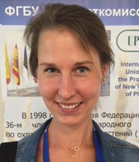 |  |  | Verena PETERSEIL (Ms.), Molecular Biologist, Austrian Agency for Health and Food safety (AGES), Institut Biochemie, Spargelfedstrasse 191, 1220 Wien  (tel.: +43 50 555 32203 fax: +43/50555/32219 e-mail: verena.peterseil@ages.at)
BELARUS
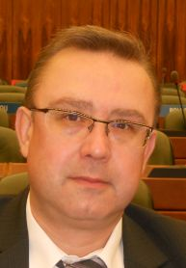 |  |  | Uladzimir BEINIA, Director, State Inspection for Testing and Protection of Plant Varieties, Kazintsa str. 62, 220108 Minsk  (tel.: +375 17 212 7051 fax: 8 1017 398 2740 e-mail: belsort@mail.ru)
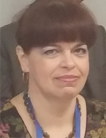 |  |  | Tatsiana SIAMASHKA (Ms.), Deputy Director of DUS Testing, State Inspection for Testing and Protection of Plant Varieties, Kazintsa str. 62, 220108 Minsk  (tel.: +375 17 2127451 fax: 8 1017 3982740 e-mail: tatianasortr@mail.ru)
Marina SALADUKHA (Ms.), Head, International Cooperation Department, State Inspection for Testing and Protection of Plant Varieties, 62 Kazintsa str., 220108 Minsk
(tel.: +375 17 212 7551 fax: 8 1017 398 27 40 e-mail: belsort@mail.ru)

Canada
Renée CLOUTIER (Ms.), Examiner, Plant Breeders' Rights Office, Canadian Food Inspection Agency (CFIA), 59 Camelot Drive, Ottawa Ontario, K1A0Y9
(tel.: +1 613 773 7191 fax: +1 613 773 7115 e-mail: Renee.Cloutier@inspection.gc.ca)
china
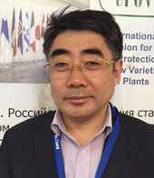 |  |  | Jiuran ZHAO, Professor, Maize Research Center, Maize Research Center, Beijing Academy of Agricultural and Forestry Sciences, Shuguang Garden Middle No. 9, Haidian District, 100097 Beijing  (tel.: +86 10 5150 3936 fax: +86 10 5150 3404 e-mail: maizezhao@126.com)
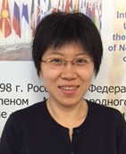 |  |  | Zi SHI (Ms.), Associate Professor, Maize Research Center, Beijing Academy of Agriculture and Forestry Sciences, No.9 Shuguang Garden Middle Road, Haidan District, Beijing  (tel.: 86 10 51502407 fax: 86 010 51503404 e-mail: shizi_baafs@126.com)
CZECH REPUBLIC
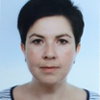 |  |  | Katerina STANKOVA (Ms.), Molecular Genetics Diagnostics, Central Institute for Supervising and Testing in Agriculture, 63/2 Hroznova, 656 06 Brno  (tel.: +420 543 548 378 e-mail: katerina.stankova@ukzuz.cz)
european Union
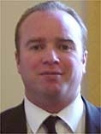 | Martin EKVAD, President, Community Plant Variety Office (CPVO), European Union, 3, boulevard Maréchal Foch, CS 10121, 49101 Angers Cedex 02  (tel.: +33 2 4125 6400 fax: +33 2 4125 6410 e-mail: ekvad@cpvo.europFa.eu)
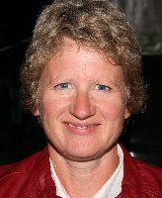 | Anne WEITZ (Ms.), Technical Expert Agricultural Species, Community Plant Variety Office (CPVO), 3, boulevard Maréchal Foch, CS 10121, 49101 Angers Cedex 02  (tel.: +33 2 41 25 64 37 fax: +33 2 41 25 64 10 e-mail: weitz@cpvo.europa.eu)
Finland
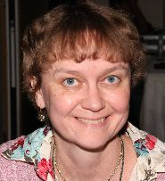 |  |  | Kaarina PAAVILAINEN (Ms.), Senior Officer, Seed Certification, Finnish Food Safety Authority Evira, Tampereentie 51, P.O. Box 111, 32200 Loimaa  (tel.: +358 40 8332480 fax: +358 29 5305317 e-mail: kaarina.paavilainen@evira.fi)
FRANCE
René MATHIS, BioGEVES Laboratory Manager, GEVES, rue Georges Morel, BP 90024, 49071 Beaucouzé Cedex
(tel.: + 33 2 41225834 fax: +33 2 41 228602 e-mail: rene.mathis@geves.fr)
Clarisse MATON (Ms.), General affairs of DUS testing, GEVES, 25 rue Georges Morel, CS 90024, 49071 Beaucouzé
(tel.: +33 241 22 85 96 e-mail: clarisse.maton@geves.fr)

germany
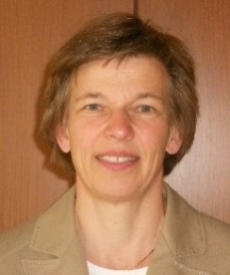 | Beate RÜCKER (Ms.), Head of Departement, Bundessortenamt, Osterfelddamm 80, Postfach 61 04 40, 30627 Hannover  (tel.: +49 511 9566 5639 fax: +49 511 956 69600 e-mail: beate.ruecker@bundessortenamt.de)
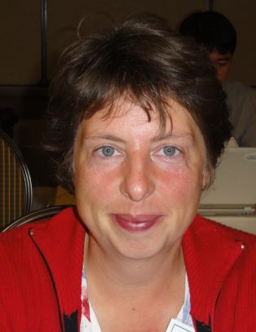 | Swenja TAMS (Ms), Head of Section General affairs of DUS testing, Bundessortenamt, Osterfelddamm 80, 30627 Hannover  (tel.: +49 511 9566 5607 fax: +49 511 9566 9600 e-mail: Swenja.Tams@bundessortenamt.de)
kenya
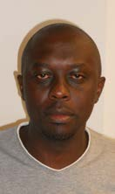 | Jared ONSANDO, DUS Coordinator, Kenya Plant Health Inspectorate Service (KEPHIS), P.O. Box 49592, 00100 Nairobi  (tel.: +254 02066180000/2/0709891000 fax: 0203536175/ e-mail: onsandoj@kephis.org / director@kephis.org)
netherlands
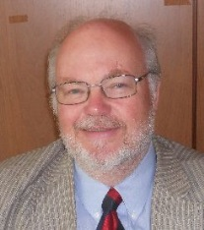 | Kees VAN ETTEKOVEN, Head, Variety Registration Department, Naktuinbouw, Sotaweg 22, 2371 GD Roelofarendsveen  (Tel.: +31 6 113 60675 email: c.v.ettekoven@naktuinbouw.nl)
Hedwich TEUNISSEN (Ms.), Senior Researcher, Naktuinbouw, Sotaweg 22, 2371 GD Roelofarendsveen
(Tel.: +31 71 332 6262 fax: +31 71 332 6363 email: h.teunissen@naktuinbouw.nl)
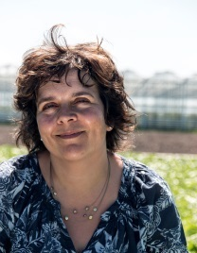 | Amanda VAN DIJK-VELDHUIZEN (Ms.), Variety testing specialist, Naktuinbouw, Sotaweg 22, P.O. Box 40, 2370 AA Roelofarendsveen  (tel.: +31 71 332 6123 fax: +31 71 332 6363 e-mail: a.v.dijk@naktuinbouw.nl)
republic of korea
Dongsun KIM, DNA Analysis, Korea Seed & Variety Service (KSVS), 119, Hyeoksin 8-ro,, Gyeongsangbuk-do, Gimcheon City 39660
(tel.: +82 54 912 0231 fax: +82 54 912 0277 e-mail: coinoia@korea.kr)
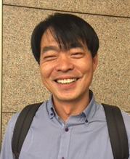 |  | Jinkee JUNG, Scientific Researcher, Korea Seed & Variety Service (KSVS), 119, Hyeoksin 8-ro, Gimcheon-si, Gyeongsangbuk-do  (tel.: +82 54 912 0230 fax: +82 54 912 0277 e-mail: jinkeejung@korea.kr)
russian federation
Ministry of Agriculture
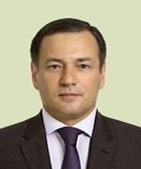 | Evgeniy V. GROMYKO, Deputy Minister, Ministry of Agriculture of the Russian Federation, Orlikov pereulok, 1/11, 107139 Moscow  (tel.: +7 (495) 607 85 75 .e-mail: pr.gromyko@mcx.ru)
Petr A.CHEKMAREV, Director, Department for Crop Production, Mechanization, Chemicalization and Plant Protection, Ministry of Agriculture of the Russian Federation, Orlikov pereulok, 1/11, 107139 Moscow
(tel.: +7 495 607 85 75 fax: +7 495 608 7257 e-mail: p.chekmarev@mcx.ru)
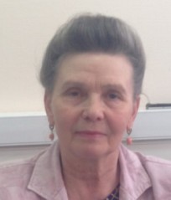 | Ludmila A. SMIRNOVA (Ms.), Head of Seed Growing Division, Dr. of Economics, Department for Crop Production, Mechanization, Chemicalization and Plant Protection, Orlikov pereulok, 1/11, 107139 Moscow  (tel.: +7 (495) 607 8586 e-mail: lu.smirnova@plem.mcx.ru)
Agro Industrial Complex Management Bodies of Constituent Entities
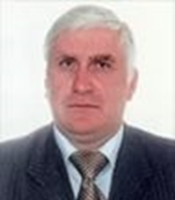 | Oleg DOLGIH, Head of the Department of Agriculture of the Lipetsk Region,  Moskovskaya Street, 83, 398055, Lipetsk city,  (tel: (4742) 30-73-10 fax 30-74-94 e-mail: agro@admlr.lipetsk.ru)
Federal State Budgetary Institutions Subordinated to the Ministry of Agriculture
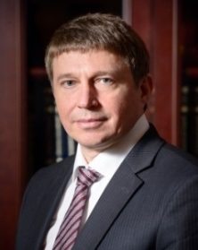 | Vyacheslav LUKOMETS, Rector of State Agrarian University – Timiryazev Agricultural Academy, Academician of Russian Academy of Sciences  (tel.: +7 (499) 976-3490 e-mail: rector@timacad.ru)
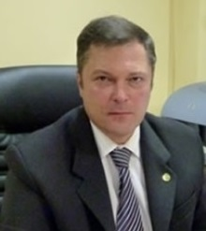 | Alexander M. MALKO, Director, The Russian Agricultural Center, FGBI "Rosselhoztsentr", 1/11, Orlikov p., 107139 Moscow  (tel.: +74957339835 fax: +74957339835 e-mail: rscenter@mail.ru)
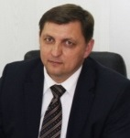 | Vitaly S. VOLOSHCHENKO, Chairman, State Commission of the Russian Federation for Selection Achievements Test and Protection (FGBU "Gossortcommissiya"),  Orlicov per. 1/11, 107139 Moscow  (tel.: +7 (495) 607 68 27 fax: +7(495) 411 8366 e-mail: gossort@gossort.com)
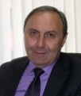 | Ismail MERZHOEV, Deputy Chairman, State Commission of the Russian Federation for Selection Achievements Test and Protection (FGBU "Gossortcommissiya"), Orlikov per., 1/11, 107139 Moscow  (tel.: +7 495 607 6827 fax: +7 495 607 4944 e-mail: gossort@gossort.com)
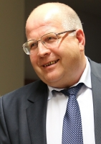 | Viktor I. STARTCEV, Deputy Chairman, State Commission of the Russian Federation for Selection Achievements Test and Protection (FGBU "Gossortcommissiya"), Orlikov Pereulok 1/11, 107139 Moscow  (tel.: +7 495 607 68 27 fax: +7495 607 49 44 e-mail: gossort@gossort.com)
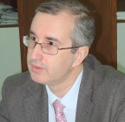 | Yuri L. GONCHAROV, Deputy Chairman, State Commission of the Russian Federation for Selection Achievements Test and Protection (FGBU "Gossortcommissiya"), Orlikov per., 1/11, 107139 Moscow  (tel.: +7 495 6078626 fax: +7 495 411 8366 e-mail: y.goncharov1@yandex.ru)
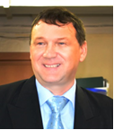 | Aleksandr N. ZARUBIN, Deputy Head, Fruit Crops, Grapes and Ornamental Crops Department, State Commission of the Russian Federation for Selection Achievements Test and Protection (FGBU "Gossortcommissiya"), Orlikov per., 1/11, 107139 Moscow  (tel.: +7 (495) 607 68 27 fax: +7 (495) 607 4944 e-mail: gossort@gossort.com)
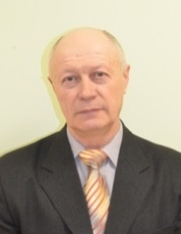 | Nikolai A. KLOCHKO, Head, Cereal Crops Department, State Commission of the Russian Federation for Selection Achievements Test and Protection (FGBU "Gossortcommissiya"), Orlikov per., 1/11, 107139, Moscow  (tel.: +7 (495) 607 68 27 fax: +7 (495) 607 49 44 e-mail: gossort@gossort.com )
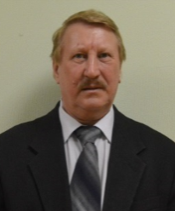 | Sergey A. KRAVTSOV, Head, Vegetable Crops and Potato Department, State Commission of the Russian Federation for Selection Achievements Test and Protection (FGBU "Gossortcommissiya"), Orlikov per., 1/11, 107139, Moscow  (tel.: +7 (495) 607 68 27 fax: +7 (495) 607 49 44 e-mail: gossort@gossort.com)
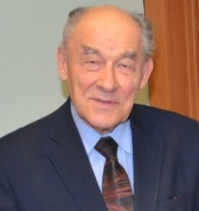 | Yury A. ROGOVSKIY, Head, Methodology and International Cooperation Department, State Commission of the Russian Federation for Selection Achievements Test and Protection (FGBU "Gossortcommissiya"), Orlikov per., 1/11, 107139 Moscow  (tel.: +7 495 411 8368 fax: +7 495 411 83 66 e-mail: yrogovskij@yandex.ru)
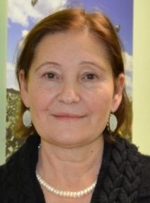 | Antonina TRETINNIKOVA (Ms.), Deputy Head, Methodology and International Cooperation Department, State Commission of the Russian Federation for Selection Achievements Test and Protection (FGBU "Gossortcommissiya"), Orlikov per., 1/11, 107139 Moscow  (tel.: +7 495 411 8368 fax: +7 495 411 8366 e-mail: tretinnikova@mail.ru)
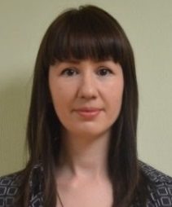 | Oksana V. ZHURAVLEVA (Ms.), Chief Agronomist, Methodology and International Cooperation Department, State Commission of the Russian Federation for Selection Achievements Test and Protection (FGBU "Gossortcommissiya"), Orlikov per., 1/11, 107139 Moscow  (tel.: +7 (495) 607 68 27 fax: +7 (495) 607 49 44 e-mail: oksana-zhuravlev@list.ru)
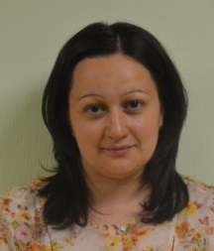 | Liliya V. BAKIEVA (Ms.), Interpreter, Methodology and International Cooperation Department, State Commission of the Russian Federation for Selection Achievements Test and Protection (FGBU "Gossortcommissiya"), Orlikov per., 1/11, 107139 Moscow  (tel.: +7 (495) 607 68 27 fax: +7 (495) 607 4944 e-mail: gossort@gossort.com)
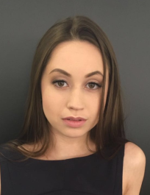 | Rita S. ARTEMYEVA (Ms.), Chief Editor, Administration, Organizational and Information Support Department, State Commission of the Russian Federation for Selection Achievements Test and Protection (FGBU "Gossortcommissiya"), Orlikov per., 1/11, 107139 Moscow  (tel.: +7 (495) 607 68 27 fax: +7 (495) 607 49 44 e-mail: gossort@gossort.com)
Tamerlan B. MARZIEV, Chief Specialist, Administration, Organizational and Information Support Department, State Commission of the Russian Federation for Selection Achievements Test and Protection (FGBU "Gossortcommissiya"), Orlikov per., 1/11, 107139 Moscow
(tel.: +7 (495) 607 68 27 fax: +7 (495) 607 49 44 e-mail: gossort@gossort.com)
Tatyana A. OVCHINNIKOVA (Ms.), Leading Agronomist, Forage Crops and Maize Department, State Commission of the Russian Federation for Selection Achievements Test and Protection (FGBU "Gossortcommissiya"), Orlikov per., 1/11, 107139 Moscow
(tel.: +7 (495) 607 68 27 fax: +7 (495) 607 49 44 e-mail: ovchinnikovat.a@mail.ru)
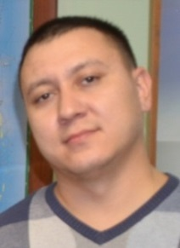 | Rinat Z. BATRGALIEV, Plant Pathology and Entomology Specialist, Forage Crops and Maize Department, State Commission of the Russian Federation for Selection Achievements Test and Protection (FGBU "Gossortcommissiya"), Orlikov per., 1/11, 107139 Moscow  (tel.: +7 (495) 607 68 27 fax: +7 (495) 607 49 44 e-mail: gossort@gossort. com)
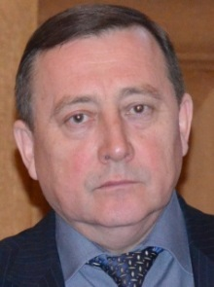 | Yury A. CHERNIY, Head of Administration, Organizational and Information Support Department, State Commission of the Russian Federation for Selection Achievements Test and Protection (FGBU "Gossortcommissiya"), Orlikov per., 1/11, 107139 Moscow  (tel.: +7 (495) 607 68 27 fax: +7 (495) 607 49 44 e-mail: cherniy.yury@yandex.ru)
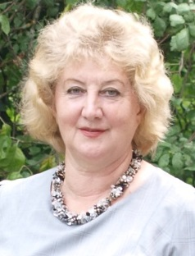 | Tatiana A. DOROKHINA (Ms.), Chief Specialist, Administration, Organizational and Information Support Department, State Commission of the Russian Federation for Selection Achievements Test and Protection (FGBU "Gossortcommissiya"), Orlikov per., 1/11, 107139 Moscow  (tel.: +7 (495) 607 68 27 fax: +7 (495) 607 49 44 e-mail: gossort@gossort.com)
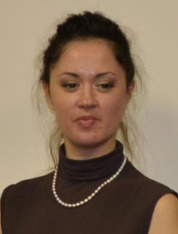 | Tatyana V. FEDOSOVA (Ms.), Chief Agronomist, Deputy Head, Fruit Crops, Grapes and Ornamental Crops Department, State Commission of the Russian Federation for Selection Achievements Test and Protection (FGBU "Gossortcommissiya"), Orlikov per., 1/11, 107139 Moscow  (tel.: +7 (495) 607 68 27 fax: +7 (495) 607 4944 e-mail: gossort@gossort.com)
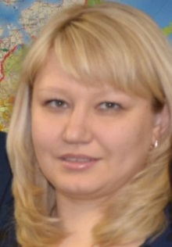 | Ekaterina P. GORBACHEVA (Ms.), Head, Staff Department, State Commission of the Russian Federation for Selection Achievements Test and Protection (FGBU "Gossortcommissiya"), Orlikov per., 1/11, 107139 Moscow  (tel.: +7 (495) 607 68 27 fax: +7 (495) 607 49 44 e-mail: gossort@gossort.com)
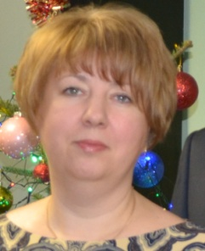 | Anna V. GORDEEVA (Ms.), Head, Planning and Economic Department, State Commission of the Russian Federation for Selection Achievements Test and Protection (FGBU "Gossortcommissiya"), Orlikov per., 1/11, 107139 Moscow  (tel.: +7 (495) 607 68 27 fax: +7 (495) 607 49 44 e-mail: gossort@gossort. com)
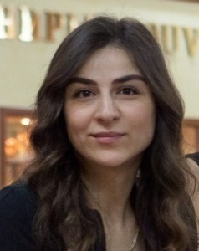 | Zeynab G. KANBEROVA (Ms.), Chief Specialist, Registration and Maintaining the Register of Property Department, State Commission of the Russian Federation for Selection Achievements Test and Protection (FGBU "Gossortcommissiya"), Orlikov per., 1/11, 107139 Moscow  (tel.: +7 (495) 607 68 27 fax: +7 (495) 607 49 44 e-mail: gossort@gossort.com)
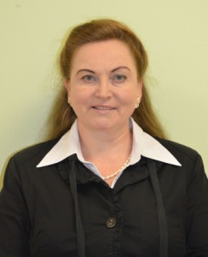 | Irina N. KOROLEVA (Ms.), Chief Specialist, Administration, Organizational and Information Support Department, State Commission of the Russian Federation for Selection Achievements Test and Protection (FGBU "Gossortcommissiya"), Orlikov per., 1/11, 107139 Moscow  (tel.: +7 (495) 607 68 27 fax: +7 (495) 607 49 44 e-mail: gossort@gossort.com)
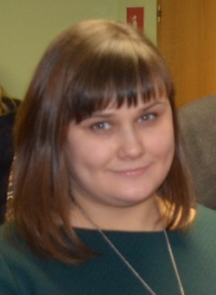 | Anastasiya V. KOTOVSKAYA (Ms.), Chief Agronomist, Cereal Crops Department, State Commission of the Russian Federation for Selection Achievements Test and Protection (FGBU "Gossortcommissiya"), Orlikov per., 1/11, 107139, Moscow  (tel.: +7 (495) 607 68 27 fax: +7 (495) 607 49 44 e-mail: gossort@gossort.com)
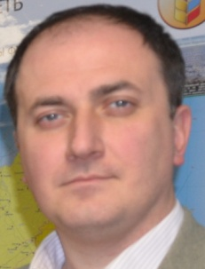 | Mikhail A. KULIKOV, Deputy Head, Technical Crops Department, State Commission of the Russian Federation for Selection Achievements Test and Protection (FGBU "Gossortcommissiya"), Orlikov per., 1/11, 107139, Moscow  (tel.: +7 (495) 607 68 27 fax: +7 (495) 607 49 44 e-mail: gossort@gossort.com)
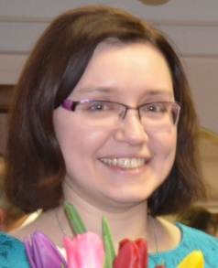 | Anna N. KULIKOVA (Ms.), Chief Agronomist, State Commission of the Russian Federation for Selection Achievements Test and Protection (FGBU "Gossortcommissiya"), Orlicov per. 1/11, 107139 Moscow  (tel.: +7 (495) 607 68 27 fax: +7(495) 411 8366 e-mail: gossort@gossort.com)
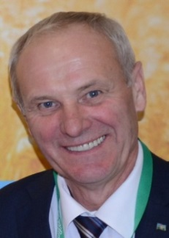 | Vladimir V. LUNEV, Head of the Archive of Administration, Organizational and Information Support Department, State Commission of the Russian Federation for Selection Achievements Test and Protection (FGBU "Gossortcommissiya"), Orlikov per., 1/11, 107139 Moscow  (tel.: +7 (495) 607 68 27 fax: +7 (495) 607 49 44 e-mail: gossort@gossort.com)
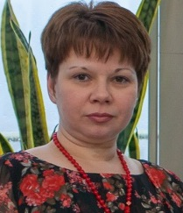 | Olga A. MASLENNIKOVA (Ms.), Head, Legal Support and public procurement Department, State Commission of the Russian Federation for Selection Achievements Test and Protection (FGBU "Gossortcommissiya"), Orlikov per., 1/11, 107139 Moscow  (tel.: +7 (495) 607 68 27 fax: +7 (495) 607 49 44 e-mail: gossort@gossort.com)
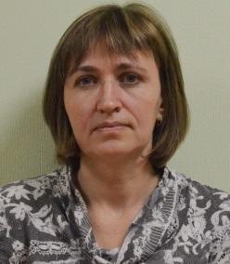 | Olga M. PERTSUKHOVA (Ms.), Head, Registration and State Register Department, State Commission of the Russian Federation for Selection Achievements Test and Protection (FGBU "Gossortcommissiya"), Orlicov per. 1/11, 107139 Moscow  (tel.: +7 (495) 607 68 27 fax: +7(495) 411 8366 e-mail: gossort@gossort.com)
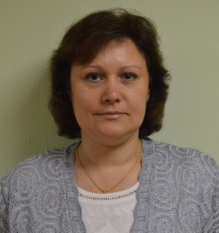 | Nataliya L. SIMONOVA (Ms.), Chief Agronomist, Deputy Head, Fruit Crops, Grapes and Ornamental Crops Department, State Commission of the Russian Federation for Selection Achievements Test and Protection (FGBU "Gossortcommissiya"), Orlikov per., 1/11, 107139 Moscow  (tel.: +7 (495) 607 68 27 fax: +7 (495) 607 4944 e-mail: gossort@gossort.com)
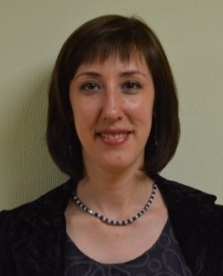 | Ekaterina S. BOYKO (Ms.), Chief Agronomist, Forage Crops and Maize Department, State Commission of the Russian Federation for Selection Achievements Test and Protection (FGBU "Gossortcommissiya"), Orlikov per., 1/11, 107139 Moscow  (tel.: +7 (495) 607 68 27 fax: +7 (495) 607 49 44 e-mail: gossort@gossort. com)
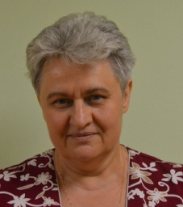 | Nina A. KON'KOVA (Ms.), Chief Agronomist, Deputy Head, Fruit Crops, Grapes and Ornamental Crops Department, State Commission of the Russian Federation for Selection Achievements Test and Protection (FGBU "Gossortcommissiya"), Orlikov per., 1/11, 107139 Moscow  (tel.: +7 (495) 607 68 27 fax: +7 (495) 607 4944 e-mail: gossort@gossort.com)
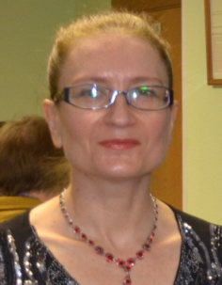 | Irina I. Timofeeva (Ms.), Chief Agronomist, Vegetable Crops and Potato Department, State Commission of the Russian Federation for Selection Achievements Test and Protection (FGBU "Gossortcommissiya"), Orlikov per., 1/11, 107139, Moscow  (tel.: +7 (495) 607 68 27 fax: +7 (495) 607 49 44 e-mail: gossort@gossort.com)
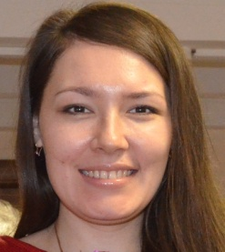 | Darya A. VINOGRADOVA (Ms.), Chief Specialist, Administrative Maintenance Department, State Commission of the Russian Federation for Selection Achievements Test and Protection (FGBU "Gossortcommissiya"), Orlikov per., 1/11, 107139 Moscow  (tel.: +7 (495) 607 68 27 fax: +7 (495) 607 49 44 e-mail: gossort@gossort. com)
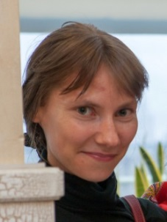 | Elena A. Zablotskaya (Ms.), Chief Agronomist, Vegetable Crops and Potato Department, State Commission of the Russian Federation for Selection Achievements Test and Protection (FGBU "Gossortcommissiya"), Orlikov per., 1/11, 107139, Moscow  (tel.: +7 (495) 607 68 27 fax: +7 (495) 607 49 44 e-mail: gossort@gossort.com)
Branches of the State Commission of the Russian Federation for Selection Achievements Test and Protection
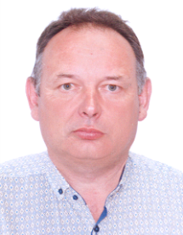 | Petr I. ANTONENKO, Director, Branch Egorievsk GSIS, State Commission of the Russian Federation for Selection Achievements Test and Protection, Poselok Noviy, 21, Moscow region, Egorievsk  (tel: 8-496-402-79-72 8-916-474-31-52 e-mail: egsortstan@mail.ru)
Fatima R. AGUZAROVA (Ms.), Chief of Branch, State Commission of the Russian Federation for Selection Achievements Test and Protection in the Republic of North Ossetia - Alania, Gadieva street, 79-a, 362001, Vladikavkaz, Republic of North Ossetia - Alania,
(tel: +7(867-2) 52 48 90 e-mail: severnaya-osetyia@yandex.ru)
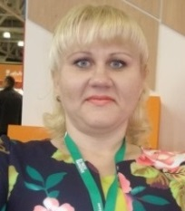 | Olga V. DYUKAREVA (Ms.), Chief of Branch in Kursk region, State Commission of the Russian Federation for Selection Achievements Test and Protection, Alexander Nevsky str., 13 A, of. 315, 305001, Kursk city  (tel: 8 471 251 46 46, 920 260 8 74 48 e-mail: kffgugs@rambler.ru)
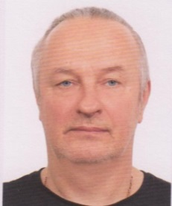 | Andrey N. ZOLOTUKHIN, Deputy Chief of Branch in Voronezh region, State Commission of the Russian Federation for Selection Achievements Test and Protection, Lomonosov street, 98-15, 394087, Voronezh city  (tel: 8 473 230 30 90 e-mail: inspecturavo@vmail.ru)
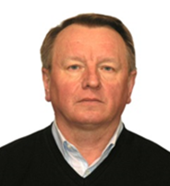 | Vasiliy N. LIFANOV, Acting Chief of Branch in Moscow region, State Commission of the Russian Federation for Selection Achievements Test and Protection, Odintsovo district, Zakharovo, 8A, 143022, Moscow region  (tel: 8 (498 69) 4–04–95 8 (498 69) 4–39–33 e-mail: zaxarovogsis@yandex.ru)
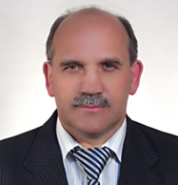 | Alexander A. SOLOVYEV, Director of Branch in Lipetsk GSIS, State Commission of the Russian Federation for Selection Achievements Test and Protection, 398517, Lipetsk region, Lipetsk district, S. Ruslanovca  (Tel: +8 474 239 94 21, e-mail: lipetskiifilial@yandex.ru, lgss@lipetsk.ru)
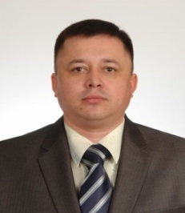 | Alexander V. KULYAEV, Director of Branch in Tambov Region, Candidate of Agricultural Sciences, State Commission of the Russian Federation for Selection Achievements Test and Protection. Avdeevka, Sadovaya str., 38., 392561, Tambov region, Tambov district,  (tel: +8 (4752)62-70-90 e-mail: incpekturatambov@mail.ru)
Viktor VASILJEV, Director of Branch, State Commission of the Russian Federation for Selection Achievements Test and Protection, Cheboksary city, Huzangaya street, 14, office 601
(tel./Fax +7 (8352) 65-52-01 e-mail: gossort-21@mail.ru)
Scientific and Educational Institutions
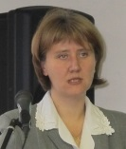 | Ekaterina V. ZHURAVLEVA (Ms.), Deputy Chief of Department for Coordination and Support of Organizations in the field of Agricultural Sciences, Federal Agency of Scientific Organizations (FASO Russia), Leninsky prospect, 32, 119334 Moscow  (tel.: +7 (495) 698 50 58 e-mail: info@fano.gov.ru)
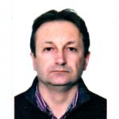 | Gennady I. KARLOV, Director of Center for Molecular Biotechnology, Federal State Budget Establishment of Higher Education "Russian State Agrarian University - Moscow Timiryazev Agricultural Academy", Timiryazevskaya St 49, 127550 Moscow  (tel.: +7 (499) 977 72 01 e-mail: karlovg@gmail.com)
Dimitriy B. DOROKHOV, Leading Scientific Officer of the Federal Research Center "Fundamentals of Biotechnology" of the Russian Academy of Sciences, Pr. 60-leyta Oktyabrya 7, korp. 1, 117312, Moscow
(tel.: +7 (499) 135 6191 fax: +70 095 135 0571 e-mail: dmitry.dorokhov@gmail.ru)
Alexander G. GOLIKOV, Science Director, Academic adviser, OOO"GenBit", Nauchnyy proyezd 20, 117246, Moscow
(tel.: +7 (926) 202 84 52 e-mail: golikov@genbitgroup.com)
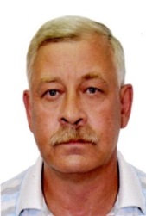 | Andrei A. POMORTCEV, Leading Researcher of the Laboratory of Plant Genetics, Federal State Budgetary Scientific Institution "Institute of General Genetics named after N. I. Vavilov (FSBSI "Vavilov Institute of General Genetics Russian Academy of Science"), Gubkina str., GSP-1, Moscow  (tel.: +7(499) 135 0460 e-mail: pomortsev@vigg.ru)
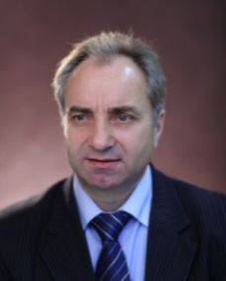 | Sergey M. SIROTA, Deputy Director for Science and Seed, Dr. of Agricultural Sciences, Federal State Budgetary Scientific Institution "All-Russian Scientific Research Institute of Vegetable Breeding and Seed Production", Selectionnaya street, 14, 143080, p. VNIISSOK, Odintsovsky district, Moscow  (tel.: +7(495) 599 24 42 e-mail: sirota@vniissok.ru)
Artur S. DOMBLIDES, Head of Laboratory of Genetics, Candidate of Agricultural Sciences, Federal State Budgetary Scientific Institution "All-Russian Scientific Research Institute of Vegetable Breeding and Seed Production", Selectionnaya street, 14, 143080, p. Vniissok, Odintsovsky district, Moscow region
(tel.: +7 (495) 599-24-42)
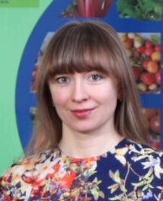 | Elena A. DOMBLIDES (Ms.), Head, Laboratory of Biotechnology, Federal State Budgetary Scientific Institution "All-Russian Scientific Research Institute of Vegetable Breeding and Seed Production", Selectionnaya street, 14, p. VNIISSOK, Odintsovsky district, 143080, Moscow  (tel.: +7(495) 599 2442)
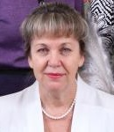 | Olga PYSHNAYA (Ms.), Deputy Director on Scientific Work, Doctor of Agricultural Sciences, Federal State Budgetary Scientific Institution “All-Russian Scientific Research Institute of Vegetable Breeding and Seed Production” (FSBI VNIISSOK), Selectionnaya street, 14, 143080, p. VNIISSOK, Odintsovsky district, Moscow region  (tel.: +7 (495) 599-24-42)
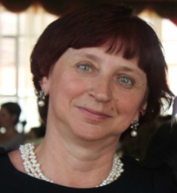 | Olga I. MOLKANOVA (Ms.), Head, Laboratory of Plant Biotechnology, Federal State Budgetary Institution of Science "N.V. Tsitsin' Main Botanical Garden Russian Academy of Sciences", Botanicheskaya street 4, 127276, Moscow  (tel.: +7(499) 977 91 72 e-mail: gbsran@mail.ru)
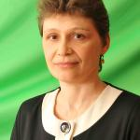 | Olga A. SOROKOPUDOVA (Ms.), Head, Center for Genetics, Selection and Introduction of Horticultural crops, Federal State Budgetary Scientific Institution "All-Russia Selection-Technological Insitute of Horticulture and Nursery" (FGBNU VSTISP), Zagorevskaya street, 4, 115598, Moscow  (tel.: +7(495) 329 51 66, +7 (495) 329 30 00 e-mail: vstisp@vstisp.org)
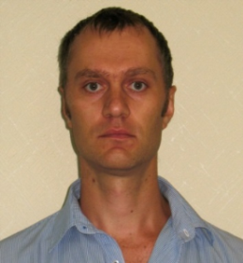 | Ivan I. SUPRUN, Head of the Laboratory of Genetics and Microbiology, Federal State Budget Scientific Organization “North Caucasian Regional Research Institute of Horticulture and Viticulture”, 40 years of Victory street, 39, Krasnodar  (tel.: ((861) 257 57 02 e-mail: supruni@mail.ru)
Petr N. HARCHENCO, Scientific Chief, All-Russian Research Institute of Agricultural Biotechnology, Timiryasevskaya street, 42, 127550, Moscow
(tel.: +7(499) 976 65 44 e-mail: kharchenko@iab.ac.ru, iab@iab.ac.ru)
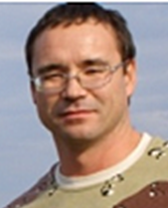 | Ilya A. SHILOV, Head of Laboratory of Genome Analysis, Group All-Russia Institute of Agricultural Biotechnology, All-Russian Research Institute of Agricultural Biotechnology, 42, Timiryazevskaya ul., 127550, Moscow  (tel.: 7 495 977 2068 fax: 7 495 977 0947 e-mail: ishilov@iab.ac.ru)
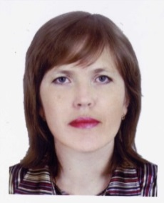 | Svetlana A. RAMAZANOVA (Ms.), Senior Researcher of the Laboratory of Immunity and Molecular Marking, Federal State Budgetary Scientific Institution "All-Russia Research Institute of Oil Crops by V.S. Pustovoit" (FSBSI VNIIMK), Filatova str., 7, 1350038 Krasnodar,  (tel.: +7(861) 255 59 33 e-mail: vniikm-centr@mail.ru)
Elli E. EGGI (Ms.), Senior Researcher, N.I. Vavilov Institute of Plant Genetic Resources (VIR), B.Morskaya street, 42-44, 190000, St. Petersburg
(tel.: (8-812) 312 22 34 fax: (8-812) 570 47 70 e-mail: zininaanna@yandex.ru)
Elena TOROP (Ms.), Head of the Laboratory of Genetics and Biotechnology, Dr. of Biological Sciences, Federal State Budgetary Scientific Institution, "Scientific Research Institute of Agriculture of the Central Black Earth Strip named after V. V. Dokuchaev", Settlement the 2nd section of the Institute. V. V. Dokuchaev, block 5, 81, 397463, Talovsky r-n, Voronezh region
(tel.: +7 (47352) 4 54 92 e-mail: helenatorop@yandex.ru)
Nadezhda GUTIEVA (Ms.), Head of Breeding Center of Subtropical Cultures, Federal State Budgetary Scientific Institution, "All-Russian Scientific Research Institute of Floriculture and Subtropical Crops", Jan Fabricius str., 2/28, 354002, city Sochi, Krasnodar region
(tel.: +7 (622) 2964 021 e-mail: ganaza777@yandex.ru)

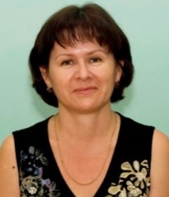 | Raisa KULYAN (Ms.), Head, Laboratory for Breeding of Subtropical Crops, Federal State Budgetary Scientific Institution "All Russian Scientific Research Institute of Floriculture and Subtropical Crops" (FGBNU/ FSBSI VNIITsiSK), Jan Fabricius str., 2/28, 354002, Sochi, Krasnodar region,  (tel.: +7(622) 2964 021 e-mail: supk-kulyan@vniisubtrop.ru)
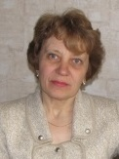 | Nadezhda S. YEVTUSHENKO (Ms.), Senior Researcher, FSBSI Sverdlosk Breeding Station of Horticulture of ARHIBAN, Shcherbakov str. 147, 620076 Ekaterinburg  (tel.: +7(343) 2586501 e-mail: sadovodnauka@mail.ru)
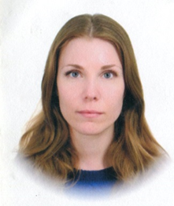 | Marta Y. PETURENKO (Ms.), Junior Researcher, Laboratory of Molecular Biology, Federal State Budgetary Scientific Institution "All-Russian Scientific Research Institute of Sugar beet and named after A.L. Mazlumov", VNIISS, 86, Ramonsky r-n, Voronezh  (tel.: +7(950) 751 85 44 e-mail: biotechnologyia@mail.ru)
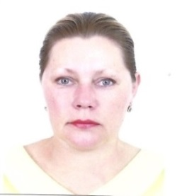 | Zhanna MUKHINA (Ms.), Deputy Director for Innovation Activities and Coordination of Research, FBGO "Rice Research Institute", 350921, Krasnodar, poselok Belozernoe, 3  (Tel / Fax: +8 (861) 2294198 e-mail: agroplazma@gmail.com)
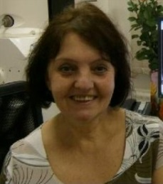 | Svetlana M. MOTYLEVA (Ms.), Head, Laboratory of Physiology and Biochemistry of Plants of the Center of the Gene Pool of Plants and Biological Resources, Federal State Scientific Institution "All-Russia Selection Technological Institute of Horticulture and Nursery" (FGBNU VSTISP), Zagorevskaya street, 4, 115598 Moscow  (tel.: +7(495) 329 51 66 e-mail: vstisp@vstisp.org)
Galina A. NAZAROVA (Ms.), Advisor of the Department of Agricultural Subsidies of the Department of Agroindustrial Policy, Eurasian Economic Commission (EEC), 119121, Moscow, Smolensky Boulevard,3/5, building 1
(tel: +7 (495) 669-24-00, ad. 41-33 fax: +7 (495) 669-24-15 /669-24-94
e-mail: nazarova@eecommission.org, info@eecommission.org)
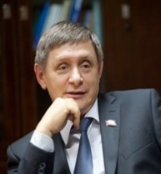 | Igor A. LOBACH, President, Non-profit Organization "National Association of Manufacturers of Seeds of Corn and Sunflower", Dzerzhinskogo str. 35, 350020 Krasnodar city  (tel.: +7(988) 242 39 29; +7(861) 268 17 03 e-mail: i.lobach@napksk.ru)
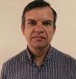 | Mikhail V. SAMUS, Executive Director, Non-profit Organization "National Association of Manufacturers of Seeds of Corn and Sunflower", Dzerzhinskogo str. 35, 350020, Krasnodar  (tel.: +7(929) 837 03 20 e-mail: m.samus@napksk.ru)
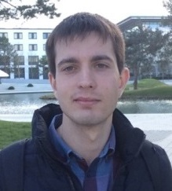 | Aleksandr A. SKLYAROV, LTD "Scientific and production Association "Seeds of Kuban", Konchenyj street, 1"g", village of Ozerki, Ust-Labinsk district, 352320, Krasnodar region  (tel: 8-918-235-35-30 e-mail: npo-sh@ahkuban.ru)
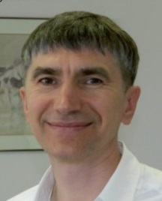 | Sergey N. LUPEKHIN, Chairman, The Potato Union, Marksistskaya str, 22, b. 1, 107149, Moscow  (e-mail: info@malino.ru, Isn@malino.ru, Is9146@yandex.ru)
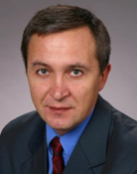 | Alexei P. KRASILNIKOV, Executive Director, The Potato Union, Marksistskaya str, 22, b. 1, 107149, Moscow  (tel.: 8(495) 670 70 06 e-mail: info@WelikePotato.ru)
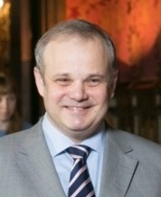 | Ruslan KOKAREV, Director, The Association of European Businesses, Krasnoproletarskaya str., 17, building 1, 127473, Moscow  (e-mail: info@aebrus.ru)
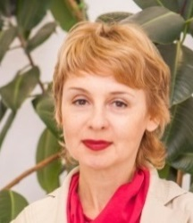 | Tatiana BELOUSOVICH (Ms.), Director for Interaction with Public Authorities in the Sphere of Crop Production, the Association of European Businesses (AEB), ul. Krasnoproletarskaya, 16,, bld 3, entrance 8, Moscow 127473  (tel.: +7 903 969 57 78 e-mail: tatiana.belousovich@aebrus.ru; info@aebrus.ru)
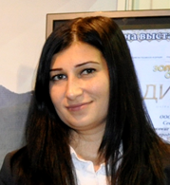 | Irina S. KARDANOVA (Ms.), Acting Head of Laboratory, "FAT-Agro", Telmana str, 45, Vladikavkaz, 362013, Republic North Ossetia-Alania  (tel: 8 918-826-92-98 e-mail: fatagro@mail.ru)
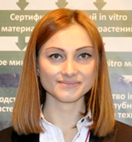 | Karina G. KASAEVA (Ms.), Biotechnologist,"FAT-Agro", Telmana str, 45, Vladikavkaz, 362013, Republic North Ossetia-Alania  (tel: Tel: 8 867 276-86-04, 8 867 224-13-93 e-mail: fatagro@mail.ru)
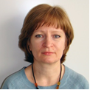 | Tatyana P. SUPRUNOVA (Ms.), Director, Selection-Genetic Center, OOO «Doka-Gene Technology», Moscowskaya str, 58, korp.8, Rogachevo, 141880, Moscow region, Dmitrov district  (tel: 8-962-927-80-88 e-mail: t.suprunova@dokagene.ru)
UNITED KINGDOM
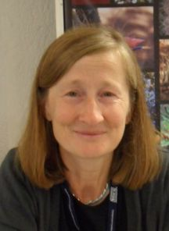 | Elizabeth M.R. SCOTT (Ms.), Head of Crop Characterisation, Varieties and Seeds, National Institute of Agricultural Botany (NIAB), Huntingdon Road, Cambridge CB3 0LE  (tel.: +44 1223 342399 fax: +44 1223 277602 e-mail: elizabeth.scott@niab.com)
Margaret WALLACE (Ms.), Technical Manager, (Cereals, Field Beans And Kale) Agricultural Crops Characterisation, National Institute of Agricultural Botany (NIAB), Huntingdon Road, Cambridge CB3 0LE
(tel.: +44 1223 342288 e-mail: margaret.wallace@niab.com)
Alex REID, Senior Molecular Biologist, SASA, Roddinglaw Road, Edinburgh EH12 9FJ
(tel.: +44 131 244 8910 e-mail: alex.reid@sasa.gsi.gov.uk)
UNITED STATES OF AMERICA
Ruihong GUO (Ms.), Deputy Administrator, AMS, Science & Technology Program, United States Department of Agriculture (USDA), 1400 Independence Avenue, SW, Room 3542 - South Building, Mail Stop 0270, 20250 Washington D.C.
(tel.: +1 202 720 8556 fax: +1 202 720 8477 e-mail: ruihong.guo@ams.usda.gov)
II. organizations
croplife international
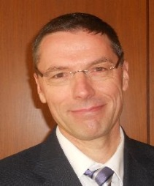 | Marcel BRUINS, Consultant, CropLife International, 326, Avenue Louise, Box 35, 1050 Bruxelles, Belgium  (tel.: +32 2 542 0410 fax: +32 2 542 0419 e-mail: mbruins1964@gmail.com)
EUROPEAN SEED ASSOCIATION (ESA)
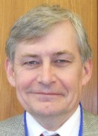 |  | Bert SCHOLTE, Technical Director, 23 rue Luxembourg, 1000 Brussels, Belgium  (tel. : +32 2 743 2860 fax: +32 2 743 2869 e-mail: bertscholte@euroseeds.eu)
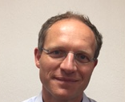 | Jeroen Rouppe VAN DER VOORT, Research Manager IP & External Projects, Enza Zaden Research & Development B.V., Haling 1/E, 1602 DB Enkhuizen, Netherlands  (tel.: +31 (0) 228 350 100 e-mail: j.rouppe@enzazaden.nl)
german plant breeders’ associatoin (bdp)
Sergei V. PLATONOV, Political Coordinator in the Russian Federation, German Plant Breeders' Association (BDP), Kaufmann str. 71-73, 53115 Bonn, Germany
(tel.: +7 (905) 501 53 81 e-mail: sergey.v.platonov@gmail.com)
INTERNATIONAL COMMUNITY OF BREEDERS OF ASEXUALLY REPRODUCED ORNAMENTAL AND FRUIT PLANTS (CIOPORA)
José Ignacio CUBERO, Prof. (emeritus) of genetics and Plant Breeding, Eurogenetic, c/ Doctor Marañon, 11 - 2 A, 14004 Cordoba, Spain
(tel.: +34 67362 67 96 fax: NP e-mail: jicubero@uco.es)
international seed federation (isf)
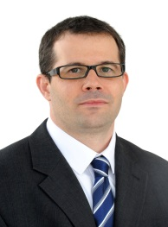 | Szabolcs RUTHNER, Regulatory Affairs Executive, International Seed Federation (ISF), Chemin du Reposoir 7, 1260 Nyon, Switzerland  (tel.: +41 22 365 4420 fax: +41 22 365 4421 e-mail: s.ruthner@worldseed.org)
international seed testing association (ista)
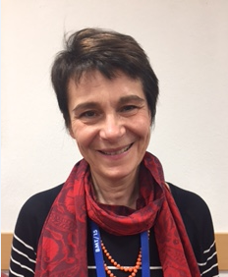 | Chiara DELOGU (Ms.), CREA-SCS Laboratorio Analisi Sementi, Via Emilia 19 KM 307, Lodi, 26838 Tavazzano, Italy  (tel.: +39 371 76 19 19 fax: +39 371 76 08 12 e-mail: chiara.delogu@crea.gov.it)
SEED ASSOCIATION OF THE AMERICAS (SAA)
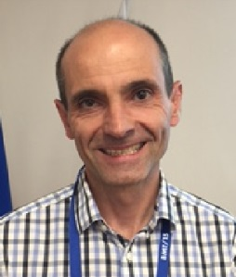 | Frédéric ACHARD, Germplasm scientist, 145 horsehoe dr, Kirkwood, MO 63122, United States of America  (tel.: 1-314-403-0222 e-mail: fred@achard.us)
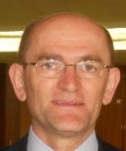 | Stevan MADJARAC, Germplasm IP Lead, American Seed Trade Association (ASTA), 1701 Duke Street, Suite 275, Alexandria, VA22314, United States of America  (tel.: +1 636 7344395 fax: +1 314 694 5311 e-mail: s.madjarac@gmail.com)
Barry K. NELSON, Research Scientist, Pioneer Hi-Bred International Inc., 7300 N.W. 62nd avenue, Johnston IA 50131, United States of America
(tel.: 1 515 535 202 fax: 1 515 535 3934 e-mail: barry.nelson@pioneer.com)
III. CHAIRMAN
Kees VAN ETTEKOVEN, Head, Variety Registration Department, Naktuinbouw, Sotaweg 22, 2371 GD Roelofarendsveen
(Tel.: +31 6 113 60675 email: c.v.ettekoven@naktuinbouw.nl)
IV. UPOV OFFICE
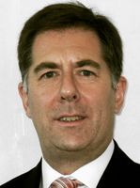 | Peter BUTTON, Vice-Secretary General, International Union for the Protection of New Varieties of Plants (UPOV), 34 chemin des Colombettes, 1211 Geneva 20  (tel.: +41 22 338 8672 fax: +41 22 733 03 36 email: peter.button@upov.int)
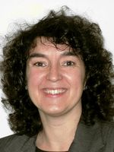 | Yolanda HUERTA (Ms.), Legal Counsel, International Union for the Protection of New Varieties of Plants (UPOV), 34 chemin des Colombettes, 1211 Geneva 20  (tel.: +41 22 338 9410 fax: +41 22 733 03 36 email: yolanda.huerta@upov.int
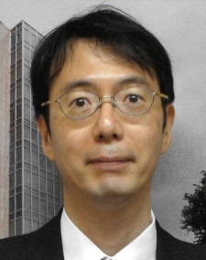 | Jun KOIDE, Technical/Regional Officer, International Union for the Protection of New Varieties of Plants (UPOV), 34 chemin des Colombettes, 1211 Geneva 20  (tel.: +41 22 338 7442 fax: +41 22 733 03 36 email: jun.koide@upov.int)
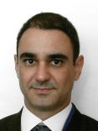 | Leontino TAVEIRA, Technical/Regional Officer (Latin America, Caribbean), International Union for the Protection of New Varieties of Plants (UPOV), 34 chemin des Colombettes, 1211 Geneva 20  (tel.: +41 22 338 9565 fax: +41 22 733 03 36 email: leontino.taveira@upov.int)

[Annex II follows]

WELCOME ADDRESS BY MR. EVGENY V. GROMYKO, FIRST DEPUTY MINISTER OF AGRICULTURE OF THE RUSSIAN FEDERATION,

Dear colleagues, dear representatives of members of the International Union for the Protection of New Varieties of Plants, dear guests!
I am glad to welcome you on Russian land and note with satisfaction the similarity of positions of the Ministry of Agriculture of the Russian Federation, and the Governing Bodies of the Union in views on the development of variety trials in the Russian Federation.
At the meeting with Vice Secretary-General of the International Union for the Protection of New Varieties of Plants, we agreed on the progressive solution of problems of harmonization of legislation of the Russian Federation and international legal acts, to the participation of the parties in the development of crop production, our export varieties and receive royalty breeders.
A large role in the implementation of these agreements belongs to the development of biotechnological and molecular methods genotyping and certification of varieties of agricultural plants.
Let me read the Minister’s of Agriculture of the Russian Federation A. N. Tkachev address to the participants of the session of the Working Group on Biochemical and Molecular Techniques, and DNA-Profiling in Particular (BMT).

Dear Participants, Organizers and Guests!

I congratulate you on the opening of the session of the Working Group on Biochemical and Molecular Technologies!
On behalf of the Ministry of Agriculture of the Russian Federation and on my own behalf I would like to express my appreciation for the fruitful cooperation existing between our competent authorities.
Representatives of the Russian Federation take part in the work of most of the meetings of the bodies of UPOV, as well as participate in the discussion and adoption of documents of the Union.
Today we are taking the first session of the Working Group on Biochemical and Molecular Technologies, and DNA-Profiling in Particular (BMT) and hope this will become a tradition in the Russian Federation to hold session of UPOV Bodies.
For the development of any industry and the formation of scientific and expert opinions, development strategy making, regular events are necessary to be held, they will serve a platform for communication of representatives of breeding, variety testing, seed production and agricultural production.
I am convinced that professionalism and responsible approach to the matter and energy of the participants of the session will promote further mutually beneficial cooperation and exchange of experience.
I wish all the participants and guests of the session of the BMT good luck, fruitful work and creative successes!

The Minister of Agriculture
Russian Federation
Aleksander N. Tkachev

I hope that the results of the session will provide as a powerful impetus for the development of breeding and seed production, as the necessary conditions for the effective solution of the food problem in the world!

[Annex III follows]

WELCOME ADDRESS BY MR. VITALY, S. VOLOSHCHENKO, CHAIRMAN OF STATE COMMISSION OF THE RUSSIAN FEDERATION FOR SELECTION ACHIEVEMENTS TEST AND PROTECTION, RUSSIAN FEDERATION

Dear colleagues and friends!

On behalf of the State Commission of the Russian Federation for Selection Achievements Test and Protection, authority on breeder’s rights under granting the Ministry of Agriculture, let me greet you here in Moscow, the capital of the Russian Federation, and wish you successful work at this session of the UPOV Working Group on Biochemical and Molecular Techniques, and DNA-Profiling in Particular (BMT).
The Russian Federation, while being a UPOV member since 1998, has national legislation that fully conforms to the 1991 Act of the UPOV Convention.
The State Commission of the Russian Federation for Selection Achievements Test and Protection interacts with applicants from members of UPOV on equal terms.
This year the Russian Federation is hosting a Technical Working Party of the UPOV for the first time, and the issues it is trying to solve are very important for the Russian Federation.
Biochemical and molecular techniques during the examination of Distinctness, Uniformity and Stability and during the settlement of molecular markers of the protected varieties and varieties in use will help to strengthen the protection of breeders’ rights, and in perspective – to develop the breeding sphere and increase agricultural production.
I wish you success and inspiration in your work at the session, as well as a pleasant stay in Moscow and sound health!

[Annex IV follows]

WELCOME ADDRESS BY MR. VLADIMIR M. KOSOLAPOV, HEAD OF DEPARTMENT OF PLANT PRODUCTION, PROTECTION AND BIOTECHNOLOGY, RUSSIAN SCIENCE ACADEMY.

Dear colleagues, allow me to voice the greeting of the Russian Academy of Sciences.
For the first time on Russian land gathered biochemists and experts in molecular technologies, to exchange opinions, to share successes in working to create methods for variety testing of agricultural plants and DNA profiling. Scientific schools of biotechnology has established and successfully functioning in the All-Russian Institute of Agricultural Biotechnology, Russian State Agrarian University - Moscow Timiryazev Agricultural Academy, Institute of General genetics RAS in the Russian Federation.
Currently, the development of agro- and biotechnologies is not only one of the priority areas of research, but already it has achieved impressive results for their practical use on an industrial scale. Here a very good example of technological platforms operating under public-private partnership. Breeders of industry institutions that use biotechnology took on a fundamentally new position in the acceleration of the process of creating varieties of programmed characteristics. The result is significantly increased efficiency investment. Domestic varieties and hybrids become competitive, and they often surpass foreign analogues in their quality indicators. However, despite the fact that many breeders, both in our country and abroad, are using methods for biomolecular technologies for a long time in their practice, often, the assessment of distinctness, uniformity and stability of characteristics of varieties and establishment of variety purity is done with the help of a soil variety control still. So it needs our joint efforts to develop new, available to every researcher of high-tech methods of evaluating genotypes of the varieties which will make the testing process more accurate, rapid, easily reproducible, and not expensive.
The Russian Academy of Sciences wishes all the participants of the BMT successful work, the implementation of set tasks, research and production activities.
Success to You!

[Annex V follows]

WELCOME ADDRESS BY MR. IGOR A. LOBACH, PRESIDENT, NATIONAL ASSOCIATION OF MANUFACTURERS OF SEEDS OF CORN AND SUNFLOWER

Dear Evgeny Vasilievich, dear Peter, dear audience
I am very grateful to UPOV for the decision to hold this session here. And not only because it is, so to speak, a political overture, a sign of politeness. As a person who has been deal with construction of our Unions breeding and seed production over 7 years, I can say that we are interested in the work of UPOV as a platform on which we can to discuss the question and issues that arise for us in the following three, and maybe even more areas. I almost completely agree with Vitaliy Sergeevich. He as an active and understanding of strategy person for moving forward in this direction, very rightly so, that took the initiative, supported by the Ministry of Agriculture and the Department of Crop Production, in order to intensify work in this direction.
Why should we, the breeders and seed growers need contacts with UPOV?
The first thing I want to draw your attention from the report Peter, we heard today a lot of applications for the registration of varieties in the UPOV receive from Russia, as I understand it. And it suggests that we are more and more activated in the protection of our rights for selection achievements.
The second. More and more companies, including members of our Union and Associations enter the international markets. I'm not talking about such a serious Breeding Centers as Institute of Rice, Krasnodar Research Institute of Agriculture, which delivers up to 17,000 tons of seed to foreign markets and furthermore there are already private seed companies, such as «Agroplasma» who are engaged in sunflower, grown in Turkey and in Pakistan, and for this market. There is such firm like «Gavrish», which is engaged in vegetable crops and has branches already in Jordan and works at the market. I.e. we more and more enter the international markets and this, I think, a promising direction that will allow us not only to improve the quality of their products in our market, but also skillfully to compete in foreign markets if there is we will create equal competitive conditions – this is what I heard today in the speech of Peter. It would be very cool to do it. And here, in this situation, the protection of breeding achievements is evident not only in the preservation of authorship, it is very important, but it is also important that we need to fight counterfeiting, which is present today on the market of the Russian Federation. This "disease" affects not only the Russian seeds, but also the foreign, which are sold here. And today we have not, in our opinion, such clear methods and methodology of determining the authorship of the variety and its identification. Therefore, consideration of the features of the methodology on biomolecular technologies is very important for us and I want to thank our representatives that they are here today.
The next question is about collecting royalties. Despite the fact that our members not in the first place put this issue to themselves, in contrast to representatives of foreign companies, for us this is also important because it is clearly putting in order with payment of royalties on the territory of the Russian Federation will contribute to the development of breeding, even the new generation, which appears today in Russia, but will create transparent working conditions for all market participants and will increase the attractiveness of plant breeding and seed production on the territory of Russia. It is also in the interests of Russian and foreign companies that today seek to find themselves in those rules, which exist in Russian Federation. And I would like to quote the words of Yevgeny Vasilyevich, who before the start of our conference said that: «Russia does not seek to be first, Russia seeks to be an equal among equals». This is the correct message, although in some places I disagree. I think that in the selection of cereal crops we first and try us catch up! I think that the continuation of the work started, will allow to create and to apply practical techniques to improve legislation on the protection of copyright, existing in the Russian Federation at the present time. Because understanding who is author of the variety is very important to us.
In this regard, I would like to wish all active work, active contacts of our breeders are members of UPOV, in order to, as Vitaliy Sergeevich said, this interaction was precisely the point of growth that would allow us all to move on the territory of the Russian Federation and not only.
Thank you all very much!

[Annex VI follows]

WELCOME ADDRESS BY MS. EKATERINA V. ZHURAVLEVA, DEPUTY CHIEF, DEPARTMENT OF COOPERATION AND SUPPORT OF ORGANIZATIONS IN THE FIELD OF AGRICULTURAL SCIENCES, FEDERAL AGENCY OF SCIENTIFIC ORGANIZATIONS

Dear members of the Presidium, dear Peter, dear Evgeny V., dear colleagues,
On behalf of the Federal Agency of Scientific Organizations, let me welcome you to this significant and I would say epochal event.
It is not only the 15th session of the UPOV, the first in the Russian Federation, but also it is the unification of fundamental science and the association of practices. I am pleased to realize that we are at that critical stage of the path when the chain of genetics-breeding-seed production to appear on a new level. Our scientists and plant breeders are working on the whole territory of the Russian Federation. And, due to the fact that we have unique natural and climatic resources, we have all the diversity of cultures. And I'd like to hope that in the days of the session, we will see new ways, new opportunities of application of the potential of molecular genetics for variety testing experts.
Very pleased that Peter Button and our colleagues will visit tomorrow St. Petersburg and the Institute named after N. I. Vavilov and they will see a high level of research of Genetic Bank, which is at the international level. And I would like to wish all participants below the level of all stages from selection to variety testing and seed production meet the highest level of all countries-participants of the UPOV
So let me on behalf of the Federal Agency of Scientific Organizations to wish you successful work and all the best.
Thank you!

[Annex VII follows]

WELCOME ADDRESS BY MR. SERGEY LUPEKHIN, PRESIDENT, RUSSIAN POTATO UNION

Dear colleagues,
I present here the Union of potato growers and of the participants of the potato market of the Russian Federation. We, as potato growers, have to solve a large enough problem in our country. This is to increase the quantity of seed material of the domestic selection, which will be in demand in the near future. Because today the best varieties of potatoes that are used in our country, we imported from Europe. And we are grateful to the European breeders that they produce is a market of varieties which are well sold and well-used Russian producers. But at this time are actively developing the direction of Russian domestic breeding and in the next 5-7 years will likely appear very interesting varieties that can be amazing for the whole world.
So I want to wish the Russian and European breeders and seed growers closer and actively communicate with each other in order to improve the quality of their seeds. With regard to the topic of today's conference or seminar about molecular diagnostics and determination of varieties it is a very important topic. Because the whole world is accelerating and of course the seed production industry needs to keep pace with this tempo, we must as soon as possible and online to determine varieties that we use in production.
Thank you for your attention.
I wish you all success!

[Annex VIII follows]

OPENING REMARK BY MR. PETER BUTTON, VICE SECRETARY-GENERAL OF THE INTERNATIONAL UNION FOR THE PROTECTION OF NEW VARIETIES OF PLANTS (UPOV)

Honorable Mr. Alexander Tkachev, Minister of agriculture of the Russian Federation,
Mr. Vitaly Voloshchenko, Chairman, State Commission of the Russian Federation for Selection Achievements Test and Protection.
Mr. Van Ettekoven, Chairman of the BMT,
Distinguished participants,
Ladies and Gentlemen,

I would like to start by extending my thanks to the State Commission of the Russian Federation for Selection Achievements Test and Protection, Ministry of Agriculture of the Russian Federation, for hosting this fifteenth session of the UPOV Working Group on Biochemical and Molecular Techniques, and DNA-Profiling in Particular (BMT). This is an historic occasion, being the first ever meeting of a UPOV Technical Working Party here in the Russian Federation. Given the warm welcome and excellent program that has been organized by the State Commission, I am sure that there will be a great desire from UPOV members to have further meetings in the Russian Federation in the future.

On any occasion, it is a great pleasure to be in the wonderful city of Moscow. However, we are here in the context of a UPOV meeting, which has particular significance. The mission of UPOV is to provide and promote an effective system of plant variety protection, with the aim of encouraging the development of new varieties of plants, for the benefit of society. The development of new varieties of plants – plant breeding – for the benefit of society might also be described as the mission of the great Nikolai Ivanovich Vavilov, who was born and studied here in Moscow. I am sure that the thought of all that Vavilov achieved will be an inspiration for all of us to be ambitious in our work this week.

The legacy of plant breeding continues to live on in the Russian Federation. The number of applications for plant breeders’ rights for new varieties has increased in the five-year period 2010-2014 by 24%, from 581 to 722. In 2014, the Russian Federation ranked 6th of all UPOV members for the number of applications and 5th of State members. In terms of applications by residents (537), the Russian Federation ranks 6th of UPOV members and 5th of State members. In terms of non-resident applications (185), the Russian Federation ranks 8th in terms of UPOV members and 7th of State members. It is particularly interesting to see that the number of applications by non-residents in the Russian Federation has increased substantially from 2010 (51) to 2014 (185), representing a 263% increase. The proportion of non-resident applications now represents around 26% of all applications in the Russian Federation, compared to only 9% in 2010. New varieties introduced by non-resident breeders will bring benefits for farmers in the Russian Federation. At the same time, varieties bred by Russian breeders are delivering benefits to farmers and growers in other countries. In 2014, breeders from the Russian Federation made applications for plant breeders’ rights of their new varieties in Australia, Chile, Germany, the European Union, Serbia and Ukraine.

The strength of the plant variety protection (PVP) systems in the individual UPOV members is important for the success of agriculture. In 2005, UPOV published a study as means of providing countries considering the introduction of a PVP system with information on the impact of PVP systems according to the UPOV Convention (the UPOV Report on the Impact of Plant Variety Protection (“Impact Study”): see http://www.upov.int/edocs/pubdocs/en/upov_pub_353.pdf) . The Impact Study demonstrated a range of beneficial impacts. In addition to the benefits seen from the introduction of plant variety protection based on the UPOV Convention, specific positive impacts were seen with regard to membership of UPOV. Those aspects reflect the value of the work of UPOV as an organization in providing advice and assistance to its members and future UPOV members. Whilst the main purpose of the study was to provide information to countries considering the introduction of a PVP system, an important result of the study was also to show that there have been benefits for all UPOV members as the Union has grown in membership. As the study concluded “farmers, growers and breeders have access to the best varieties produced by breeders throughout UPOV member territories”.

In order to realize the full benefits of UPOV, it is important for breeders to have incentives to breed and to be able to make applications in UPOV members where their varieties could be of benefit for agriculture. In recognition of this, a key objective for UPOV in the coming years will be to facilitate applications through the development of an electronic application system and to further facilitate cooperation in the examination of varieties.

One of the aims of the electronic application form (EAF) project is help breeders to overcome language barriers by providing the possibility to read all application form questions in all languages of participating members. The EAF will also provide an electronic tool for breeders to use in relation to applications in UPOV members that participate in the EAF project, even when there is no electronic application system in the UPOV members concerned. The project will also facilitate the exchange of data in a standard XML format and will allow breeders to re-use relevant application data for an application in one UPOV member for applications in other UPOV members.

With regard to cooperation in examination, it is apparent that molecular data has the potential to offer new possibilities to enhance cooperation in the examination of Distinctness, Uniformity and Stability (“DUS”). I am sure that this is one of the aspects that will be the subject of the discussions this week in the BMT. Another important subject of discussion will be methods that may have the potential to enable molecular techniques to improve the efficiency and effectiveness of the DUS examination. It will be interesting to see if any of these methods will provide a basis for a new model for the use of biochemical and molecular markers in the examination of DUS.

One of the aims of the BMT is to provide a forum for discussion on the use of biochemical and molecular techniques in the consideration of essential derivation and variety identification. These matters will form the core of the “Breeders’ Day”, which will provide an opportunity for UPOV members to hear about developments in the use of these techniques by breeders.

I have made several references to cooperation between UPOV members. At the same time, UPOV has been exploring cooperation in relation to the use of molecular techniques with other organizations. A first initiative was the organization of a joint workshop on molecular techniques with the Organization for Economic Co-operation and Development (OECD), the International Seed Testing Association (ISTA) and UPOV, in conjunction with the fourteenth session of the BMT, which was held in Seoul, Republic of Korea, in November 2014. There have been further developments with regard to this initiative, which will be reported to participants at this BMT session.

In conclusion: we have an agenda with many interesting and important topics. We are in a city that is the birthplace of Nikolai Ivanovich Vavilov. We have excellent meeting facilities and a wonderful meeting environment. Therefore, we should ensure that we make the most of this opportunity to achieve valuable results.

[Annex IX follows]

Presentation by Mr. Viktor I. Startcev on “Plant Variety Test and Protection System in the Russian Federation”

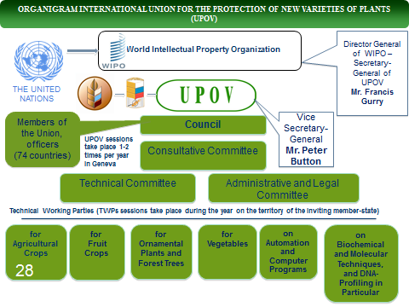

[End of Annex IX and of document]

