E
BMT/15/21
ORIGINAL: English
DATE: May 20, 2016
INTERNATIONAL UNION FOR THE PROTECTION OF NEW VARIETIES OF PLANTS
Geneva
WORKING GROUP ON BIOCHEMICAL AND MOLECULAR
TECHNIQUES AND DNA PROFILING IN PARTICULAR
Fifteenth Session
Moscow, Russian Federation, May 24 to 27, 2016
Efficient DUS test in French bean by using molecular data
Document prepared by experts from the Netherlands
Disclaimer: this document does not represent UPOV policies or guidance
The Annex to this document contains a copy of a presentation “Efficient DUS test in French bean
by using molecular data” to be made at its fifteenth session of the Working Group on Biochemical and Molecular Techniques and DNA-Profiling in particular (BMT).

Amanda van Dijk, Specialist Variety Testing, Naktuinbouw
Hedwich Teunissen, Molecular Biologist, Naktuinbouw
Kees van Ettekoven, Head Variety testing Department, Naktuinbouw

[Annex follows]

EFFICIENT DUS TEST IN FRENCH BEAN BY USING MOLECULAR DATA

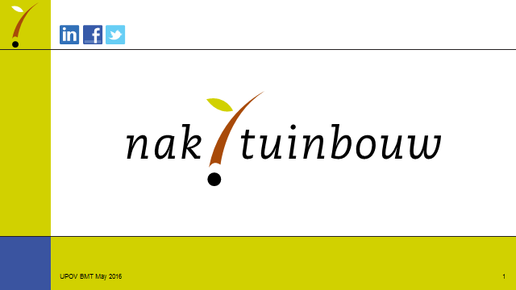

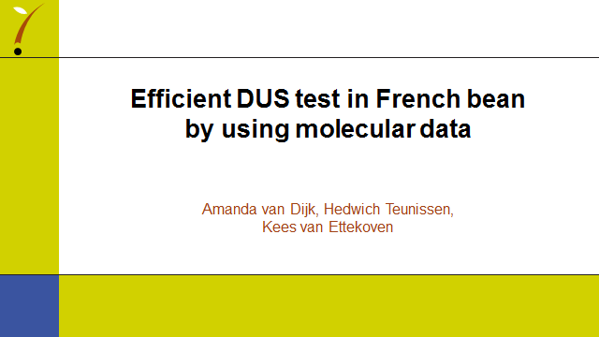

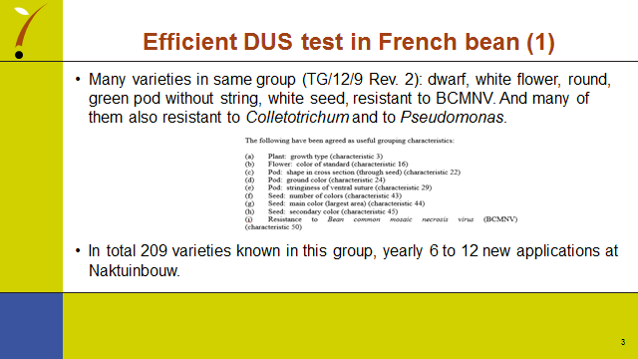

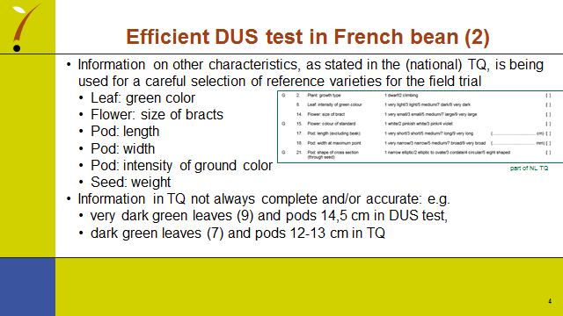

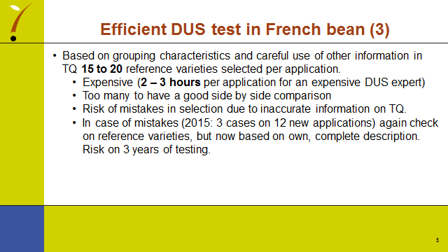

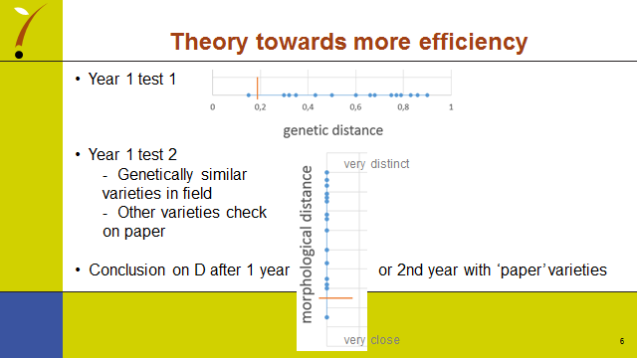

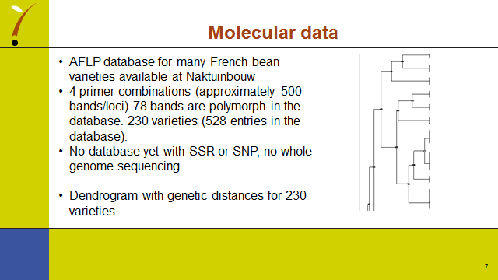

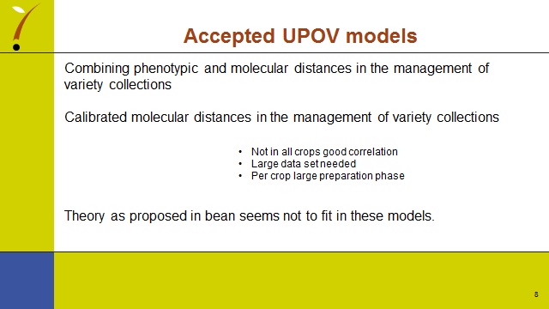

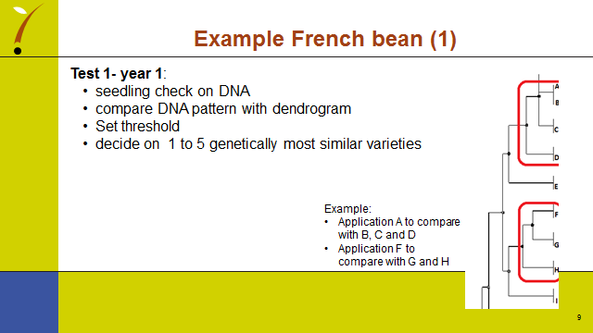

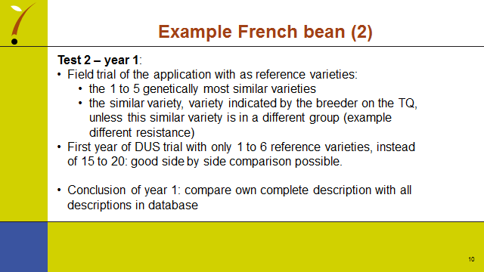

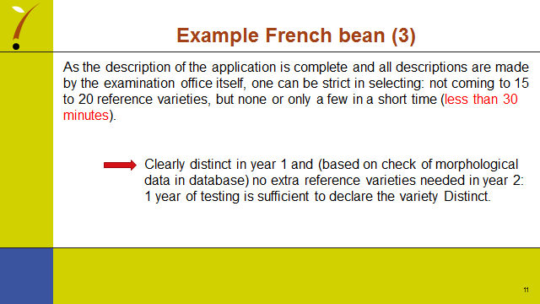

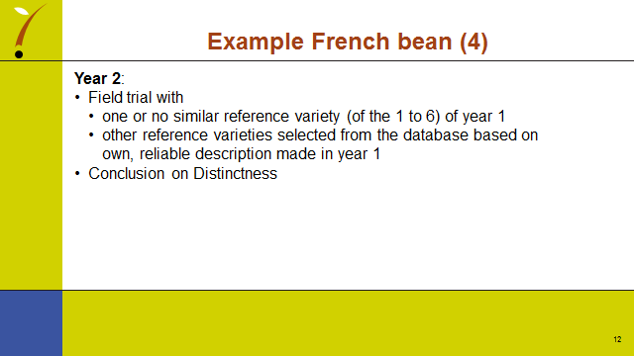

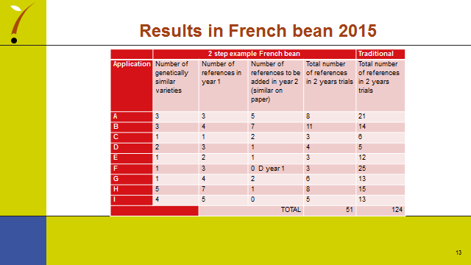

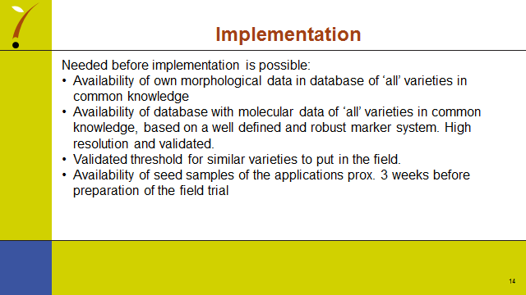

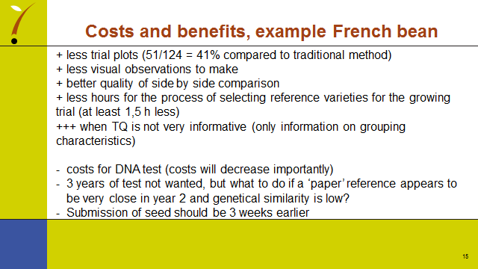

End of Annex and of document]

