E
BMT/15/20
ORIGINAL: English
DATE: May 19, 2016
INTERNATIONAL UNION FOR THE PROTECTION OF NEW VARIETIES OF PLANTS
Geneva
WORKING GROUP ON BIOCHEMICAL AND MOLECULAR
TECHNIQUES AND DNA PROFILING IN PARTICULAR
Fifteenth Session
Moscow, Russian Federation, May 24 to 27, 2016
Advances in the construction and application of DNA fingerprint database in maize
Document prepared by experts from China
Disclaimer: this document does not represent UPOV policies or guidance
The Annex to this document contains a copy of a presentation “Advances in the construction and application of DNA fingerprint database in maize” to be made at its fifteenth session of the Working Group on Biochemical and Molecular Techniques and DNA-Profiling in particular (BMT).

Jiuran Zhao and Zi Shi
The Maize Research Center, Beijing Academy of Agriculture and Forestry Sciences, China

[Annex follows]

ADVANCES IN THE CONSTRUCTION AND APPLICATION OF DNA FINGERPRINT DATABASE IN MAIZE

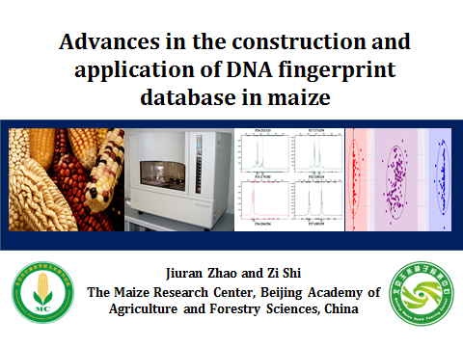

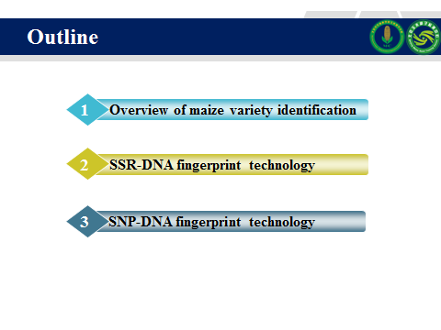

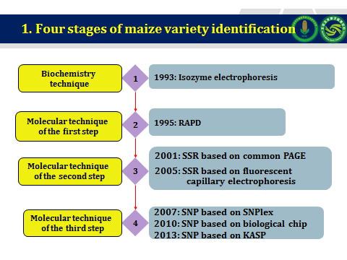

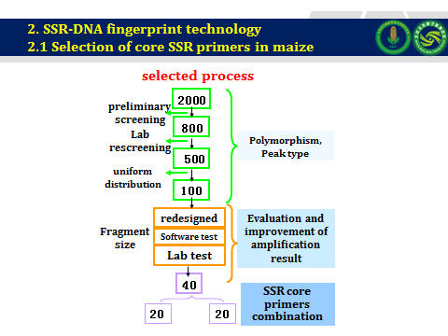

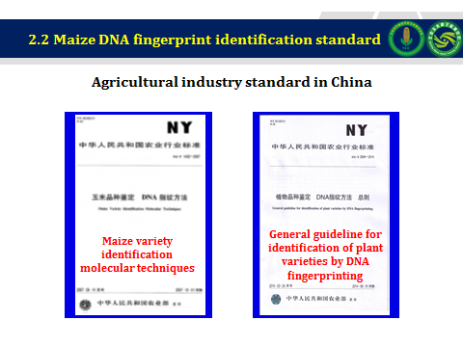

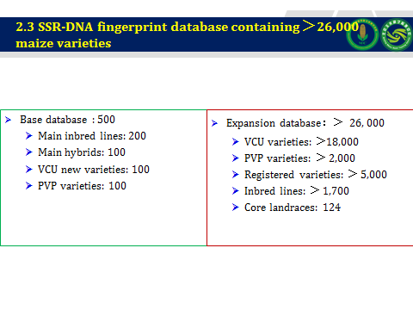

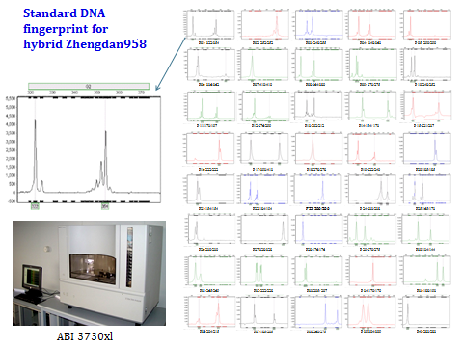

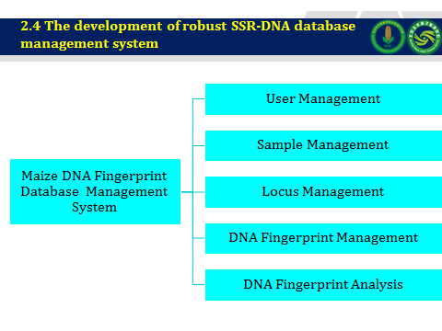

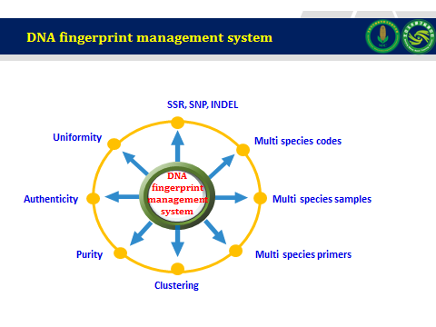

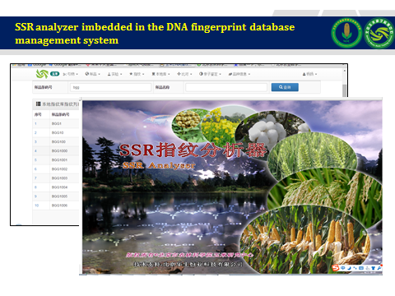

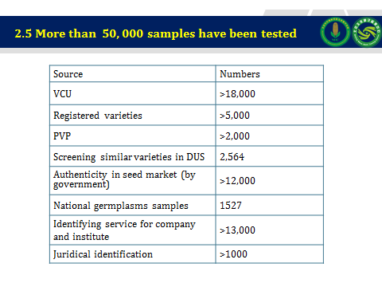

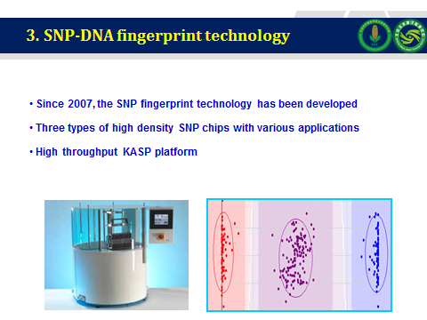

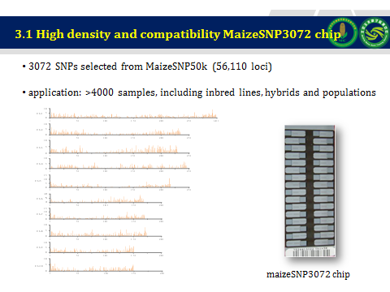

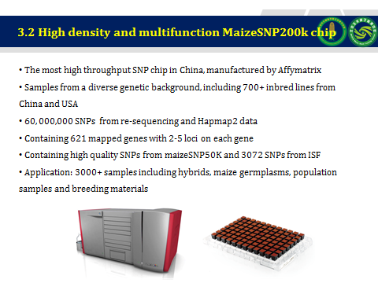

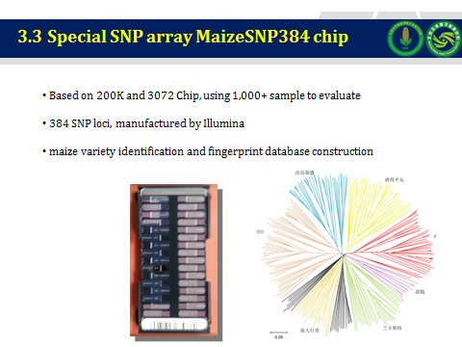

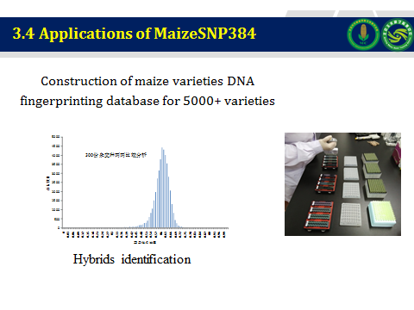

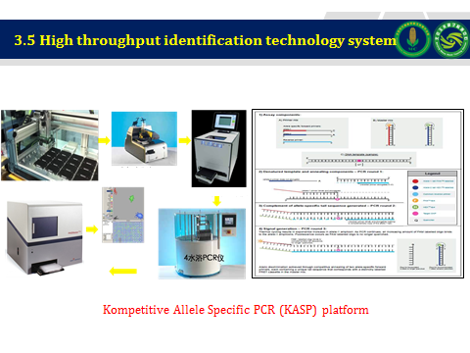

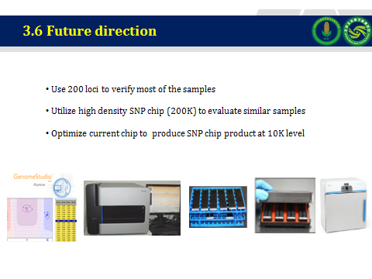

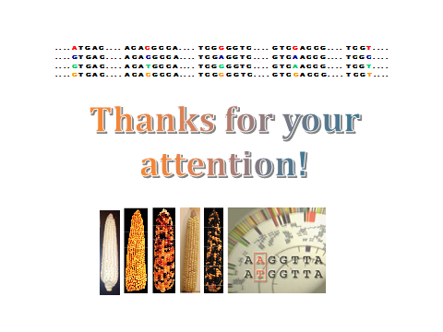

[End of Annex and of document]

