E
BMT/15/19
ORIGINAL: English
DATE: May 19, 2016
INTERNATIONAL UNION FOR THE PROTECTION OF NEW VARIETIES OF PLANTS
Geneva
WORKING GROUP ON BIOCHEMICAL AND MOLECULAR
TECHNIQUES AND DNA PROFILING IN PARTICULAR
Fifteenth Session
Moscow, Russian Federation, May 24 to 27, 2016
DNA-based method for variety testing: ISTA approach
Document prepared by an expert from International Seed Testing Association (ISTA)
Disclaimer: this document does not represent UPOV policies or guidance
The Annex to this document contains a copy of a presentation “DNA-based method for variety testing: ISTA approach” to be made at its fifteenth session of the Working Group on Biochemical and Molecular Techniques and DNA-Profiling in particular (BMT).

Chiara Delogu, ISTA Variety Committee member, Consiglio per la Ricerca in Agricoltura e l’Analisi dell’Economia Agraria, Centro di Sperimentazione e Certificazione delle Sementi (CREA – SCS), Council for Agricultural Research and Economics, Seed Experimentation and Certification Centre, Seed testing Laboratory – Tavazzano, Italy

[Annex follows]

DNA-BASED METHOD FOR VARIETY TESTING: ISTA APPROACH

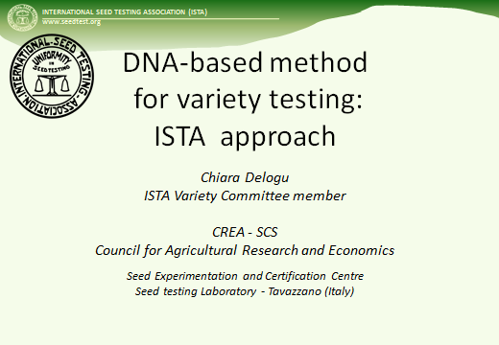

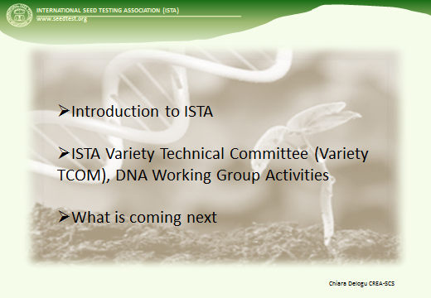

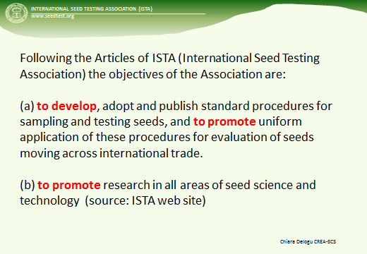

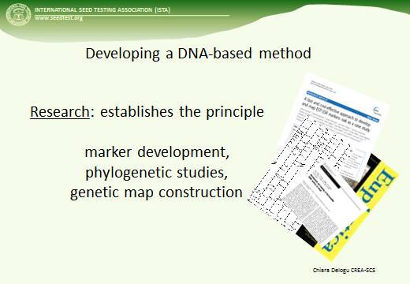

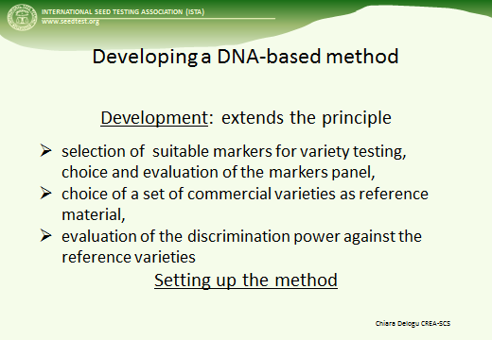

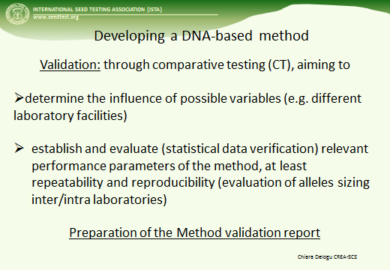

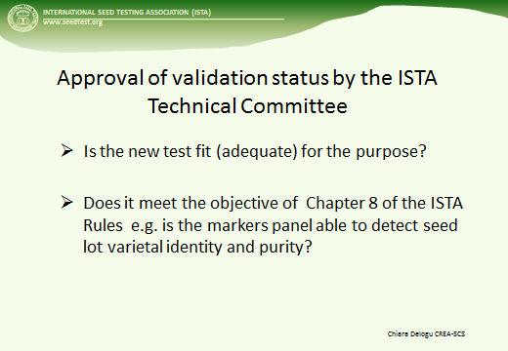

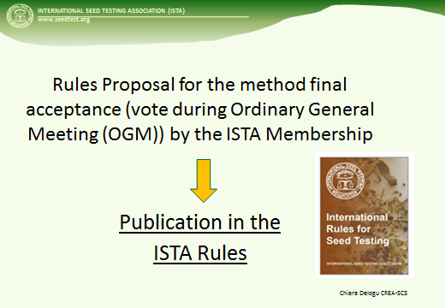

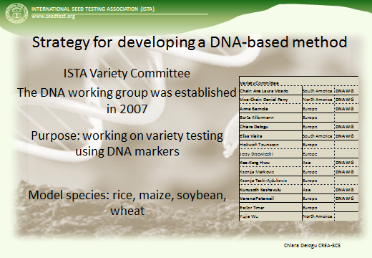

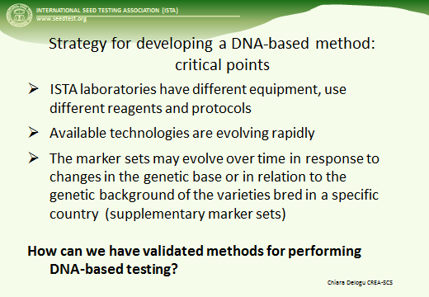

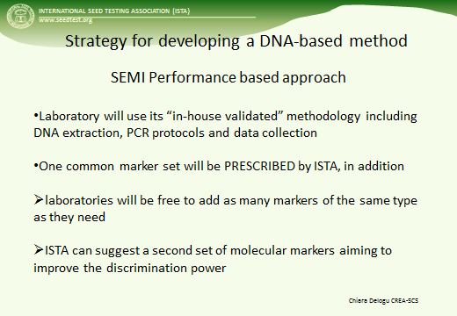

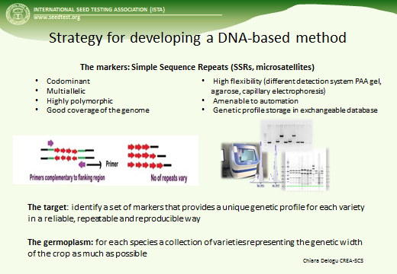

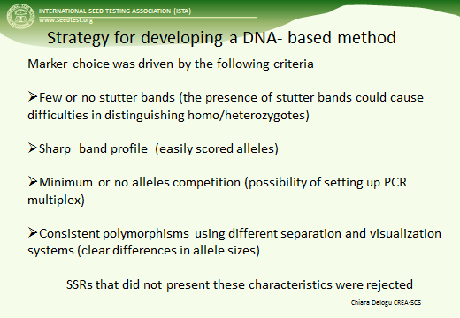

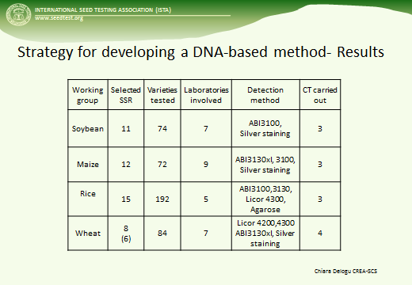

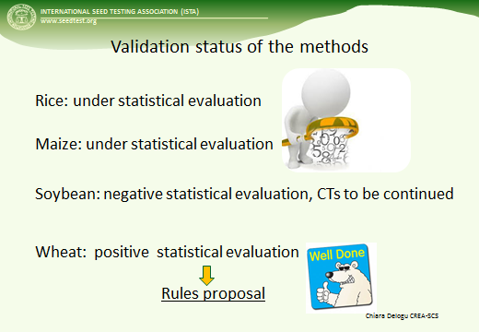

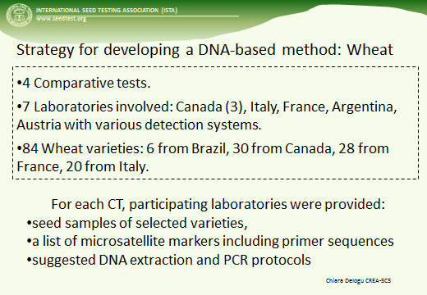

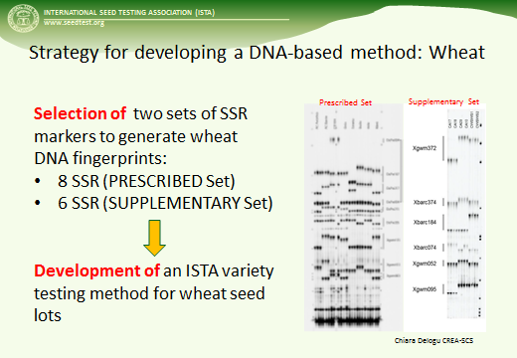

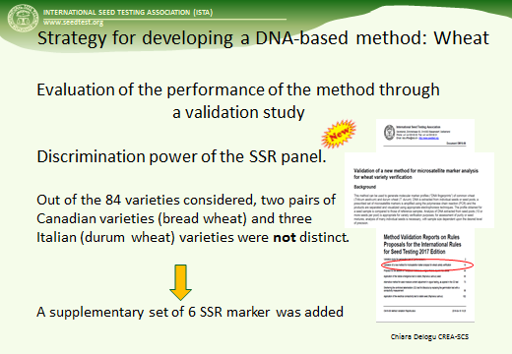

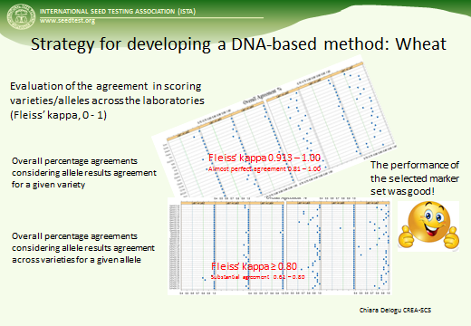

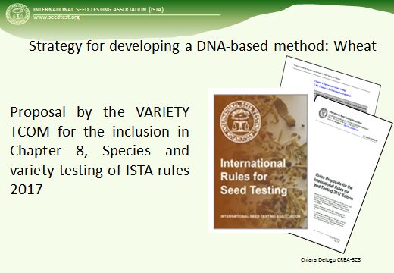

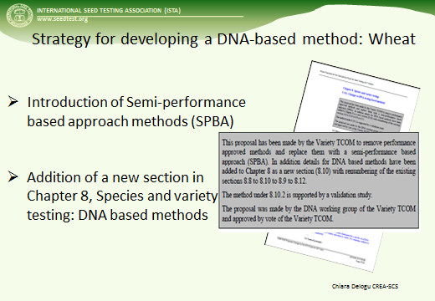

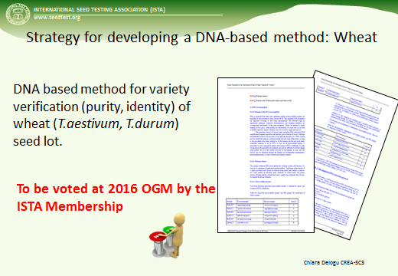

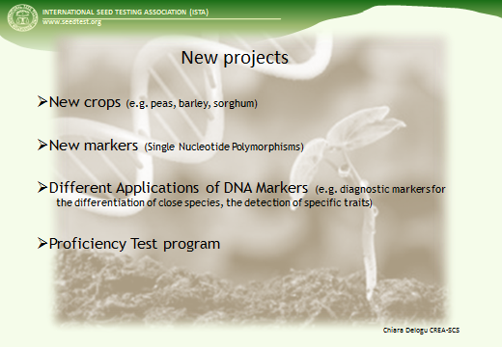

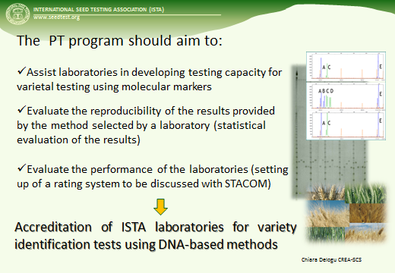

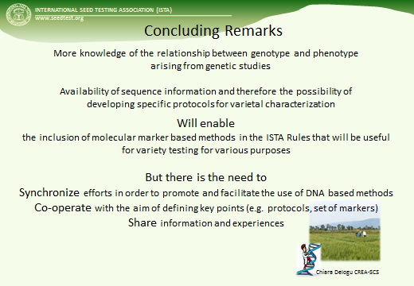

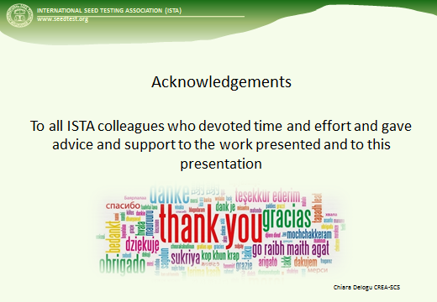
[End of Annex and of document]

