E
BMT/15/17
ORIGINAL: English
DATE: May 20, 2016
INTERNATIONAL UNION FOR THE PROTECTION OF NEW VARIETIES OF PLANTS
Geneva
WORKING GROUP ON BIOCHEMICAL AND MOLECULAR
TECHNIQUES AND DNA PROFILING IN PARTICULAR
Fifteenth Session
Moscow, Russian Federation, May 24 to 27, 2016
Gene and genome editing with CRISPR-cas9
Document prepared by an expert from the Netherlands
Disclaimer: this document does not represent UPOV policies or guidance
The Annex to this document contains a copy of a presentation “Gene and genome editing
with CRISPR-cas9” to be made at its fifteenth session of the Working Group on Biochemical and Molecular Techniques and DNA-Profiling in particular (BMT).

Hedwich Teunissen, Molecular Biologist, Naktuinbouw

[Annex follows]

GENE AND GENOME EDITING WITH CRISPR-CAS9

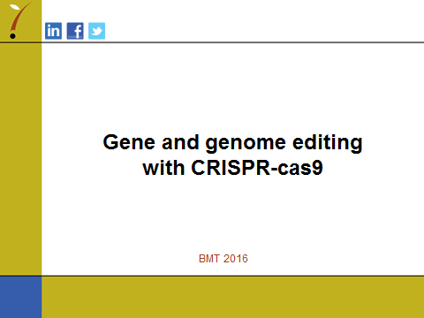

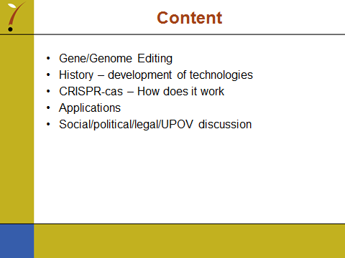

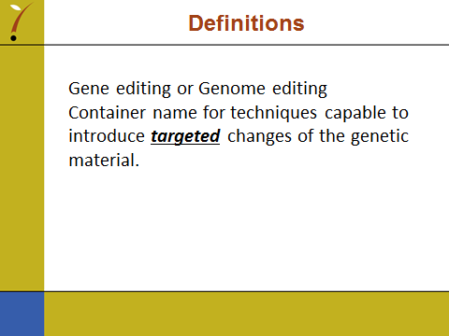

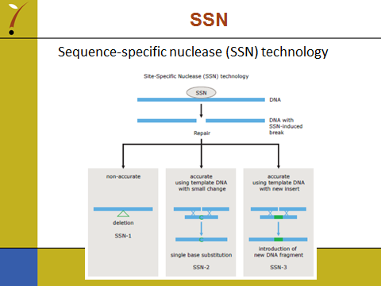

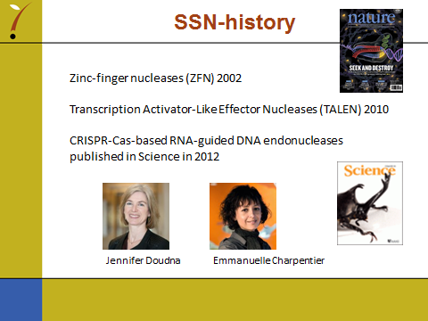

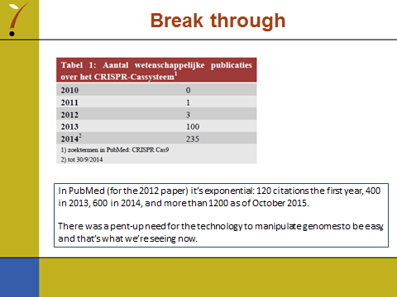

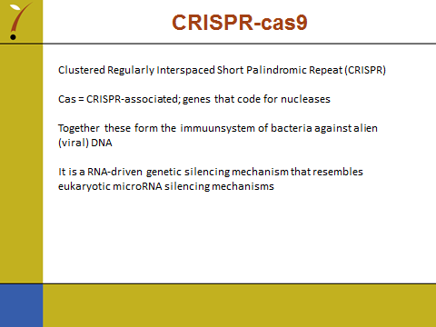

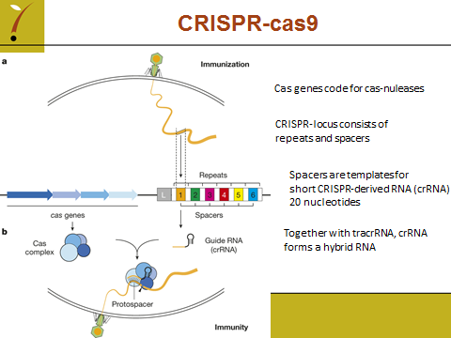

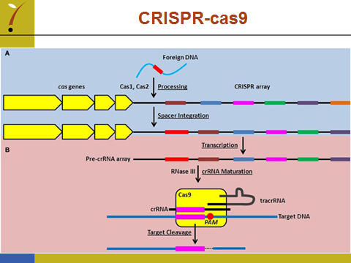

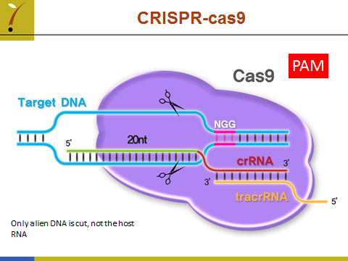

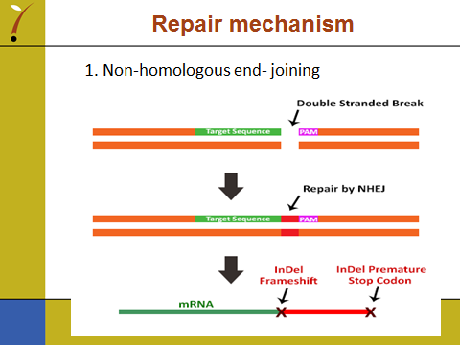

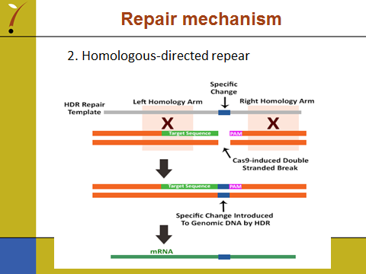

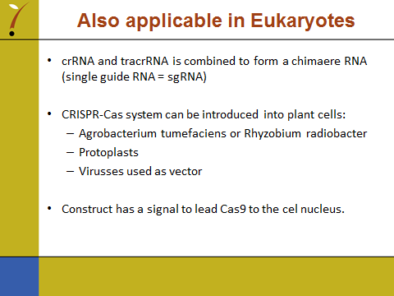

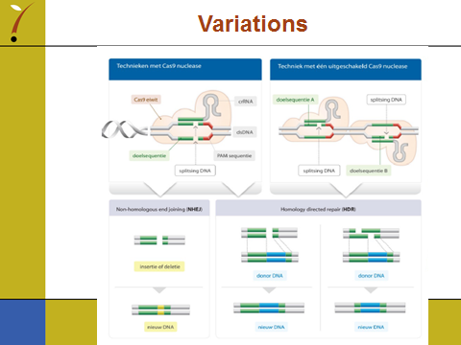

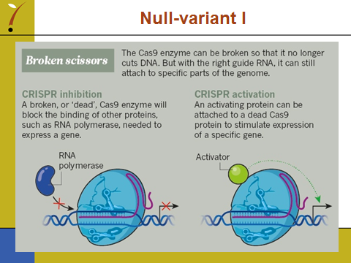

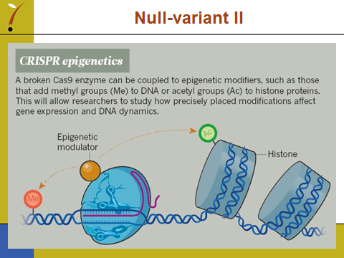

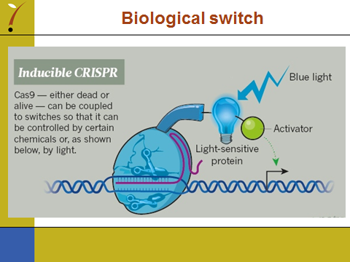

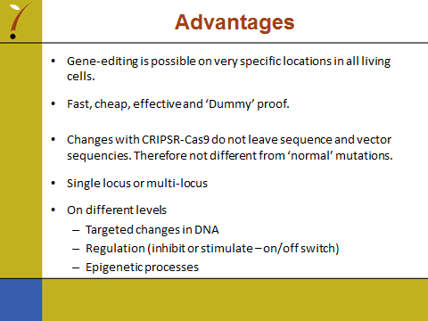

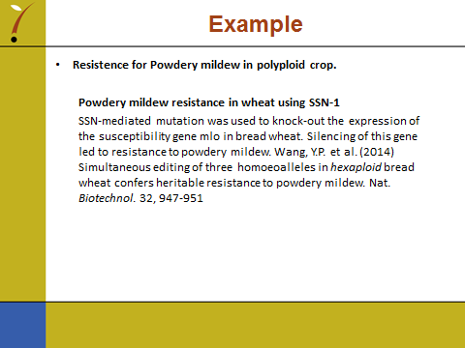

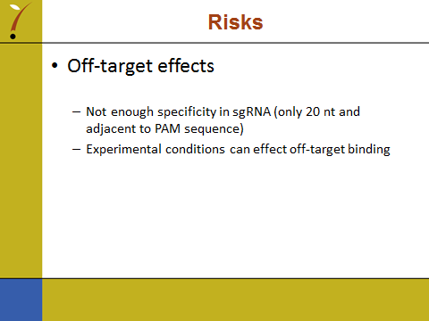

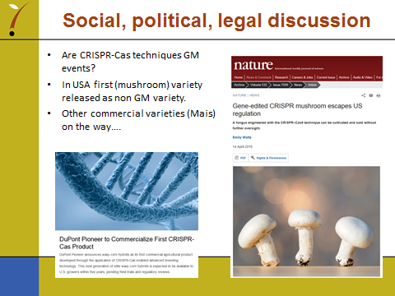

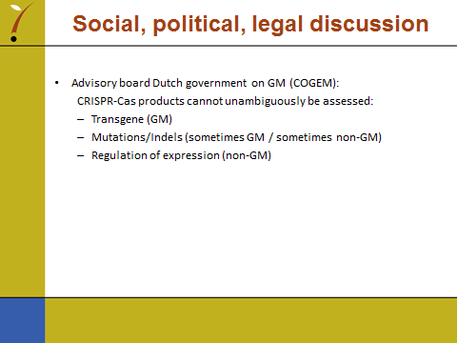

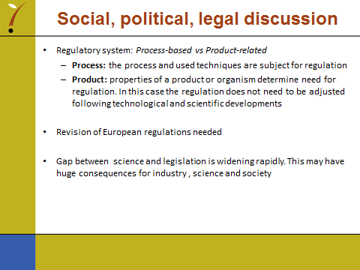

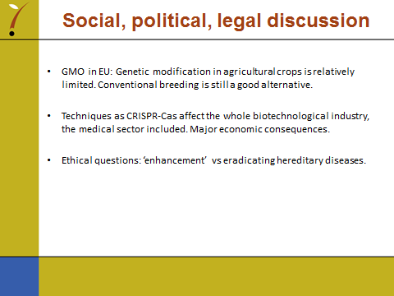

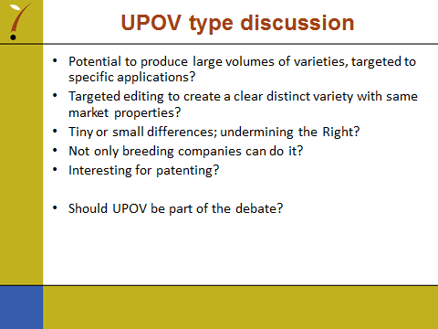

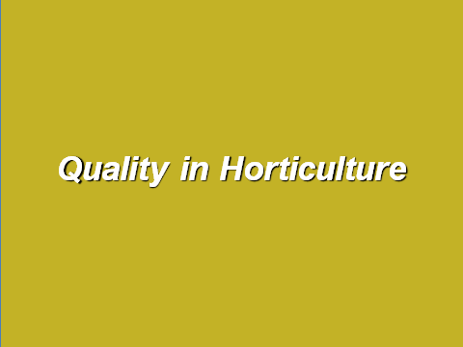

[End of Annex and of document]

