E
BMT/15/16
ORIGINAL: English
DATE: May 20, 2016
INTERNATIONAL UNION FOR THE PROTECTION OF NEW VARIETIES OF PLANTS
Geneva
WORKING GROUP ON BIOCHEMICAL AND MOLECULAR
TECHNIQUES AND DNA PROFILING IN PARTICULAR
Fifteenth Session
Moscow, Russian Federation, May 24 to 27, 2016
Towards durable DNA databases to support DUS testing
Document prepared by an expert from the Netherlands
Disclaimer: this document does not represent UPOV policies or guidance
The Annex to this document contains a copy of a presentation “Towards durable DNA databases to support DUS testing” to be made at its fifteenth session of the Working Group on Biochemical and Molecular Techniques and DNA-Profiling in particular (BMT).

Hedwich Teunissen, Molecular Biologist, Naktuinbouw

[Annex follows]

TOWARDS DURABLE DNA DATABASES TO SUPPORT DUS TESTING

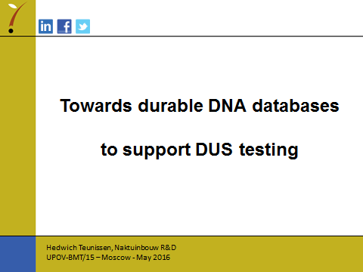

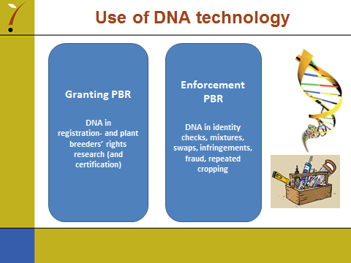

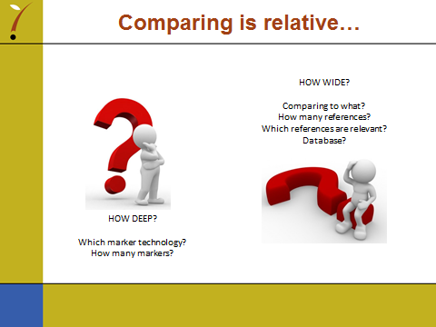

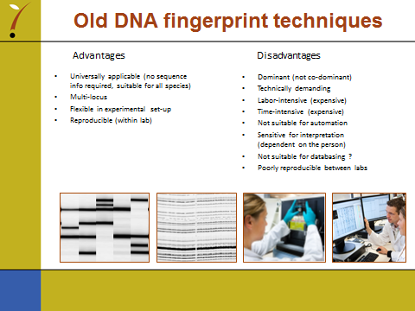

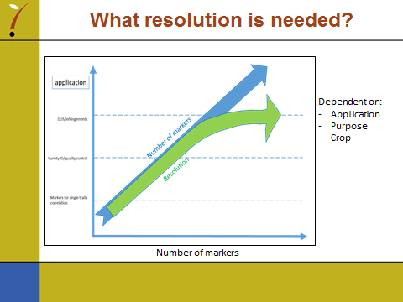

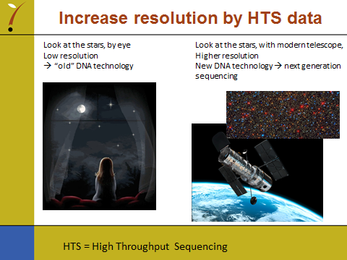

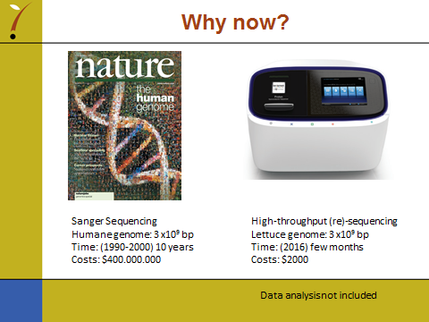

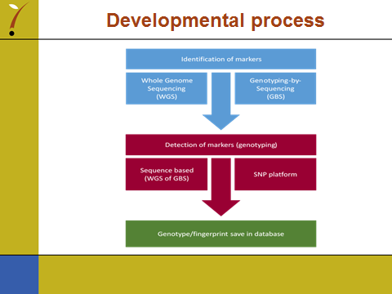

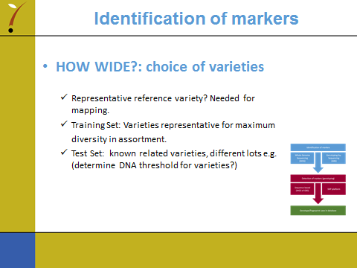

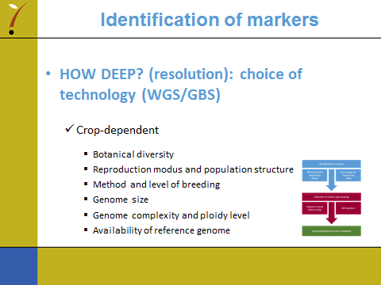

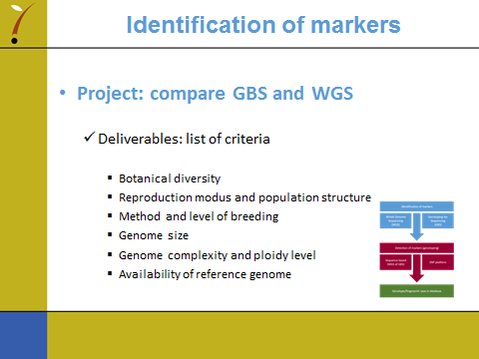

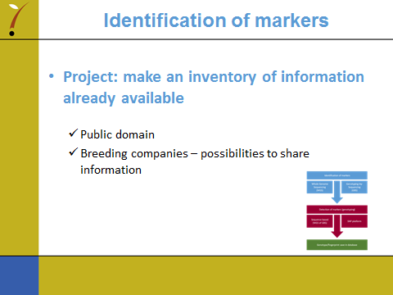

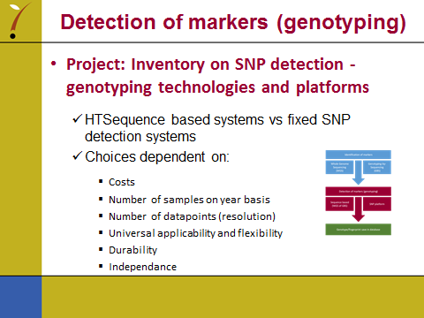

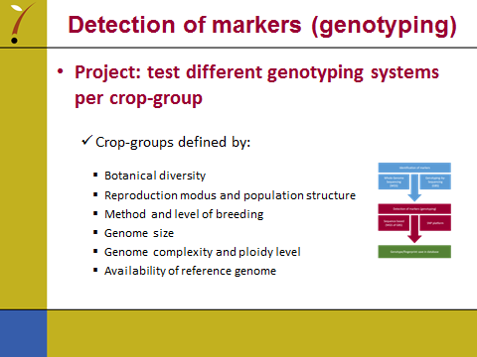

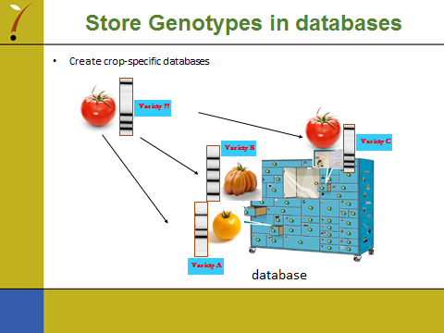

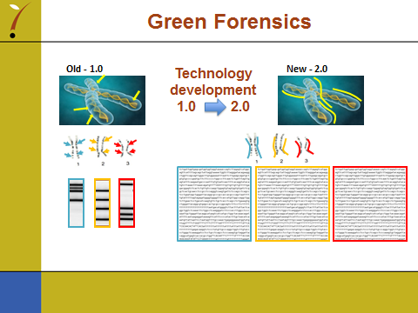

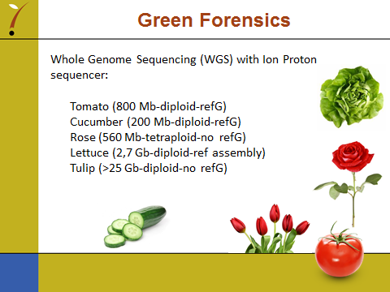

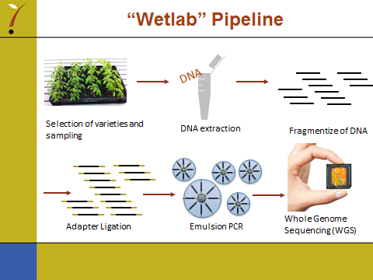

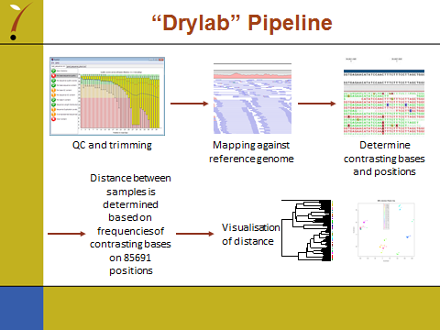

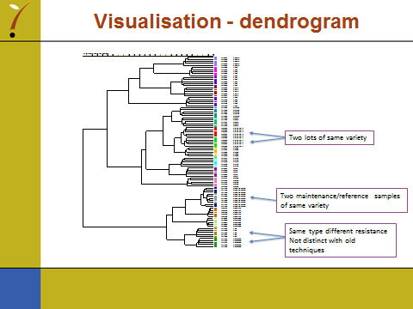

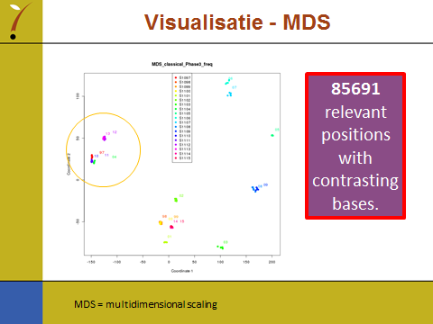

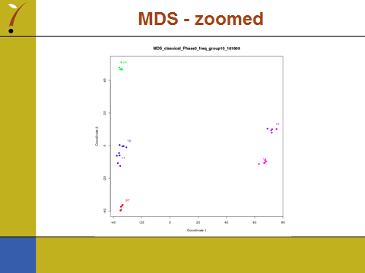

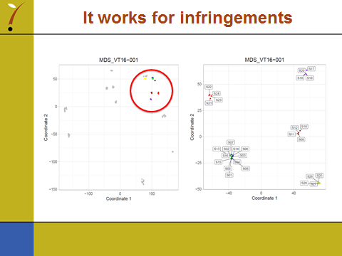

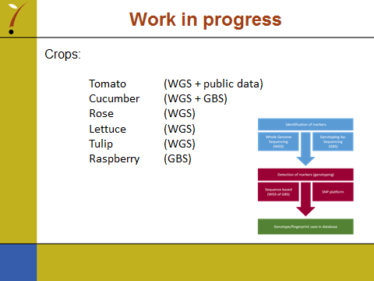

[End of Annex and of document]

