E
BMT/14/Joint/2
ORIGINAL: English
DATE: October 28, 2014
INTERNATIONAL UNION FOR THE PROTECTION OF NEW VARIETIES OF PLANTS
Geneva
OECD/UPOV/ISTA JOINT WORKSHOP ON MOLECULAR TECHNIQUES
Seoul, Republic of Korea, November 12, 2014
Horizontal Methods for Molecular Biomarker Analysis SC16
Document prepared by the International Organization for Standardization (ISO)
Disclaimer: this document does not represent UPOV policies or guidance
The Annex to this document contains a copy of a presentation “Horizontal Methods for Molecular Biomarker Analysis SC16” to be made at the OECD/UPOV/ISTA Joint Workshop on Molecular Techniques.

[Annex follows]

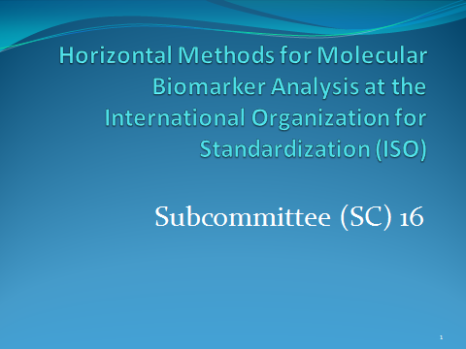

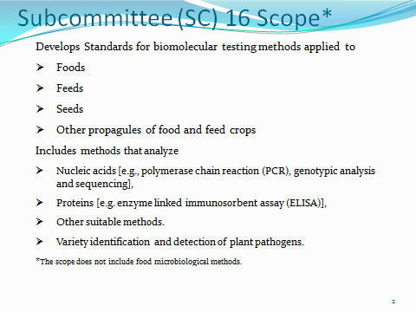

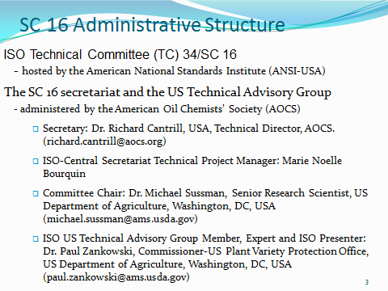

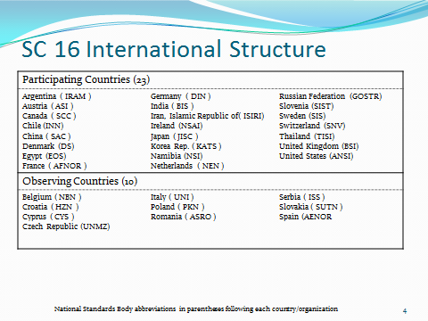

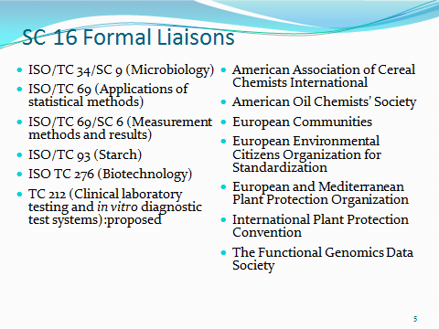

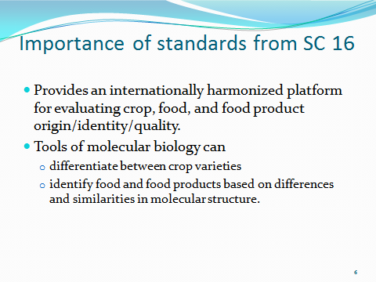

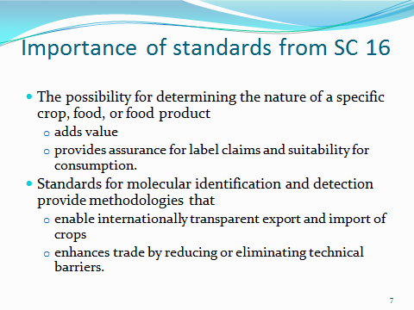

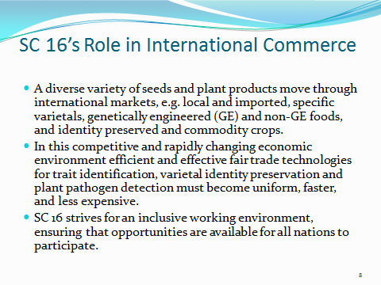

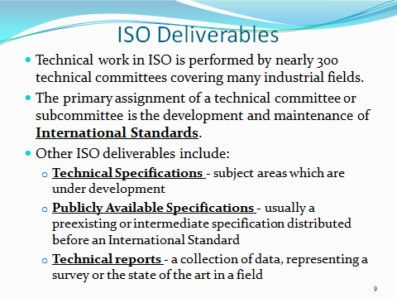

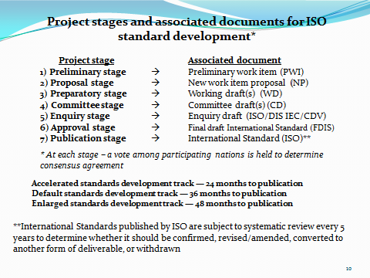

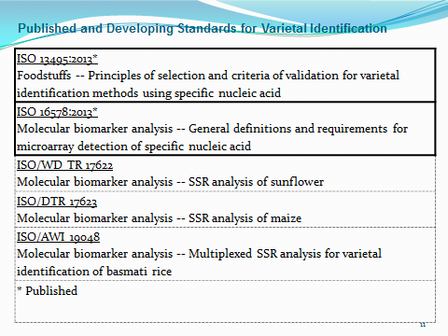

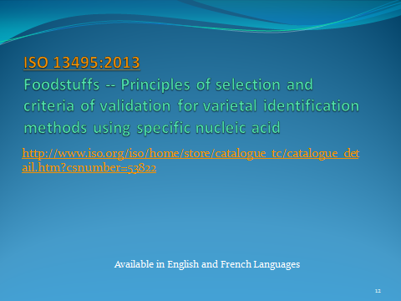

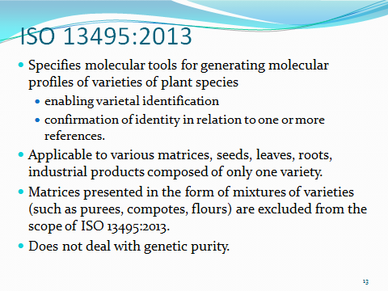

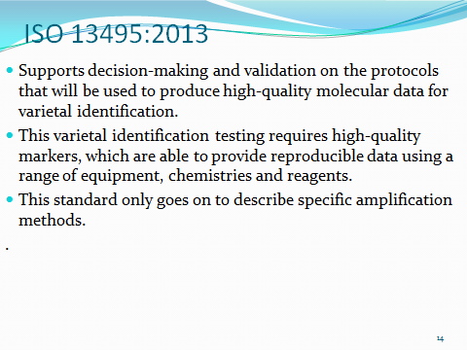

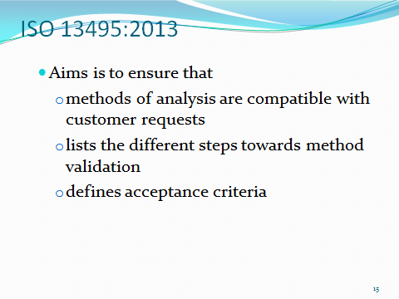

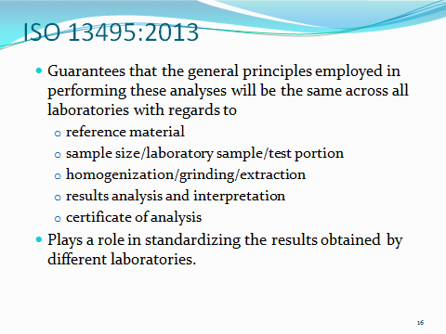

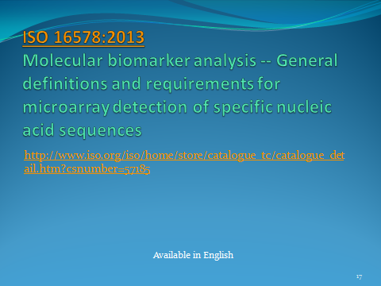

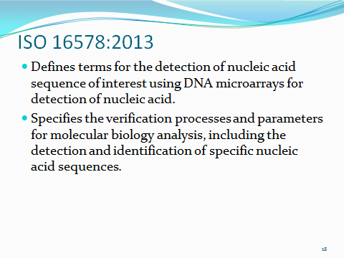

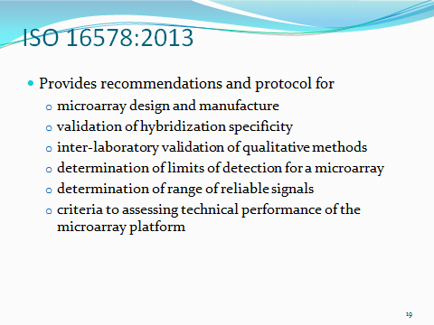

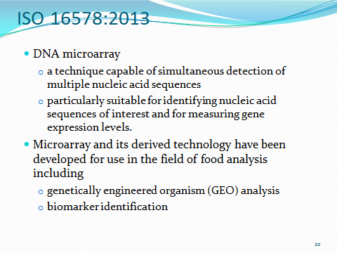

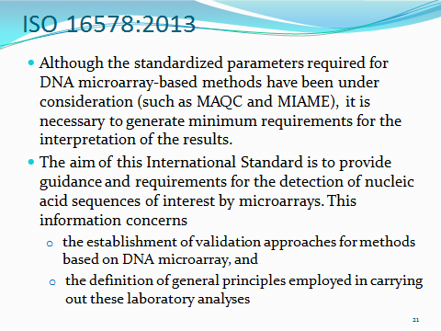

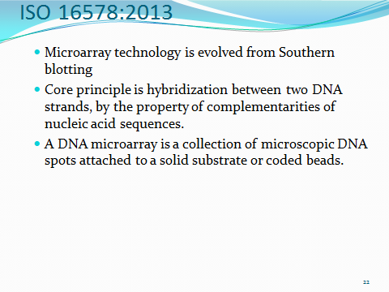

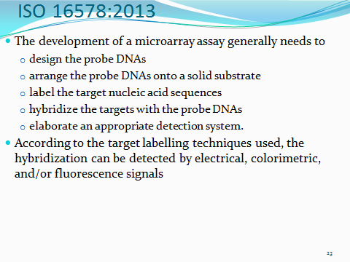

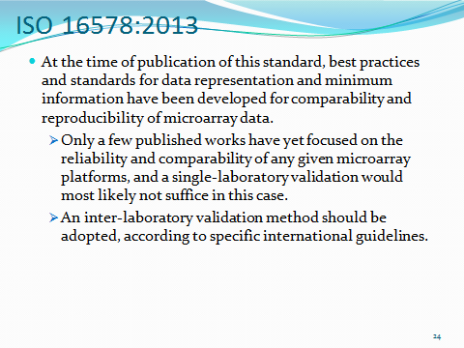
[End of annex and of document]

