E
BMT/14/9 Add.
ORIGINAL: English
DATE: December 5, 2014
INTERNATIONAL UNION FOR THE PROTECTION OF NEW VARIETIES OF PLANTS
Geneva
WORKING GROUP ON BIOCHEMICAL AND MOLECULAR TECHNIQUES
AND DNA-PROFILING IN PARTICULAR
Fourteenth Session
Seoul, Republic of Korea, November 10 to 13, 2014
addendum to document bmt/14/9

DETERMINING A THRESHOLD FOR GENETIC CONFORMITY IN POTATO SEEDLINGS
Document prepared by experts from the United Kingdom
Disclaimer: this document does not represent UPOV policies or guidance
The Annex to this document contains a copy of a presentation “Determining a Threshold for Genetic Conformity in Potato Seedlings” made at the fourteenth session of the Working Group on Biochemical and Molecular Techniques and DNA-Profiling in particular (BMT).

Alex Reid, Science and Advice for Scottish Agriculture (SASA),
Roddinglaw Road, Edinburgh EH12 9FJ, the United Kingdom

Abbreviations used in the Annex;
CPVO Community Plant Variety Office of the European Union
EU European Union
ESA European Seed Association

[Annex follows]

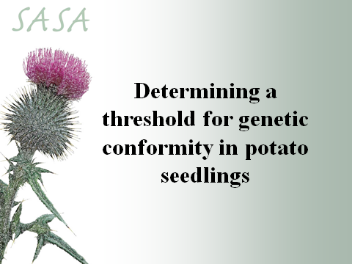

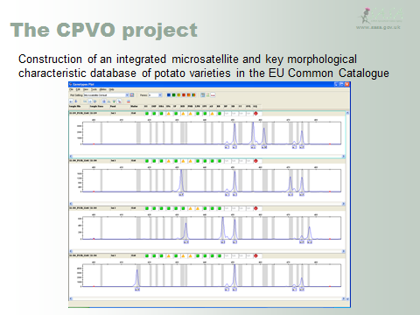

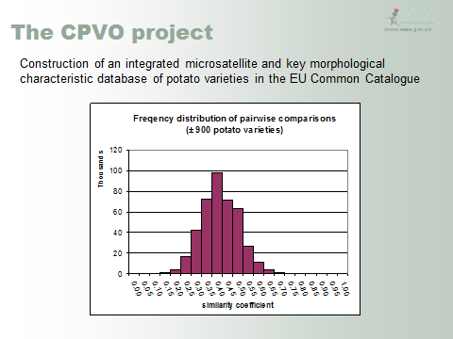

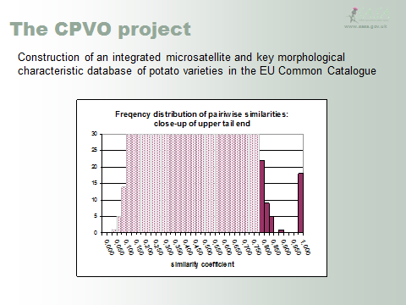

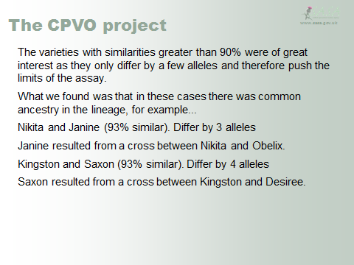

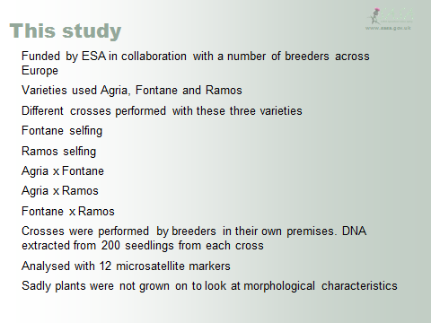

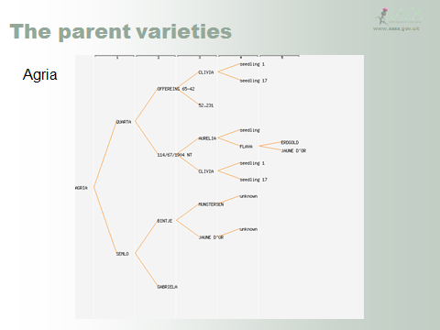

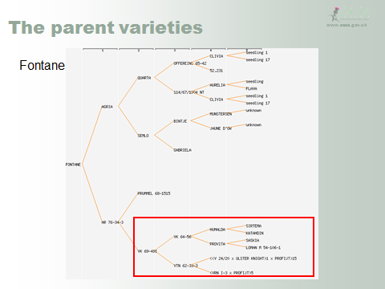

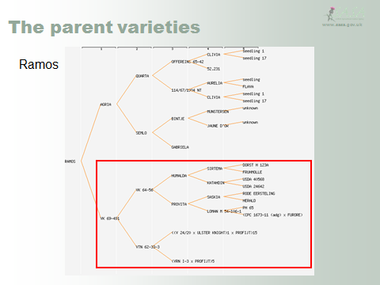

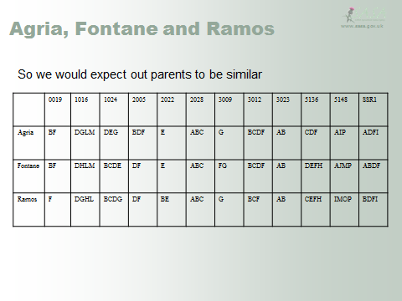

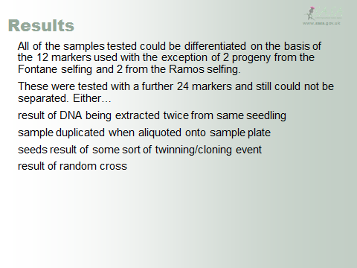

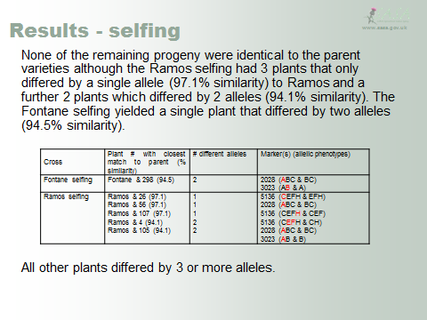

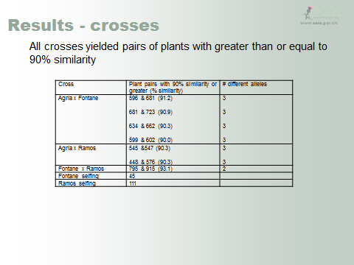

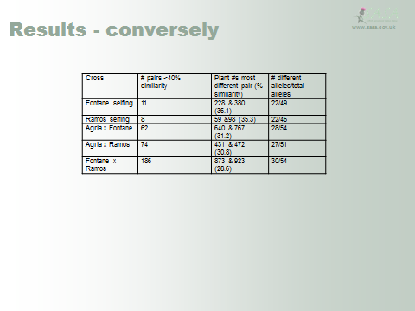

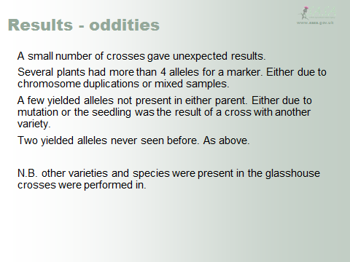

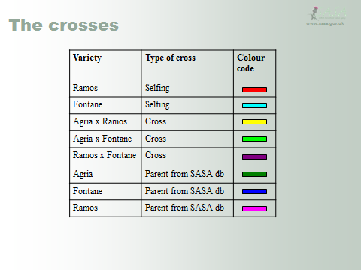

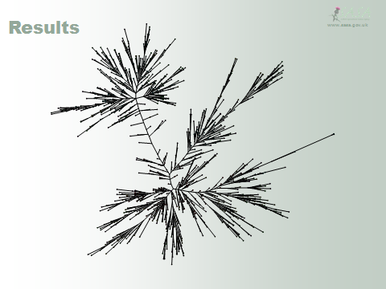

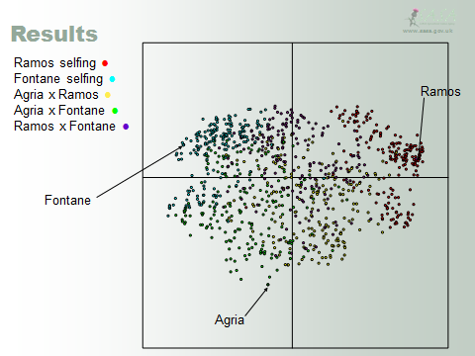

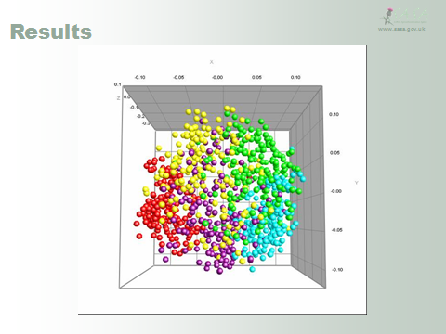

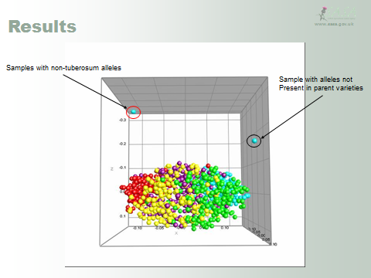

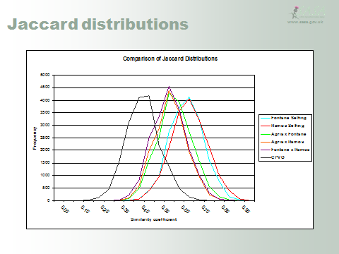

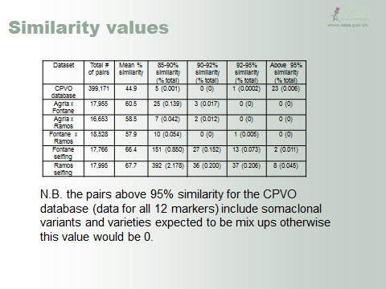

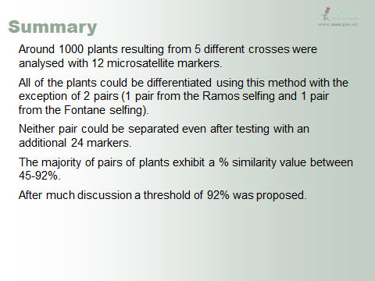

[End of annex and of document]

