E
BMT/14/2 Rev2.
ORIGINAL: English
DATE: November 24, 2014
INTERNATIONAL UNION FOR THE PROTECTION OF NEW VARIETIES OF PLANTS
Geneva
WORKING GROUP ON BIOCHEMICAL AND MOLECULAR
TECHNIQUES AND DNA PROFILING IN PARTICULAR
Fourteenth Session
Seoul, Republic of Korea, November 10 to 13, 2014
Reports on developments in UPOV concerning biochemical
and molecular techniques
Document prepared by the Office of the Union
Disclaimer: this document does not represent UPOV policies or guidance
The purpose of this document is to report on developments concerning the:

(a) Use of biochemical and molecular markers in the examination of Distinctness, Uniformity and Stability (DUS)

(b) Ad Hoc Crop Subgroups on Molecular Techniques (Crop Subgroups); and

(c) Presentation of information on the situation in UPOV with regard to the use of molecular
techniques to a wider audience, including breeders and the public in general.

The following abbreviations are used in this document:

BMT: Working Group on Biochemical and Molecular Techniques, and DNA-Profiling
in Particular
CAJ: Administrative and Legal Committee
TC: Technical Committee
TC-EDC: The Enlarged Editorial Committee

Use of biochemical and molecular markers in the examination of Distinctness, Uniformity and Stability (DUS)

The situation with regards to the use of biochemical and molecular markers is set out in the following documents, which have been adopted by the Council of UPOV;

UPOV/INF/18/1 “Possible use of Molecular Markers in the Examination of Distinctness, Uniformity and Stability (DUS)

The purpose of document UPOV/INF/18 is to provide guidance on the possible use of biochemical and molecular markers in the examination of Distinctness, Uniformity and Stability (DUS).

TGP/15/1 “Guidance on the Use of Biochemical and Molecular Markers in the Examination of Distinctness, Uniformity and Stability (DUS)”

Document UPOV/INF/18 “Possible Use of Molecular Markers in the Examination of Distinctness, Uniformity and Stability (DUS)” considers possible application models for the use of biochemical and molecular markers in the examination of DUS that were proposed to the Ad hoc Subgroup of Technical and Legal Experts of Biochemical and Molecular Techniques (BMT Review Group) by the Technical Committee, on the basis of the work of the Working Group on Biochemical and Molecular Techniques, and DNA-Profiling in Particular (BMT) and Ad Hoc Crop Subgroups on Molecular Techniques (Crop Subgroups) (see http://www.upov.int/about/en/organigram.html). The assessment of the BMT Review Group and the views of the Technical Committee, the Administrative and Legal Committee (CAJ) on those models are presented in document UPOV/INF/18.

The purpose of document TGP/15 is to provide guidance on the use of biochemical and molecular markers in the examination of Distinctness, Uniformity and Stability (DUS) on the basis of the models in document UPOV/INF/18 that have received a positive assessment and for which accepted examples have been provided.

UPOV/INF/17/1 “Guidelines for DNA-Profiling: Molecular Marker Selection and Database Construction (“BMT Guidelines”)”

The purpose of the BMT Guidelines is to provide guidance for developing harmonized methodologies with the aim of generating high quality molecular data for a range of applications. The BMT Guidelines are also intended to address the construction of databases containing molecular profiles of plant varieties, possibly produced in different laboratories using different technologies. In addition, the aim is to set high demands on the quality of the markers and on the desire for generating reproducible data using these markers in situations where equipment and/or reaction chemicals might change. Specific precautions need to be taken to ensure quality entry into a database.

Joint Workshop on DUS Testing and Molecular Techniques

On September 23 and 24, 2013, a Joint Workshop on DUS Testing and Molecular Techniques (Workshop) was held in Beijing, China, organized by the State Forestry Administration, China, in cooperation with the Ministry of Agriculture, China, and the Office of the Union. A copy of the program is attached as Annex I to this document.

At the Workshop, experts from China and the Republic of Korea reported on their use of molecular techniques to supplement the selection of varieties to be included in the DUS field trial on the basis of descriptions based on morphological characteristics (see document TC/50/13 “Molecular Techniques”, paragraph 4 and 5).

At its fiftieth session, held in Geneva, from April 7 to 9, 2014, the TC encouraged experts from China, the Republic of Korea and other members of the Union to make presentations at the fourteenth session of the BMT, on the use of molecular techniques to supplement the selection of similar varieties for inclusion in the growing trial, as set out in document TC/50/13, paragraph 6 (see document TC/50/36 “Report on the Conclusion”, paragraph 77).

AD HOC CROP SUBGROUPS ON MOLECULAR TECHNIQUES (CROP SUBGROUPS)

There have been no meetings of the Crop Subgroups since the twelfth session of the BMT.

At its thirteenth session, held in Brasilia, Brazil, from November 22 to 24, 2011, the BMT did not make any recommendation on the establishment of new crop specific subgroups. The BMT proposed to the TC to consider the possibility of the discontinuation of the meeting of the Ad-hoc Crop Subgroups and to include the individual species discussion within the BMT sessions (see document BMT/13/36 “Report”, paragraph 69).

The TC, at its forty-eighth session, held in Geneva, from March 26 to March 28, 2012, agreed to discontinue separate meetings of the Ad-hoc Crop Subgroups and to include the discussions within the BMT sessions (see document TC/48/22 “Report on the Conclusions”, paragraph 83).

Presentation of information on the situation in UPOV with regard to the use of molecular techniques to a wider audience, including breeders and the public in general

The TC, at its forty-ninth session, held in Geneva from March 18 to 20, 2013, agreed that there was a need to provide suitable information on the situation in UPOV with regard to the use of molecular techniques to a wider audience, including breeders and the public in general. That information should explain the potential advantages and disadvantages of the techniques, and the relationship between genotype and phenotype, which lay behind the situation in UPOV (see document TC/49/41 “Report on the Conclusions”, paragraph 136).

The Consultative Committee, at its eighty-sixth session, held in Geneva on October 23 and 24, 2013, considered a series of answers to frequently asked questions. One of the questions included was “does UPOV allow molecular techniques (DNA profiles) in the DUS examination?” In that regard the Consultative Committee agreed that the answer should be developed via the Technical Committee.

The TC, at its fiftieth session, held in Geneva on April 7 to 9, 2014 and the CAJ, at its sixty-ninth session, held in Geneva on April 10, 2014, agreed the proposed explanation of the situation in UPOV with regard to the use of molecular techniques, as set out below:

Question: Does UPOV allow molecular techniques (DNA profiles) in the DUS examination?

Answer: “It is important to note that, in some cases, varieties may have a different DNA profile but be phenotypically identical, whilst, in other cases, varieties which have a large phenotypic difference may have the same DNA profile for a particular set of molecular markers (e.g. some mutations).

“In relation to the use of molecular markers that are not related to phenotypic differences, the concern is that it might be possible to use a limitless number of markers to find differences between varieties at the genetic level that are not reflected in phenotypic characteristics.

“On the above basis, UPOV has agreed the following uses of molecular markers in relation to DUS examination:

“(a) Molecular markers can be used as a method of examining DUS characteristics that satisfy the criteria for characteristics set out in the General Introduction if there is a reliable link between the marker and the characteristic.

“(b) A combination of phenotypic differences and molecular distances can be used to improve the selection of varieties to be compared in the growing trial if the molecular distances are sufficiently related to phenotypic differences and the method does not create an increased risk of not selecting a variety in the variety collection which should be compared to candidate varieties in the DUS growing trial.

“The situation in UPOV is explained in documents TGP/15 ‘Guidance on the Use of Biochemical and Molecular Markers in the Examination of Distinctness, Uniformity and Stability (DUS)’ and UPOV/INF/18 ‘Possible use of Molecular Markers in the Examination of Distinctness, Uniformity and Stability (DUS)’”.

With regard to a wider audience, the TC agreed that the question was not framed in an appropriate way and, therefore, it would not be appropriate to seek to develop an answer to that question. The TC agreed that the question should be rephrased after clarification of the issues of interest to a wider audience.

The Council, at its thirty-first extraordinary session, held in Geneva, April 12, 2014, adopted the answers to the frequently asked questions (see document C(Extr.)/31/5 “Report on the Decisions”, paragraph 15) including the FAQ as set out in paragraph 13 above.

The answers to Frequently Asked Questions are published on the website at http://www.upov.int/about/en/faq/.

The Annex to this document contains a copy of a presentation “Report on Developments in UPOV Concerning Biochemical and Molecular Techniques” to be made at its fourteenth session of the Working Group on Biochemical and Molecular Techniques and DNA-Profiling in particular (BMT).
The BMT is invited to note the report on developments concerning:

(a) documents UPOV/INF/18/1 “Possible use of Molecular Markers in the Examination of Distinctness, Uniformity and Stability (DUS)”, TGP/15/1 “Guidance for Members of UPOV on Ongoing Obligations and Related Notifications and on the Provision of Information to Facilitate Cooperation” and UPOV/INF/17/1 “Guidelines for DNA-Profiling: Molecular Marker Selection and Database Construction ("BMT Guidelines")”;

(b) discontinuation of the Ad Hoc Subgroups on Biochemical and Molecular Techniques (Crop subgroups); and

(c) development of an FAQ concerning the use of molecular techniques in the DUS examination.

[Annex follows]

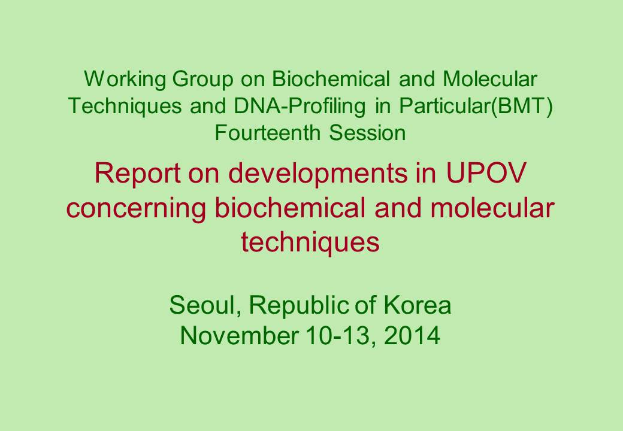  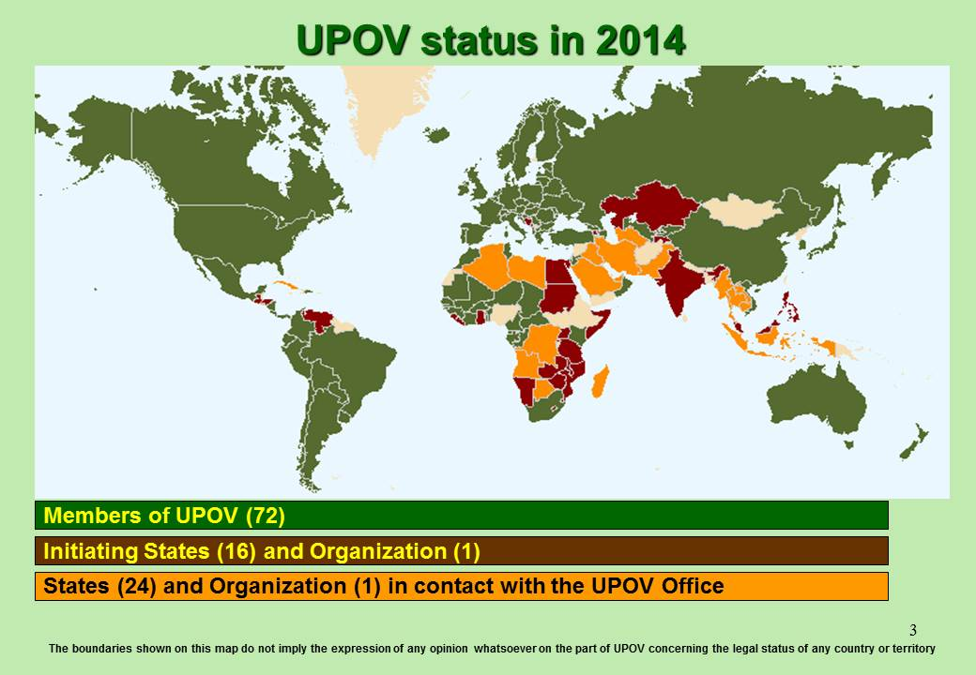  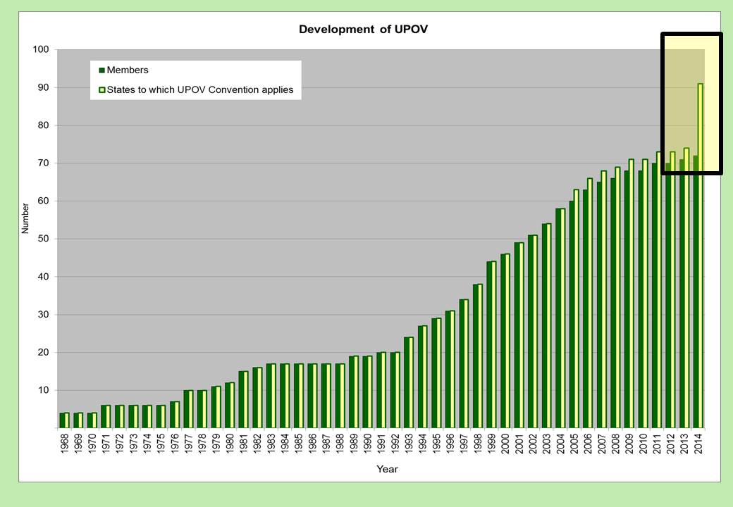  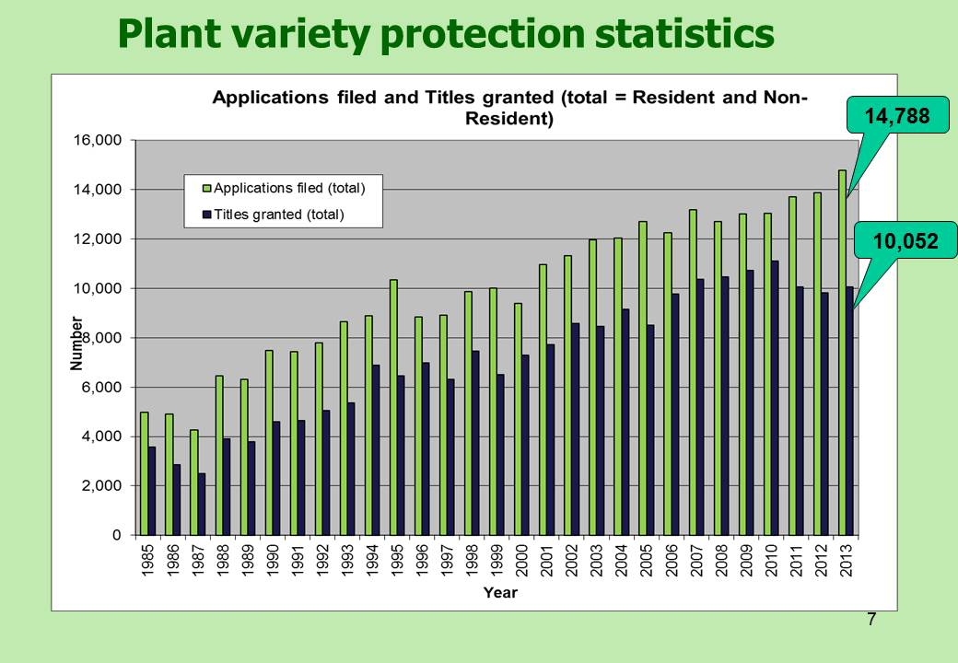  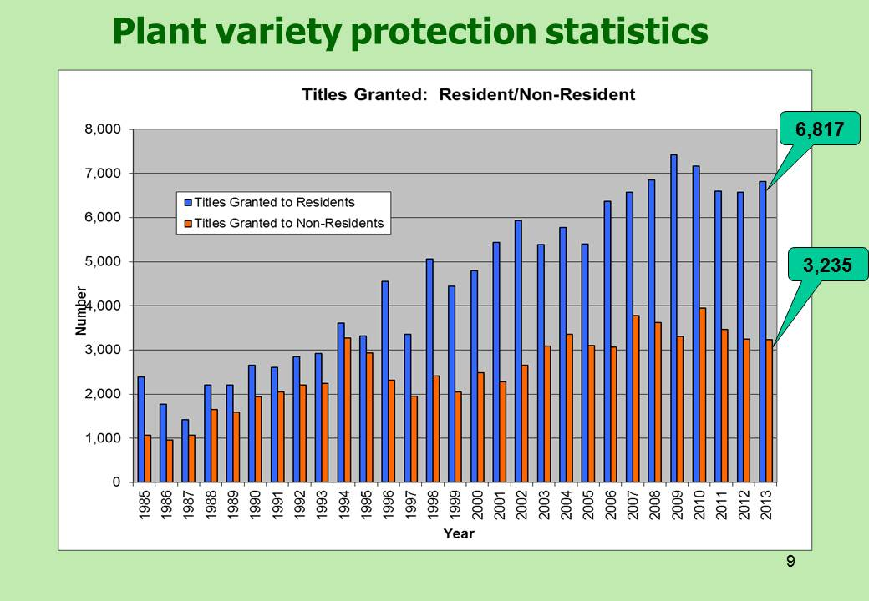  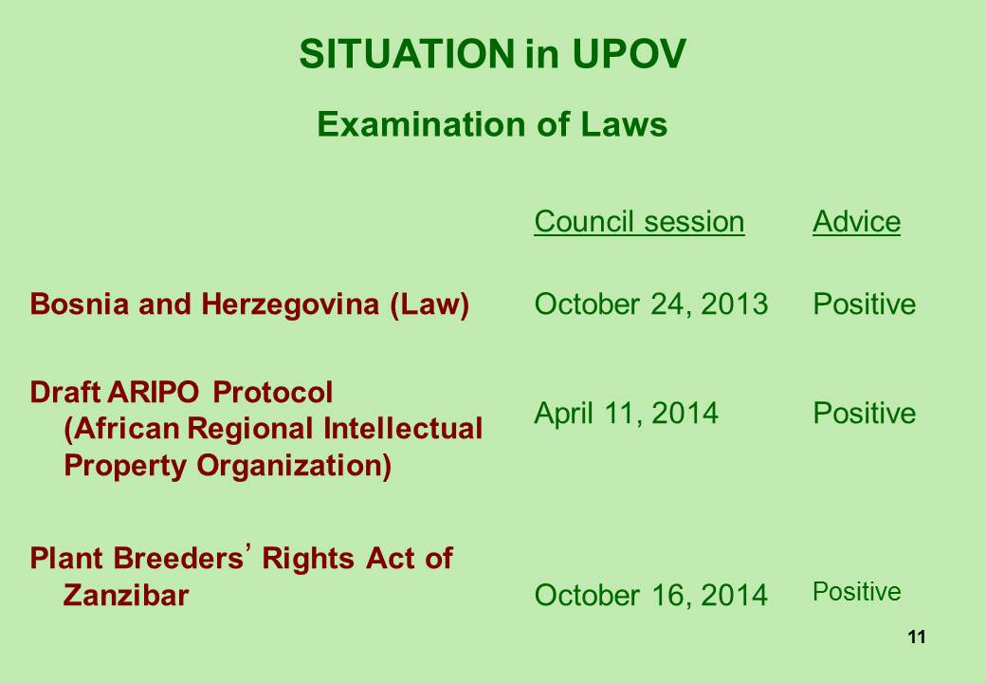  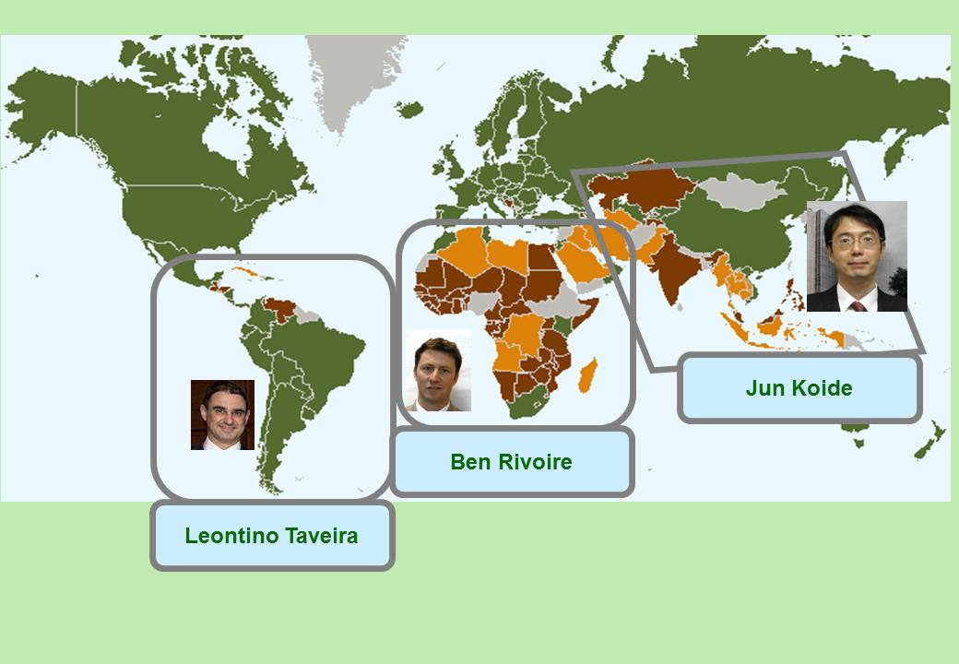  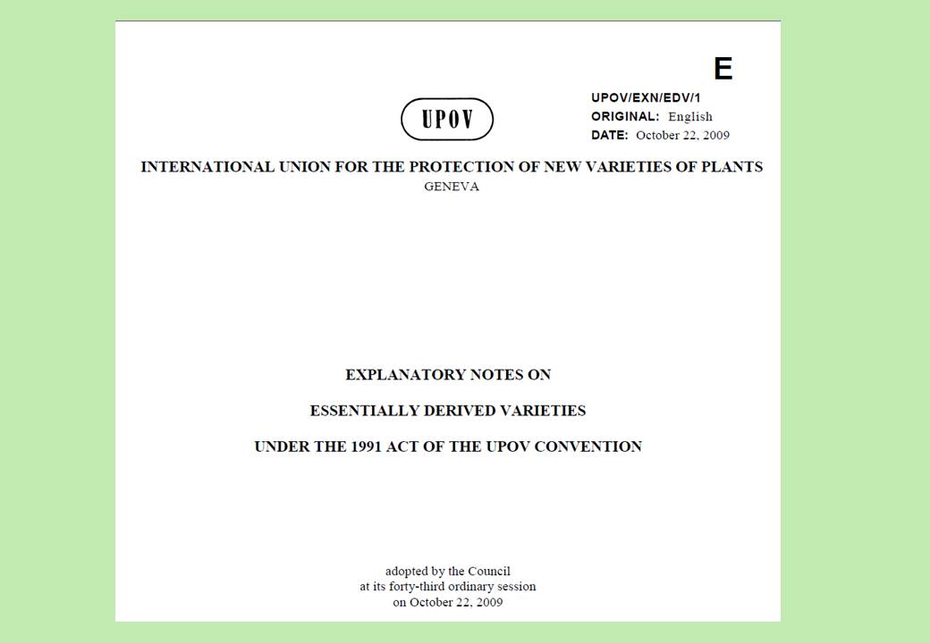  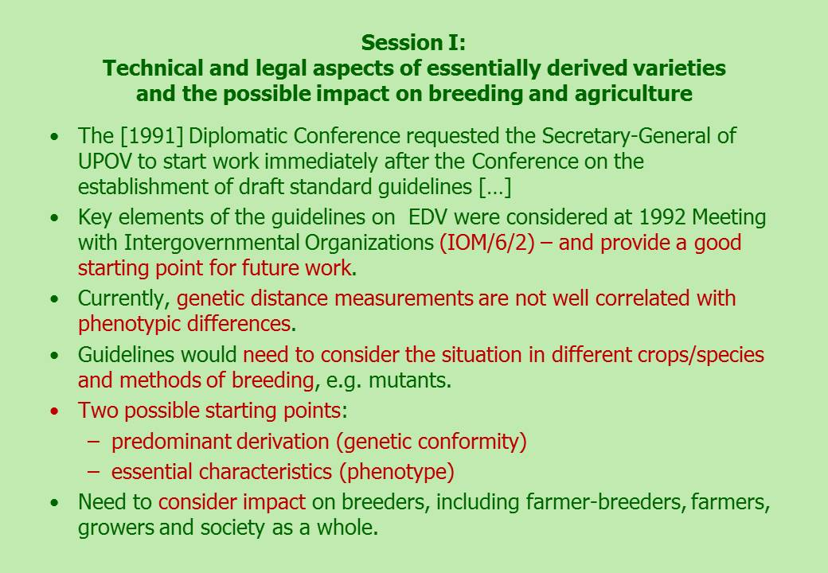  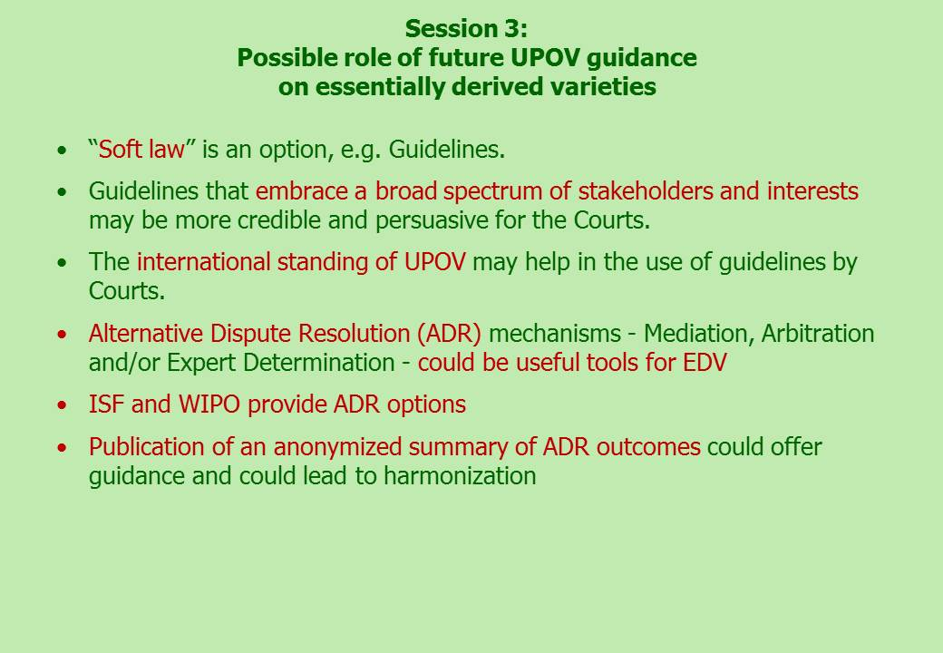  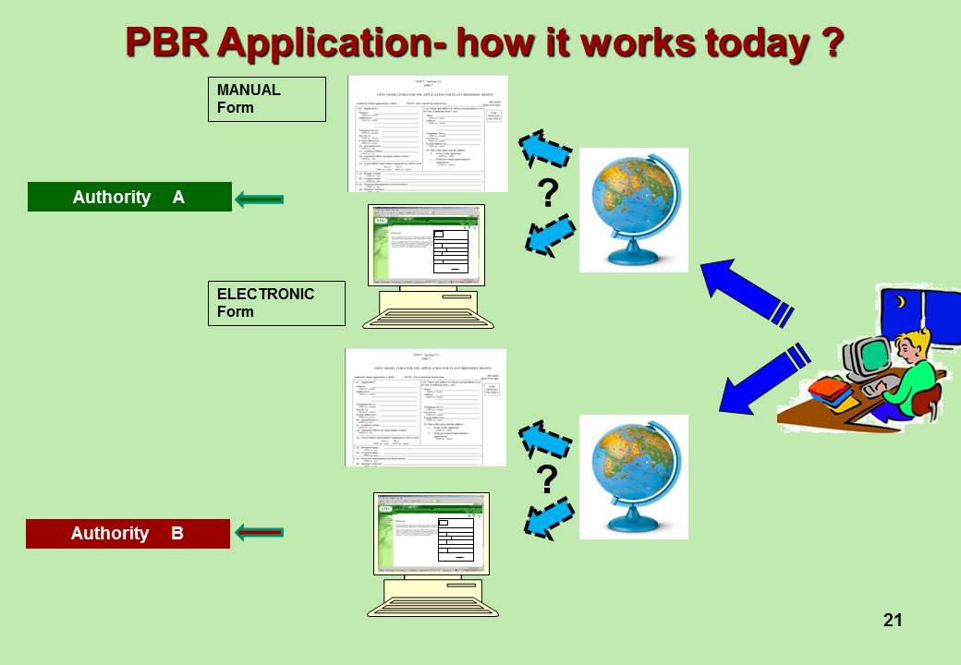  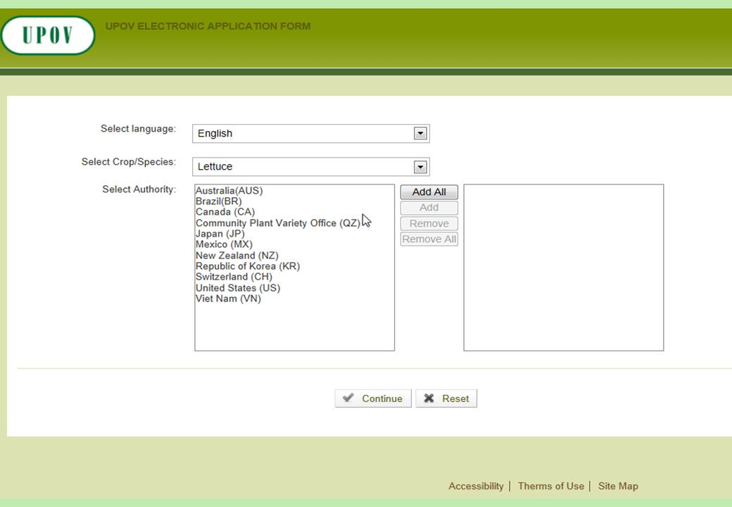  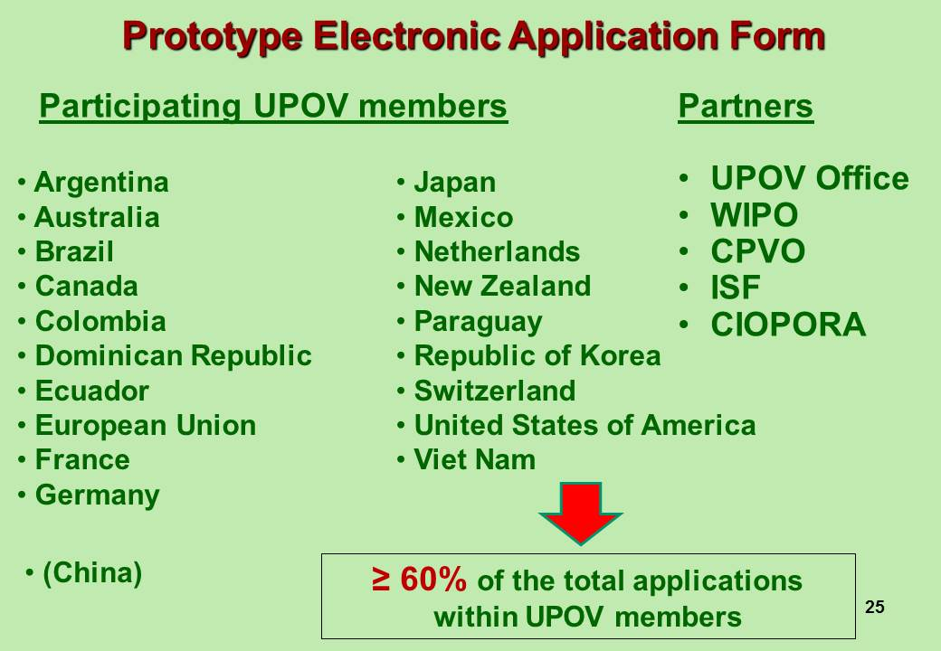  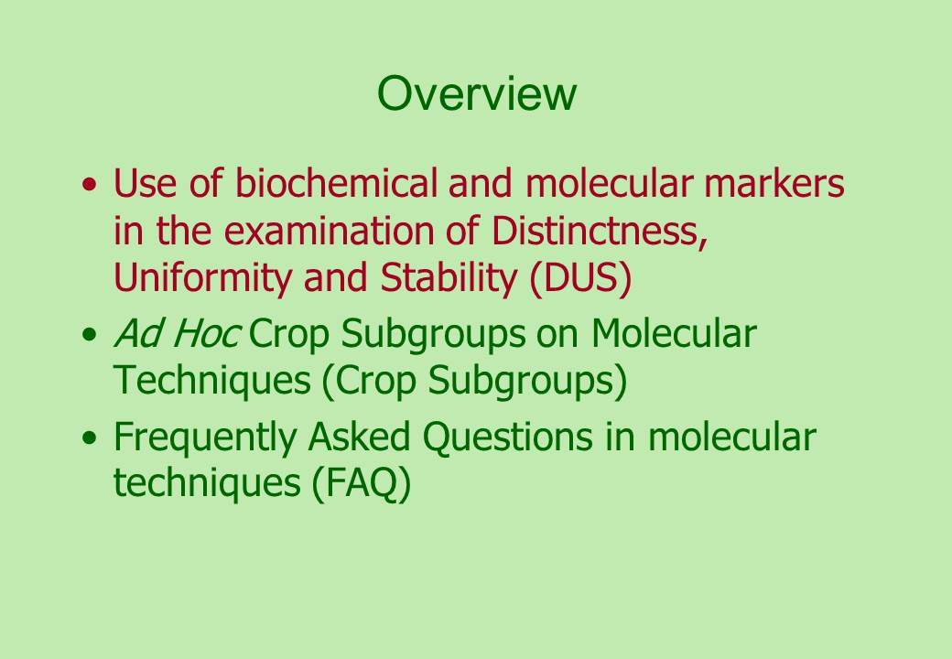  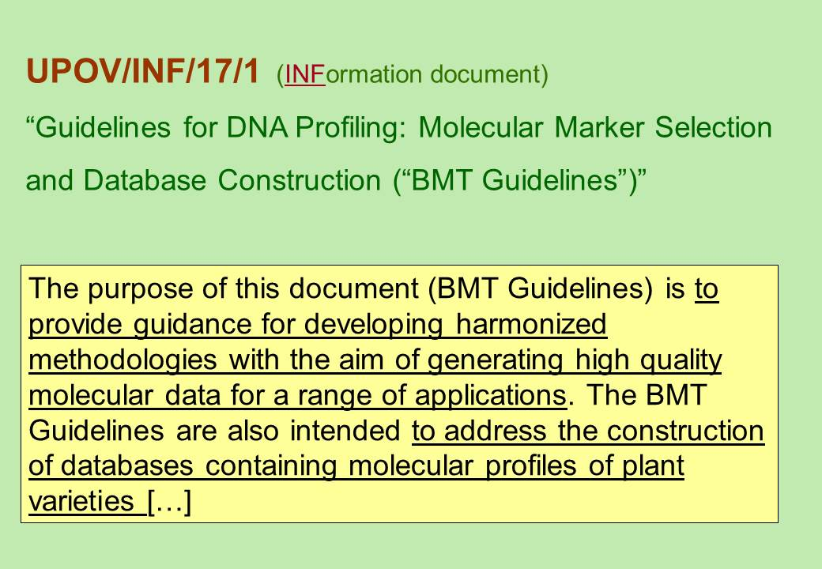  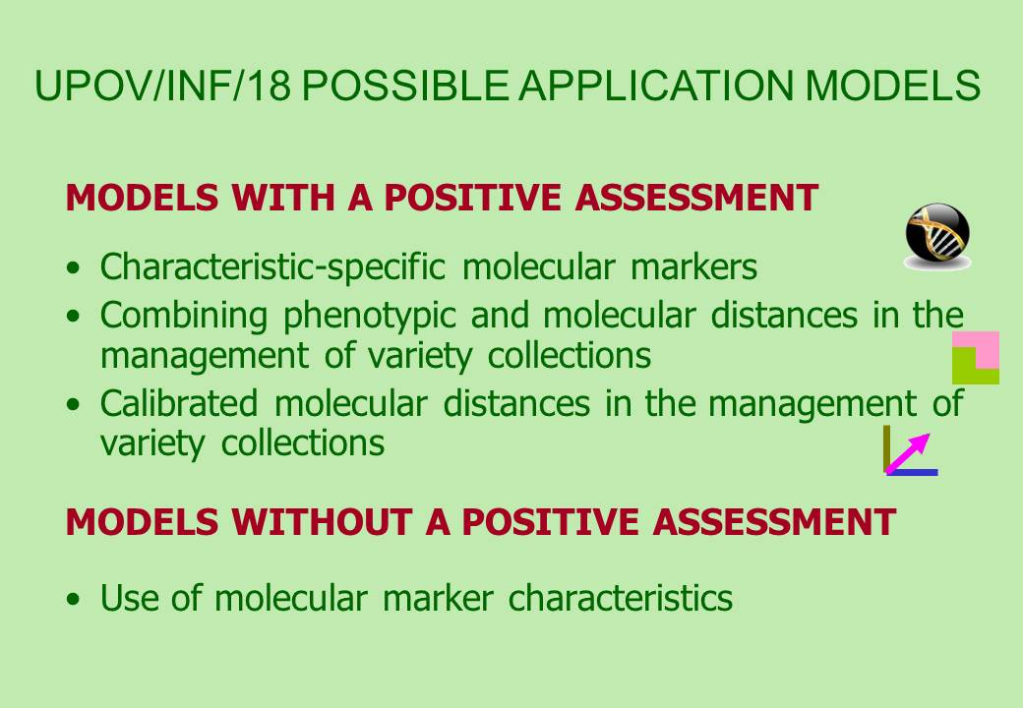  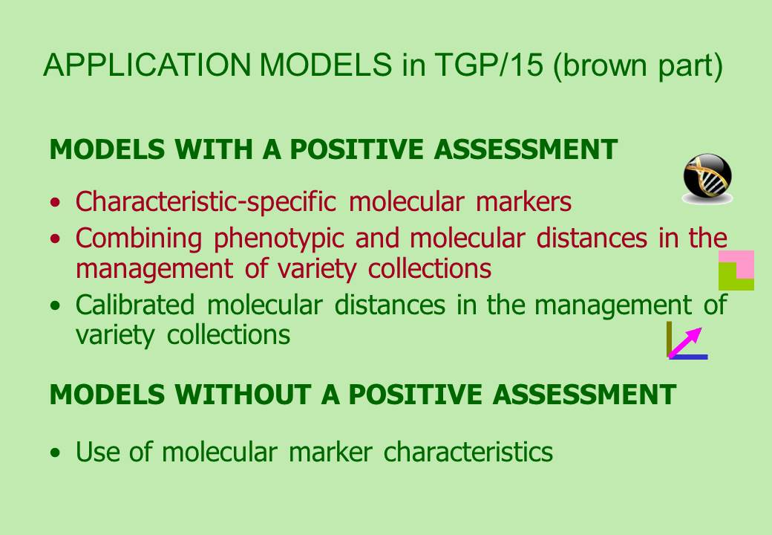  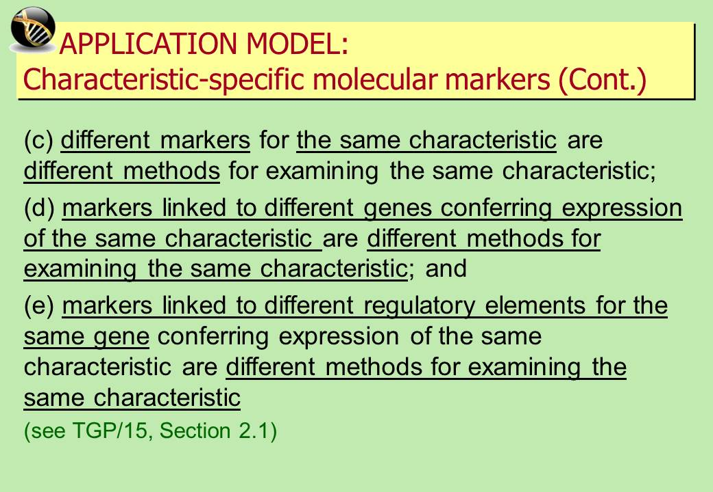  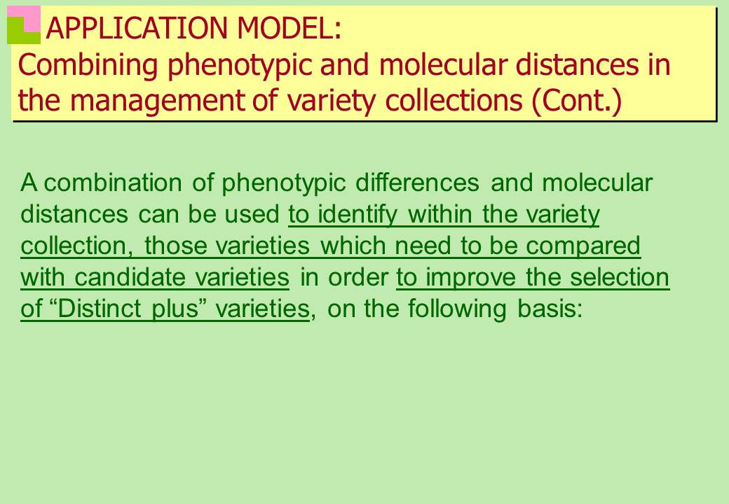  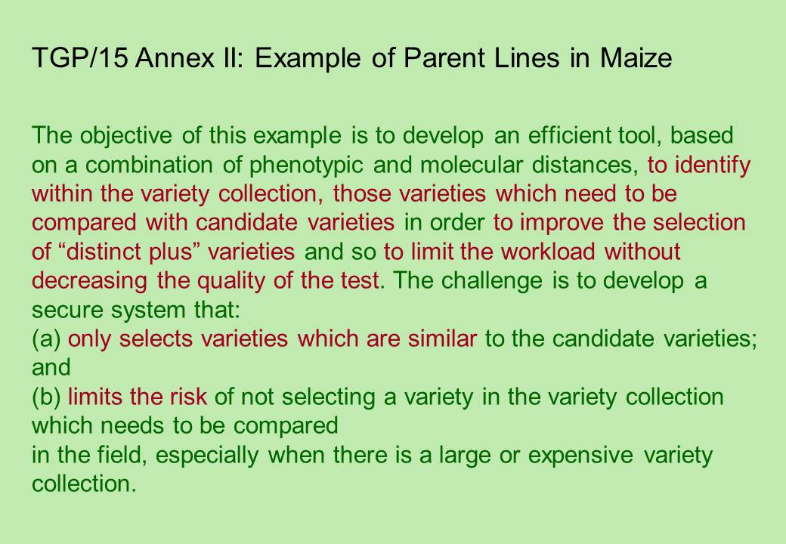  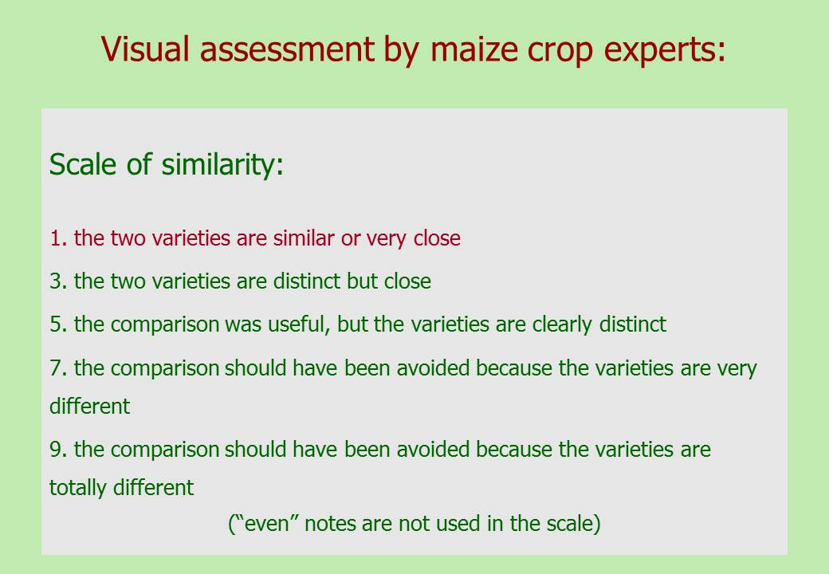  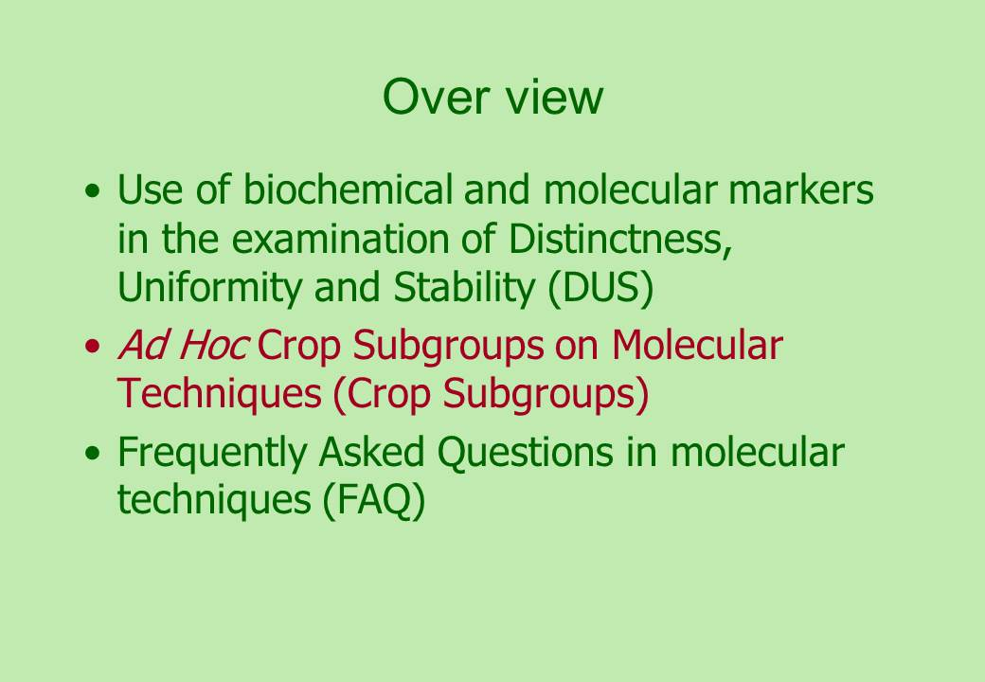  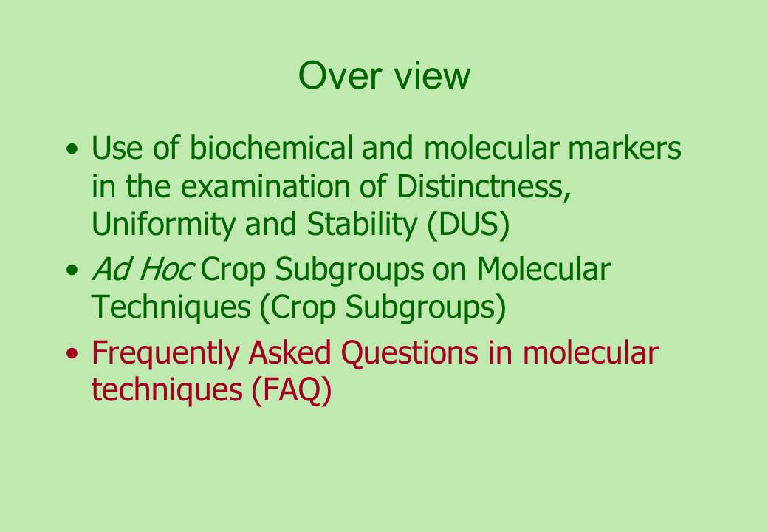  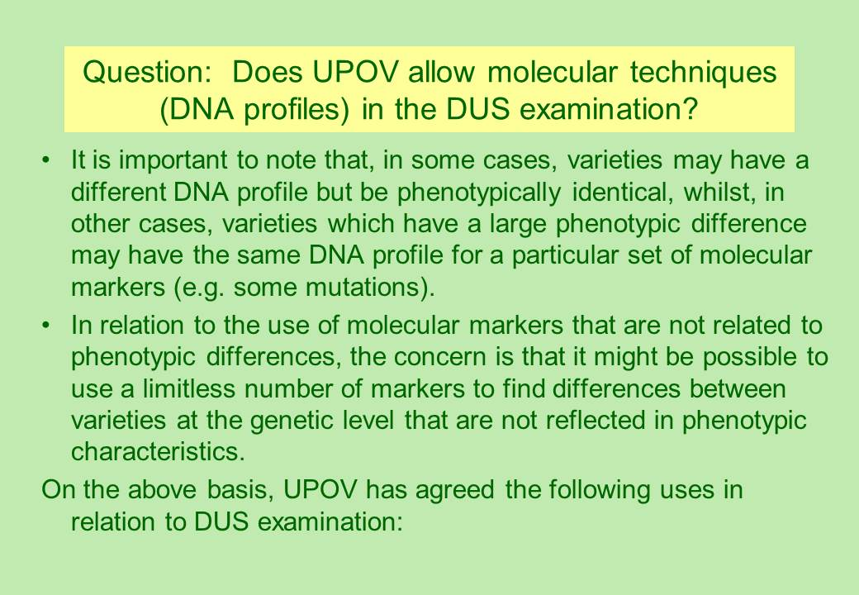  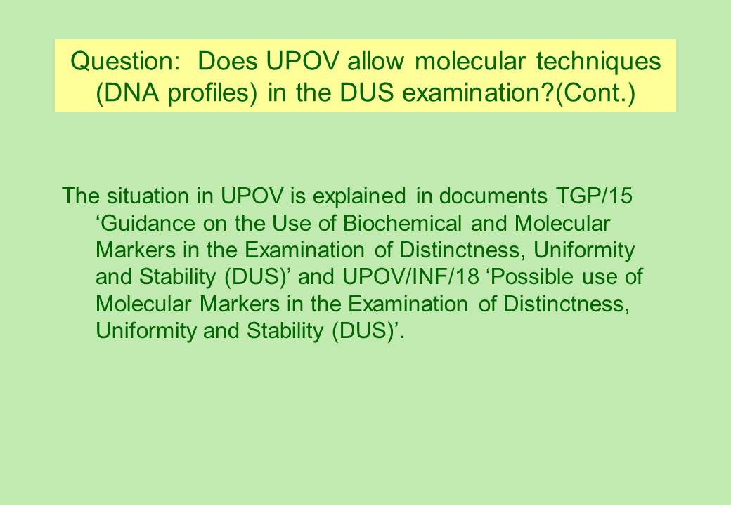  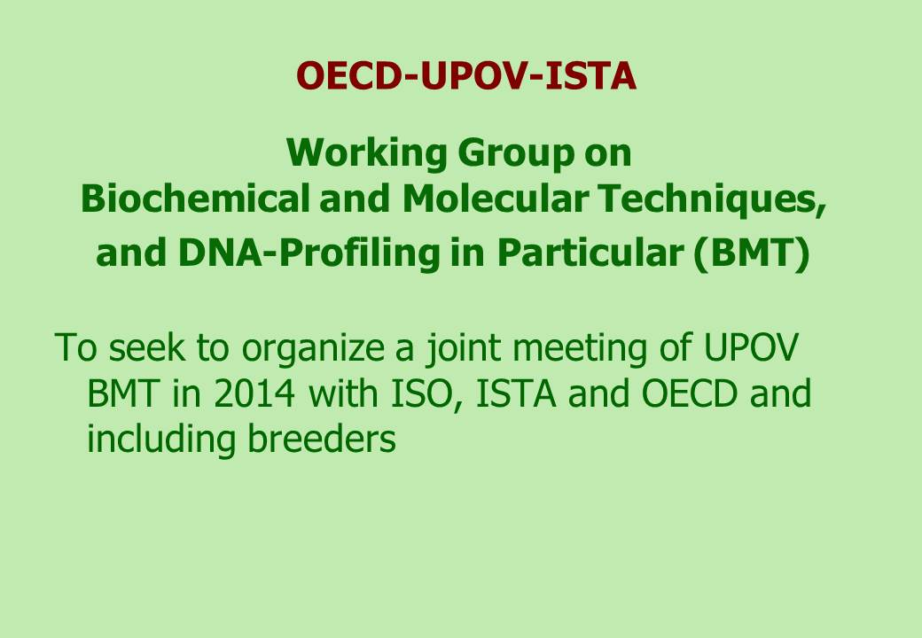  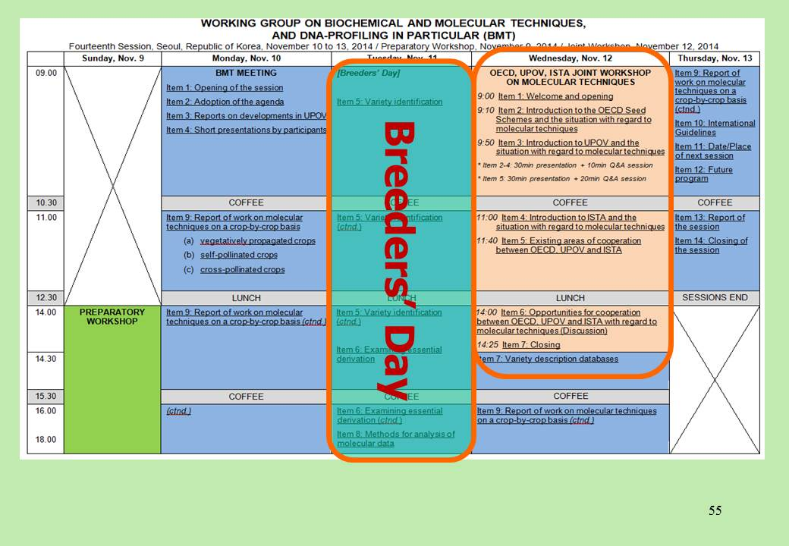 | 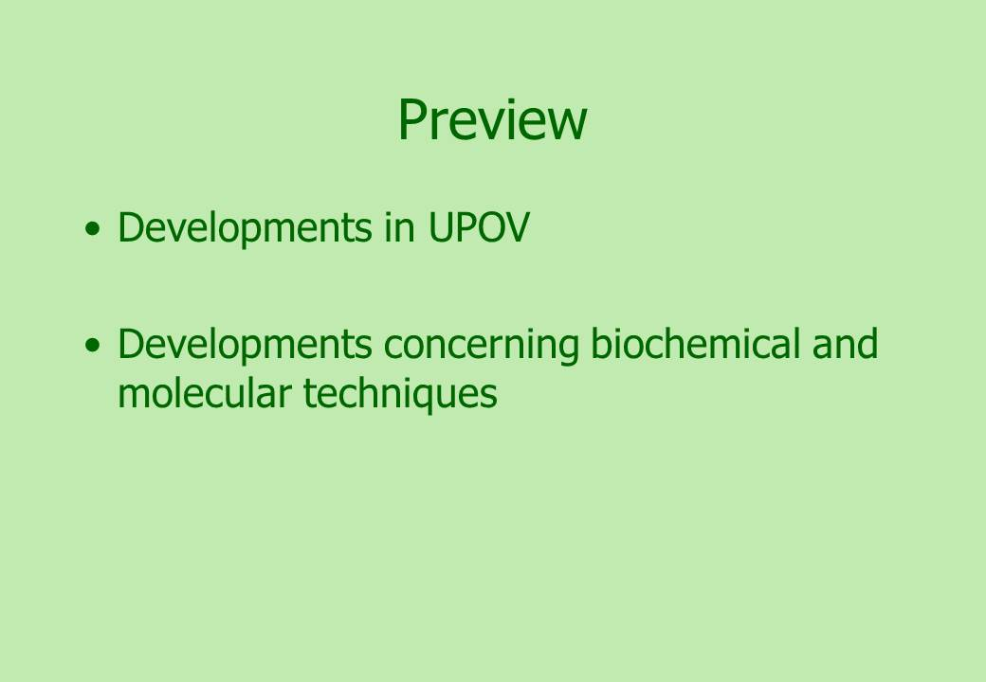  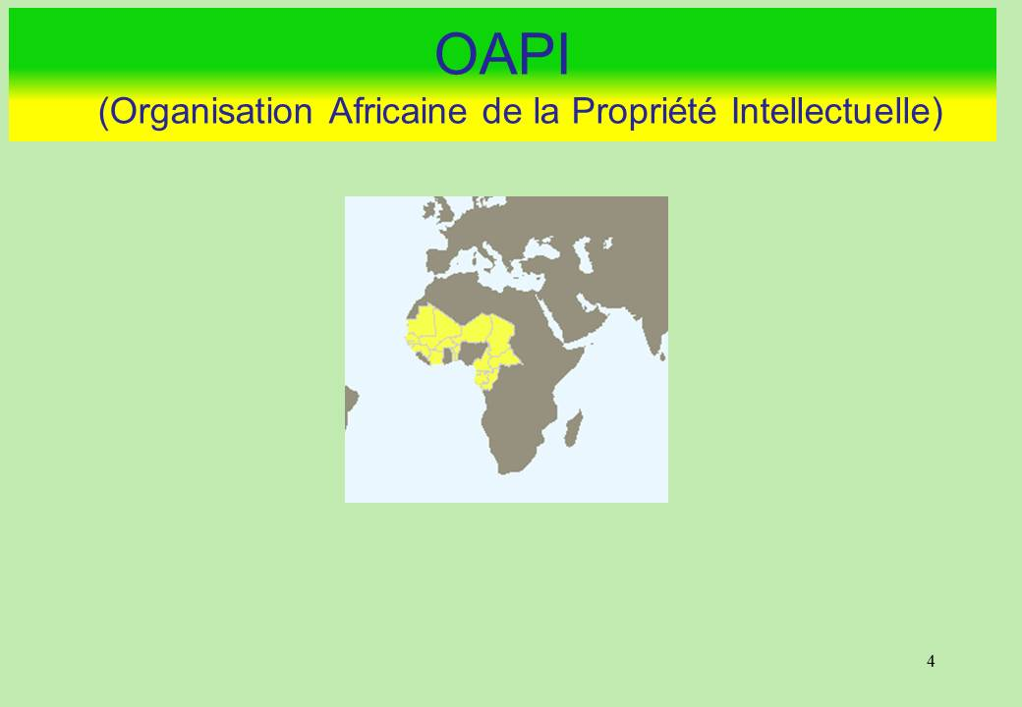  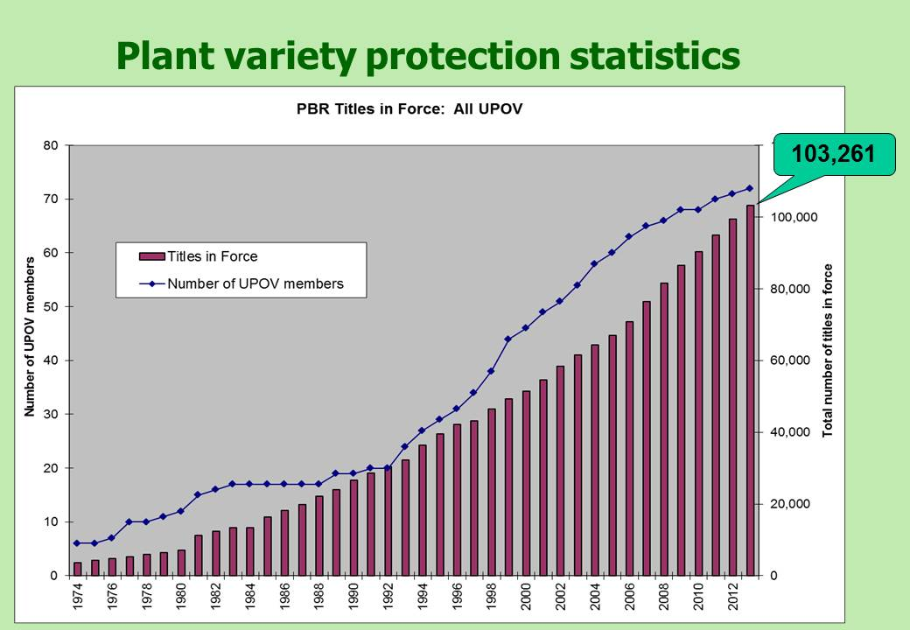  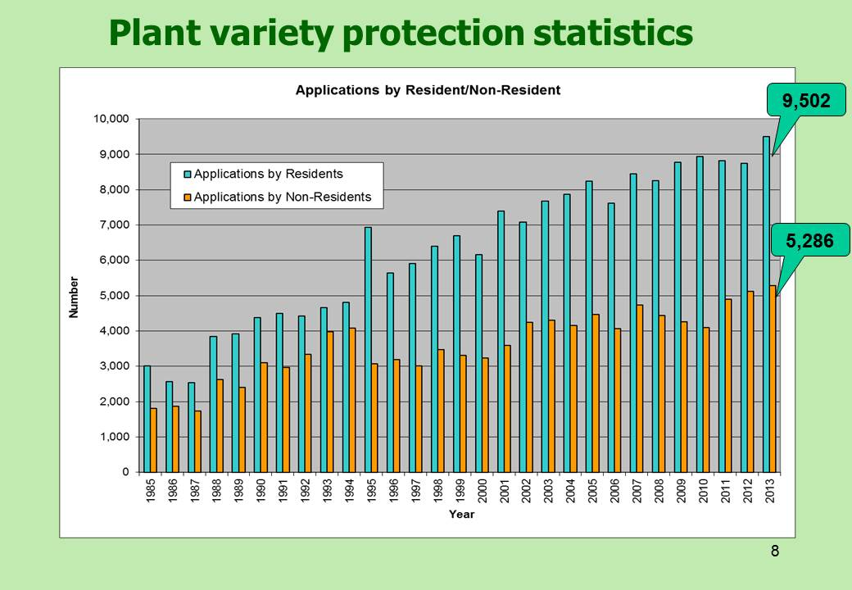  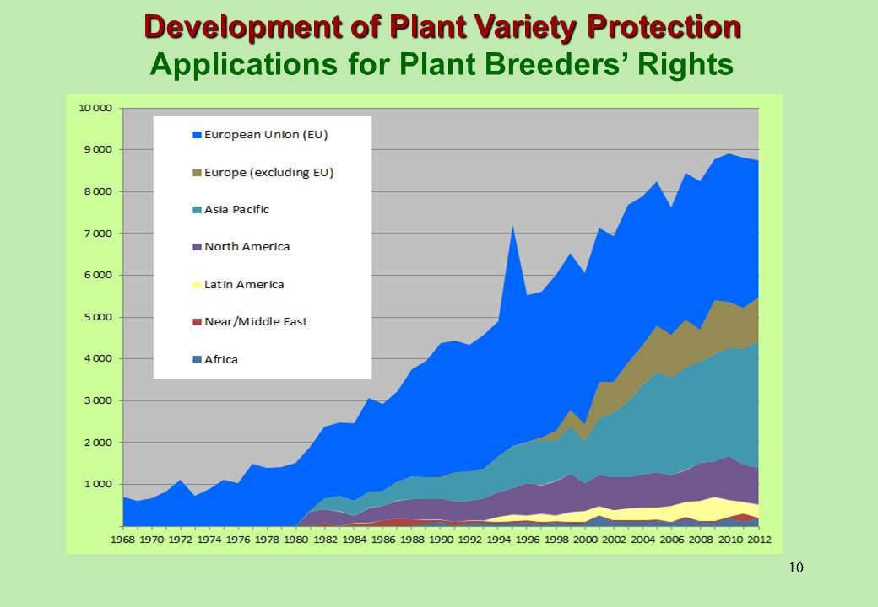  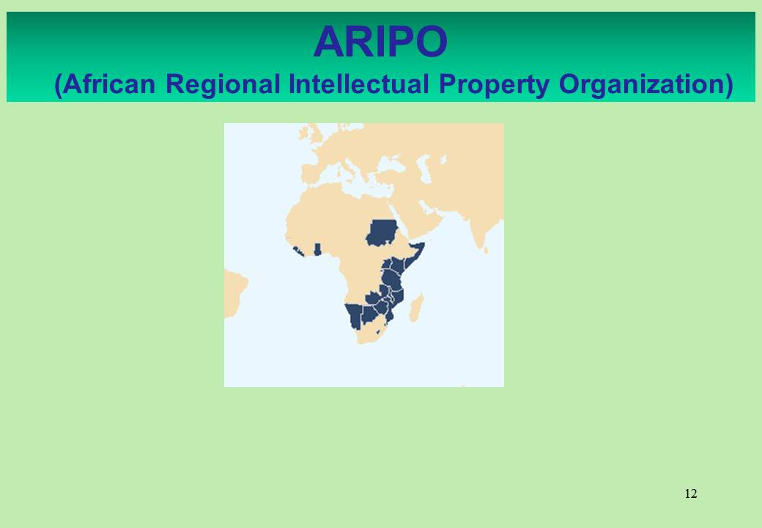  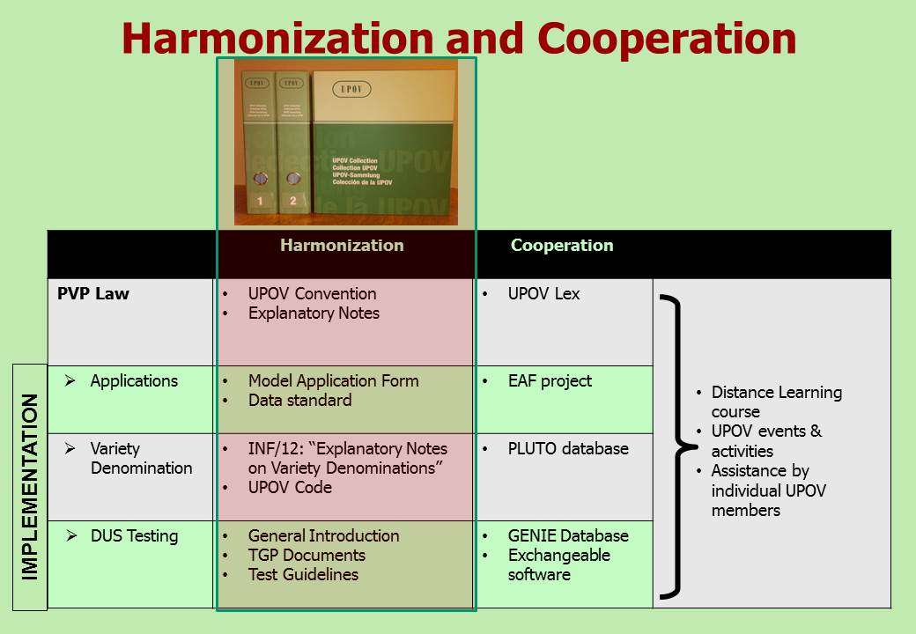  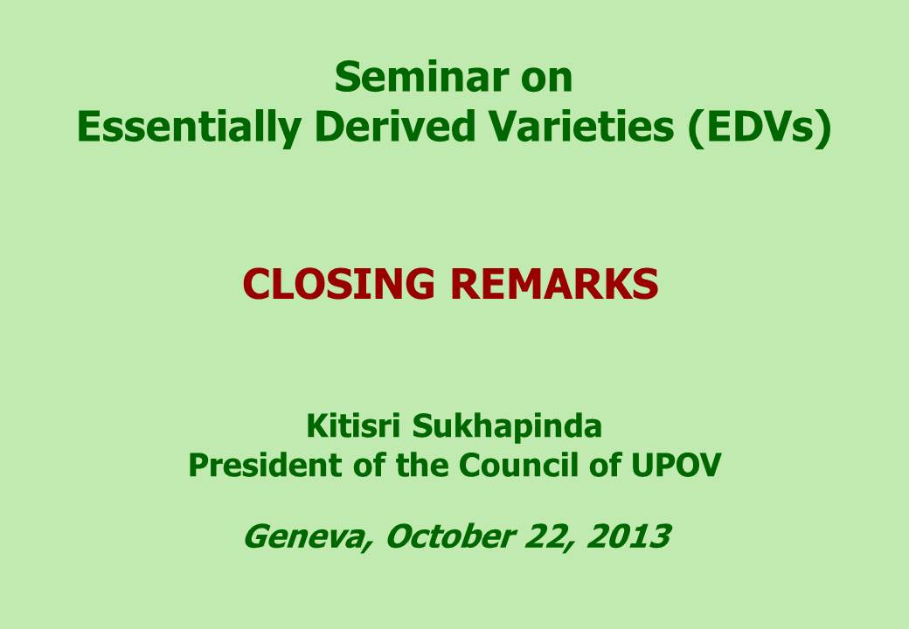  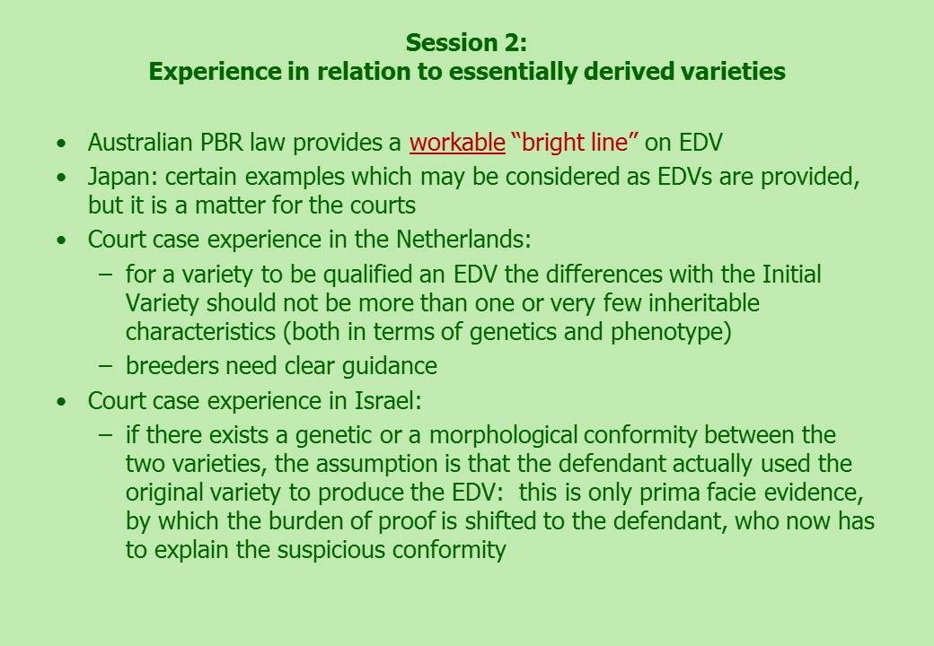  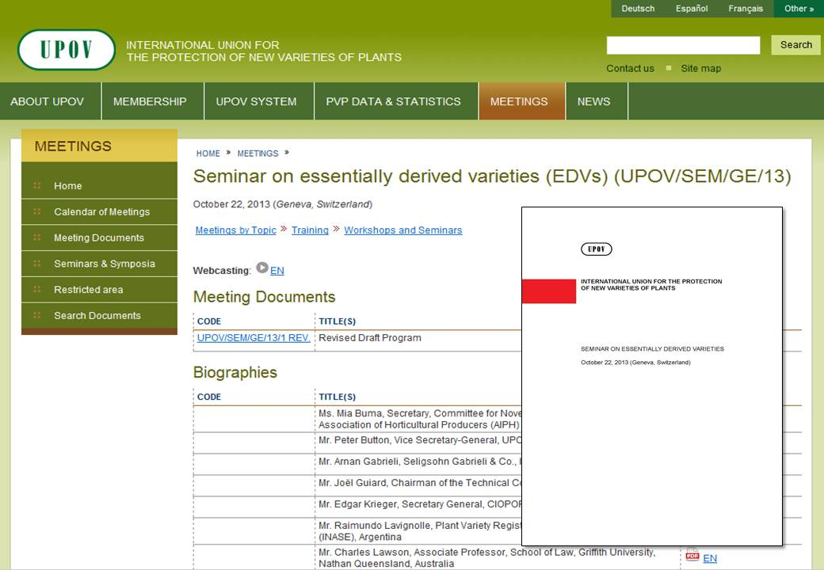  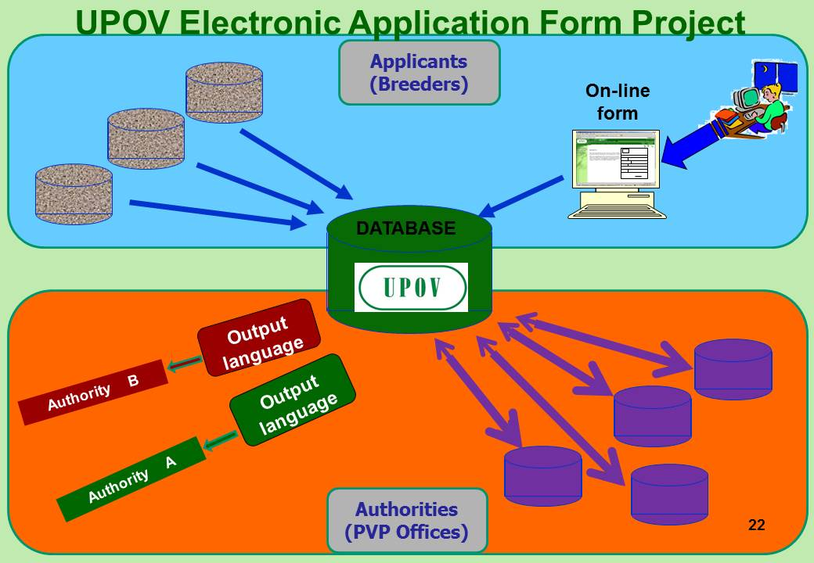  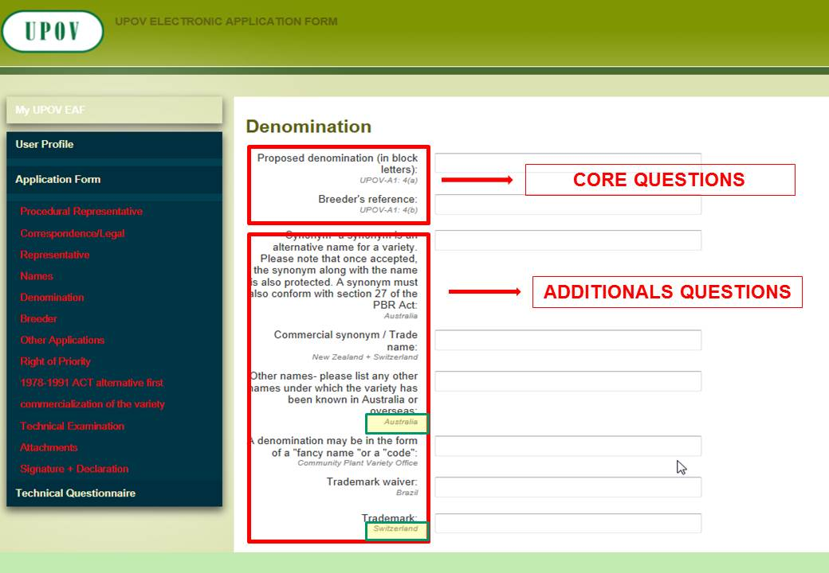  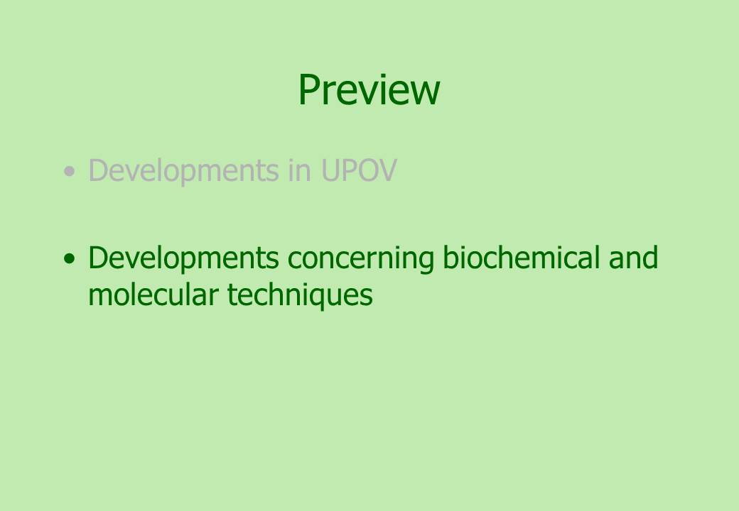  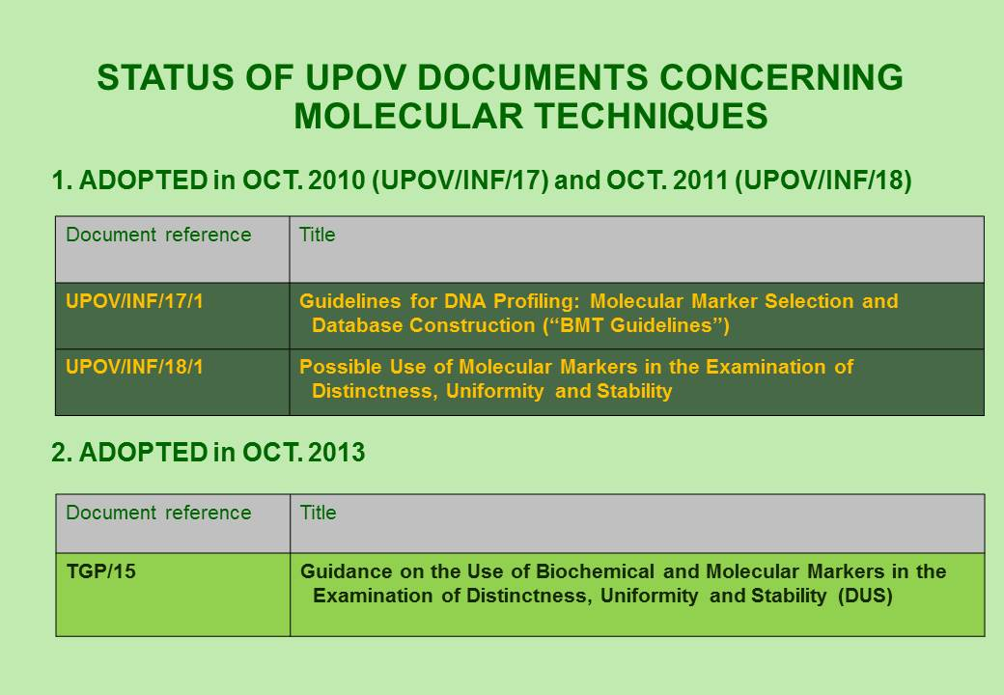  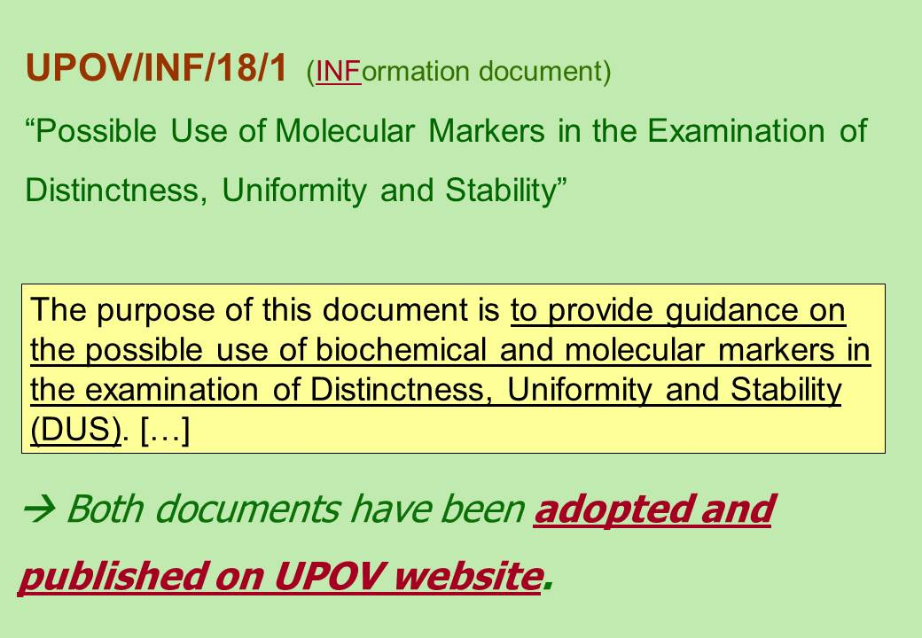  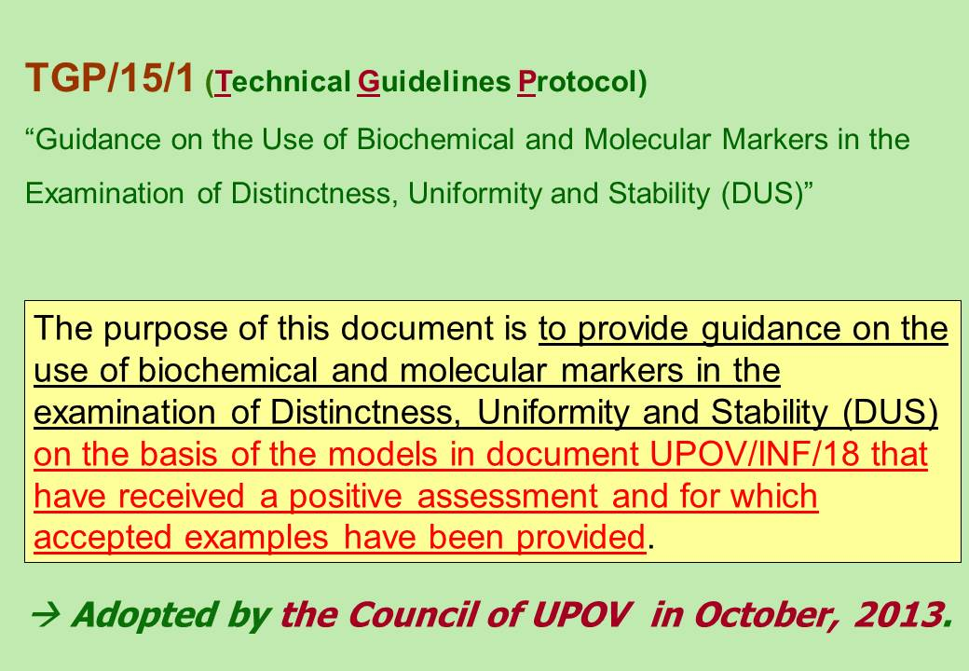  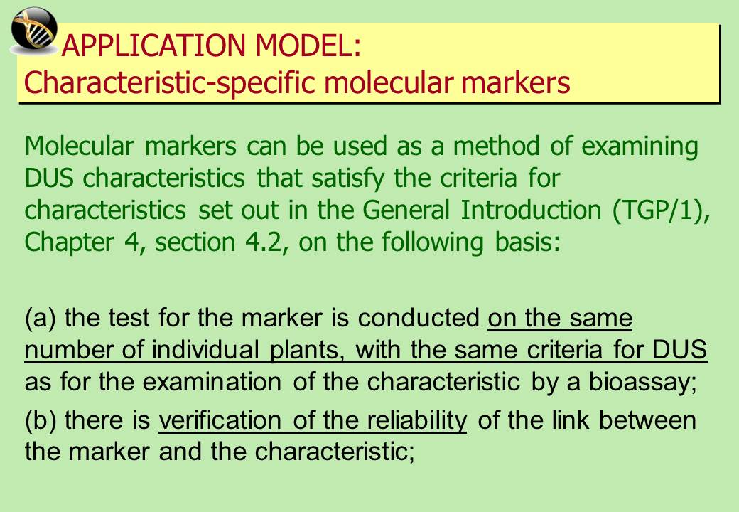  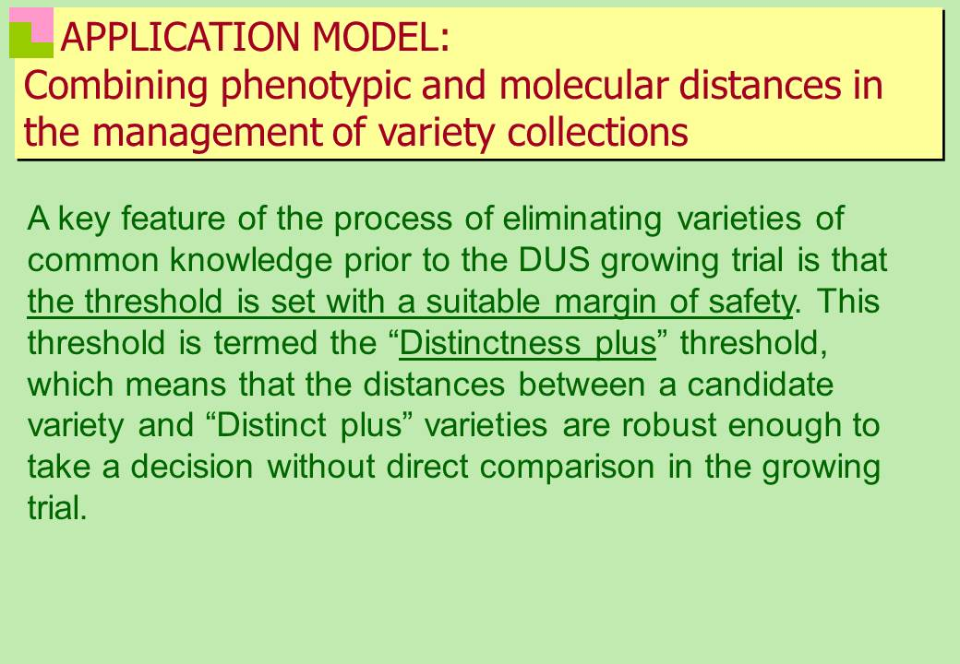  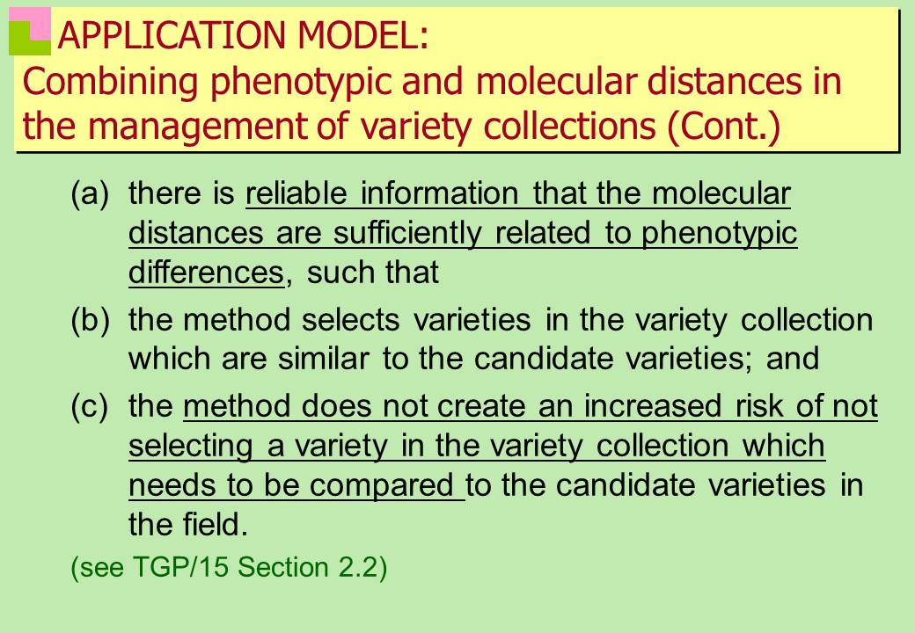  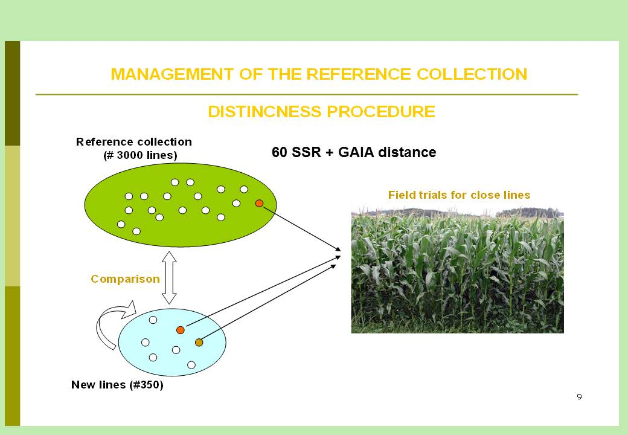  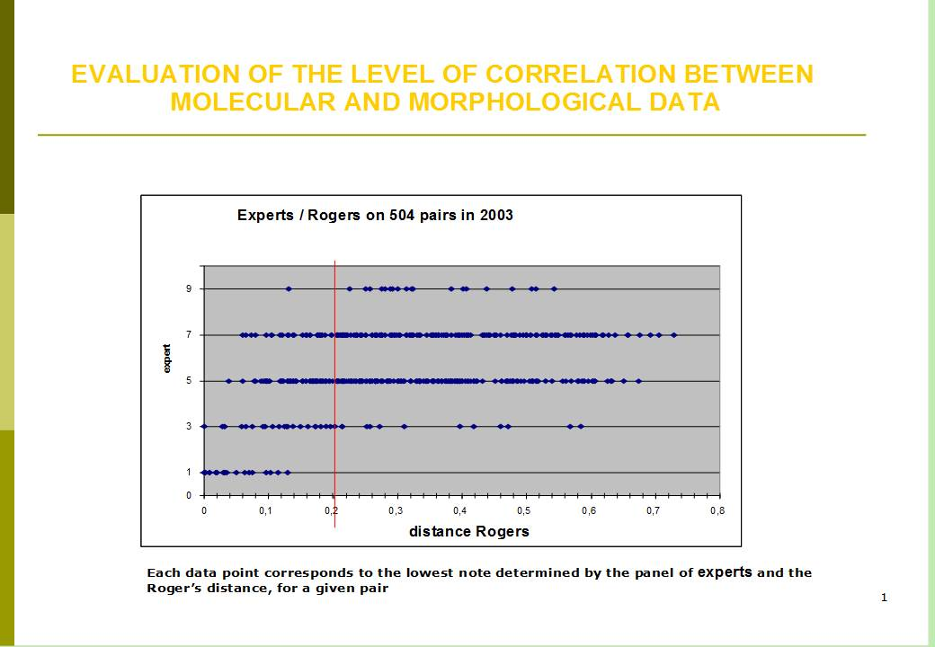  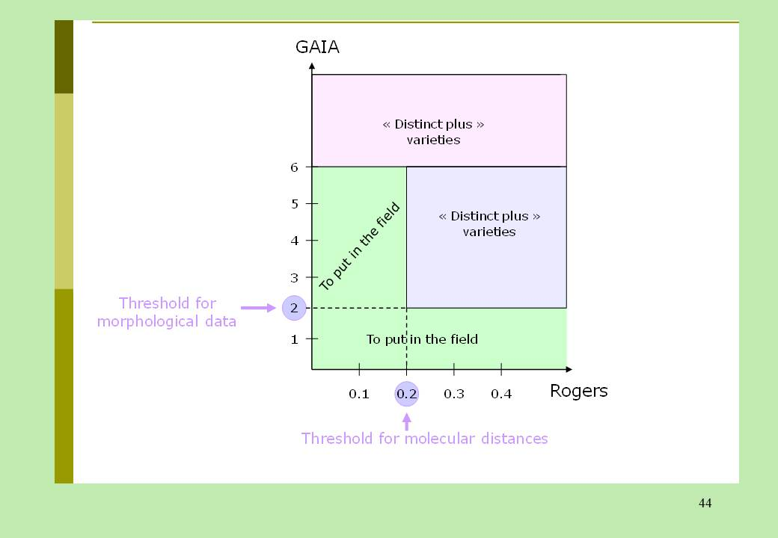  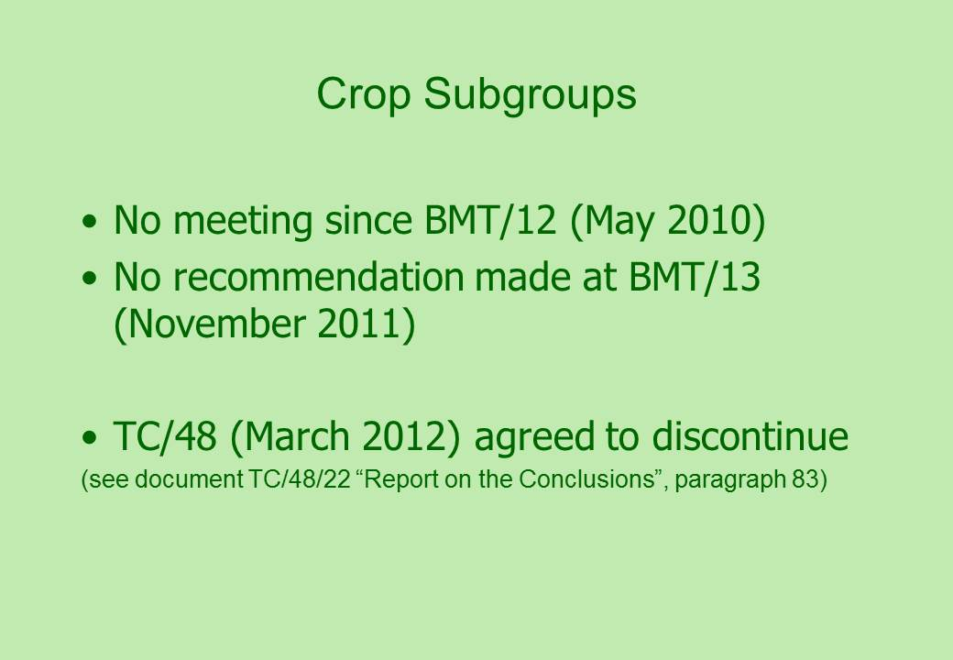  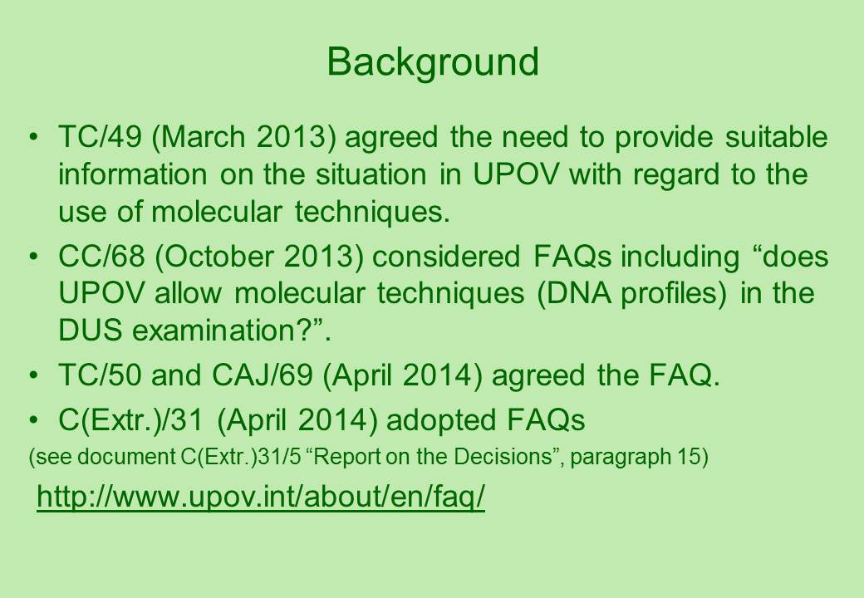  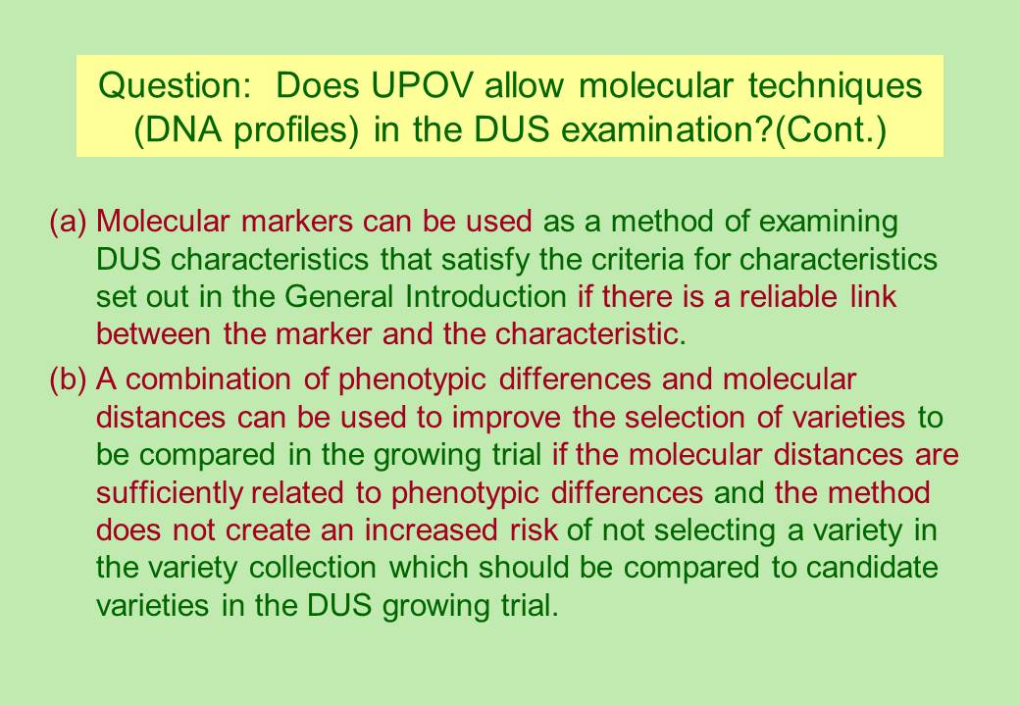  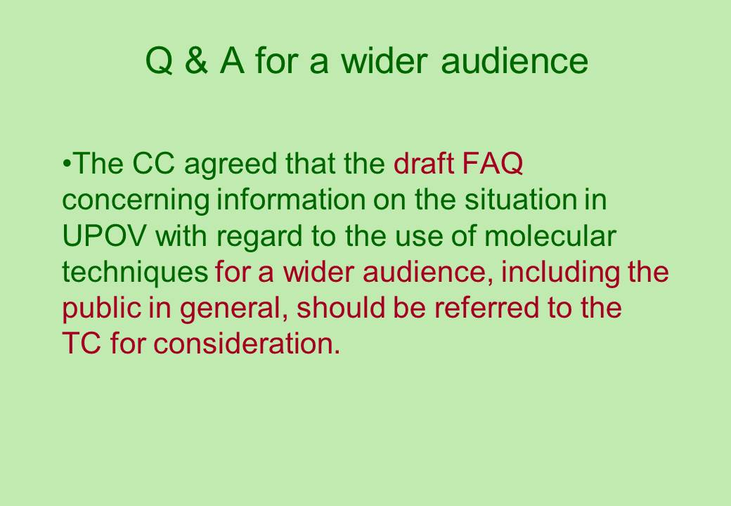  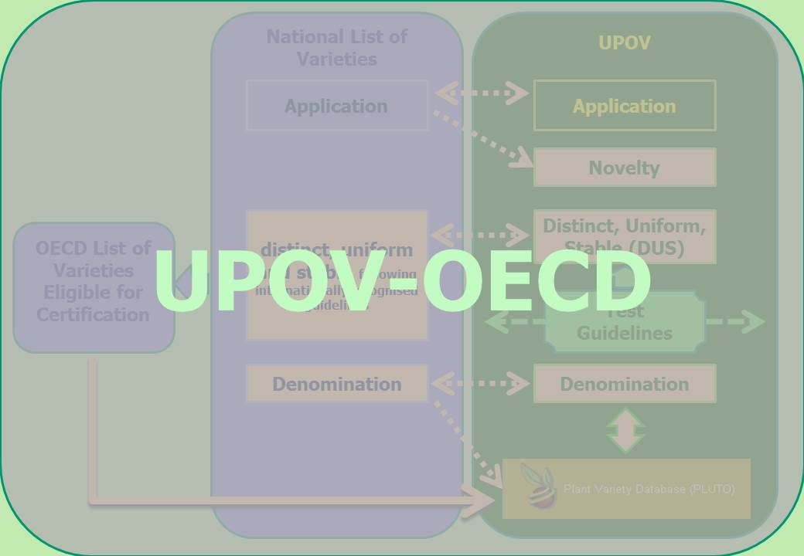

[End of Annex and of document]

