E
BMT/14/20
ORIGINAL: English
DATE: November 13, 2014
INTERNATIONAL UNION FOR THE PROTECTION OF NEW VARIETIES OF PLANTS
Geneva
WORKING GROUP ON BIOCHEMICAL AND MOLECULAR TECHNIQUES
AND DNA-PROFILING IN PARTICULAR
Fourteenth Session
Seoul, Republic of Korea, November 10 to 13, 2014
Report
Document prepared by the Office of the Union

Disclaimer: this document does not represent UPOV policies or guidance

The Working Group on Biochemical and Molecular Techniques and DNA-Profiling in Particular (BMT) held its fourteenth session in Seoul, Republic of Korea, from November 10 to 13, 2014. The list of participants is reproduced in Annex I to this report.

The BMT was welcomed by Mr. Hyun Kwan Shin, Director General, Korea Seed & Variety Service (KSVS). A copy of his welcoming address is reproduced in Annex II to this report.

The BMT received a presentation on the plant variety protection on the Republic of Korea from Mr. Moo Kyung Yoon, Director of Plant Variety Protection Division, Korea Seed & Variety Service (KSVS). A copy of his presentation is reproduced in Annex III to this report.

The session was opened by Mr. Alejandro F. Barrientos-Priego (Mexico), Chairman of the BMT, who welcomed the participants.

Adoption of the Agenda

The BMT adopted the Agenda as reproduced in document BMT/14/1 Rev.

Reports on developments in UPOV concerning biochemical and molecular techniques

The Office of the Union (the Office) provided a report on developments in UPOV concerning Biochemical and Molecular Techniques, on the basis of document BMT/14/2 Rev2.

Short presentations on new developments in biochemical and molecular techniques by DUS experts, biochemical and molecular specialists, plant breeders and relevant international organizations

The BMT noted the information on developments in plant variety protection from members and observers provided in document BMT/14/15 Prov. and received a presentation from the United States of America. The BMT noted that the presentation by the United States of America and other reports submitted to the Office of the Union would be included in the final version of document BMT/14/15.

Report of work on molecular techniques on a crop-by-crop basis

The Use of Reference Varieties in Varietal Distinctness : An Approach under Investigation in the United States of America for Potential Application in Plant Variety Protection

(document BMT/14/5 and BMT/14/5 Add.)

The BMT received a presentation by Mr. Paul Nelson (ASTA), based on document BMT/14/5 and BMT/14/5 Add.

The BMT noted that the proposal was at an early stage of consideration by the Plant Variety Protection Office in the United States of America, but agreed that it would be useful to invite the Technical Committee to consider the possible approach for the use of molecular markers.

The BMT recalled the importance of harmonization within UPOV for the purposes of cooperation in examination.

Identification of Rice Varieties Using Genic Markers for Three DUS Characteristics

(document BMT/14/8 Rev. And BMT/14/8 Add.)

The BMT received a presentation by Mr. Seyed Hossein Jamali (Iran (Islamic Republic of)), based on document BMT/14/8 Rev. and BMT/14/8 Add.

The BMT noted that the use of characteristic-specific molecular markers for grouping would require that there was no overlap in allelic groups.

The Use of Molecular markers (SNP) for Maize DUS Testing
(document BMT/14/10 and BMT/14/10 Add.)

The BMT received a presentation by Mr. René Mathis and Mrs. Clarisse Maton (France), based on document BMT/14/10 and BMT/14/10 Add.

Mrs. Maton clarified that the morphological descriptions were produced in the first growing cycle and the method described in document BMT/14/10 and BMT/14/10 Add. was used for selecting similar varieties to be grown in the second growing cycle.

The BMT noted that the KASP (Kompetitive Allele Specific PCR) chemistry proposed by LGC Genomics did not provide information on the sequences used.

Potential Uses of Molecular Markers in Management of Rose Varieties for the PVP System

(document BMT/14/12 and BMT/14/12/ Add.)

The BMT received a presentation by Mr. Zheng Yongqi (China), based on document BMT/14/12 and BMT/14/12 Add.

With regard to the number of different loci used to decide if two varieties were distinct from each other, Mr. Yongqi explained that two had been chosen for consistency with the approach proposed by some Chinese researchers on agriculture and ornamental breeding and because of the “two note rule” that was used by UPOV in relation to quantitative characteristics.

Development of EST-SSR Markers of Lettuce and Variety Identification Using EST-SSR Markers (document BMT/14/13 Rev.)

The BMT received a presentation by Ms. Jee-Hwa Hong (Republic of Korea), based on document BMT/14/13 Rev.

The BMT recalled that the report on work by experts from France at the thirteenth session of the BMT had concluded that construction of a reference collection management tool on the basis of the SSR markers was not powerful enough to avoid potential risks (see document BMT/13/12). The BMT agreed that it would be useful to exchange information between the Republic of Korea, France and the Netherlands, and possibly other members of the Union, to explore the potential to use markers in lettuce for the management of variety collections.

Construction of DNA Profile Database of Strawberry Varieties Using SSR Markers

(document BMT/14/14 Rev.)

The BMT received a presentation by Ms. Jee-Hwa Hong (Republic of Korea), based on document BMT/14/14 Rev.

Use of Molecular Marker Techniques for Selection of ‘Similar Variety’ about ‘Candidate Variety’ (document BMT/14/16 Rev2.)

The BMT received a presentation by Ms. Kyoung-In Seo (Republic of Korea), based on document BMT/14/16 Rev2.

The BMT agreed that the approach of using molecular markers for identifying similar varieties should be considered further by the Technical Committee, bearing in mind that it was not covered by an existing model in document TGP/15. In that regard, it agreed that it would be useful to consider whether molecular markers might be used as first step for selecting varieties to be included in the growing trial, with additional varieties being included if necessary after morphological and physiological information was obtained in the growing trial. The BMT noted that such an approach would need to be considered on a crop-by-crop basis and that it would be necessary to have molecular data for the varieties of common knowledge. It was also noted that molecular markers could be used in parallel with morphological and physiological characteristics to select varieties of common knowledge for the growing trial, or could be used as a form of “safety net” to check for omitted varieties selected on the basis of morphological and physiological characteristics.

Improving Efficiency of DUS Testing of Perennial Ryegrass by Combining Morphological and Molecular Variety Distances (document BMT/14/17 and BMT/14/17 Add.)

The BMT received a presentation by Mrs. Hedwich Teunissen, (Netherlands), based on document BMT/14/17 and BMT/14/17 Add.

The BMT noted that the project was a pilot project to explore the potential use of molecular markers in the management of the variety collection. It further noted that, if results were sufficiently positive, the project could be expanded in cooperation with other UPOV members (e.g. in Europe, Australia, New Zealand etc.).

A European Potato Database as Centralized Collection of Varieties of Common Knowledge
(document BMT/14/18 and BMT/14/18 Add)

The BMT received a presentation by Mr. Alex Reid, (United Kingdom), based on document BMT/14/18 and BMT/14/18 Add.

The BMT noted that the database covered only potato varieties in the variety collections of European countries and suggested that it would be important to expand the database to cover all varieties of common knowledge. It noted that such an initiative would require funding and observed that participating UPOV members, breeders and other interested organizations might be approached with regard to funding the work involved. The BMT noted that the database of the result was not accessible by the breeders.

The BMT discussed the possibility for the database to be used to reduce the number of varieties of common knowledge to be compared with candidate varieties in the DUS growing trial in the framework of the Model “Combining phenotypic and molecular distances in the management of variety collections” in document TGP/15.

It was agreed that it would be useful to report on the project and the discussions in the BMT at the forty-third session of the Technical Working Party for Agricultural Crops (TWA), to be held in Mar del Plata, Argentina, from November 17 to November 21, 2014.

Molecular Markers as Predictors for ‘Traditional’ Characteristics (document BMT/14/19 Rev.)

The BMT received a presentation by Mrs. Hedwich Teunissen, (Netherlands), based on document BMT/14/19 Rev.

An expert from France recalled the discussions at the forty-eighth session of the Technical Working Party for Vegetables (TWV), held in Paestum, Italy, from June 23 to 27, 2014, concerning the reliability of the prediction of disease resistance in tomato. In that regard, it was agreed that it would be useful for relevant members of the Union to share information and to consider possible problems for predictability, such as genetic background.

It was agreed that it would be useful to consider the introduction of decision rules for the use of the markers, particularly with regard to situations where the molecular data was inconsistent with the information provided in the Technical Questionnaire. The BMT noted that, if it was agreed to include a PCR method in the Test Guidelines, a bioassay method would also be provided in the Test Guidelines.

The BMT heard that the experts from the Netherlands were in contact with the Office of the Union about the issues around the possible inclusion in Test Guidelines of methods that are covered by confidentiality agreements.

International guidelines on molecular methodologies

The BMT received a report on developments in UPOV concerning international guidelines on molecular methodologies, on the basis of document BMT/14/3.

Variety description databases

The BMT received a report on developments in UPOV concerning variety description databases, on the basis of document BMT/14/4.

Ownership and Use of DUS Samples and of DNA and DNA Data During and After the DUS Tests (document BMT/14/11 Rev.)

The BMT received a presentation by Mr. Kees Van Ettekoven (Netherlands), based on document BMT/14/11 Rev.

The BMT agreed that it would be useful to:

- review the examples in document TGP/5 “Experience and Cooperation in DUS Testing”, Section 11 “Examples of Policies and Contracts for Material Submitted by the Breeder” to see if they should be updated
- provide guidance in document INF/15 “Guidance for Members of UPOV on Ongoing Obligations and Related Notifications and on the Provision of Information to Facilitate Cooperation” on the need for transparency in relation to material submitted for DUS examination purposes, in addition to taking suitable measures to safeguard the legitimate interests of the breeder.
- provide guidance that the principles applied to the handling of plant material should be applied to DNA

The BMT noted that the publication of variety descriptions, photographs, DNA profiles etc. were subject to certain legal requirements within UPOV members and that it would be difficult to develop a harmonized approach. It was also recalled that, according to document TGP/5 “Experience and Cooperation in DUS Testing”, Section 6 “UPOV Report on Technical Examination and UPOV Variety Description”, the variety description comprises the following elements:

(a) characteristics of the variety; and
(b) similar varieties and differences from these varieties; combined with
(c) the information on the basis for (a) and (b), namely:
Date and document number of UPOV Test Guidelines;
Date and/or document number of Reporting Authority’s test guidelines;
Reporting Authority;
Testing station(s) and place(s) ;
Period of testing;
Date and place of issue of document;
Group: (Table: Characteristics; States of Expression; Note; Remarks);
Additional Information;
(a) Additional Data
(b) Photograph (if appropriate)
(c) RHS Colour Chart version used (if appropriate)
(d) Remarks

Methods for analysis of molecular data

The BMT noted that no information had been provided for this agenda item.

The use of molecular techniques in examining essential derivation

Identification of SNP Markers to aid Assessment of Essential Derivation in Maize

(document BMT/14/7/ Rev2.)

The BMT received a presentation by Mr. Barry Nelson (ISF), based on document BMT/14/7 Rev 2.

The BMT noted that the set of SNP markers had been published on the ISF website (http://www.worldseed.org/isf/edv.html) and EDV guidelines using SNPs adopted at the ISF congress in Beijing, 2014.

The use of molecular techniques in variety identification

Use of DNA Variety Identification Technique for Measures Against the Infringement of Plant Breeders’ Rights in Japan (document BMT14/6 and BMT/14/6 Add. Rev.)

The BMT received a presentation by Mr. Hiroshi Goto (Japan), based on document BMT/14/6 and BMT/14/6 Add. Rev.

The BMT noted that variety identity was established on the basis of the molecular data and did not include a morphological analysis. The BMT was informed that the cost of the storage of DNA and plant material was borne by the government of Japan. Mr. Goto reported that there were plans to provide variety identification techniques for other species in the future.

Determining a Threshold for Genetic Conformity In Potato Seedlings

(document BMT/14/9 and BMT/14/9 Add.)

The BMT received a presentation by Mr. Alex Reid (United Kingdom), based on document BMT/14/9 and BMT/14/9 Add.

OECD, UPOV, ISTA Joint Workshop

The OECD, UPOV, ISTA Joint Workshop (Workshop) was held in Seoul, Republic of Korea, on November 12, 2014.

The Workshop was opened by Mr. Kees van Ettekoven (Netherlands),

Introduction to the OECD Seed Scheme and the situation with regard to molecular techniques (document BMT/14/Joint/6)

The Workshop received a presentation by Mr. Gerald Hall (OECD), a copy of which is reproduced in document BMT/14/Joint/6.

The Workshop noted that the requirements for Distinctness, Uniformity and Stability (“DUS”) and for variety identification were different and that the use of molecular markers would not necessarily be the same.

The Workshop noted that it could be possible to use molecular markers as the basis for alternative methods whilst retaining the possibility for authorities to use existing methods where molecular methods were not appropriate for their circumstances. For example, it was recalled that, in UPOV, the use of characteristic-specific molecular markers and combining phenotypic and molecular distances in the management of variety collections, always enabled UPOV members to use alternative methods that did not involve molecular techniques. It was agreed that UPOV methods could be relevant for OECD and that coordination and exchange of information between UPOV and OECD would be beneficial.

Introduction to UPOV and the situation with regard to molecular techniques (document BMT/Joint/4)

The Workshop received a presentation from the Office of the Union, a copy of which is reproduced in document BMT/Joint/4.

Introduction to ISTA and the situation with regard to molecular techniques

(document BMT/14/Joint/3 Rev.)

The Workshop received a presentation by Mr. Benjamin Kaufman (ISTA), based on document BMT/14/Joint/3 Rev.

The Workshop noted that ISTA was developing molecular techniques for a range of applications. It was clarified that, to date, ISTA had not included molecular marker techniques in its Rules.

Introduction to ISO and the situation with regard to molecular techniques (document BMT/14/Joint2)

The Workshop received a presentation by Mr. Paul Zankowski (ISO), based on document BMT/14/Joint/2.

Existing areas of cooperation between OECD, UPOV and ISTA (document BMT/Joint/5)

The Workshop received a presentation from the Office of the Union, a copy of which is reproduced in document BMT/Joint/5.

Opportunities for cooperation between OECD, UPOV, ISO and ISTA with regard to molecular techniques

The Workshop agreed that it would be useful to develop a joint document explaining the principle features (e.g. DUS, variety identification, variety purity, etc. ) of the systems of OECD, UPOV and ISTA. It was also agreed that it would be useful for mutual understanding, to repeat the joint workshop at relevant meetings of the OECD and ISTA.

The Workshop agreed to propose an inventory by UPOV, OECD and ISTA of the use of molecular marker techniques, by crop, with a view to developing a document containing that information, in a similar format to UPOV document UPOV/INF/16 “Exchangeable Software”. It was noted that OECD had already collected some information regarding the use of molecular techniques by its designated authorities.

The Workshop further agreed to propose to invite UPOV, OECD and ISTA to develop lists of possible joint initiatives in relation to molecular techniques. It was noted that, in the case of UPOV, the list could be drafted by the BMT at its fifteenth session, subject to approval by the Technical Committee.

Date and place of next session

In response to the invitation received from Russian Federation, the BMT agreed to hold its fifteenth session and a preparatory workshop in Moscow, Russian Federation, in May 2016.

Future program

During its fourteenth session, the BMT planned to discuss the following items:

1. Opening of the session
2. Adoption of the agenda
3. Reports on developments in UPOV concerning biochemical and molecular techniques
4. Short presentations on new developments in biochemical and molecular techniques by DUS experts, biochemical and molecular specialists, plant breeders and relevant international organizations
5. Report of work on molecular techniques in relation to DUS examination
6. International guidelines on molecular methodologies
7. Variety description databases
8. Methods for analysis of molecular data
9. The use of molecular techniques in examining essential derivation
10. The use of molecular techniques in variety identification¹
11. Cooperation between OECD, UPOV, ISTA and ISO
12. Date and place of next session
13. Future program
14. Report of the session (if time permits)
15. Closing of the session

Medal

Mr. Alejandro F. Barrientos-Priego was awarded a UPOV bronze medal in recognition of his chairmanship of the BMT from 2012-2014.

The BMT adopted this report at the close of the session.

[Annexes follow]

LIST OF PARTICIPANTS

I. MEMBERS

china
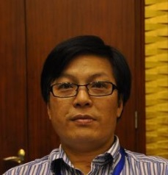 |  |  | Yongqi ZHENG (Dr.), Director, Research Professor, Molecular Identification of Plant Varieties, PVP Office, State of Forestry Administration, China/ Xiangshan Road, Haidian District Beijing 100091, China  (tel.: 86 10 6288 8565 e-mail: zyq8565@126.com, zhengyq@caf.ac.cn)
european Union
Anne WEITZ (Mrs.), Expert in Agricultural Crops, Community Plant Variety Office (CPVO), 3 boulevard Foch, CS 10121, 49101 Angers Cedex 2
(tel.: +33 2 41 25 64 37 fax: +33 2 41 25 64 10 email: weitz@cpvo.europa.eu)
france
René MATHIS, Laboratory Manager, BioGEVES, GEVES, 25 rue Georges Morel,
CS 90024, 49071 Beaucouzé Cedex
(Tel.: +33 2 41 22 58 34 Fax: +33 2 41 22 86 02 email: rene.mathis@geves.fr)
Clarisse MATON (Mrs.), DUS Coordinator, GEVES, 25 rue Georges Morel, CS 90024, 49071 Beaucouzé Cedex
(Tel.: +33 2 41 22 85 96 email: clarisse.maton@geves.fr)
japan
Hiroshi GOTO, Deputy Plant Variety Protection Advisor, Plant Variety Protection Division, National Centre for Seeds and Seedlings (NCSS), 2-2, Fujimoto, Tsukuba,
Ibaraki 305-0852
(Tel.: +81 29 838 6589 fax: +81 29 838 6595 email: gotohiro@ncss.go.jp)
mexico
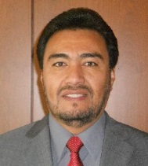 | Alejandro F. BARRIENTOS-PRIEGO, Professor, Departamento de Fitotecnia,  Universidad Autónoma de Chapingo, Km 38.5 Carretera, México-Texcoco, Chapingo, CP56230  (Tel.: +52 595 952 1559 email: abarrien@gmail.com / abarrien@correo.chapingo.mx)
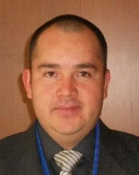 | Eduardo PADILLA VACA, Director of the Registry of Plant Varieties, National Service of Seed Inspection and Certification (SNICS), Av. Presidente Juárez #13, Col. El Cortijo,  C.P. 54000, Tlalnepantla de Baz  (Tel.: +52 55 3622 0667 fax: +52 55 3622 0670 email: eduardo.padilla@sagarpa.gob.mx)
netherlands
Hedwich TEUNISSEN (Mrs.), Senior Researcher, Naktuinbouw, Sotaweg 22, 2371 GD Roelofarendsveen
(Tel.: +31 71 332 6262 fax: +31 71 332 6363 email: h.teunissen@naktuinbouw.nl)
Kees VAN ETTEKOVEN, Head, Variety Registration Department, Naktuinbouw, Sotaweg 22, 2371 GD Roelofarendsveen
(Tel.: +31 6 113 60675 email: c.v.ettekoven@naktuinbouw.nl)
Monika Slawiak (Mrs.), Molecular Quality Assurance Scientist, Bayer CropScience Vegetable Seeds, P.O. Box 4005, 6080 AA Haelen, the Netherlands
(tel.: +31 475 599 222 email: monika.slawiak@bayer.com)
republic of korea
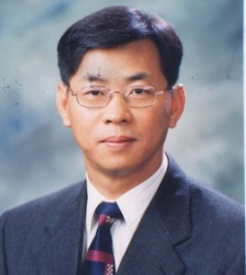 |  | Hyunkwan SHIN, Director General, Korea Seed & Variety Service (KSVS), Ministry of Agriculture, Food and Rural Affairs (MAFRA), 119, Hyeoksin 8ro, Kimcheon-si, Gyeongsangbuk-do, 740-220  (tel.: +82 54 912 0100 fax: +82 54 912 0145 e-mail: boseyo58@korea.kr)
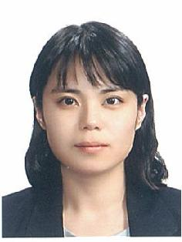 |  | Jeehwa HONG (Ms.), Researcher, Seed & Variety Service (KSVS), Ministry of Agriculture, Food and Rural Affairs (MAFRA), 119, Hyeoksin 8ro, Kimcheon-si, Gyeongsangbuk-do, 740-220  (tel.: +82 54 912 0230 fax: +82 54 912 0277 e-mail: hongjh19@korea.kr)
Oksun KIM (Ms.), Researcher, Korea Seed & Variety Service, Ministry of Agriculture, Food and Rural Affairs (MAFRA), 119, Hyeoksin 8ro, Kimcheon-si, Gyeongsangbuk-do, 740-220
(tel.: +82 54 912 0170 fax: +82 54 912 0175 e-mail: oksunkim@korea.kr)
Byungchun YU, Senior Researcher, Korea Seed and Variety Service (KSVS), Ministry of Agriculture, Food and Rural Affairs (MAFRA), Yepyoung-ro 456, Sangnam-myun, Miryang-si Gyoungsangnam-do,
(tel.: 82 55 352 9552 fax: 82 55 352 2590 e-mail: ybc1209@korea.kr)
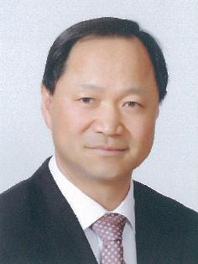 |  | Keunjin CHOI, Director, Vegetable research division, NIHHS/RDA  (tel.: +10 8878 8599 fax: +82 31 240 3669 e-mail: kjchoi1001@korea.kr)
Eunhee SOH (Ms.), Head of Seed Testing & Research Center, Korea Seed & Variety Service, Ministry of Agriculture, Food and Rural Affairs (MAFRA), 119, Hyeoksin 8ro, Kimcheon-si, Gyeongsangbuk-do, 740-220
(tel.: +82 54 912 0220 fax: +82 54 912 0277 e-mail: : eunhee.soh @korea.kr)
Kyounginn SEO (Ms.), Researcher, Ministry of Agriculture, Food and Rural Affairs(MAFRA), 119, Hyeoksin 8ro, Kimcheon-si, Gyeongsangbuk-do, 740-220
(tel.:+82 54 912 0231 fax:+82 54 912 0277 e-mail: ski760@korea.kr)
Hongsup KIM, Researcher, Korea Seed & Variety Service, Ministry of Agriculture, Food and Rural Affairs(MAFRA), 119, Hyeoksin 8ro, Kimcheon-si, Gyeongsangbuk-do, 740-220
(tel.:+82 54 912 0236 fax:+82 54 912 0277 e-mail: hskim98@korea.kr)
Dongmin KIM, Researcher, Korea Seed & Variety Service, Ministry of Agriculture, Food and Rural Affairs(MAFRA), 119, Hyeoksin 8ro, Kimcheon-si, Gyeongsangbuk-do, 740-220
(tel.:+82 54 912 0222 fax:+82 54 912 0277 e-mail: acekdm@korea.kr)
Eunhee BAE (Ms.), Korea Seed & Variety Service, Ministry of Agriculture, Food and Rural Affairs(MAFRA), 119, Hyeoksin 8ro, Kimcheon-si, Gyeongsangbuk-do, 740-220
(tel.:+82 54 912 0224 fax:+82 54 912 0277 e-mail: eunhb@korea.kr)
Eunsun CHUNG (Ms.), Senior Researcher, Korea Seed & Variety Service, Ministry of Agriculture, Food and Rural Affairs(MAFRA), 119, Hyeoksin 8ro, Kimcheon-si, Gyeongsangbuk-do, 740-220
(tel.:+82 54 912 0111 fax:+82 54 912 0210 e-mail: eschung@korea.kr)
Seungin YI, Chief Examainer, Korea Seed & Variety Service, Ministry of Agriculture, Food and Rural Affairs(MAFRA), 119, Hyeoksin 8ro, Kimcheon-si, Gyeongsangbuk-do, 740-220
(tel.:+82 54 912 0110 fax:+82 54 912 0210 e-mail: seedin@korea.kr)
Mookyung YOON, Director of division, , Korea Seed & Variety Service, Ministry of Agriculture, Food and Rural Affairs(MAFRA), 119, Hyeoksin 8ro, Kimcheon-si, Gyeongsangbuk-do, 740-220
(tel.:+82 54 912 0200 fax:+82 54 912 0210 e-mail: yoonmk@korea.kr)
Hwajin, CHO (Ms.), NONGWOO BIO, 113-141, Yanghwa-ro, Ganam-eup, Yeoju-si
(tel.: 019-406-6810 e-mail: hjchohn@nongwoobio.co.kr)
Soungwoo PARK, Team Leader NongHyup Seed, NongHyup seed, 164, Jeongbong-gil, Gongdo-eup, Anseong-si, Gyeonggi-do 456-825
(tel.: 031-652-5526 e-mail: psw0729@nonghyup.com)
Yongseok JANG, Examiner, Korea Forest Seed & Variety Center, 72 Suhoeri-ro Suanbo-myeon Chungju-si, 380-941
(tel.: 010-6217-1644 e-mail: mushrm@forest.go.kr)
Yongrak KWON, Researcher, Korea Forest Seed & Variety Center, 72 Suhoeri-ro Suanbo-myeon Chungju-si, 380-941
(tel.: 010-5285-3866 e-mail: yongrak@forest.go.kr)
Taehoon KIM, Researcher, Korea Forest Seed & Variety Center, 72 Suhoeri-ro Suanbo-myeon Chungju-si, 380-941
(tel.: 010-7547—3759 e-mail: algae@forest.go.kr)
Kyungah LEE (Ms.), Research Scientist, NongWoo Bio, 113-141, Yanghwa-ro, Ganam-eup, Yeoju-si
(tel.: 010-4729-3272 e-mail: blueye00@hanmail.net)
Jihyun HWANG (Ms.),Research Scientist, NongWoo Bio, 113-141, Yanghwa-ro, Ganam-eup, Yeoju-si
(tel.: 010-4303-3735 e-mail: hwangg3735@nate.com)
Seungyong OH, Director of Reaserch, SeungYong Flower Consulting & Managements Institue., WooRhim@ 101-105, 149, Gian-dong, Hwasung-si, GeoyongGi-do
(tel.: 010-3746-6436 e-mail: ohyn@nate.com)
Dongsun KIM, Researcher, KSVS, 570-892, 1177, Hamnang-ro, Nangsan-myeon, Iksan, Jeonbuk
(tel.:+82 63 861 2595 e-mail: coinoia@korea

.kr)
Hyounjoung KIM, Resercher, Nongwoo Bio, 113-141, Yanghwaro, Ganam, Yeoju, Gyeonggi 469-885
(tel.:010-3209-3608 e-mail: baubany@nongwoobio.co.kr)
Songji AN, Resercher, Nongwoo Bio, 113-141, Yanghwaro, Ganam, Yeoju, Gyeonggi 469-885
(tel.: 010-8741-8238 e-mail: mani9251@nongwoobio.co.kr)
Juyeon JUNG(Ms.), Researcher, Dongbu Farm Hannong, 576-44, Deokbongsewon-ro, Yangseong-myeon, Anseong-si, Gyeonggi-do, 456-833, Republic of Korea
(tel.: 010-87007-8376 e-mail: juyeon@dongbu.com)
 |  | Dongyoon KIM, Dong Farm Hannong, 576-44, Deokbongsewon-ro, Yangseong-myeon, Anseong-si, Gyeonggi-do, 456-833, Republic of Korea
 |  | JiWon BAEK(Ms.), Dongbu Farm Hannong, 576-44, Deokbongsewon-ro, Yangseong-myeon, Anseong-si, Gyeonggi-do, 456-833, Republic of Korea
 |  | Kangie LEE(Ms.), Dongbu Farm Hannong, 576-44, Deokbongsewon-ro, Yangseong-myeon, Anseong-si, Gyeonggi-do, 456-833, Republic of Korea
 |  | Kibong LEE, Korea Seed & Variety Service, Ministry of Agriculture, Food and Rural Affairs (MAFRA), 119, Hyeoksin 8ro, Kimcheon-si, Gyeongsangbuk-do, 740-220
Nari HA, Korea Seed & Variety Service, Ministry of Agriculture, Food and Rural Affairs (MAFRA), 119, Hyeoksin 8ro, Kimcheon-si, Gyeongsangbuk-do, 740-220
(tel.: +82 54 912 0171 fax: +82 54 912 0175 e-mail: hnr318@korea.kr)
russian federation
Dmitry DOROKHOV (Dr.), Leading Scientific Officer, Centre Bioengineering of Russian Academy of Sciences, Pr. 60-leyta Oktyabrya 7, korp. 1, Moscow 117312
(tel.: +7 9262351164 fax: +7 (499) 135 0571 email: dmitry.dorokhov@gmail.com)
UNITED KINGDOM
Alex REID, Molecular Biologist, Science and Advice for Scottish Agriculture (SASA), Roddinglaw Road, Edinburgh EH12 9FJ
(Tel.: +44 131 244 8910 fax: +44 131 244 8987 email: alex.reid@sasa.gov.uk)
Margaret WALLACE (Ms.), Technical Manager, DUS, National Institute of Agricultural Botany (NIAB), Huntingdon Road, Cambridge, CB3 0LE
(Tel.: +44 1223 342288 email: margaret.wallace@niab.com)
UNITED STATES OF AMERICA
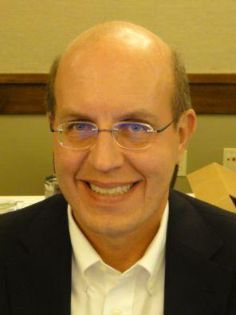 | Paul M. ZANKOWSKI, Commissioner, USDA, AMS, S&T, Plant Variety Protection Office, 1400 Independence Avenue, S.W., Room 4512, South Building, Mail Stop 0273, Washington D.C. 20250  (tel.: +1 202 720 1128 fax: +1 202 260 8976 email: Paul.Zankowski@ams.usda.gov)
II. OBSERVER stateS
IRAN (ISLAMIC REPUBLIC OF)
Seyed Hossein JAMALI, Head of Molecular Laboratory and DUS Examiner for Oil Seed Crops, Seed and Plant Certification and Registration Institute (SPCRI),
P.O. Box 31535-1516, Karaj
(tel.: +98 26 32740555 fax: +98 26 32740333
email: jamaly.h@gmail.com / hjamali@spcri.ir)
III. organizations
american seed TRADE association (asta)
Paul T. NELSON, Corn Breeder, 605 11th St SW, Spencer, Iowa 51301
(tel.: +1 712 262 1804 fax: +1 712 262 1806 email: paul.t.nelson@monsanto.com)
croplife
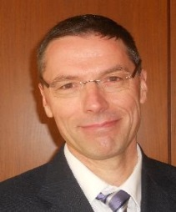 | Marcel BRUINS, Consultant, CropLife International A.I.S.B.L., 326 Avenue Louise, Box 35, 1050 Brussels, Belgium  (tel.: +32 2 542 04 10 fax: +32 2 542 04 19 email: mbruins1964@gmail.com)
international seed federation (isf)
Barry NELSON, Research Scientist, 7300 NW 62nd Avenue, Johnston, Iowa 50131
(tel.: +1 515 535 2202 email: barry.nelson@pioneer.com)
international seed testing association (ista)
Benjamin KAUFMAN, Secretary General, International Seed Testing Association (ISTA), Zürichstrasse 50, 8303 Bassersdorf
(tel.: +41 44 838 60 09 fax: +41 44 838 60 01 email: Beni.Kaufman@ista.ch)
organization for economic co-operation and development (oecd)
Gerald HALL, Chair of Ad Hoc Working Group on Molecular and Biochemical Techniques, OECD, Seed Certification for Scotland, Science and Advice for Scottish Agriculture (SASA), Roddinglaw Road, Edinburgh EH12 9FJ
(tel.: +44 131 244 8856 fax: +44 131 244 8966 email: gerry.hall@sasa.gsi.gov.uk)
IV. CHAIRMAN
 | Alejandro F. BARRIENTOS-PRIEGO
V. UPOV OFFICE
Peter BUTTON, Vice-Secretary General, International Union for the Protection of New Varieties of Plants (UPOV), 34 chemin des Colombettes, 1211 Geneva 20
(tel.: +41 22 338 8672 fax: +41 22 733 03 36 email: peter.button@upov.int)
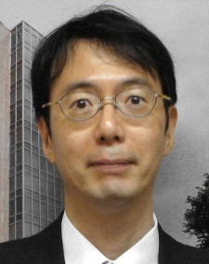 | Jun KOIDE, Technical/Regional Officer, International Union for the Protection of New Varieties of Plants (UPOV), 34 chemin des Colombettes, 1211 Geneva 20  (tel.: +41 22 338 7442 fax: +41 22 733 03 36 email: jun.koide@upov.int)

[Annex II follows]

WELCOME ADDRESS BY MR. Shin Hyunkwan, Director General, Korea Seed & Variety Service, Ministry of Agriculture, Food and Rural Affairs, republic OF korea

Honorable guests and participants! Good morning, everyone.
I am the Director-General of Korea Seed & Variety Service under the Ministry of Agriculture, Food and Rural Affairs.
I am very pleased to meet international PVP leaders home and abroad today, participating in the “fourteenth session of the Working Party on Biochemical and Molecular Techniques and DNA-Profiling in Particular of UPOV.”I would like to welcome all of you and convey my special appreciation to Mr. Peter Button, Vice Secretary-General of UPOV and Dr. Alejandro Barrientos Priego, Chairperson of BMT. And it is my personal honor to be amongst you.
Republic of Korea has enforced plant variety protection since 1998. The first five years was very tough. We struggled over not having many commercial plant varieties and discussed with farmers and stakeholders. After 15 years since the enforcement, our breeders now have a correct understanding and widen awareness on Plant Variety Protection. Let me give you an example, as for individual plant breeders, there were only 200 of them in 2005, but by 2012 the number tripled to about 600 individual breeders.
In recent years, our attractive national varieties have gained popularity abroad. These are incredible developments, thanks to sincere efforts of the government, seed companies, agriculture research institutes, individual breeders, farmers and consumers. As a government organization that manages plant variety protection system, this is indeed a very rewarding experience.
The last 15 years was the time of establishing and raising awareness of plant variety protection system. The coming 15 years will be the time of operating our PVP system effectively. It's been almost 30 years since the development of molecular markers. Recent breeding in Republic of Korea also includes selection programs using molecular markers. The age of breeding on demand has come. We use molecular markers in various ways but variety identification with the markers still needs more research. I hope this meeting will provide valuable discussions and propose practical cooperation between OECD, UPOV, ISO and ISTA with regard to molecular techniques.
Once again I am grateful to your presence here at the 14th UPOV BMT meeting. I wish you a safe and pleasant stay in Republic of Korea.
Thank you.

[Annex III follows]

Plant Variety Protection in republic of Korea

Presentation by Mr. Moo Kyung Yoon, Director of Plant Variety Protection Division, Korea Seed & Variety Service (KSVS).

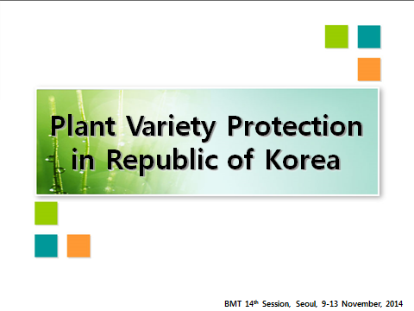

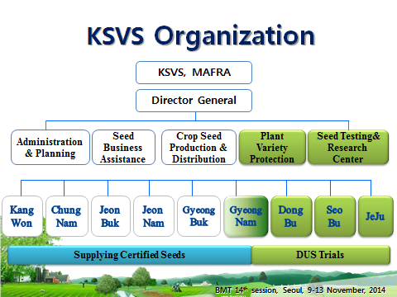

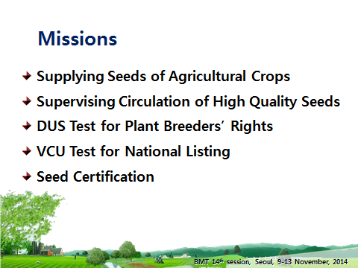

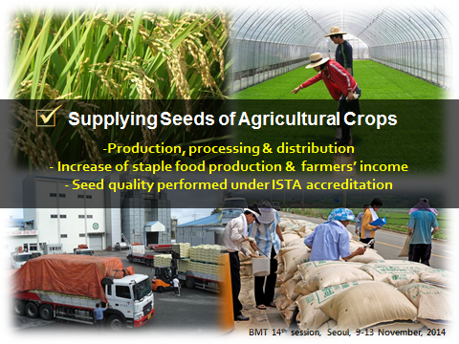

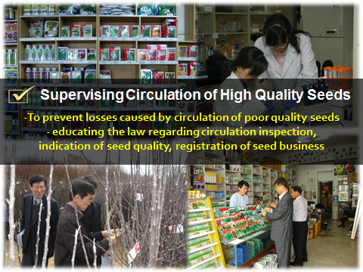

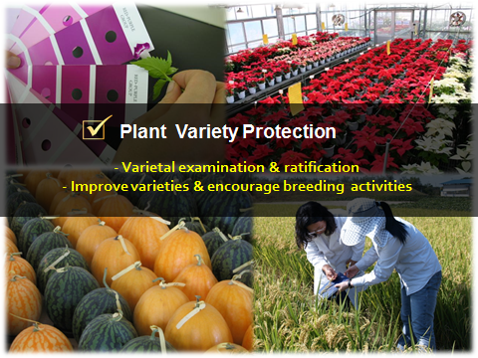

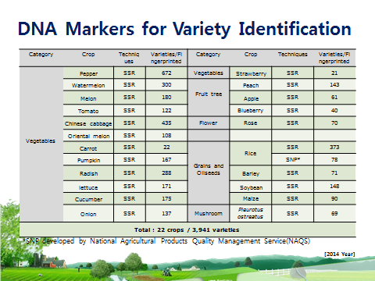

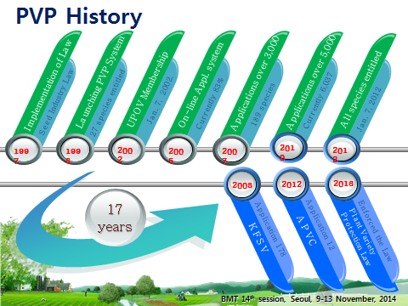

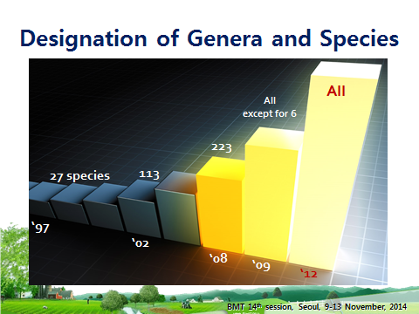

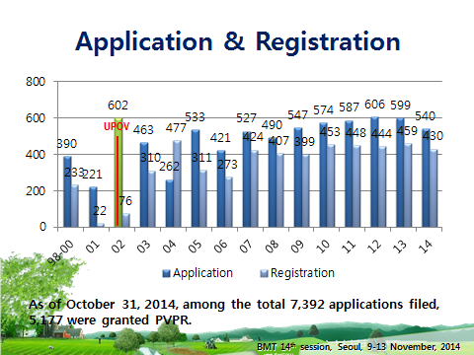

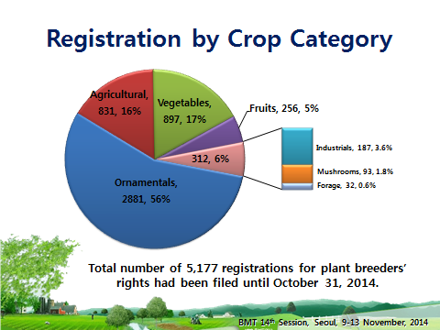

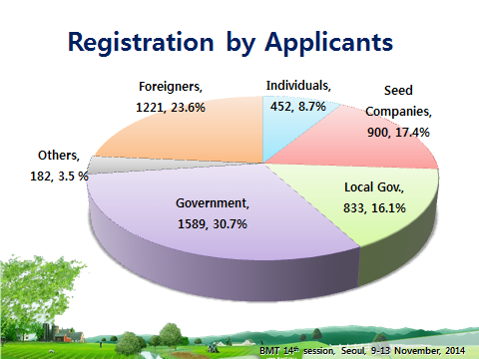

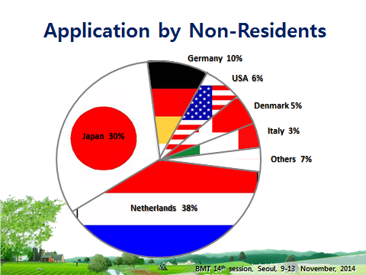

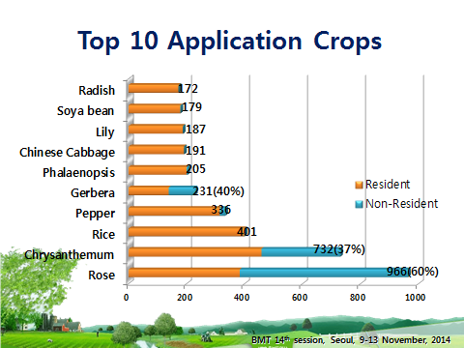

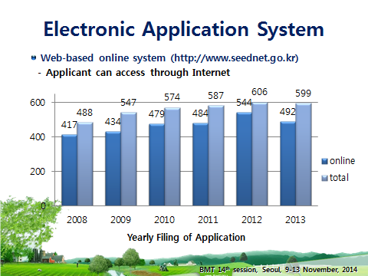

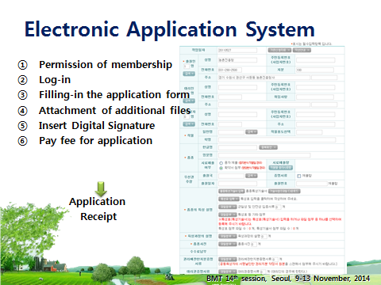

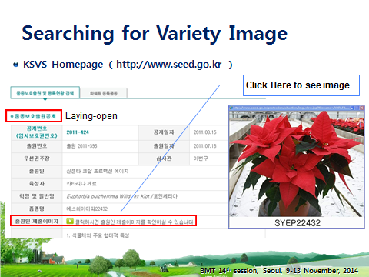

[End of Annexes and of document]

Breeders-Day

