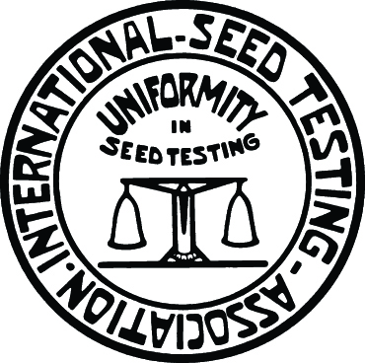
INTERNATIONAL SEED TESTING ASSOCIATION | INTERNATIONAL UNION FOR THE PROTECTION OF NEW VARIETIES OF PLANTS | ORGANISATION FOR ECONOMIC CO-OPERATION AND DEVELOPMENT
BMT/14/Joint/1 Rev2.
ORIGINAL: English
DATE: November 24, 2014

OECD/UPOV/ISTA JOINT WORKSHOP ON MOLECULAR TECHNIQUES
Seoul, Republic of Korea, November 12, 2014
REVISED pROVISIONAL PROGRAM
prepared by the Office of the Union
1. Welcome and opening

2. Introduction to the OECD Seed Schemes and the situation with regard to molecular techniques (document BMT/14/Joint/6)

3. Introduction to UPOV and the situation with regard to molecular techniques
(document BMT/14/Joint/4 Rev.)

4. Introduction to ISTA and the situation with regard to molecular techniques
(document/BMT/14/Joint/3 Rev.)

5. Introduction to ISO and the situation with regard to molecular techniques (document BMT/14/Joint/2)

6. Existing areas of cooperation between OECD, UPOV and ISTA (document/BMT/14/Joint/5)

7. Opportunities for cooperation between OECD, UPOV, ISO and ISTA with regard to molecular techniques (Discussion)

8. Closing
[End of document]

