E
BMT/14/19 Rev.
ORIGINAL: English
DATE: November 27, 2014
INTERNATIONAL UNION FOR THE PROTECTION OF NEW VARIETIES OF PLANTS
Geneva
WORKING GROUP ON BIOCHEMICAL AND MOLECULAR TECHNIQUES
AND DNA-PROFILING IN PARTICULAR
Fourteenth Session
Seoul, Republic of Korea, November 10 to 13, 2014
Molecular markers as predictors for ‘traditional’ characteristics
Document prepared by an expert from the Netherlands
Disclaimer: this document does not represent UPOV policies or guidance
The Annex to this document contains a copy of a presentation “Molecular markers as predictors for ‘traditional’ characteristics” made at the fourteenth session of the Working Group on Biochemical and Molecular Techniques and DNA-Profiling in particular (BMT).

Hedwich Teunissen, Naktuinbouw R&D
The Netherlands

[Annex follows]

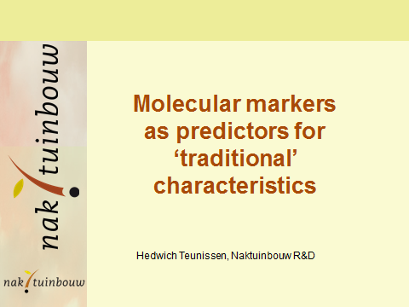

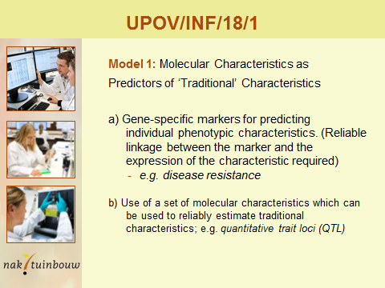

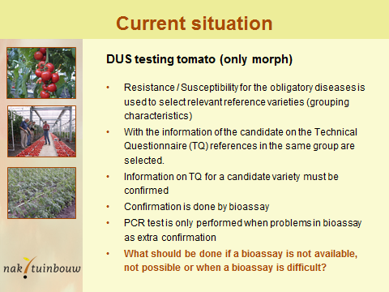

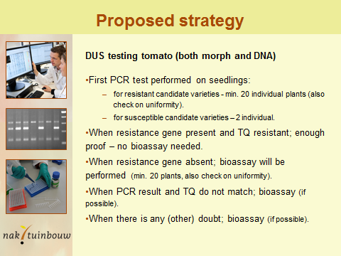

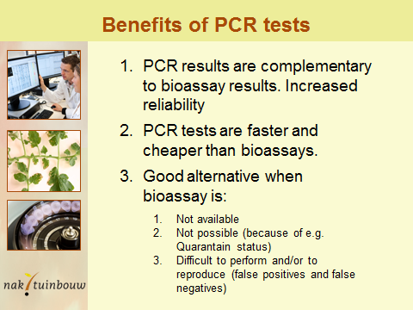

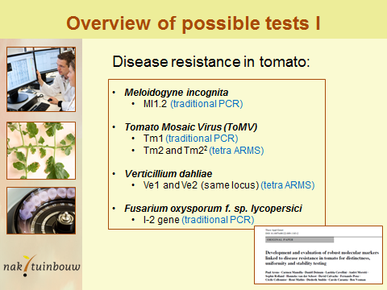

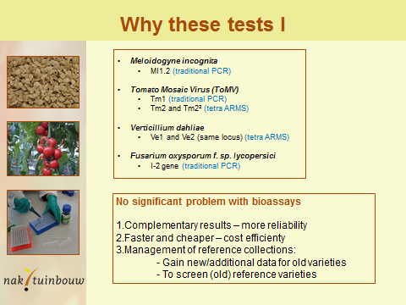

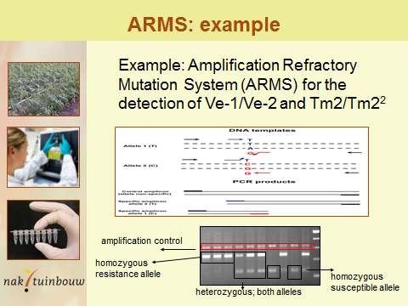

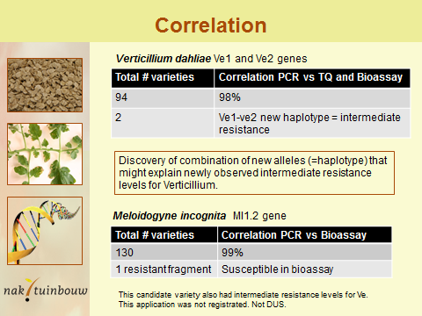

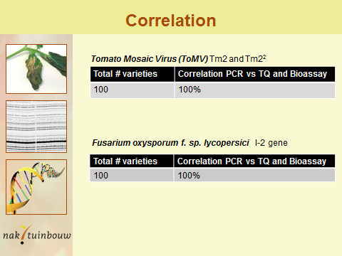

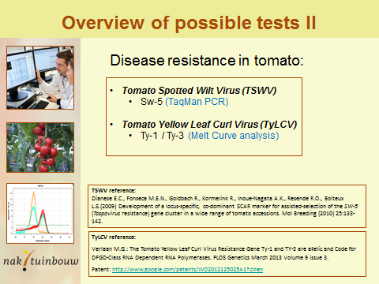

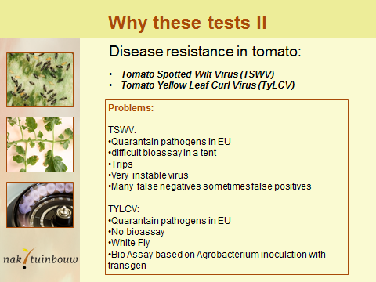

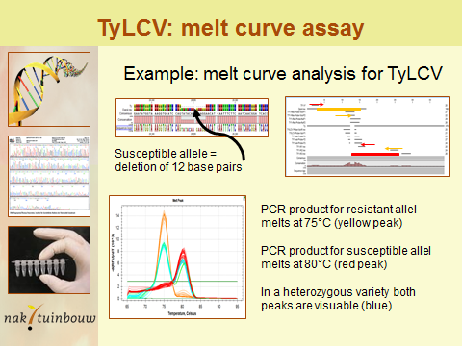

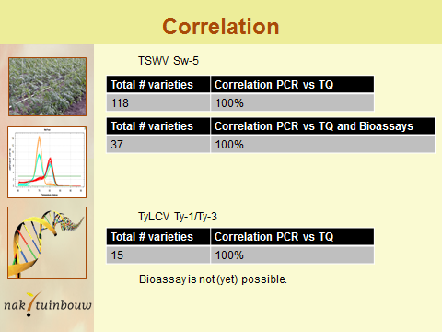

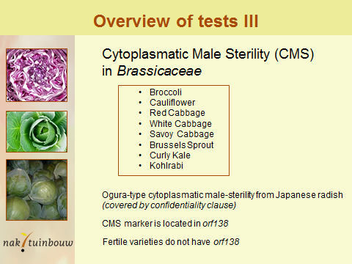

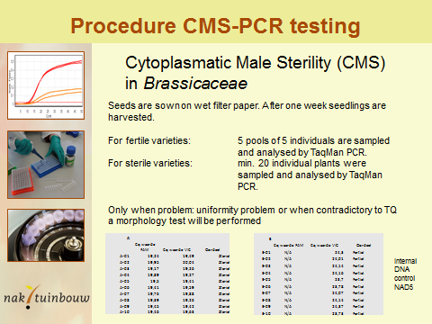

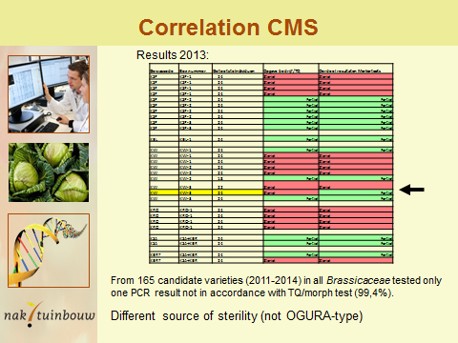

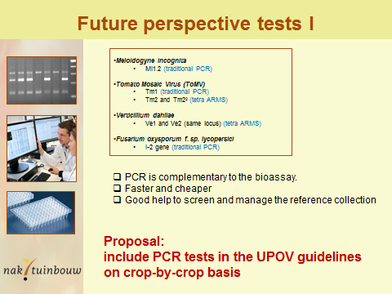

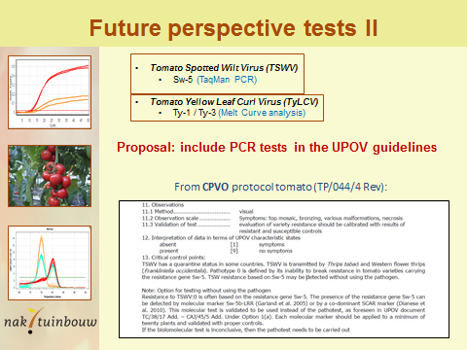

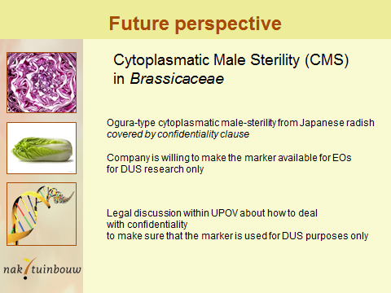

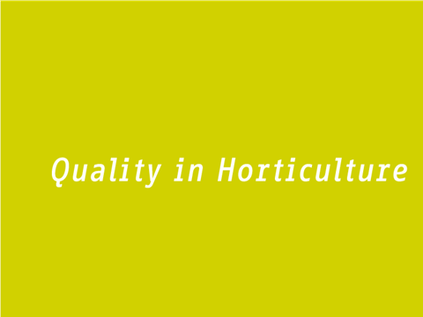

[End of Annex and of document]

