E
BMT/14/17 Add.
ORIGINAL: English
DATE: November 27, 2014
INTERNATIONAL UNION FOR THE PROTECTION OF NEW VARIETIES OF PLANTS
Geneva
WORKING GROUP ON BIOCHEMICAL AND MOLECULAR TECHNIQUES
AND DNA-PROFILING IN PARTICULAR
Fourteenth Session
Seoul, Republic of Korea, November 10 to 13, 2014
addendum to document bmt/14/17

IMPROVING EFFICIENCY OF DUS TESTING OF PERENNIAL RYEGRASS BY COMBINING MORPHOLOGICAL AND MOLECULAR VARIETY DISTANCES
Document prepared by experts from Expert from the Netherlands
Disclaimer: this document does not represent UPOV policies or guidance
The Annex to this document contains a copy of a presentation “The use of molecular markers (SNP) for maize DUS testing” made at the fourteenth session of the Working Group on Biochemical and Molecular Techniques and DNA-Profiling in particular (BMT).

Henk Bonthuis and Hedwich Teunissen,
Naktuinbouw, Wageningen, the Netherlands

[Annex follows]

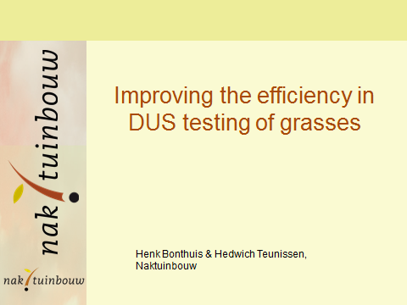

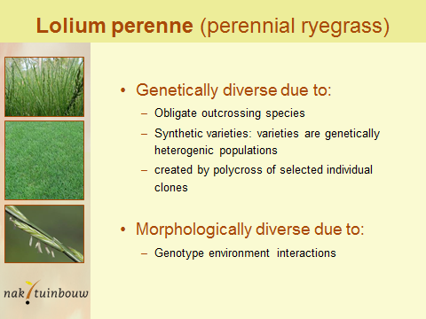

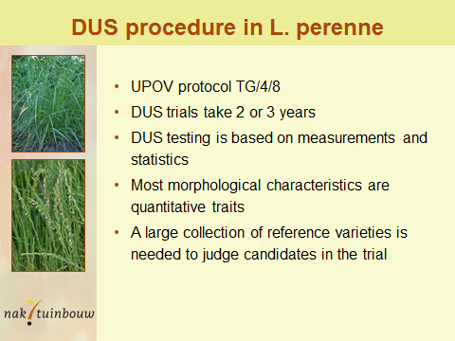

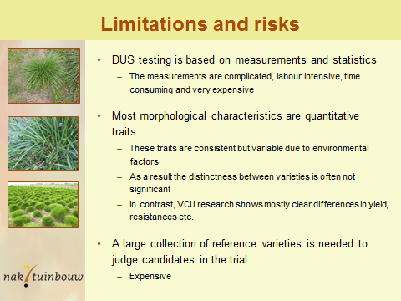

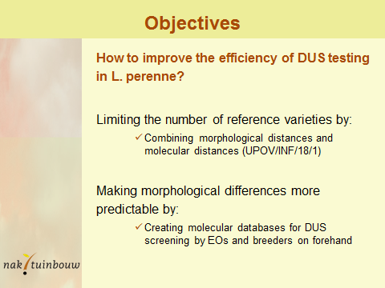

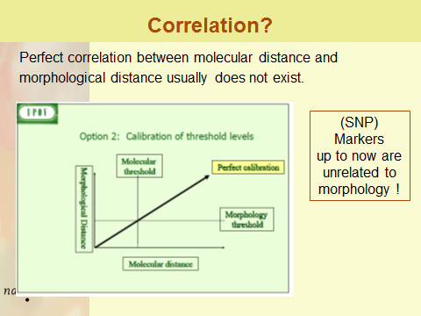

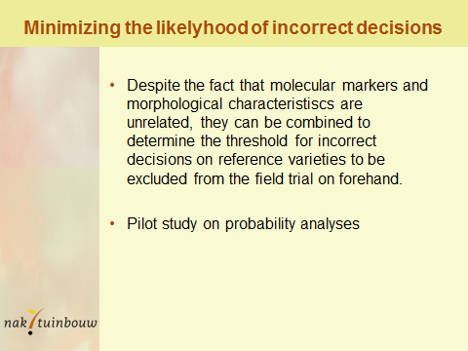

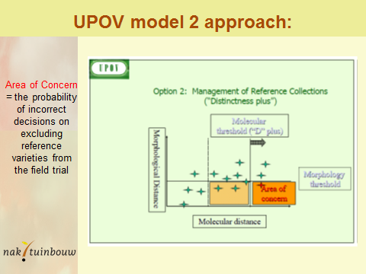

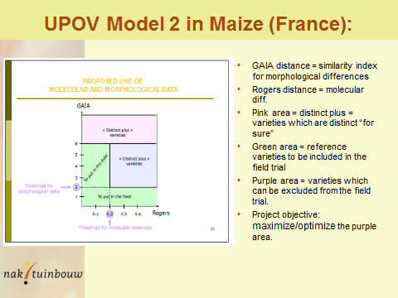

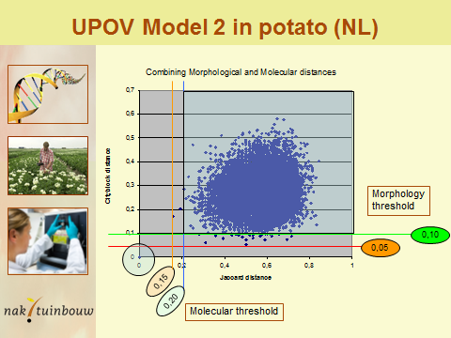

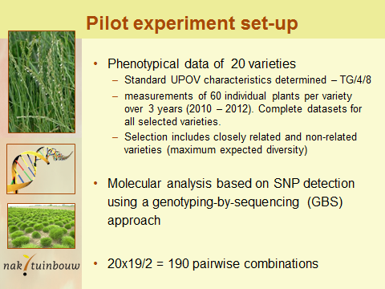

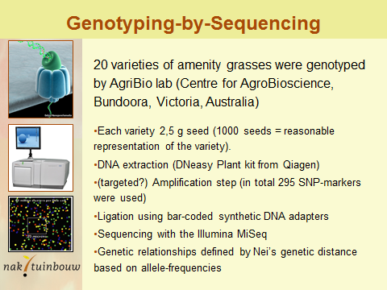

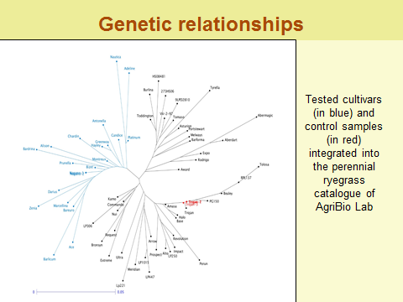

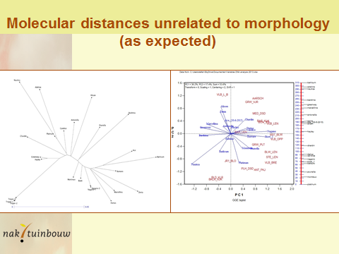

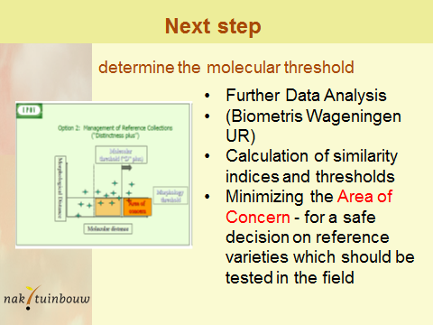

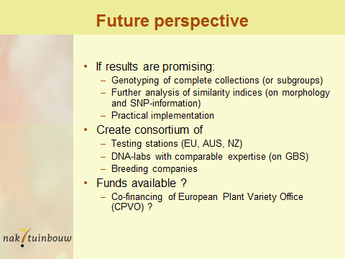

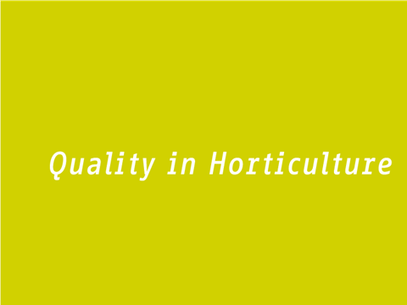

[End of Annex and of document]

